**Course Description**

As a data scientist, you'll often find that the data you need is not in a single file. It may be spread across a number of text files, spreadsheets, or databases. You’ll want to be able to import the data you’re interested in as a collection of DataFrames and combine them to answer your central questions.

This course is all about the act of combining—or merging—DataFrames, an essential part of any data scientist's toolbox. You'll hone your pandas skills by learning how to organize, reshape, and aggregate multiple datasets to answer your specific questions.

**1. Preparing data**

In this chapter, you'll learn about different techniques you can use to import multiple files into DataFrames. Having imported your data into individual DataFrames, you'll then learn how to share information between DataFrames using their indexes. Understanding how indexes work is essential to merging DataFrames, which you’ll learn later in the course.



This course is all about merging and combining DataFrames for your data science needs. Your data rarely exists as DataFrames from the outset: you generally have to deal with text files, spreadsheets, and databases. Let's first check out how to read multiple files into a collection of DataFrames.

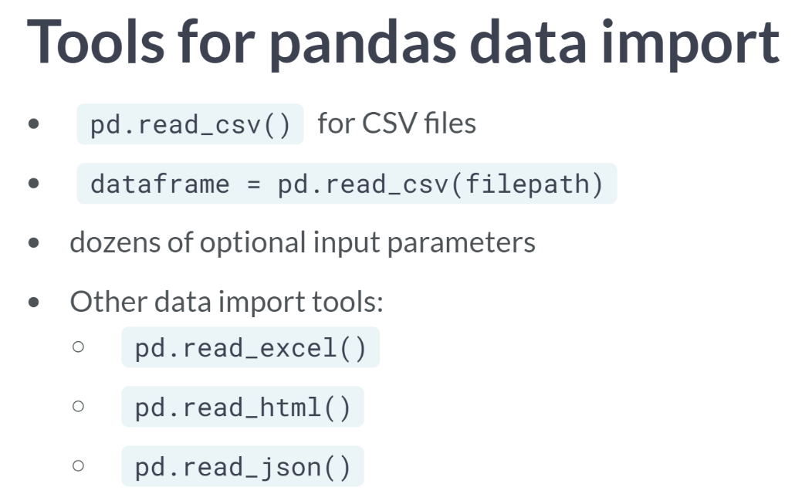

The primary tool we've used for data import is ***read_csv()***. This function accepts the file path of a comma-separated values file as input and returns a Pandas DataFrame directly.

***read_csv()*** has about 50 optional calling parameters permitting very fine-tuned data import. Pandas has other convenient tools (with similar default calling syntax) that import various data formats like Excel, HTML, or JSON into DataFrame.

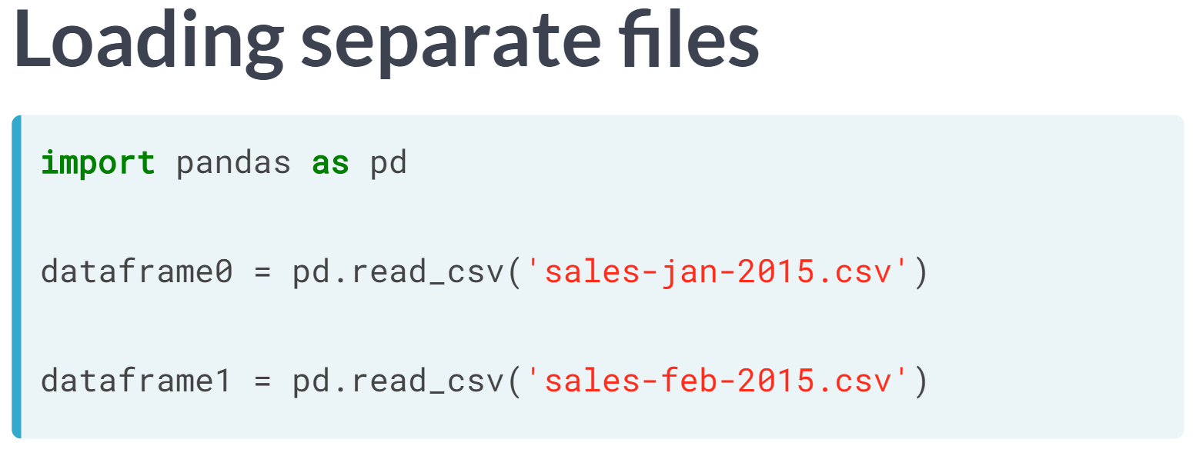  
To read multiple files using Pandas, we generally need separate DataFrames. For example, here we call ***pd.read_csv()*** twice to read two CSV files into two distinct DataFrames.

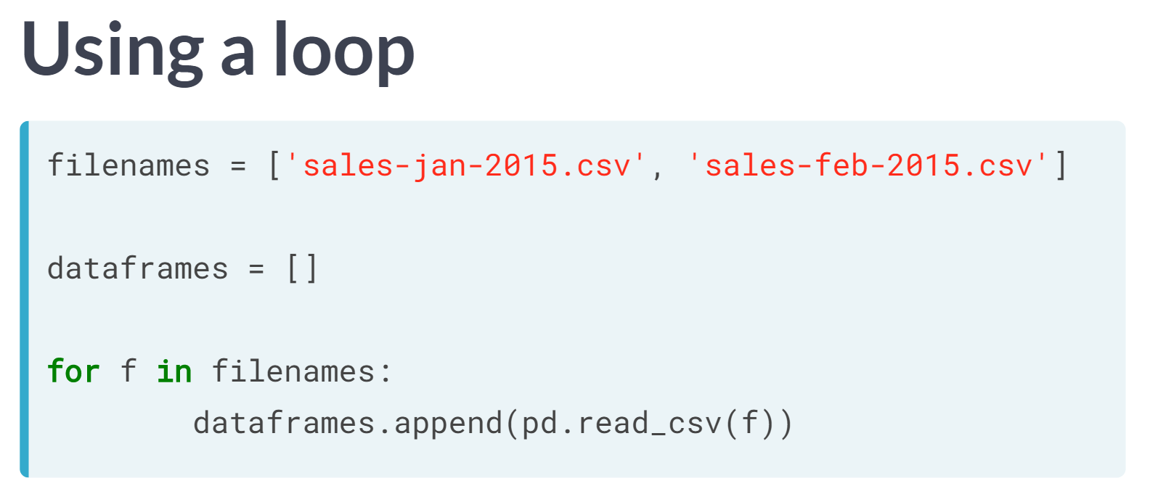  
It's generally more efficient to iterate over a collection of file names. With that goal, we can create a list, filenames, with the two file paths from before. We then initialize an empty list called DataFrames and iterate through the list filenames.

Within each iteration, we invoke ***read_csv()*** to read a DataFrame from a file and we append the resulting DataFrame to the list DataFrames.

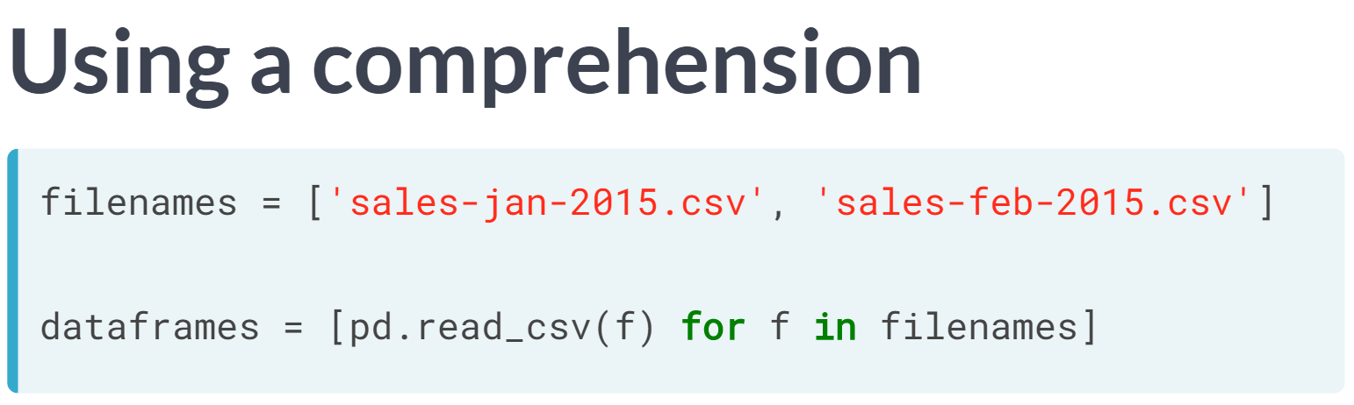  
We can also do the preceding computation with a list comprehension. Comprehensions are basically a convenient Python construction for exactly this kind of loop where an empty list is appended to within each iteration. You can check out DataCamp's Python programming courses for more details on comprehensions.

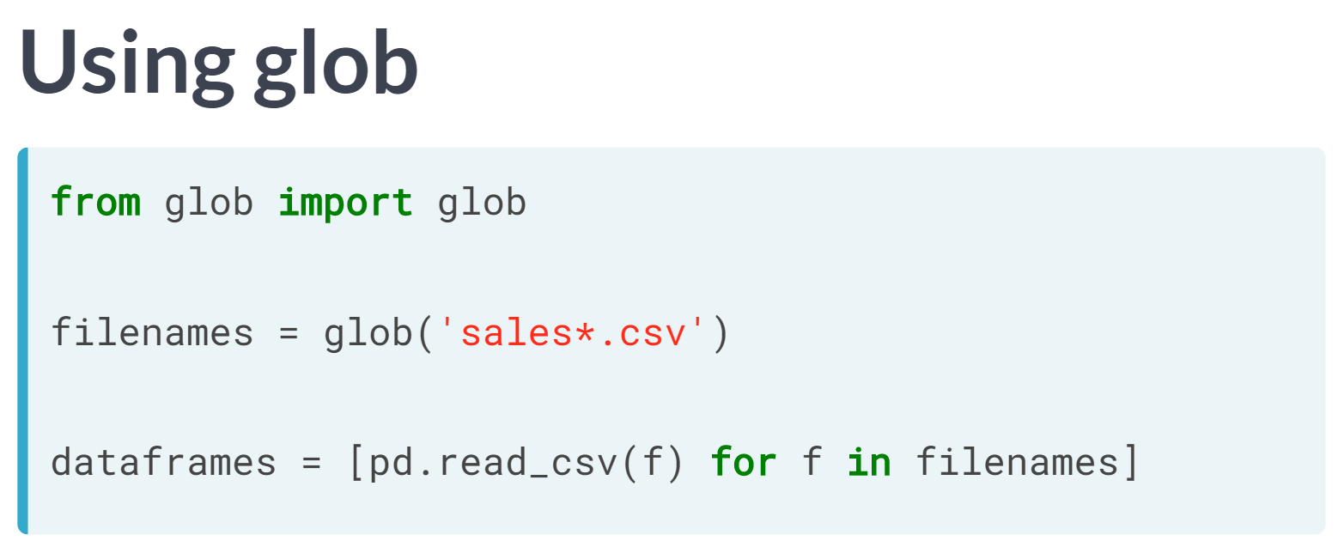  
When many filenames have a similar pattern, the glob module from the Python Standard Library is very useful. Here, we start by importing the function glob() from the built-in glob module.

We use the pattern 'sales*.csv' to match any strings that start with prefix sales and end with the suffix .csv; here, the asterisk is a wildcard that matches zero or more standard characters.

The function ***glob()*** uses the wildcard pattern to create an iterable object filename containing all matching filenames in the current directory.

Finally, the iterable filenames is consumed in a list comprehension that makes a list called DataFrames containing the relevant data structures.

# Reading DataFrames from multiple files

When data is spread among several files, you usually invoke pandas' read_csv() (or a similar data import function) multiple times to load the data into several DataFrames.

The data files for this example have been derived from a [**list of Olympic medals awarded between 1896 & 2008**](https://www.theguardian.com/sport/datablog/2012/jun/25/olympic-medal-winner-list-data) compiled by the Guardian.

The column labels of each DataFrame are NOC, Country, & Total where NOC is a three-letter code for the name of the country and Total is the number of medals of that type won (bronze, silver, or gold).

This course touches on a lot of concepts you may have forgotten, so if you ever need a quick refresher, download the [***Pandas Cheat Sheet***](https://datacamp-community-prod.s3.amazonaws.com/9f0f2ae1-8bd8-4302-a67b-e17f3059d9e8) and keep it handy!

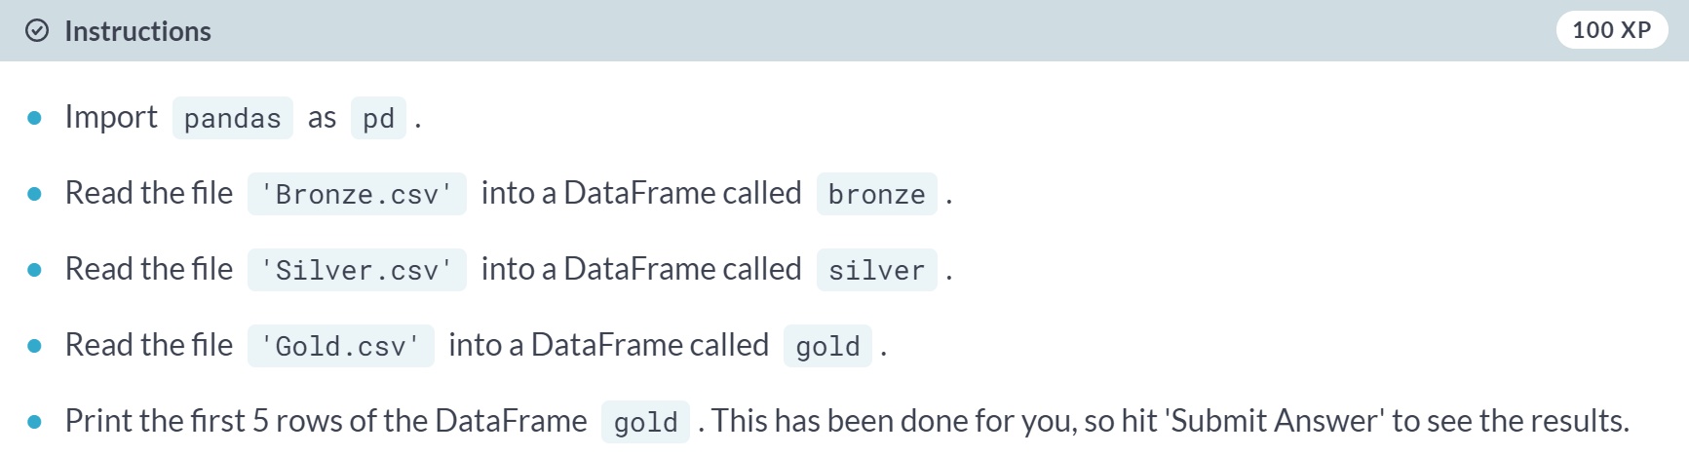

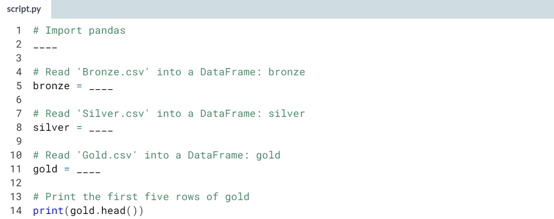

Hint

1. Use the command import x as y to import x as the alias y.
2. Use the ***pd.read_csv()*** function with the name of the CSV file as the argument to read it into a DataFrame.

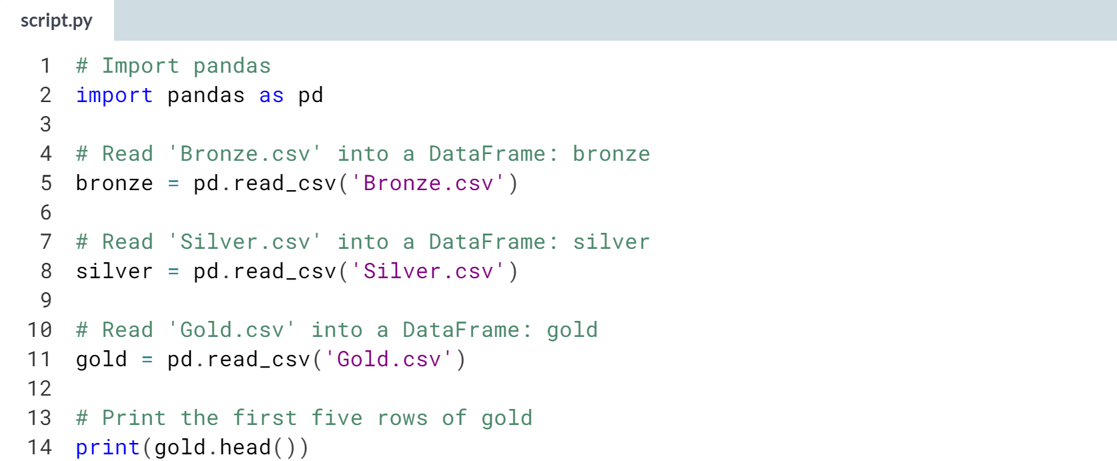

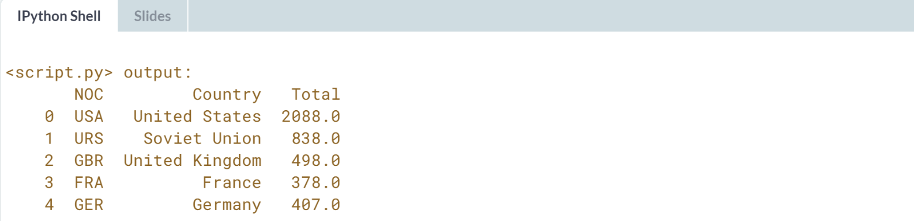

Well done! Reading csv files into DataFrames like this should now be second nature to you!

# Reading DataFrames from multiple files in a loop

As you saw in the video, loading data from multiple files into DataFrames is more efficient in a loop or a list comprehension.

Notice that this approach is not restricted to working with CSV files. That is, even if your data comes in other formats, as long as pandas has a suitable data import function, you can apply a loop or comprehension to generate a list of DataFrames imported from the source files.

Here, you'll continue working with [**The Guardian's Olympic medal dataset**](https://www.theguardian.com/sport/datablog/2012/jun/25/olympic-medal-winner-list-data).

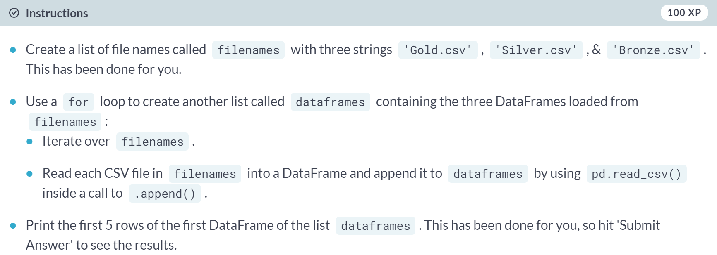

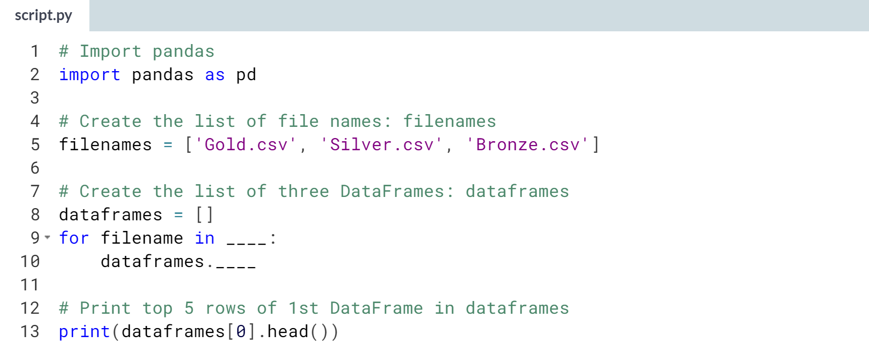

Hint

1. In the for loop, you need to iterate over the list filenames.
2. There are two steps involved in building the list of DataFrames:
   1. First, use the ***.append()*** method on DataFrames.
   2. Inside ***.append()***, read each CSV file filename into a DataFrame using ***pd.read_csv()***.

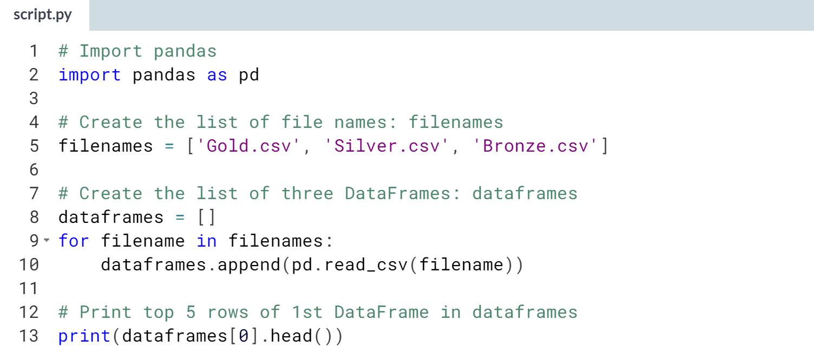

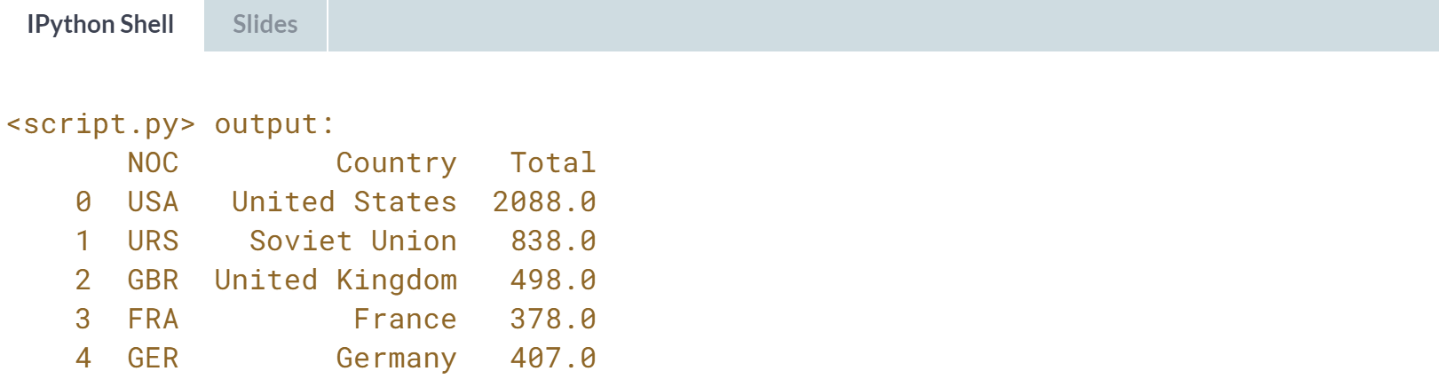

Great work! When you are dealing with multiple csv files like this, it is more efficient to read them into DataFrames using a loop.

# Combining DataFrames from multiple data files

In this exercise, you'll combine the three DataFrames from earlier exercises - gold, silver, & bronze - into a single DataFrame called medals.

The approach you'll use here is clumsy. Later on in the course, you'll see various powerful methods that are frequently used in practice for concatenating or merging DataFrames.

Remember, the column labels of each DataFrame are NOC, Country, and Total, where NOC is a three-letter code for the name of the country and Total is the number of medals of that type won.

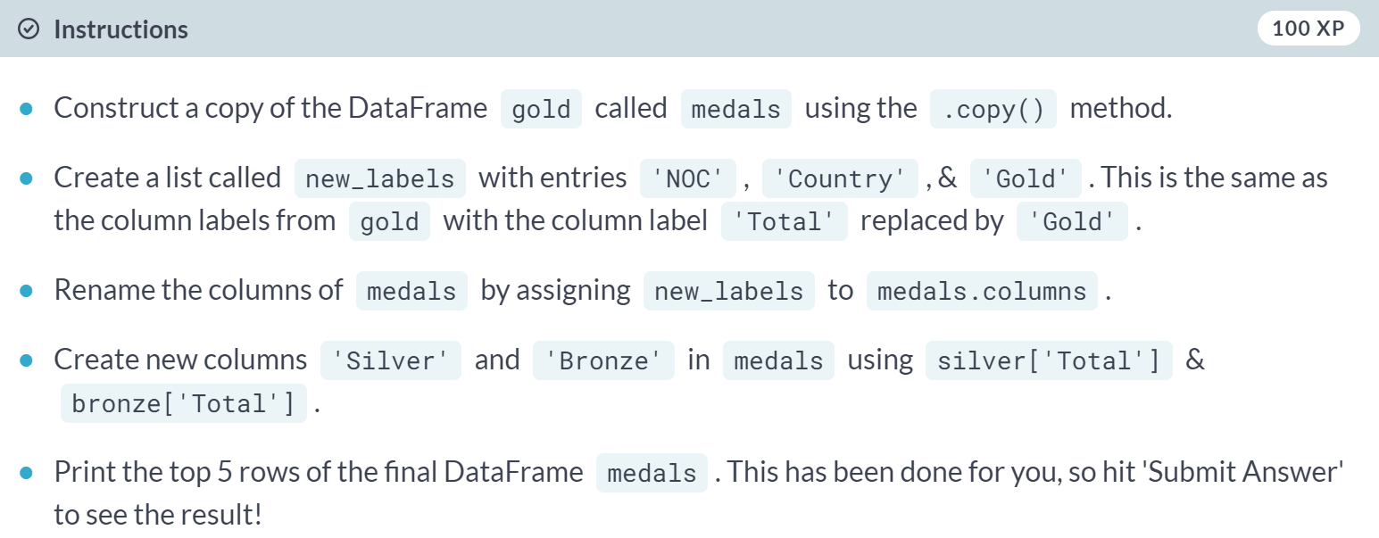

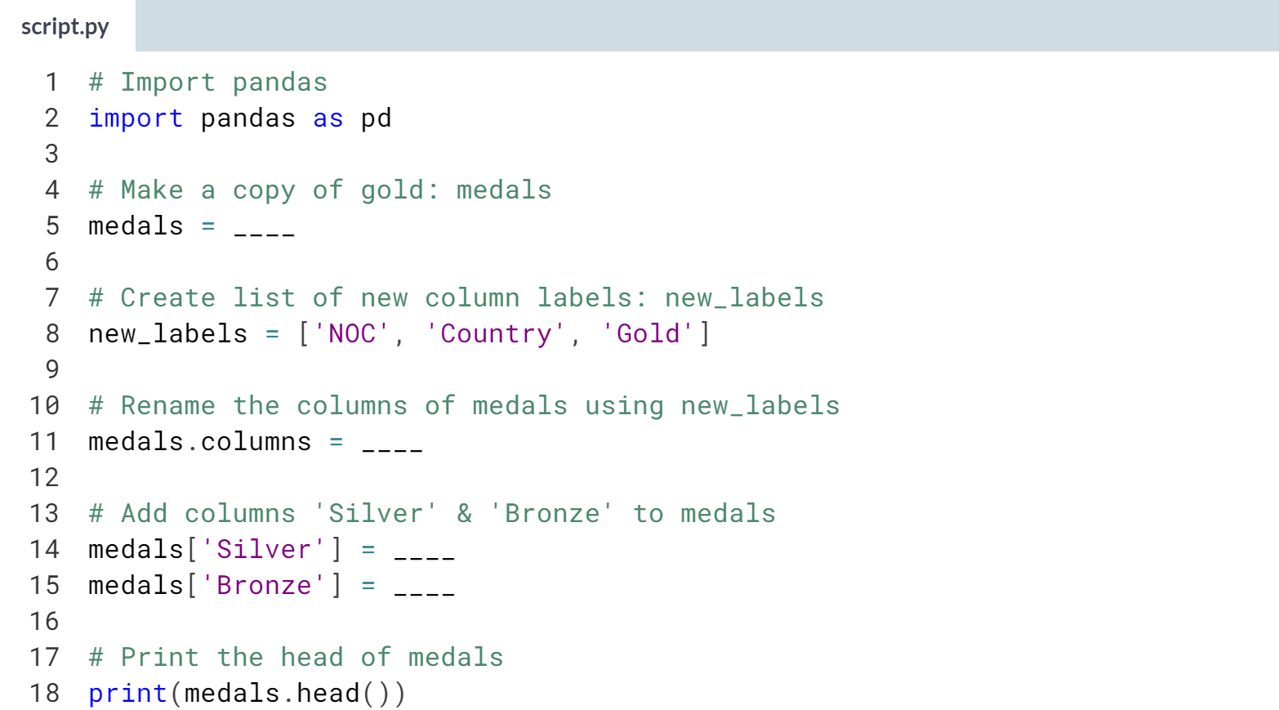

Hint

1. Use the ***.copy()*** method on gold to copy gold.
2. Assign the result to medals. Assign *new_labels* to *medals.columns* to rename the columns of medals.
3. Assign **silver['Total']** and **bronze['Total']** to **medals['Silver']** and **medals['Bronze']** to create the new columns *'Silver'* and *'Bronze'*.

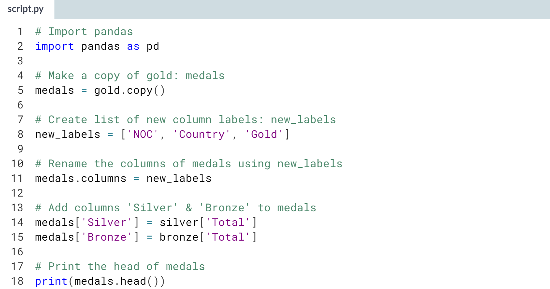

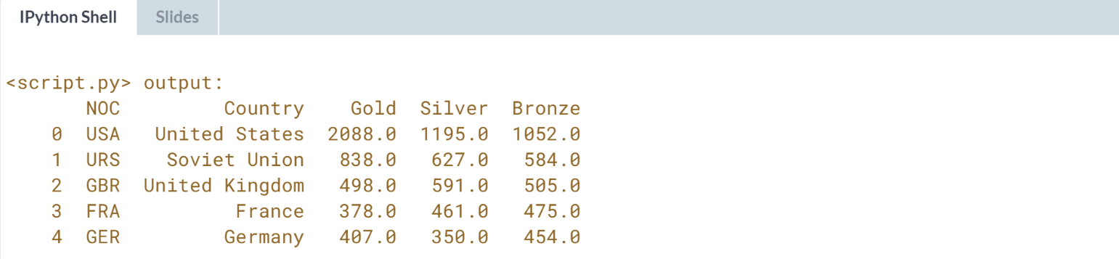

Excellent! Later in this course, you'll learn far more powerful tools for combining DataFrames!



Now we can import many files into individual DataFrames. Let's now focus on sharing information between DataFrames using their indexes.

This is essential for combining DataFrames as Indexes are the means by which DataFrame rows are labeled.

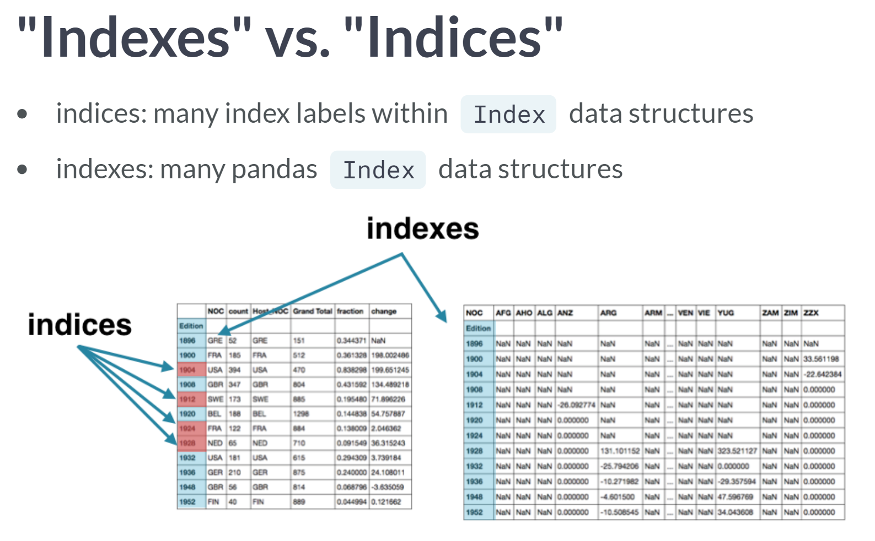  
Let's adopt the convention of using indices as the plural of index when referring to individual labels within an index data structure.

By contrast, we can use indexes as the plural of index with reference to many index data structures associated with several Pandas Series or DataFrames. This is not a standard convention, but it helps us resolve ambiguity in thinking about, say, sets of indices within many indexes.

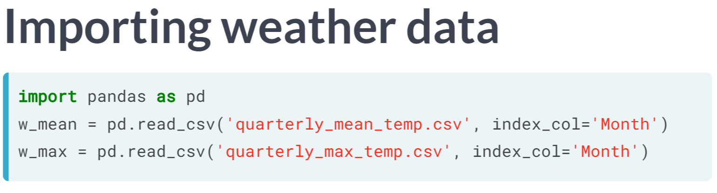  
To start, let's load two DataFrames of temperature data recorded from Pittsburg in 2013. *Index_col* specifies which column becomes the DataFrame Index ("Month" in both cases). Remember that the index is a previlaged column in Pandas providing convenient access to Series or DataFrame rows.

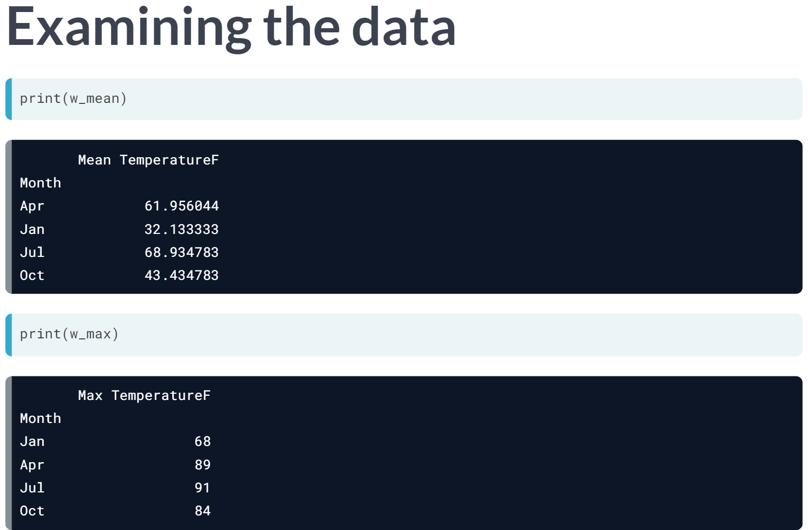  
For both DataFrames, the column Month is the DataFrame Index. The month listed in each Index row is the first month of each quarter. By virtue of how the CSV files are sorted, the index of *w_mean* is in alphabetical order while the index of *w_max* is in chronological order; the former gives a distorted sense of time-dependent trends.

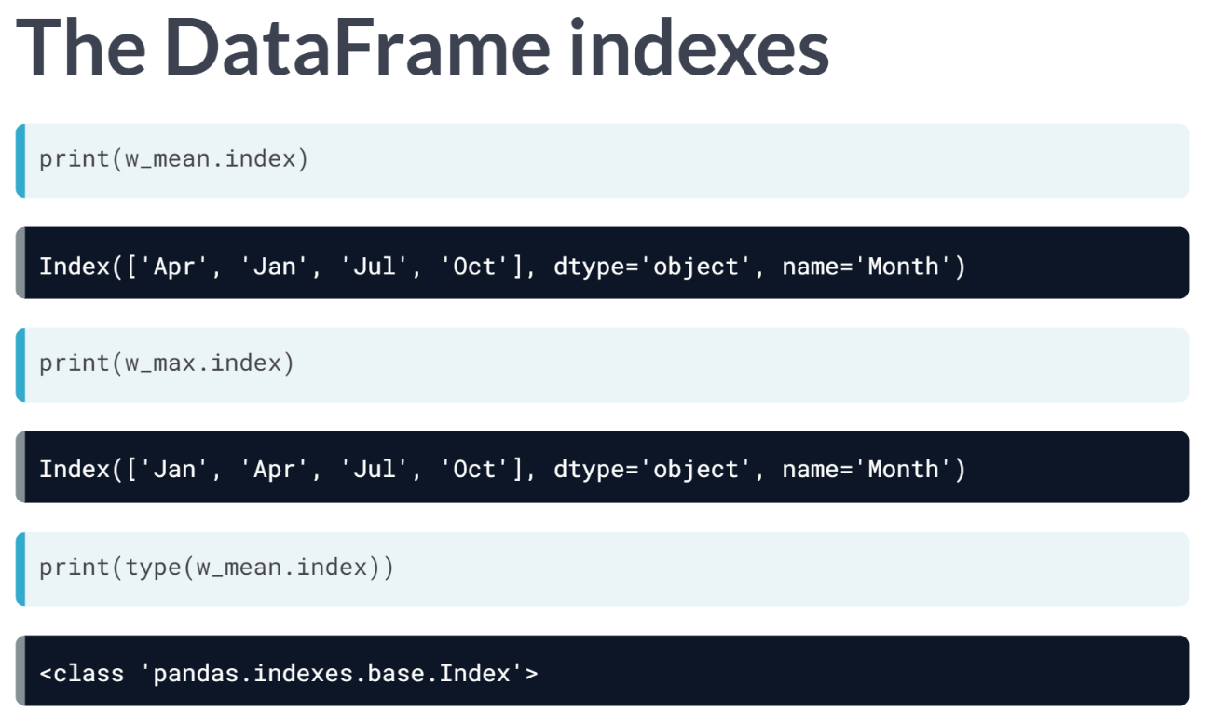  
The DataFrame Indexes are accessed directly with the .index attribute. Both DataFrames have indexes of type object because the index labels are strings. The Pandas ***type()*** function shows us the data type of the index.

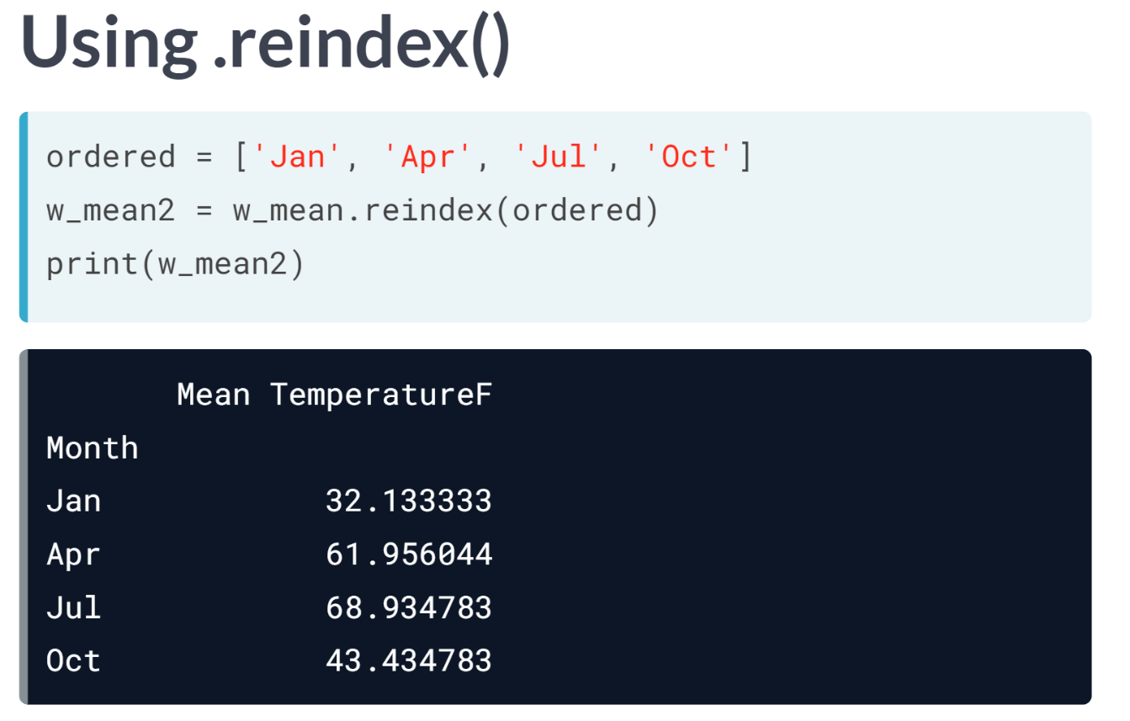  
We define a list called ordered to impose a deliberate ordering for the Index labels of *w_mean*. The DataFrame ***.reindex()*** method creates a new DataFrame w_mean2 with the same data as *w_mean* but with a new row ordering according to the input list ordered. We can see that w_mean2 has the desired chronological ordering.

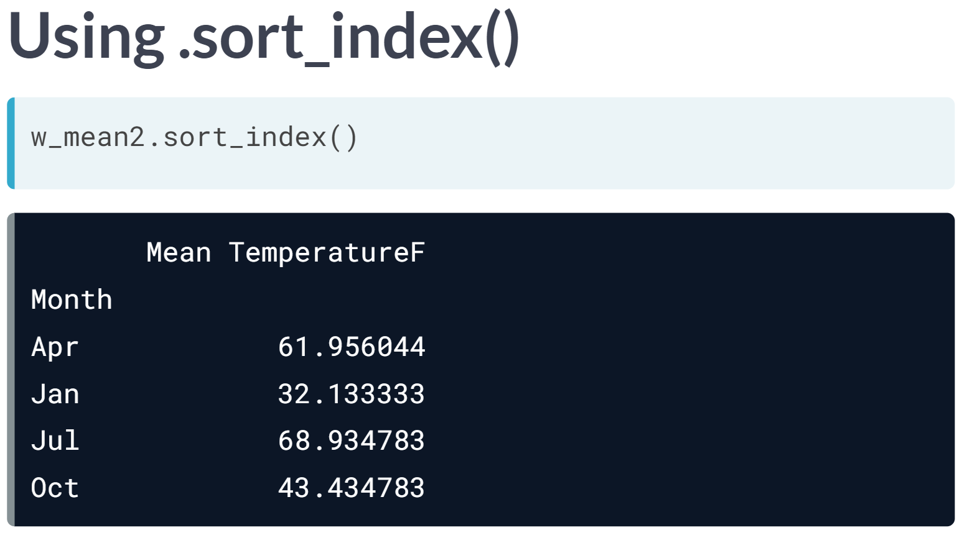  
The original alphabetically ordered DataFrame can be recovered with the DataFrame ***.sort_index()*** method. Pandas Index labels are typically sortable data, such as numbers, strings, or datetimes.

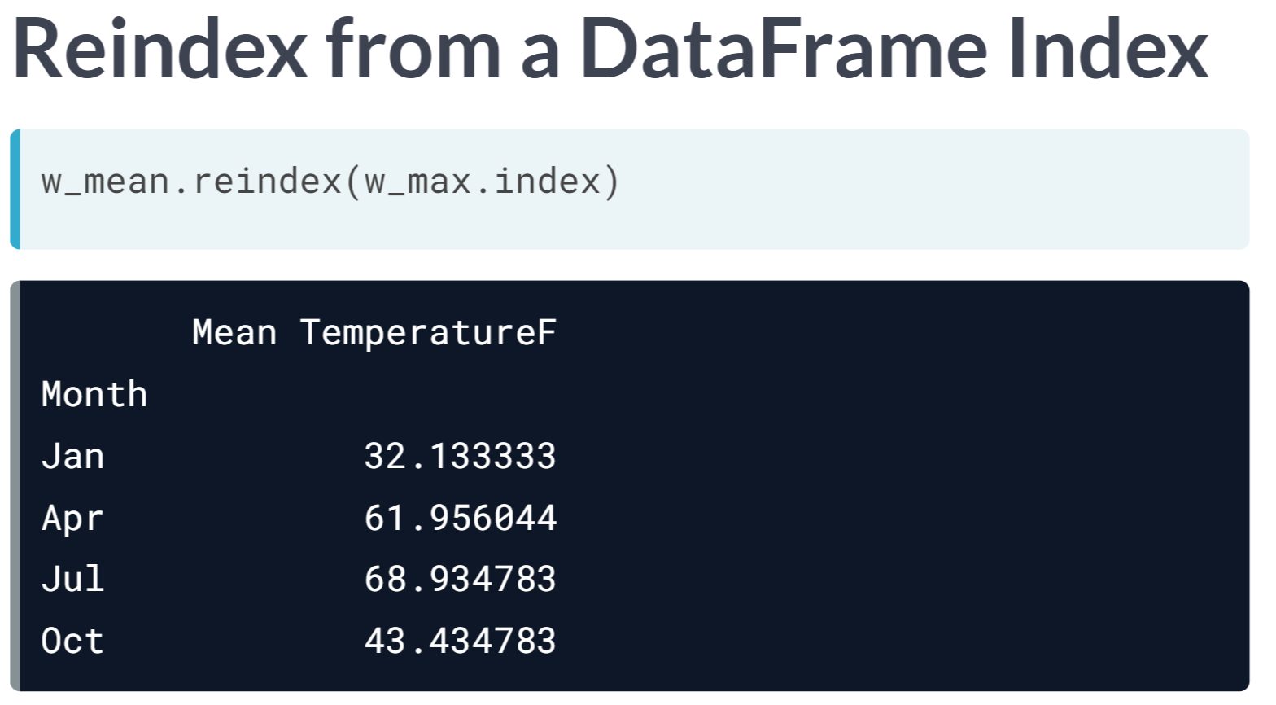  
The input argument to the ***.reindex()*** method can also be another DataFrame Index. For instance, here, we use the Index from *w_max* to reindex *w_mean* in chronological order.

When a suitably indexed DataFrame is available, the ***reindex()*** method spares us having to create a list manually or having to sort the Index.

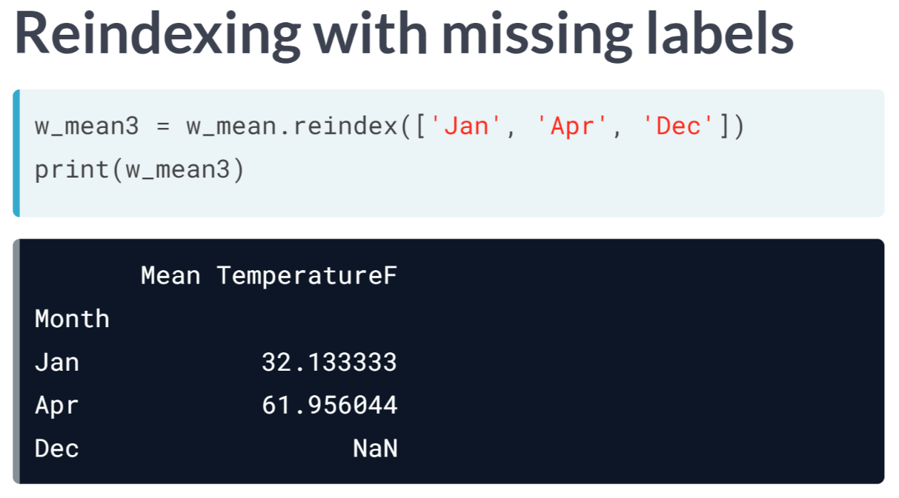  
The specific Index labels provided to the ***.reindex()*** method are important.

For instance, if we invoke ***.reindex()*** again using an input list containing a label that is not in the original DataFrame Index (Dec in this case), an entirely new row is inserted & filled with the null value NaN or not-a-number.

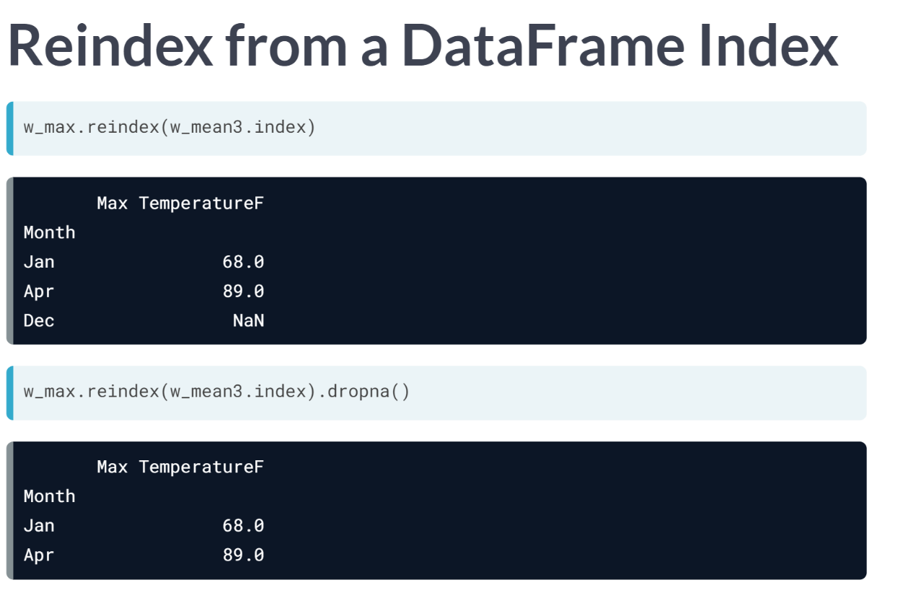  
We can also use ***.reindex()*** to see where DataFrame rows overlap. For instance, here, we reindex *w_max* with the index of w_mean3 showing that *w_max* does not have a row labelled Dec either. Using ***.dropna()*** removes entire rows in which null values occur. This is a common first step when merging DataFrames.

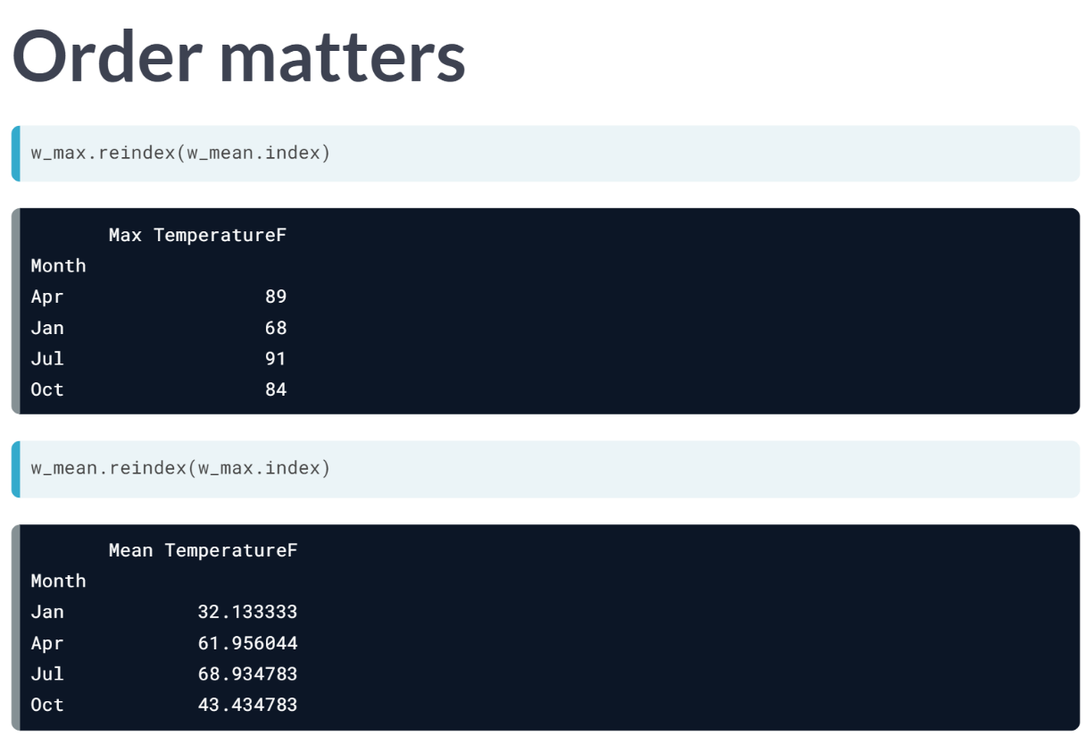  
Finally, we should realize that order counts. That is, *w_max.reindex(w_mean.index)* is not the same as *w_mean.reindex(w_max.index)*. The latter fixes the row order as desired in w_mean; the former replicates the misleading alphabetical row order in w_max; this is likely not desired.

# Sorting DataFrame with the Index & columns

It is often useful to rearrange the sequence of the rows of a DataFrame by sorting. You don't have to implement these yourself; the principal methods for doing this are .sort_index() and .sort_values().

In this exercise, you'll use these methods with a DataFrame of temperature values indexed by month names. You'll sort the rows alphabetically using the Index and numerically using a column.

Notice, for this data, the original ordering is probably most useful and intuitive: the purpose here is for you to understand what the sorting methods do.

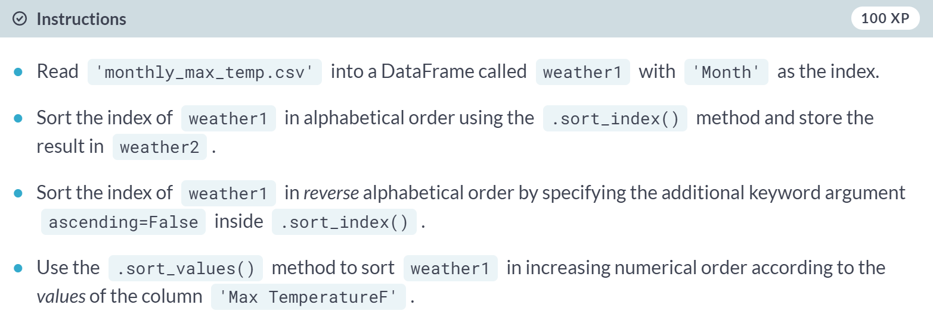  
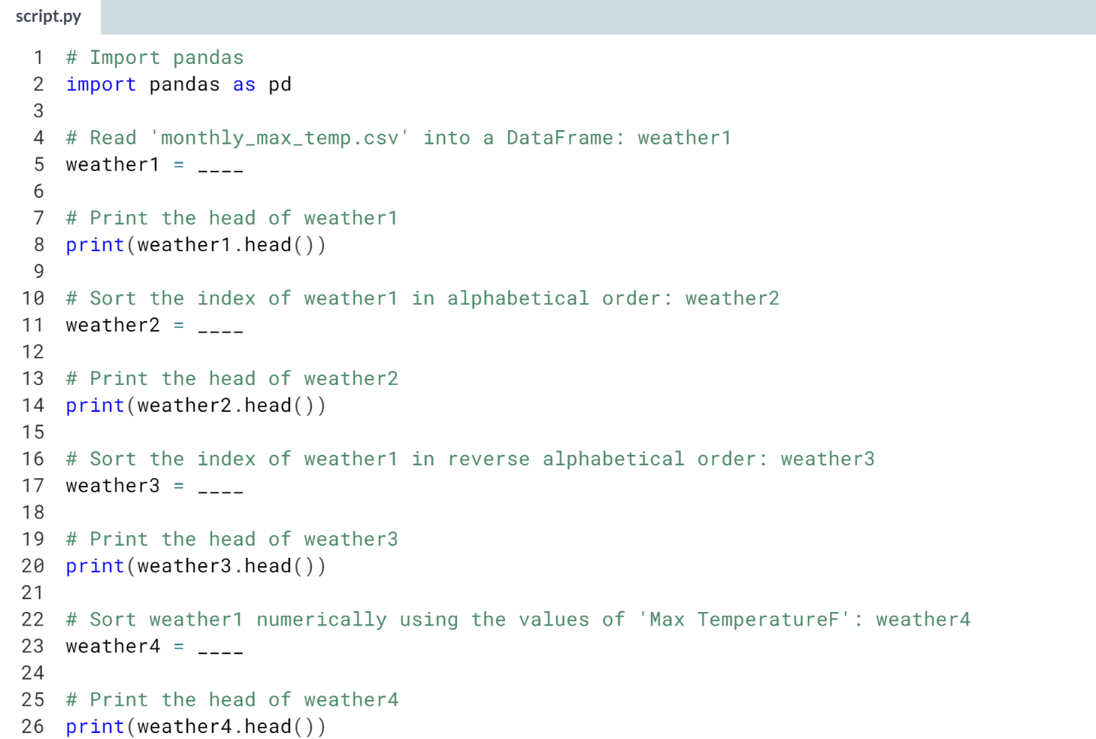

1. Use ***pd.read_csv()*** with *index_col='Month'* to read *'monthly_max_temp.csv'* into a DataFrame called *weather1*.
2. Use the ***.sort_index()*** method on *weather1* to sort its index in alphabetical order.
3. Use the ***.sort_index()*** method on *weather1* with the keyword argument *ascending=False* to sort it in reverse alphabetical order.
4. Use the ***.sort_values()*** method on *weather1* with *'Max TemperatureF'* as argument to sort *weather1* in increasing numerical order according to the values of the column *'Max TemperatureF'*.

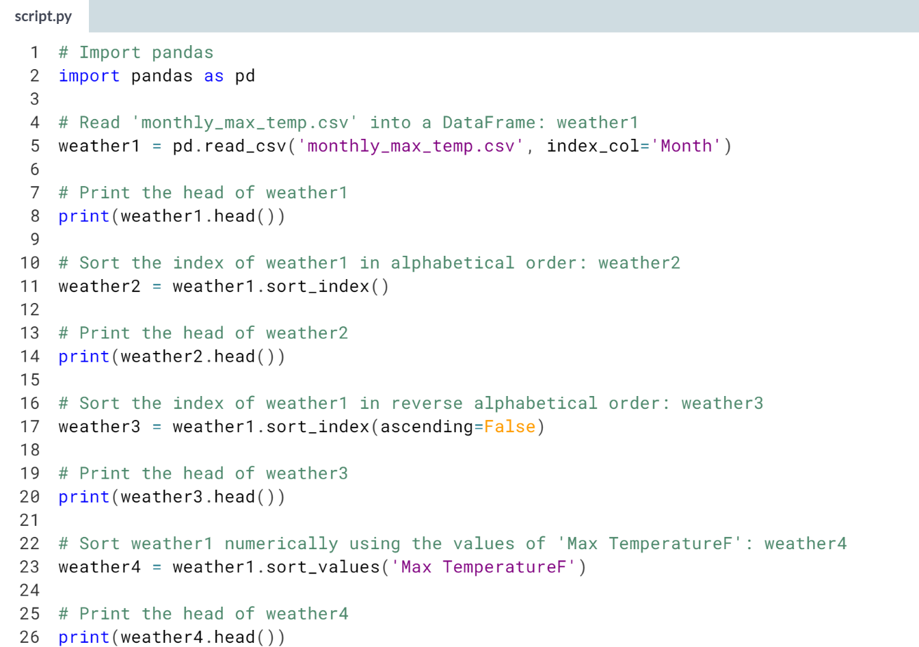  
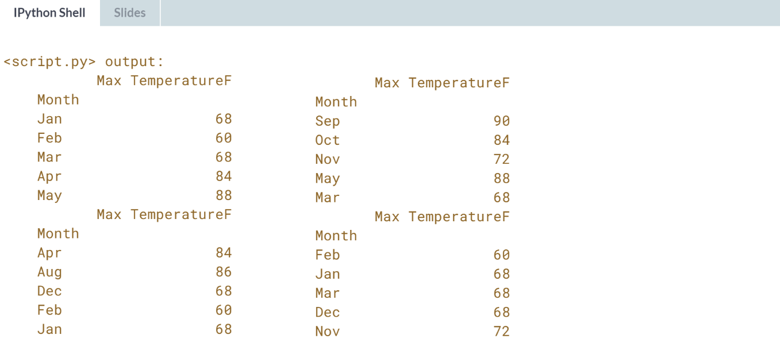  
Good job! Being able to sort DataFrames is an important skill. When your DataFrames are sorted, it becomes easier to see how you can combine them.

# Reindexing DataFrame from a list

Sorting methods are not the only way to alter DataFrame Indexes. There is also the .reindex() method.

In this exercise, you'll reindex a DataFrame of quarterly-sampled mean temperature values to contain monthly samples (this is an example of upsampling or increasing the rate of samples, which you may recall from the [**pandas Foundations**](https://www.datacamp.com/courses/pandas-foundations) course).

The original data has the first month's abbreviation of the quarter (three-month interval) on the Index, namely Apr, Jan, Jul, and Oct. This data has been loaded into a DataFrame called weather1 and has been printed in its entirety in the IPython Shell.

Notice it has only four rows (corresponding to the first month of each quarter) and that the rows are not sorted chronologically.

You'll initially use a list of all twelve-month abbreviations and subsequently apply the .ffill() method to forward-fill the null entries when upsampling. This list of month abbreviations has been pre-loaded as year.

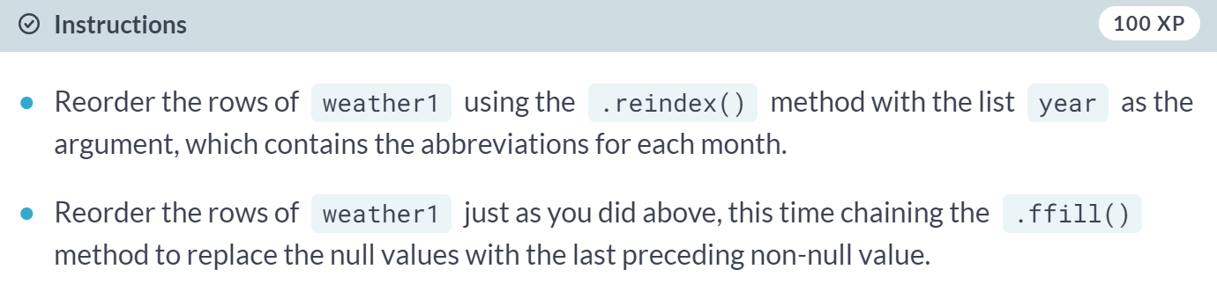

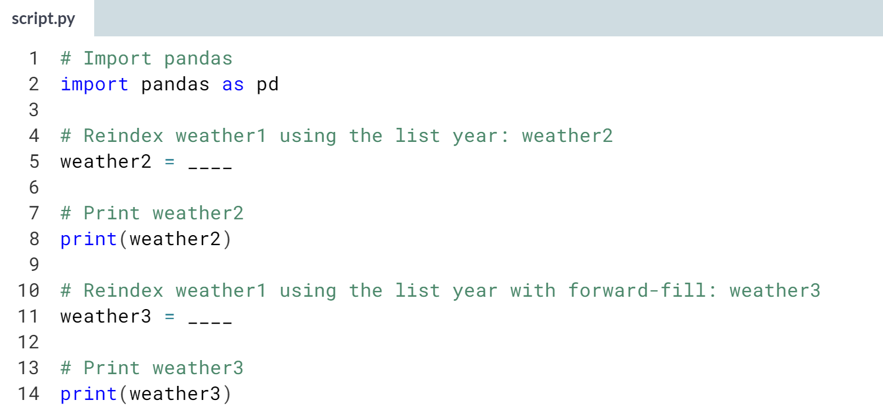

Hint

1. Use the ***.reindex()*** method on *weather1* with the list of month abbreviations year as the argument.
2. To forward-fill, repeat the same process above, and then chain the ***.ffill()*** method.

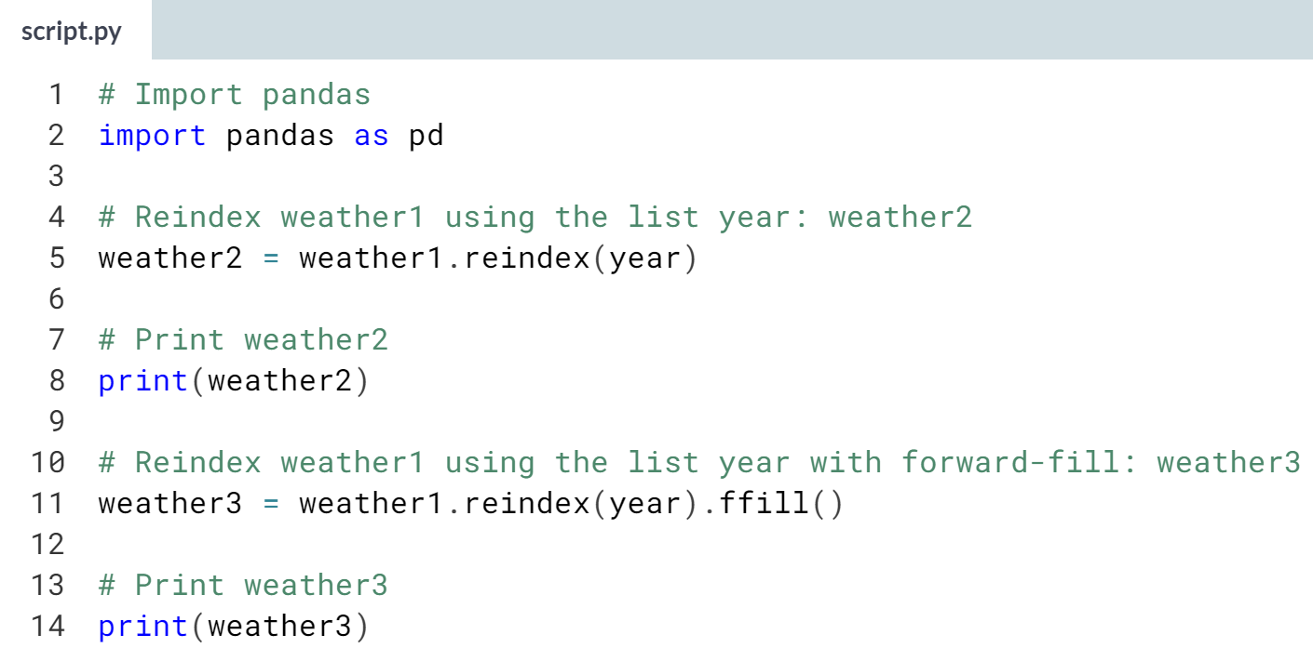

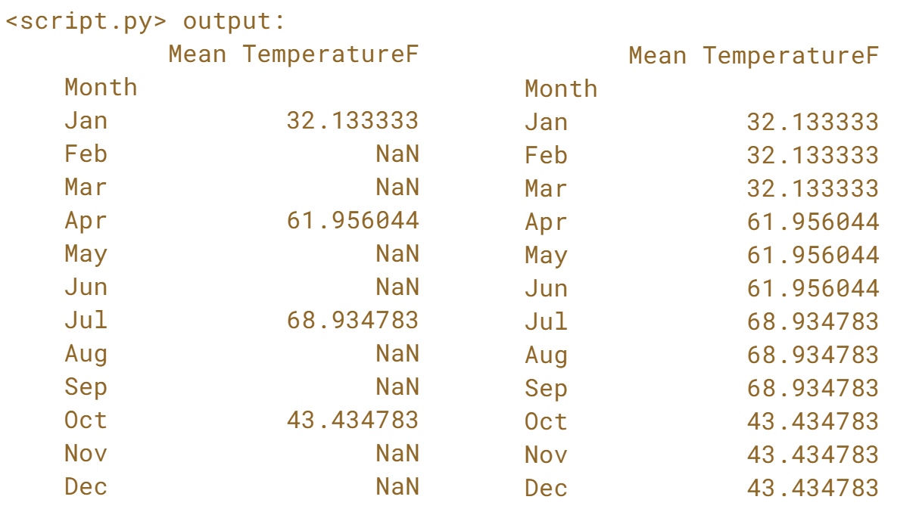  
Great work! Notice that values corresponding to months missing from *weather1* are filled with *NaN* values in *weather2*. This does not happen in *weather3*, since you used forward-fill.

# Reindexing using another DataFrame Index

Another common technique is to reindex a DataFrame using the Index of another DataFrame. The DataFrame .reindex() method can accept the Index of a DataFrame or Series as input. You can access the Index of a DataFrame with its .index attribute.

The [**Baby Names Dataset**](https://www.data.gov/developers/baby-names-dataset/) from [**data.gov**](http://data.gov/) summarizes counts of names (with genders) from births registered in the US since 1881.

In this exercise, you will start with two baby-names DataFrames names_1981 and names_1881 loaded for you.

The DataFrames names_1981 and names_1881 both have a MultiIndex with levels name and gender giving unique labels to counts in each row.

If you're interested in seeing how the MultiIndexes were set up, names_1981 and names_1881 were read in using the following commands:



As you can see by looking at their shapes, which have been printed in the IPython Shell, the DataFrame corresponding to 1981 births is much larger, reflecting the greater diversity of names in 1981 as compared to 1881.

Your job here is to use the DataFrame .reindex() and .dropna() methods to make a DataFrame common_names counting names from 1881 that were still popular in 1981.

(Exercise begins on the next page)

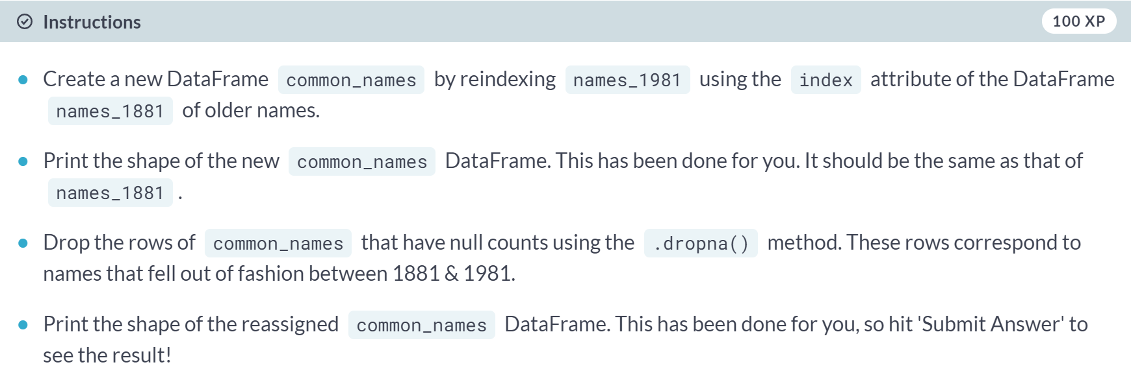  
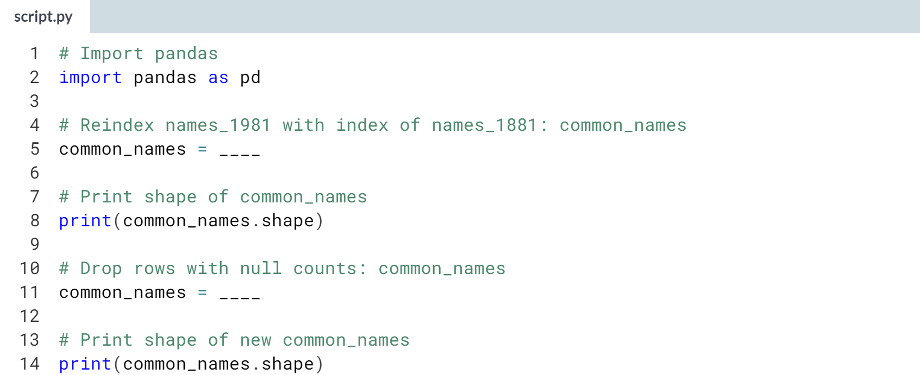

Hint

1. Use the ***.reindex()*** method on *names_1981* with the index of *names_1881* as the argument.
2. Use the ***.dropna()*** method on *common_names* to drop the rows with null counts.

(Solution on the next page)

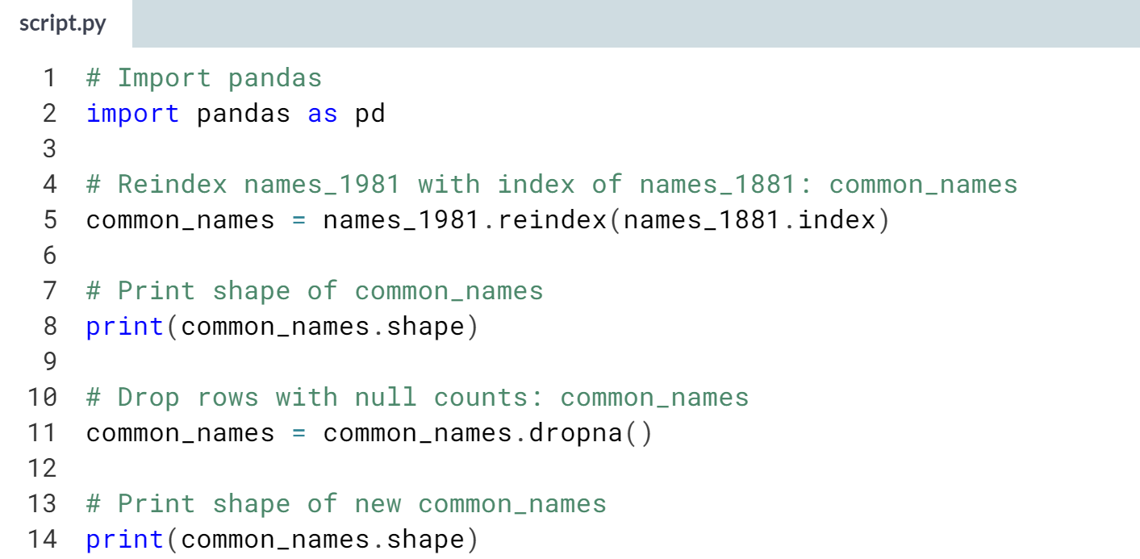

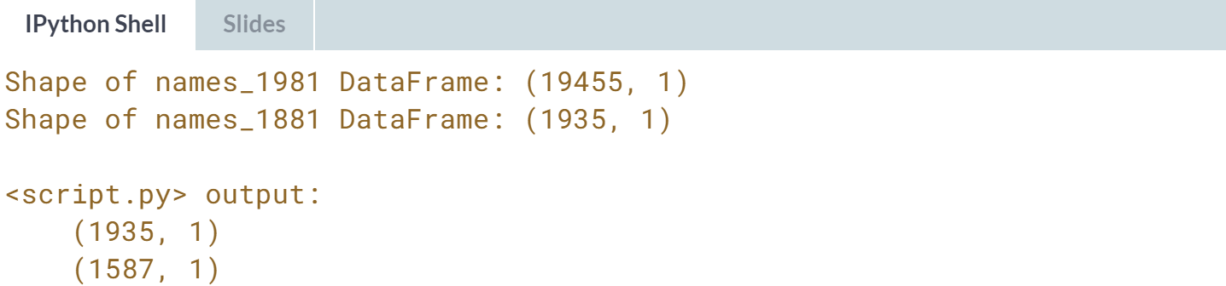



Let's explore various arithmetic & mathematical operations between Pandas Series & DataFrames.

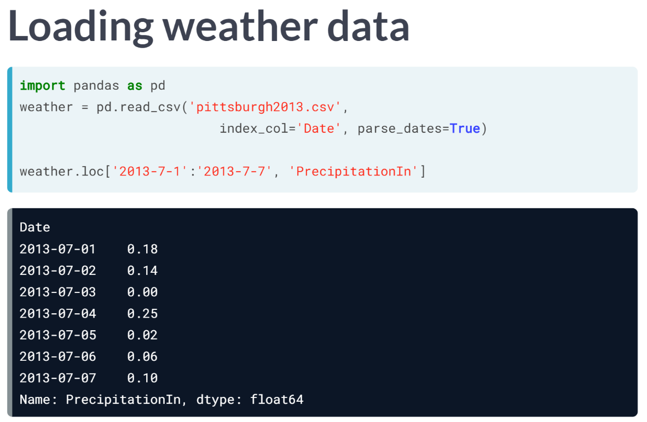  
We load daily weather measurements for Pittsburgh from 2013. We make 'Date' the Index & we use parse_dates=True to get datetime objects.

With datetime Indexes, we can use convenient strings to slice, say, the first week of July from the 'PrecipitationIn' column. The Precipitation data are in inches; let's convert them to centimeters.

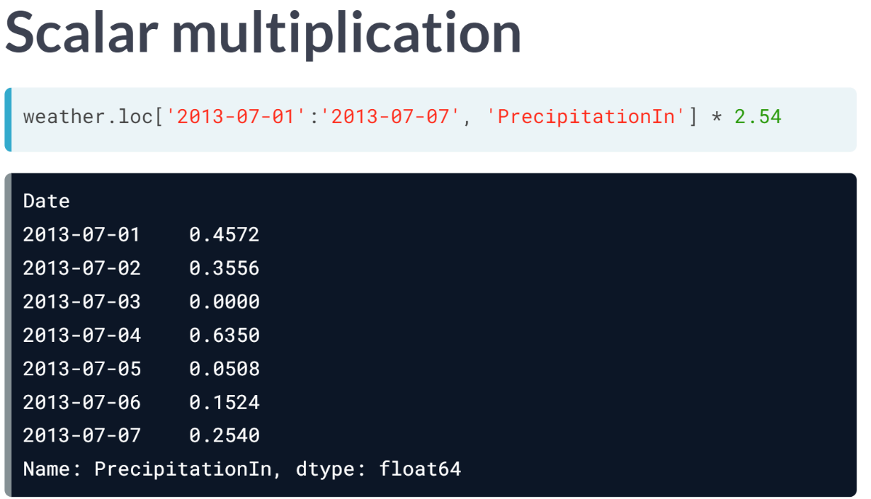  
We use the asterisk to multiply a Series elementwise by 2.54. Remember, we can broadcast standard scalar mathematical operations. Here, broadcasting means the multiplication is applied to all entries in the DataFrame.

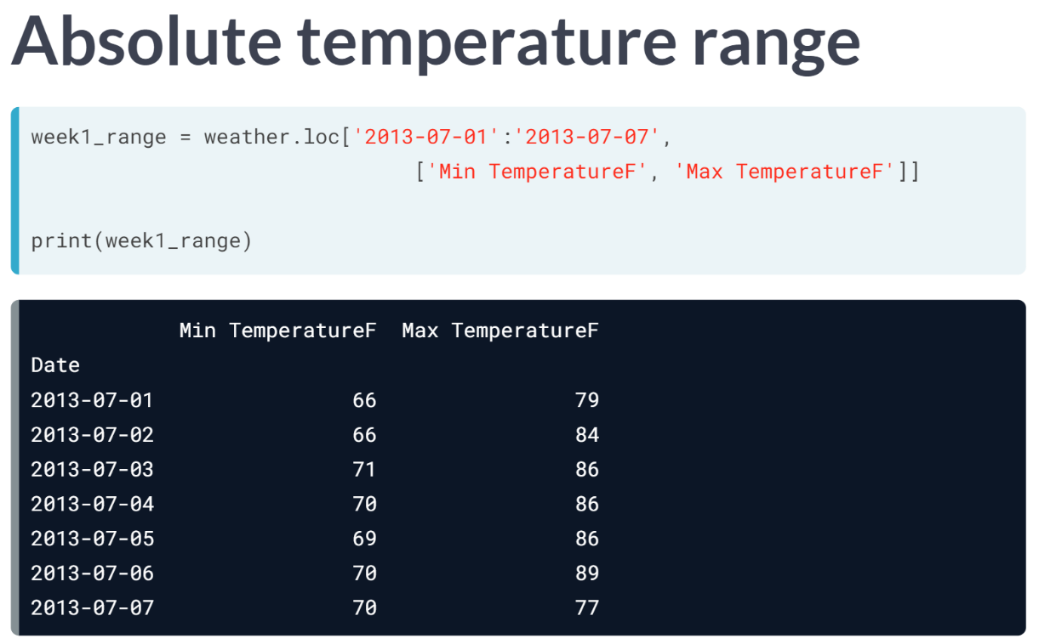  
Let's find the percentage variation in temperature in the first week of July. That is, the daily minimum & the daily maximum temperatures expressed as a percentage of the daily mean temperature.

We compute this by dividing both the *'Min TemperatureF' & the 'Max TemperatureF'* columns by the Mean *TemperatureF* column and multiplying both by 100.

To begin, slice the *'Min TemperatureF' & 'Max TemperatureF'* columns as a DataFrame *week1_range*.

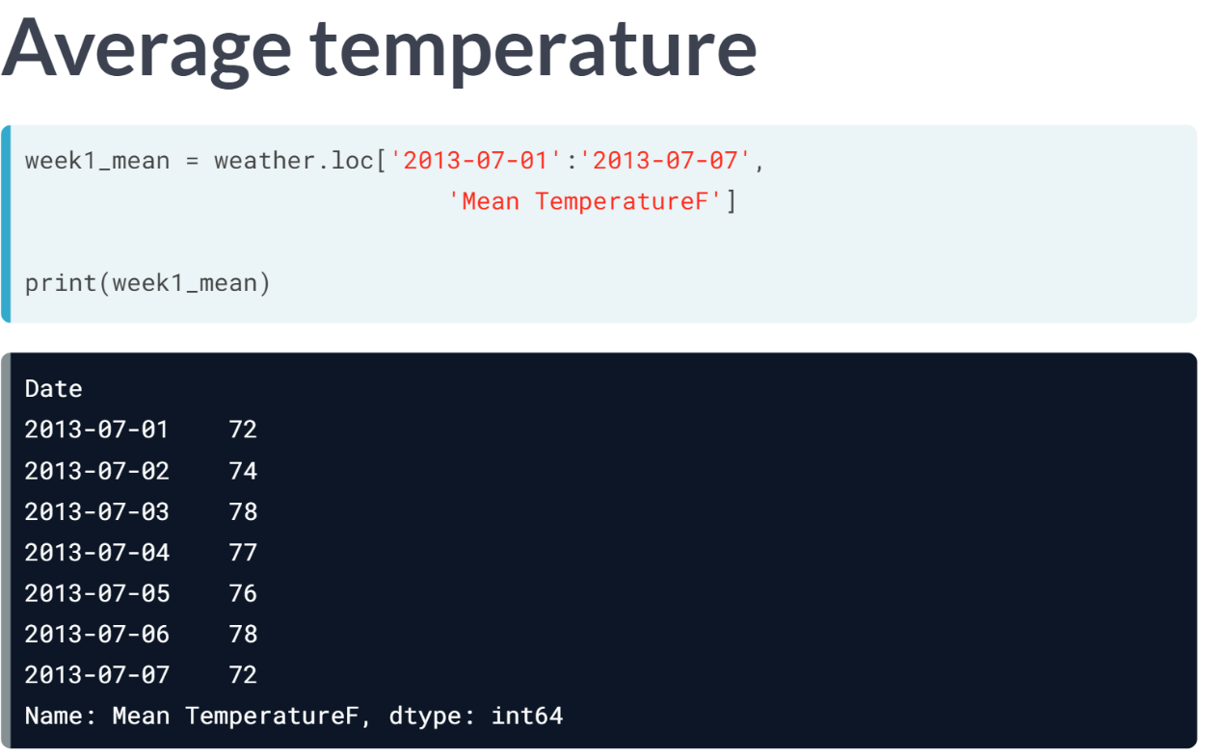  
Next, slice the Mean *TemperatureF* column as a Series *week1_mean*.

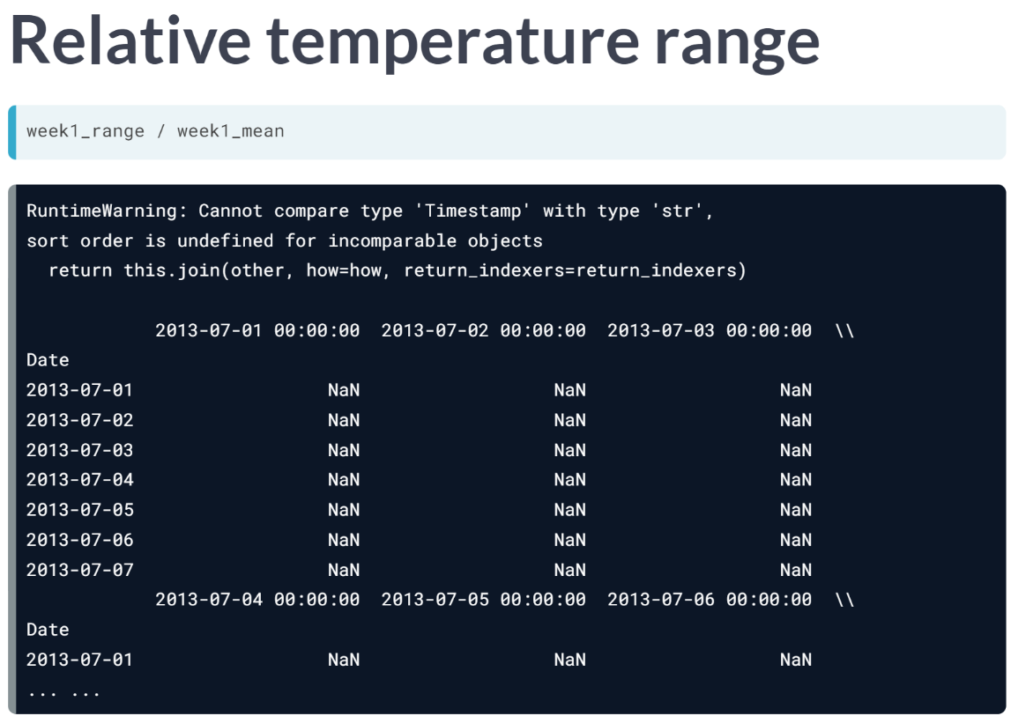  
Dividing DataFrame *week1_range* by *Series week1_mean* doesn't quite work. The column labels don't match so the result has all null values.

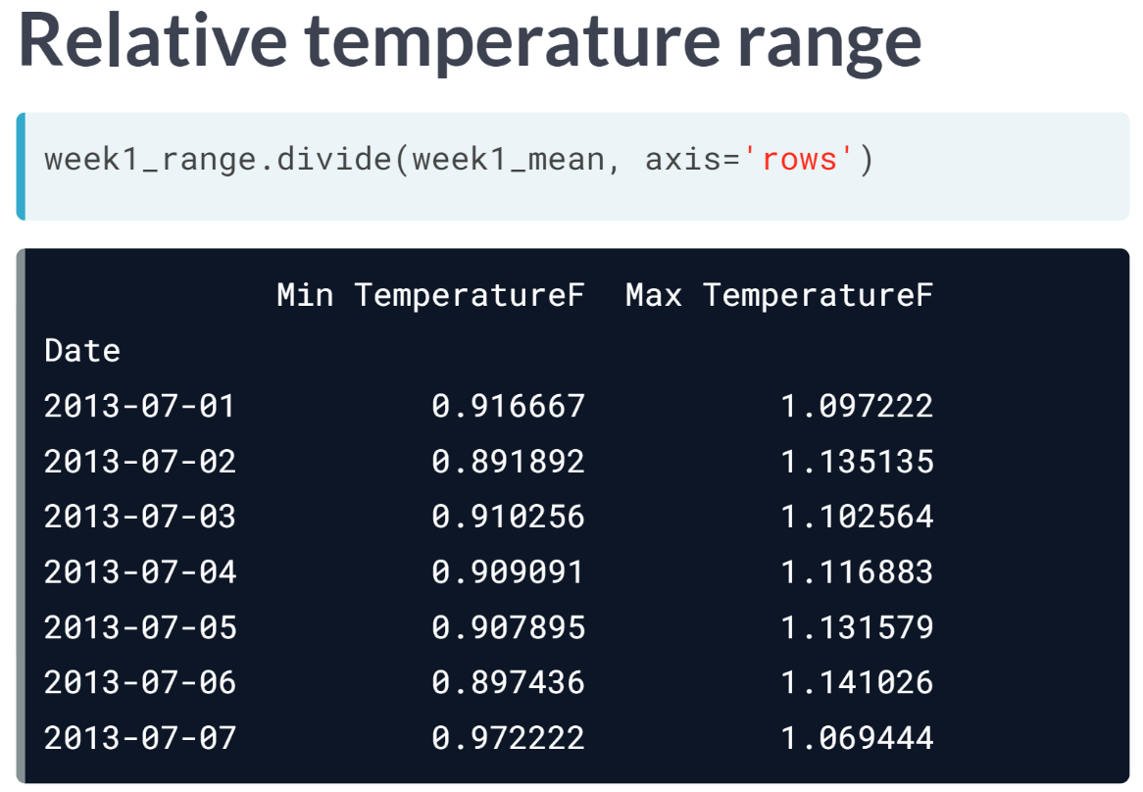  
Instead, we want to use the DataFrame ***.divide()*** method with option *axis='rows'*. The ***.divide()*** method provides more fine-grained control than the division operator by itself.

This broadcasts the Series *week1_mean* values across each row to produce the desired ratios. We can see the temperature range varies by at most about 10% from the mean in that week.

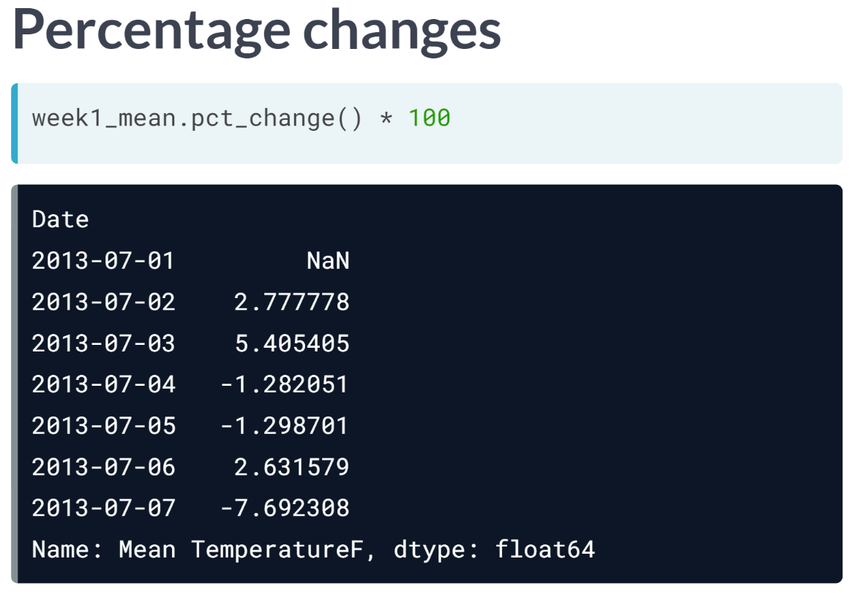  
A related computation is to compute a percentage change along a time series. We do this by subtracting the previous day's value from the current day's value and dividing by the previous day's value.

The ***pct_change()*** method does precisely this computation for us. Here, we also multiply the resulting series by 100 to yield a percentage value. Notice the value in the first row is *NaN* because there is no previous entry.

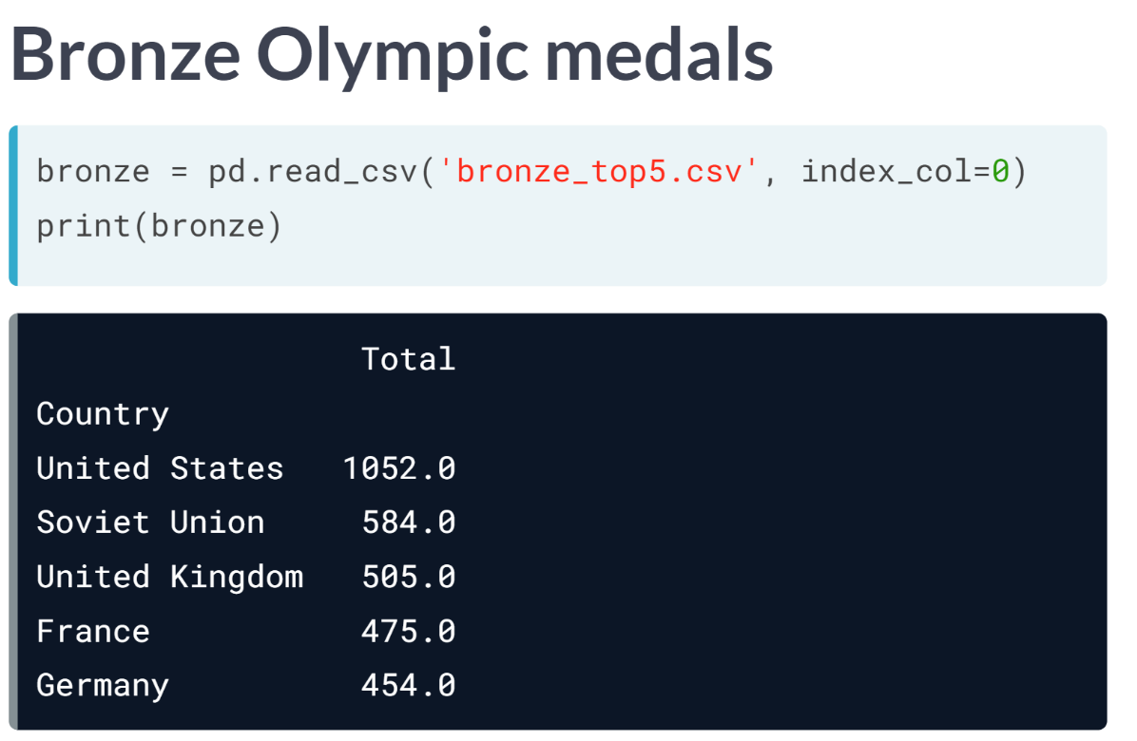  
Finally, let's examine how arithmetic operations work between distinct Series or DataFrames with non-aligned indexes, which happens often in practice. We'll use Olympic medal data from 1896 to 2008.

Here above are the top five Bronze-medal winning countries...

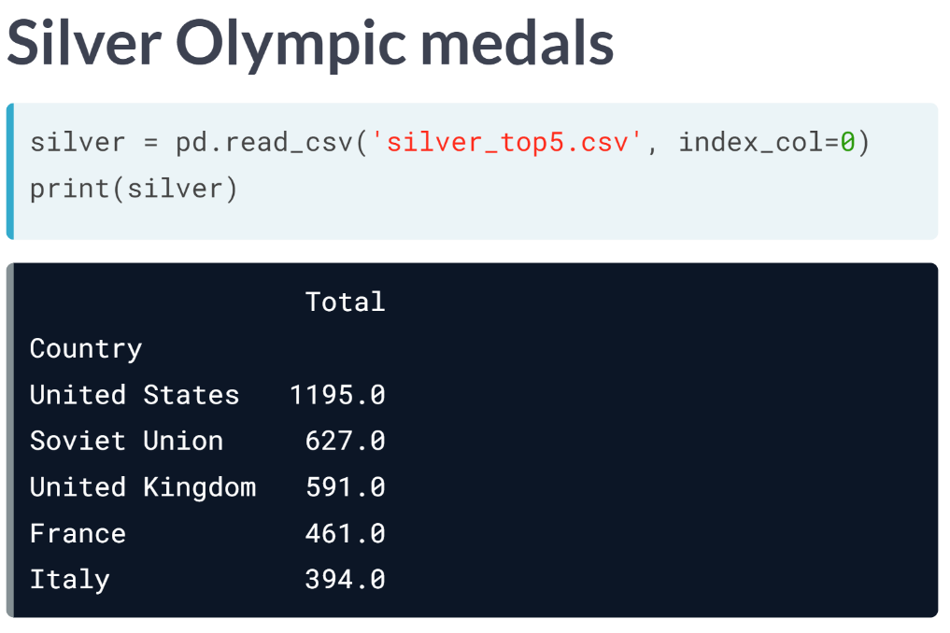  
...the top five Silver-medal winning countries…

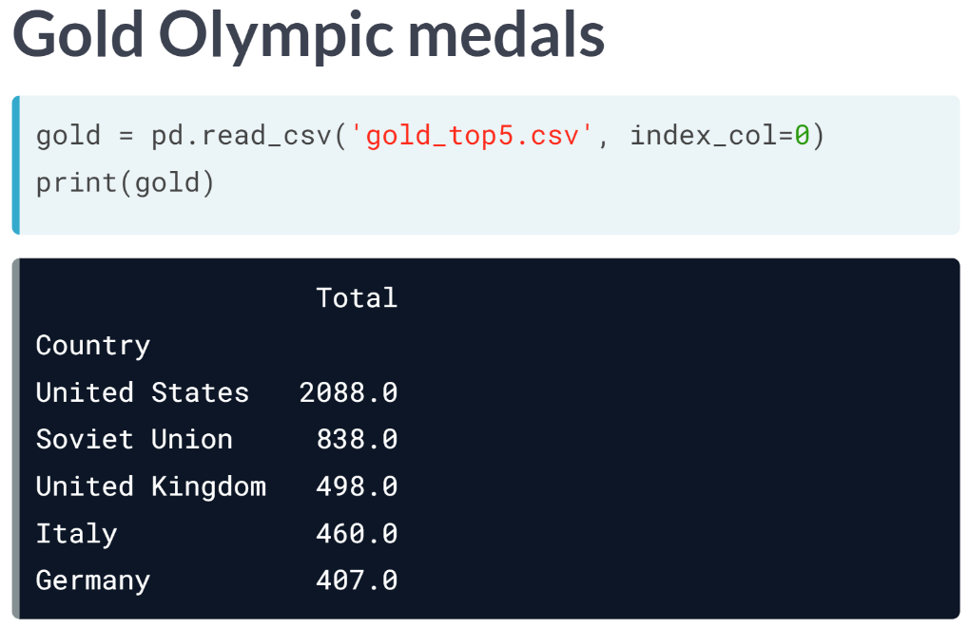  
... and the top five Gold-medal winning countries

All three DataFrames have the same indices for the first three rows ('United States', 'Soviet Union', & 'United Kingdom').

By contrast, the next two rows are either 'France', 'Germany', or 'Italy'.

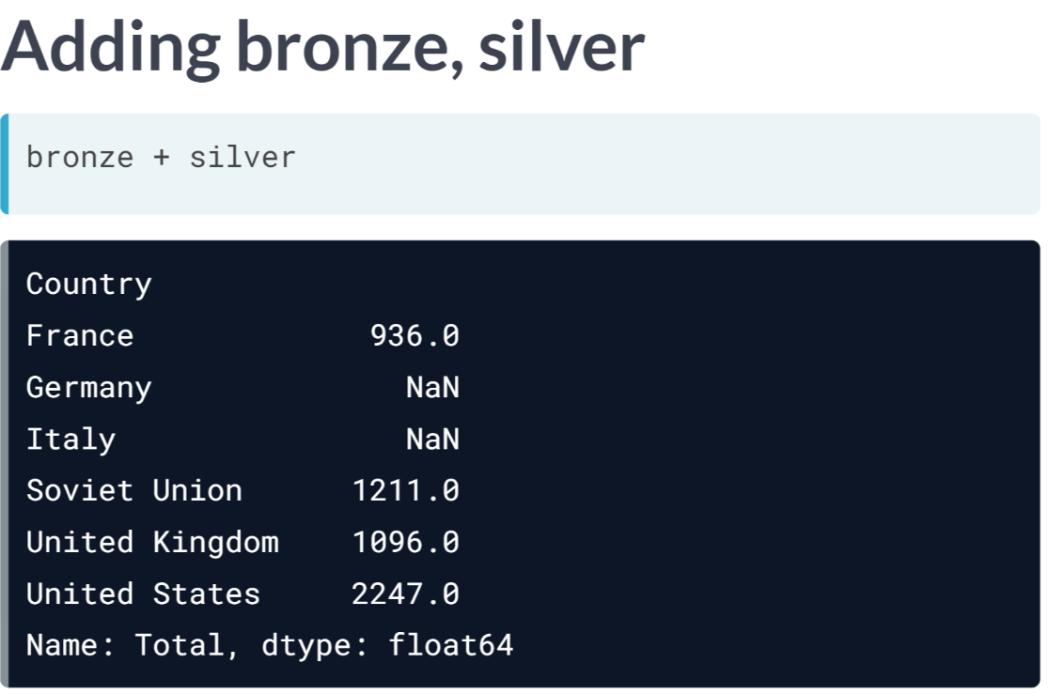  
Let's compute total medals awarded to each country. We start by adding *bronze* and *silver*. Here, we add two Series of 5 rows & get back a Series with 6 rows.

The index of the sum is the union of the row indices from the original two Series. Arithmetic operations between Pandas Series are carried out for rows with common index values.

Since *'Germany'* does not appear in *silver* & *'Italy'* does not appear in *'bronze'*, those rows have *NaN* in the sum.

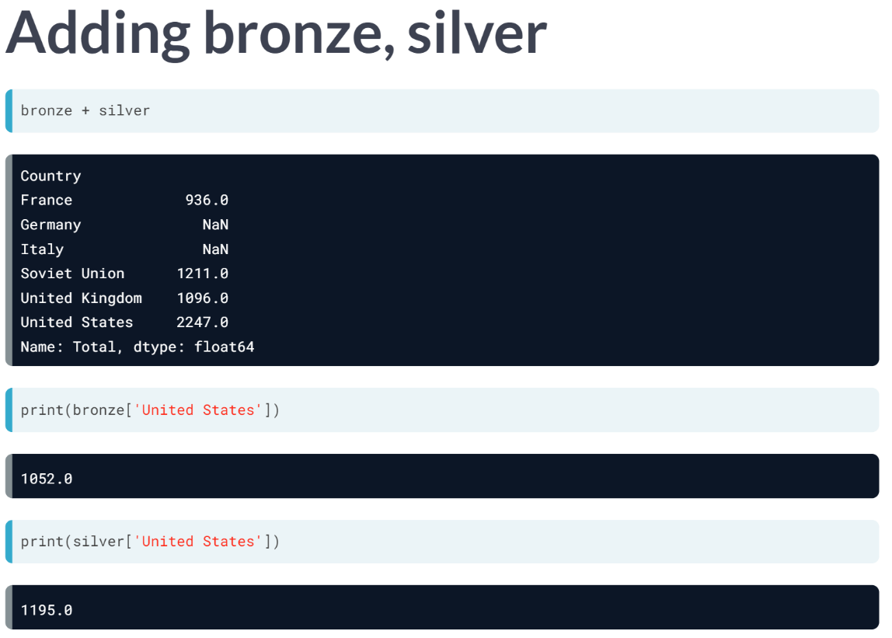  
On examination, we see the value 2247 for the United States row is the sum of 1052 and 1195 from the corresponding rows of the *bronze* & *silver* Series, respectively.

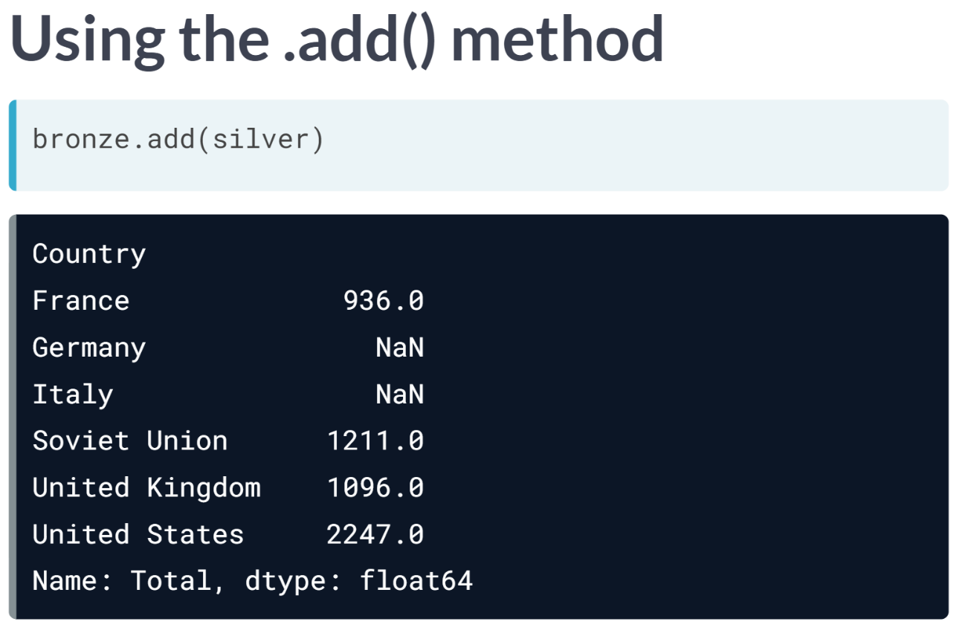  
We can get the same sum *bronze* + *silver* with a method invocation using ***bronze.add(silver)***. The null values occur in the same places.

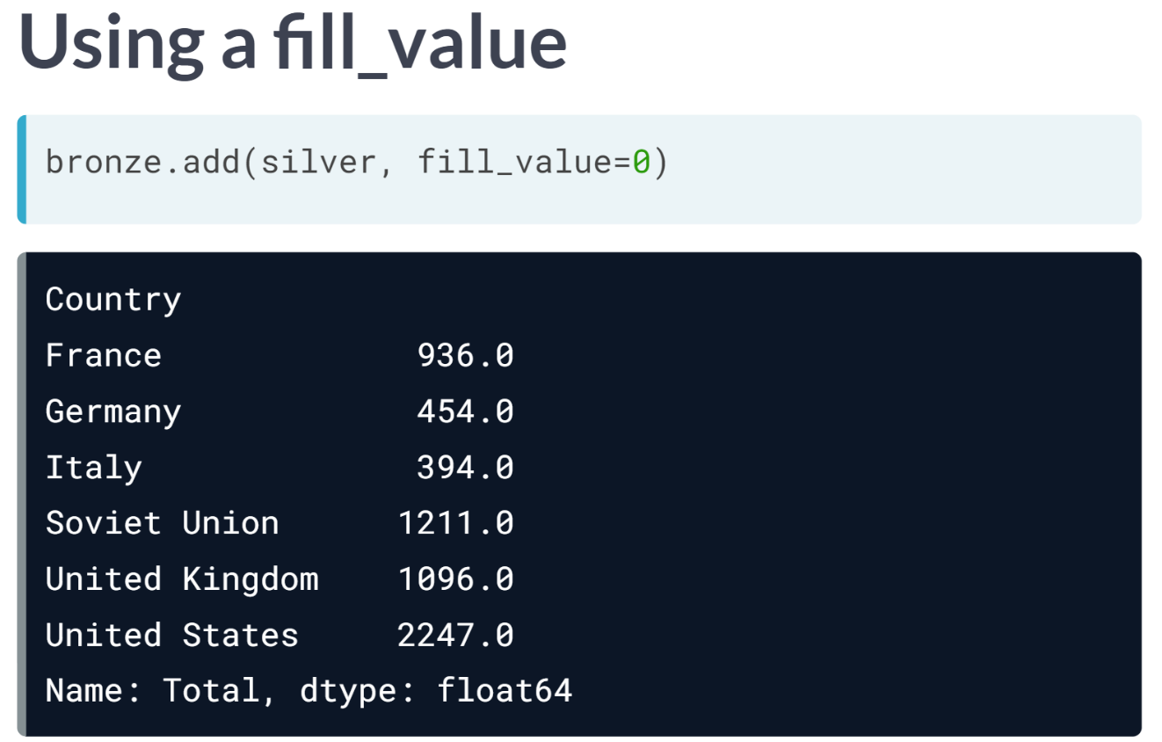  
The default fill value is NaN when summand rows fail to align. We can modify this behavior using the *fill_value* option. By specifying **fill_value=0**, the values of Germany & Italy are no longer null.

Just as the ***divide()*** method is more flexible than the slash operator for division, the ***add()*** method is more flexible than the plus operator for addition.

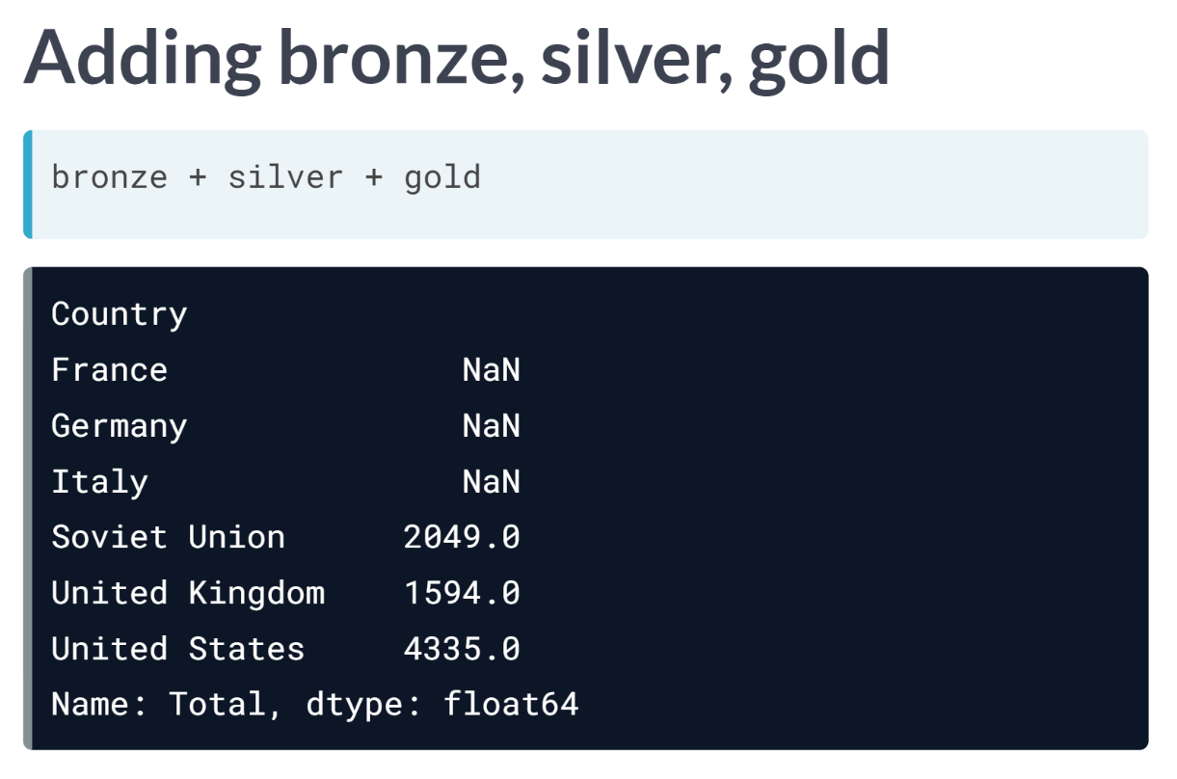  
Adding all three series together yields six rows of output, but only three rows have non-null values. That is, *'France', 'Germany' & 'Italy'* are not Index labels in all three Series, so each of those rows is *NaN* in the sum.

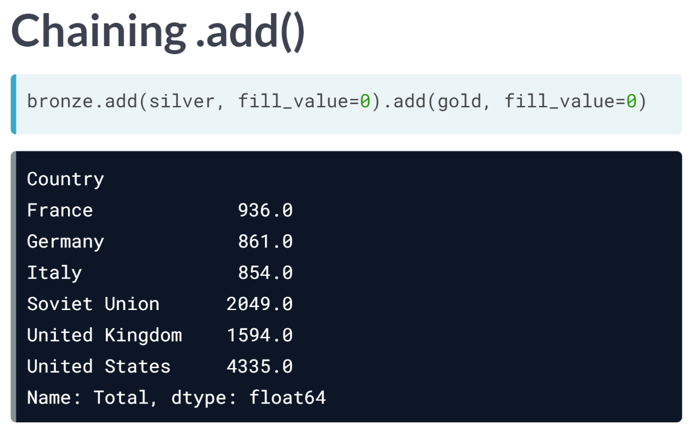  
We can chain multiple method calls to ***.add()*** with **fill_value=0** to get rid of those null values in the triple sum.

Now you can get some experience with standard arithmetic operations & methods for Series & DataFrames in the exercises.

# Adding unaligned DataFrames

The DataFrames january and february, which have been printed in the IPython Shell, represent the sales a company made in the corresponding months.

The Indexes in both DataFrames are called Company, identifying which company bought that quantity of units. The column Units is the number of units sold.

If you were to add these two DataFrames by executing the command total = january + february, how many rows would the resulting DataFrame have? Try this in the IPython Shell and find out for yourself.

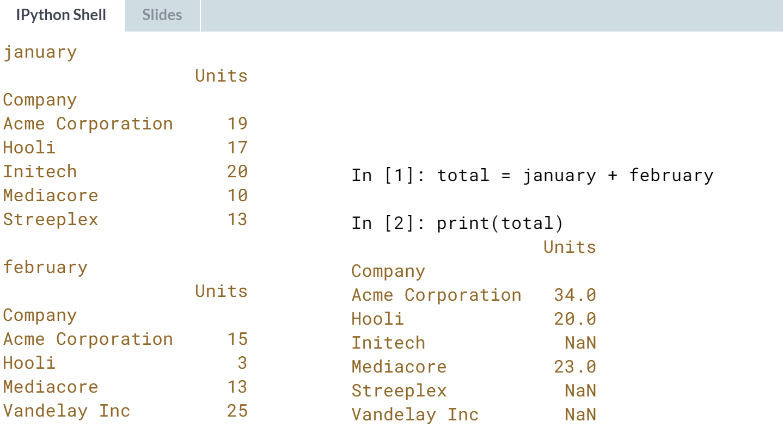



Correct! *january* and *february* both consist of the sales of the Companies Acme Corporation, *Hooli*, and *Mediacore*.

*january* has the additional two companies *Initech* and *Streeplex*, while *february* has the additional company Vandelay Inc.

Together, they consist of the sales of 6 unique companies, and so total would have 6 rows.

# Broadcasting in arithmetic formulas

In this exercise, you'll work with weather data pulled from [**wunderground.com**](https://www.wunderground.com/). The DataFrame weather has been pre-loaded along with pandas as pd. It has 365 rows (observed each day of the year 2013 in Pittsburgh, PA) and 22 columns reflecting different weather measurements each day.

You'll subset a collection of columns related to temperature measurements in degrees Fahrenheit, convert them to degrees Celsius, and relabel the columns of the new DataFrame to reflect the change of units.

Remember, ordinary arithmetic operators (like +, -, *, and /) broadcast scalar values to conforming DataFrames when combining scalars & DataFrames in arithmetic expressions. Broadcasting also works with pandas Series and NumPy arrays.

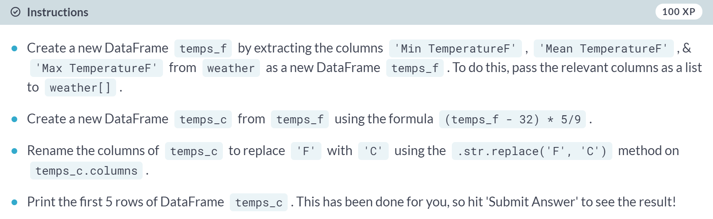

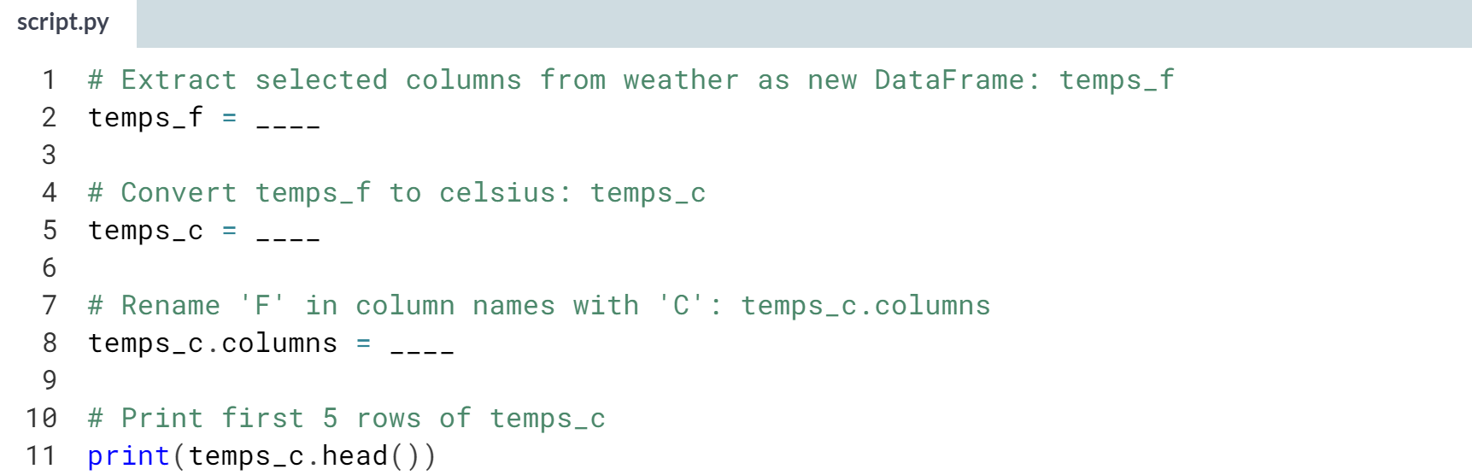

Hint

1. To extract the relevant columns, pass a list consisting of *'Min TemperatureF'*, *'Mean TemperatureF'*, & *'Max TemperatureF'* as an argument to **weather[]**.
2. To convert the temperatures to degrees Celsius, assign *(temps_f - 32) * 5/9* to *temps_c*.
3. Use *temps_c.columns.str.replace('F', 'C')* to replace *'F'* with *'C'* in all columns of *temps_c*.

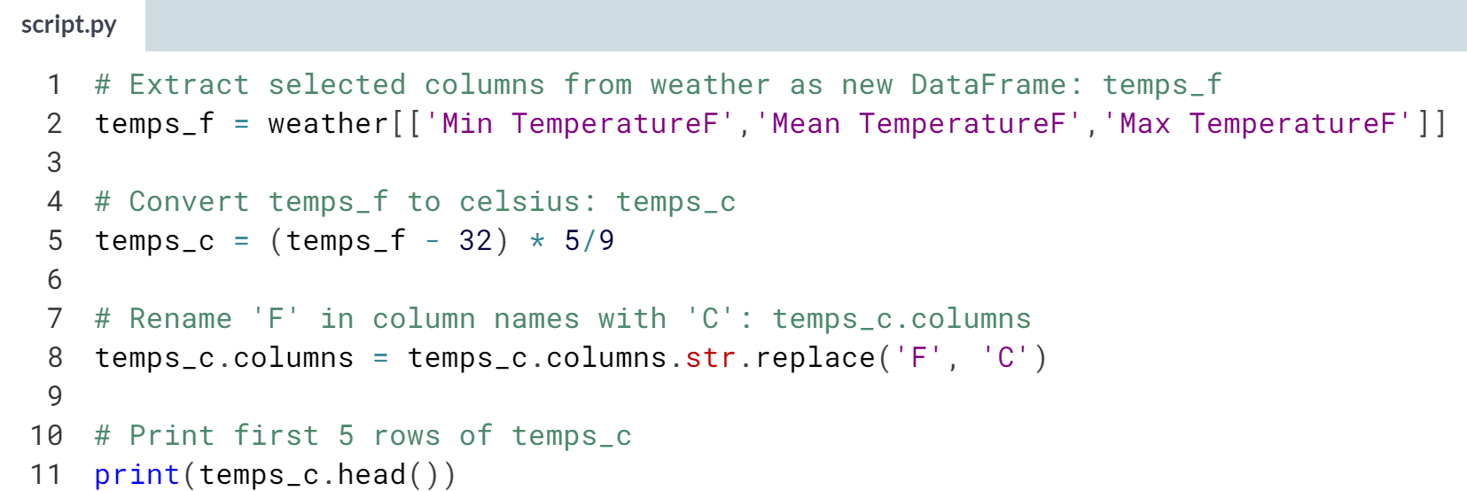

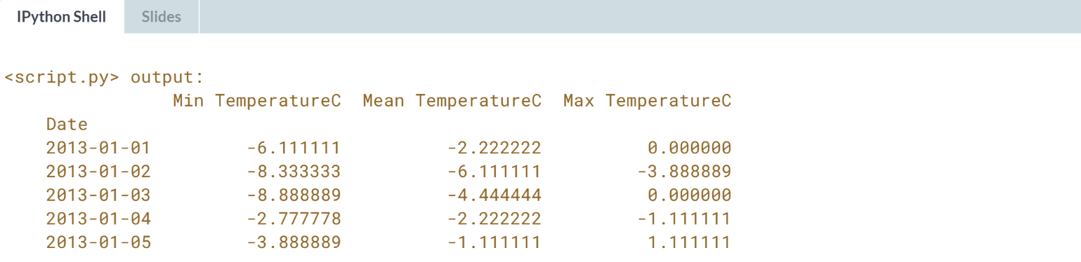

Well done! In only three lines of code, you converted the units of 365 data points (over three columns) from degrees Fahrenheit to degrees Celsius.

# Computing percentage growth of GDP

Your job in this exercise is to compute the yearly percent-change of US GDP ([**Gross Domestic Product**](https://en.wikipedia.org/wiki/Gross_domestic_product)) since 2008.

The data has been obtained from the [**Federal Reserve Bank of St. Louis**](https://fred.stlouisfed.org/series/GDP/downloaddata) and is available in the file GDP.csv, which contains quarterly data; you will resample it to annual sampling and then compute the annual growth of GDP. For a refresher on resampling, check out the relevant material from [**pandas Foundations**](https://campus.datacamp.com/courses/pandas-foundations/time-series-in-pandas?ex=7).

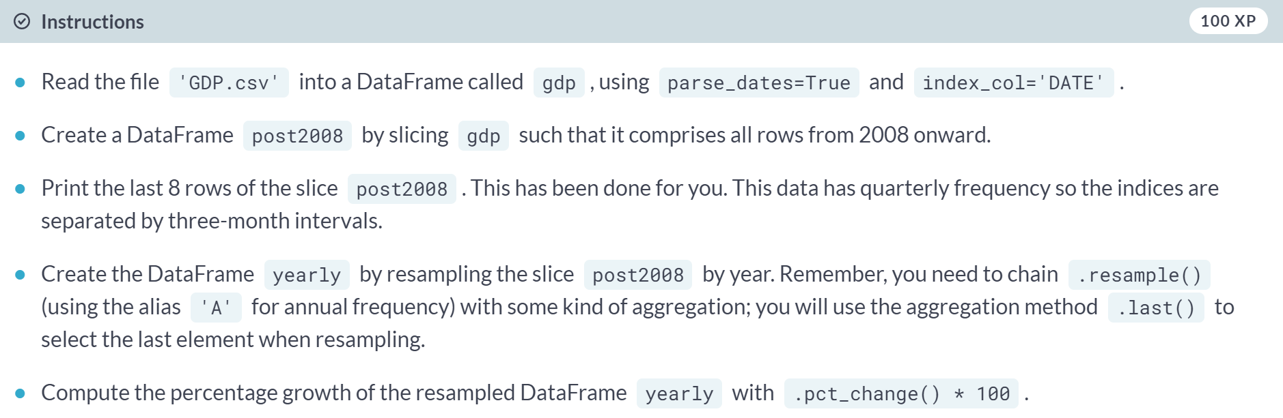

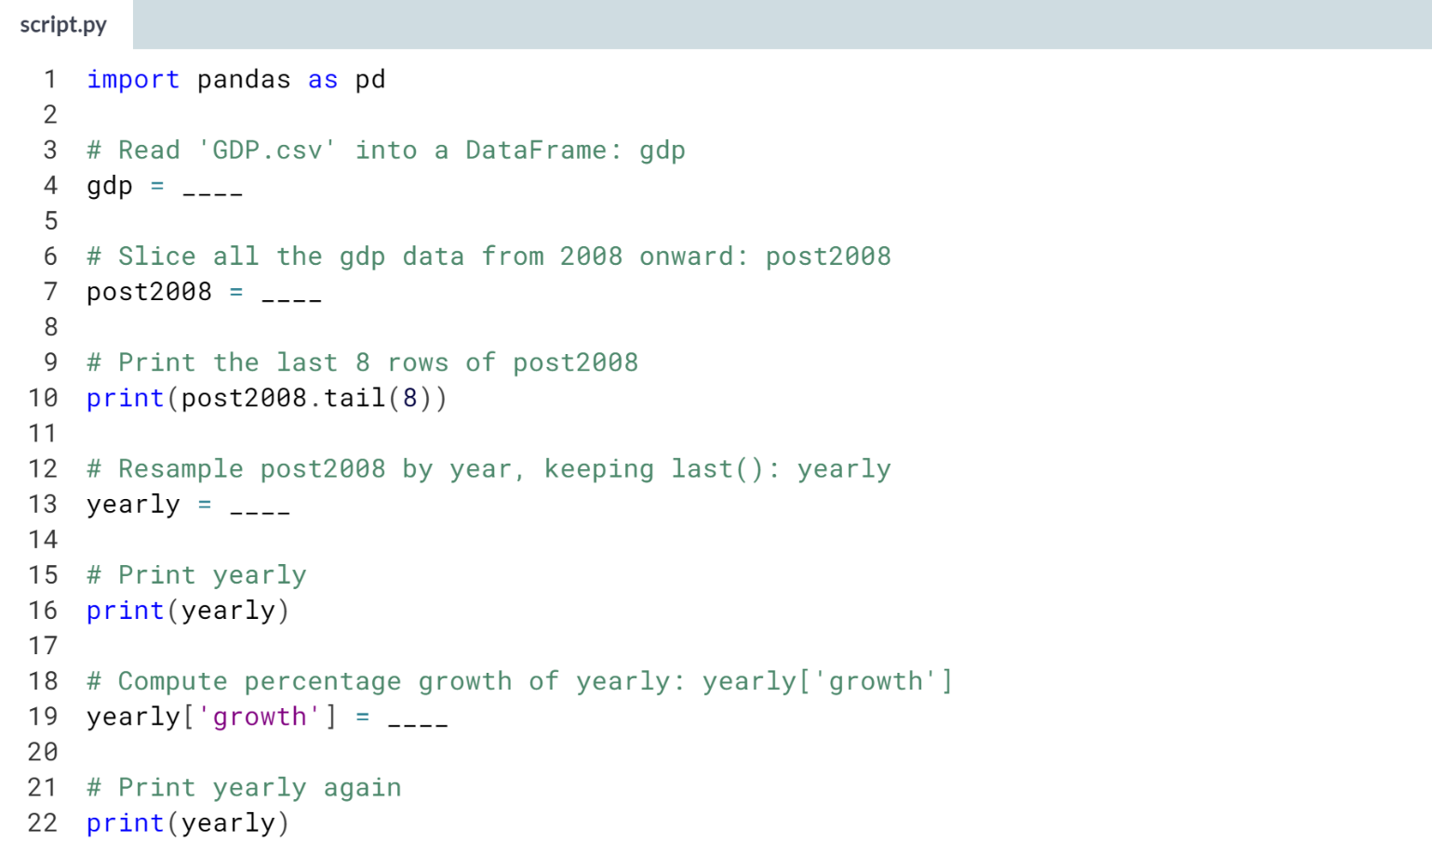

Hint

1. Use ***pd.read_csv()*** with *'GDP.csv'* as an argument along with the keyword arguments **parse_dates=True** and **index_col='DATE'**.
2. Create *post2008* by assigning **gdp['2008':]** to it.
3. Use the ***.resample()*** method on post2008 with 'A' as the argument. Then, chain the ***.last()*** method to this.
4. Use the ***.pct_change()*** method on yearly and multiply this by 100 to compute the percentage growth of the resampled DataFrame.

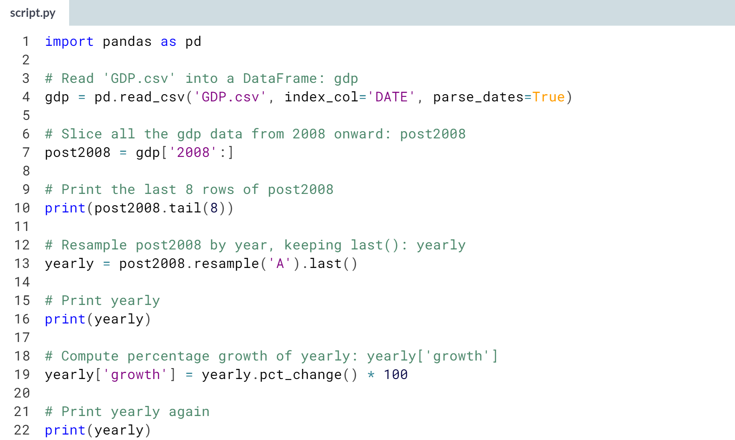

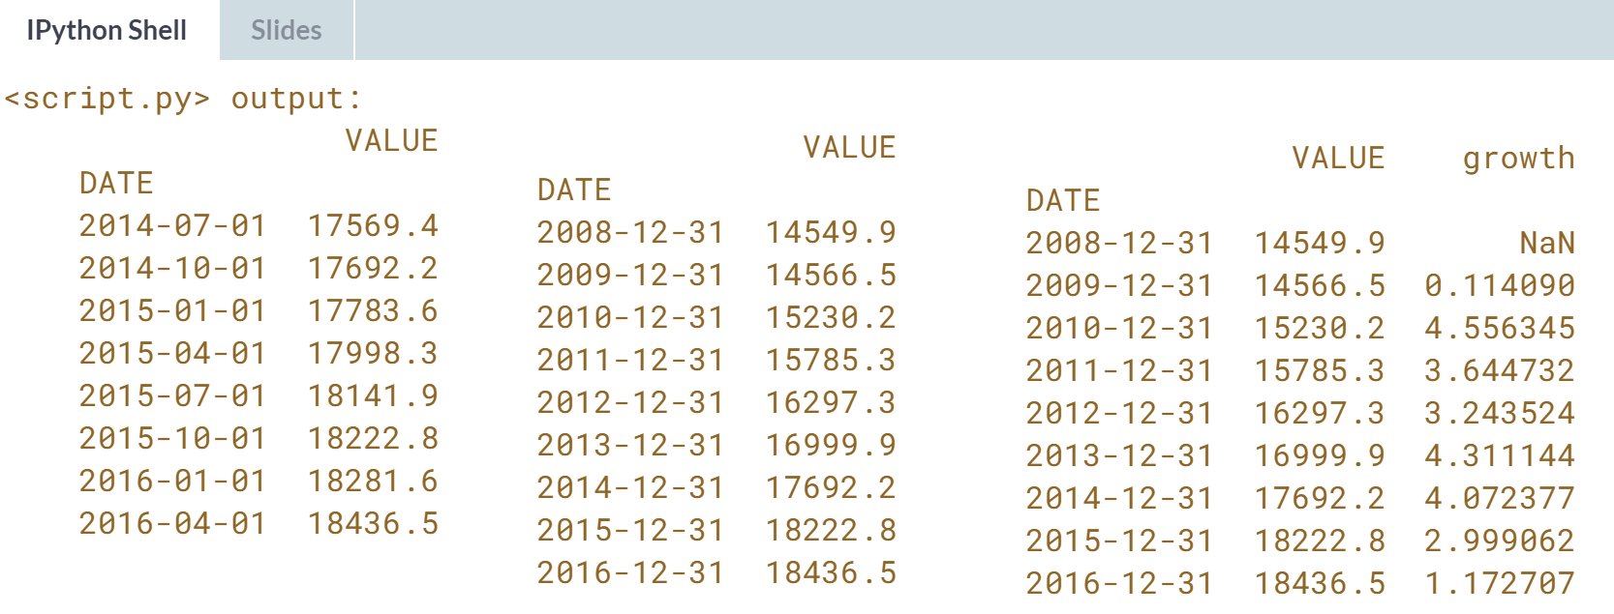  
Fantastic! Note that the first column of the 'growth' column is *NaN* because there is no data for the year 2007

# Converting currency of stocks

In this exercise, stock prices in US Dollars for the S&P 500 in 2015 have been obtained from [**Yahoo Finance**](https://finance.yahoo.com/). The files sp500.csv for sp500 and exchange.csv for the exchange rates are both provided to you.

Using the daily exchange rate to Pounds Sterling, your task is to convert both the Open and Close column prices.

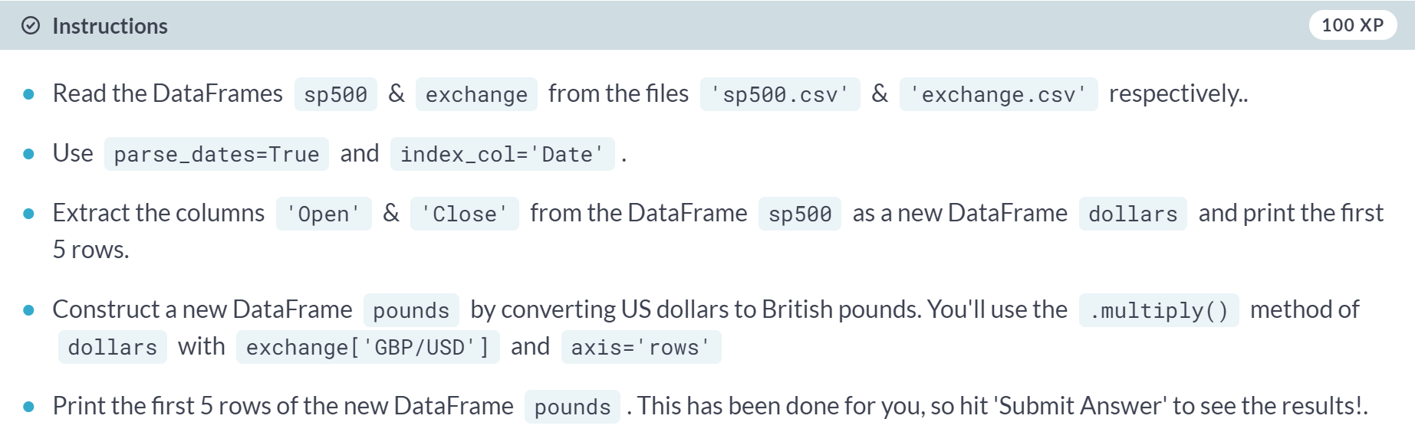

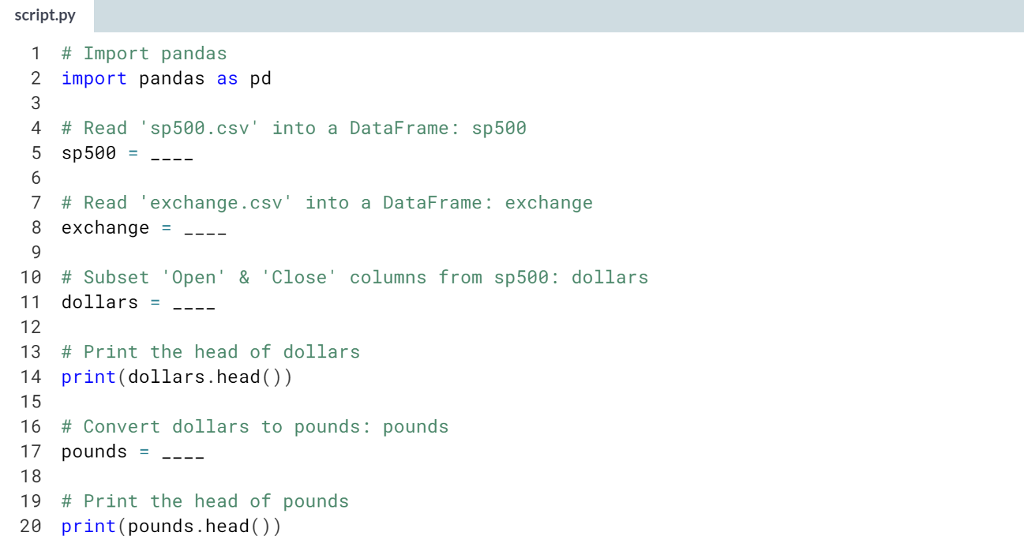

Hint

1. Use ***pd.read_csv()*** with the name of the CSV file as an argument along with the keyword arguments **parse_dates=True** and **index_col='Date'**.
2. Pass the list **['Open','Close']** to **sp500[]** to extract the relevant columns.
3. To perform the conversion, use the ***.multiply()*** method on dollars with **exchange['GBP/USD']** and **axis='rows'** as the two arguments.

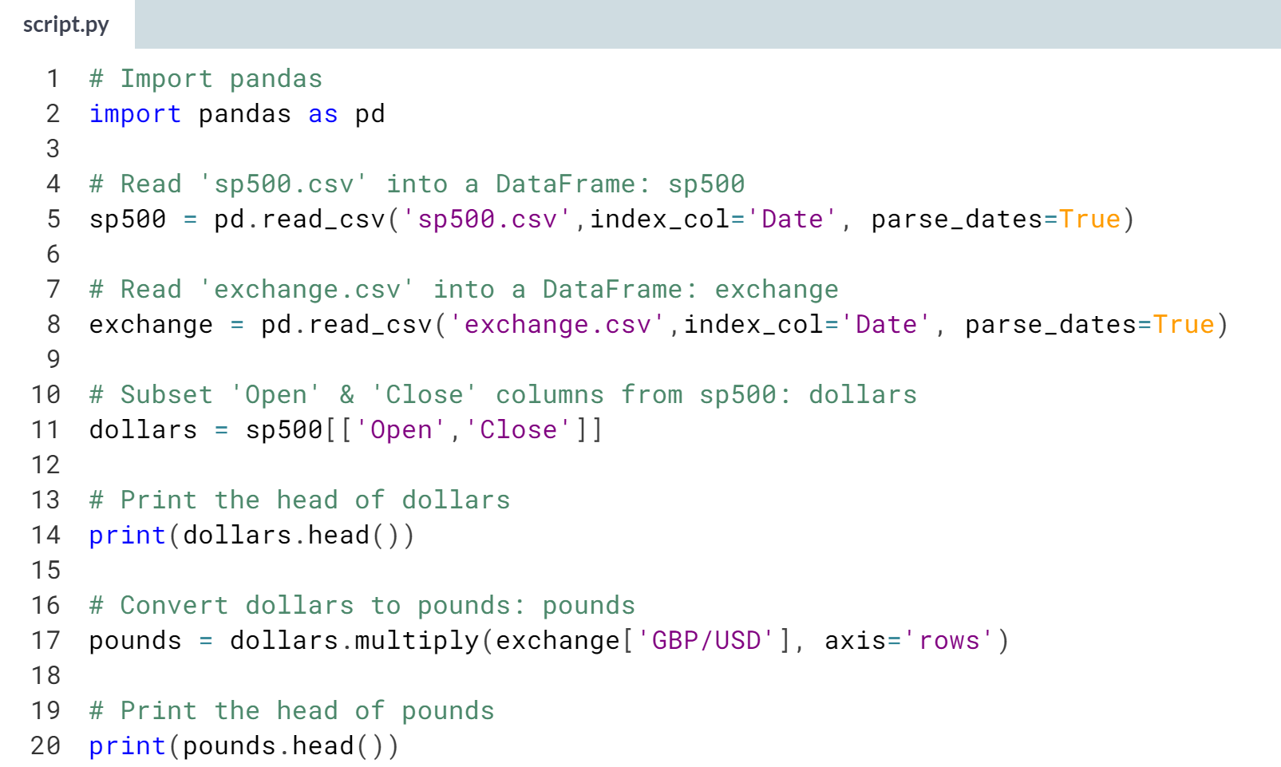

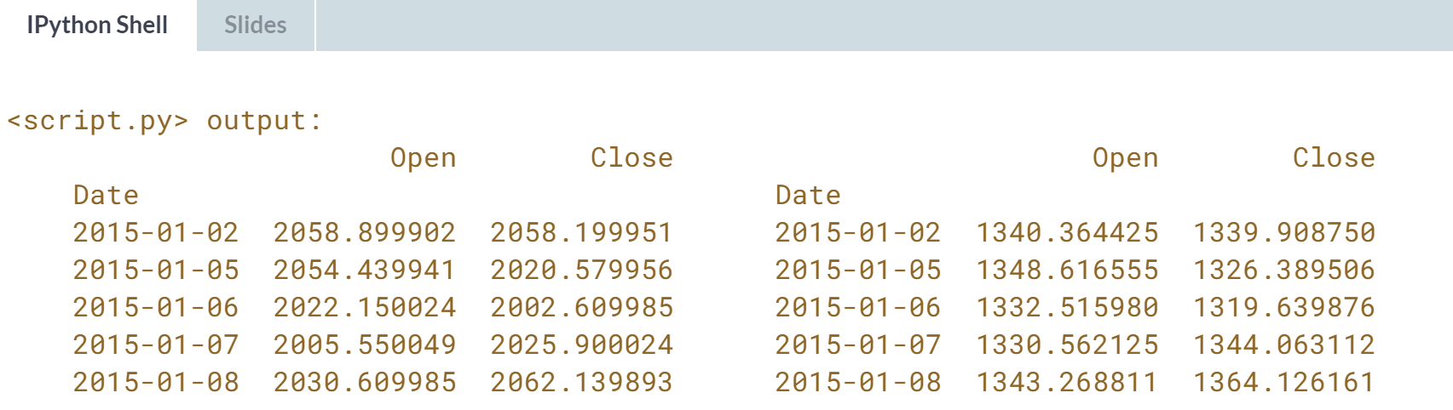

Excellent! Now that you've become familiar with how to share information between DataFrames, you'll learn about concatenating DataFrames in the next chapter.

**2. Concatenating data**

You'll learn how to perform database-style operations to combine DataFrames. In particular, you'll learn about appending and concatenating DataFrames while working with a variety of real-world datasets.



Let's now learn about how to combine DataFrames. As a first step, let's stack Series on top of one another by appending and concatenating. Again, the index is a big part of these operations.

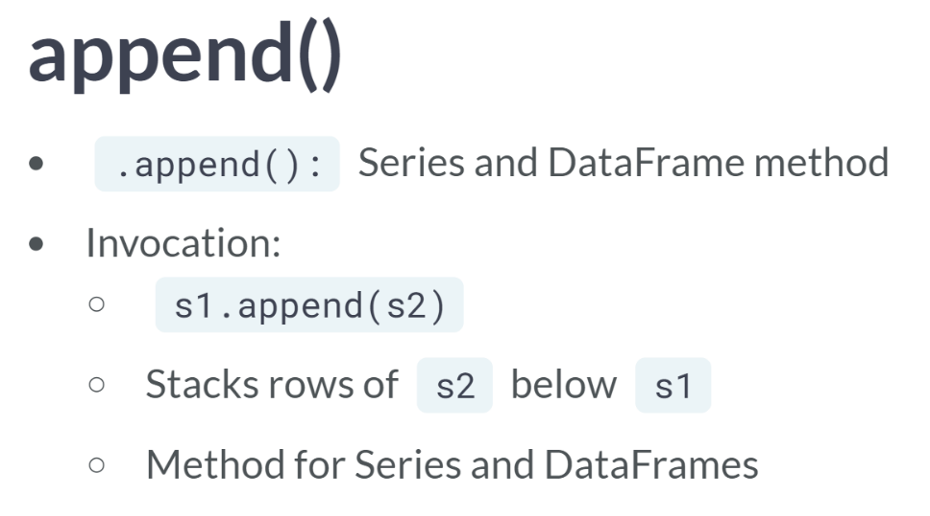  
The principle tools are the .append() methods and the function ***pandas.concat()***. The basic syntax of the .append() method is, for example, *s1.append(s2)*. The rows of *s2* are stacked underneath those of *s1*. This method works with both DataFrames and Series.

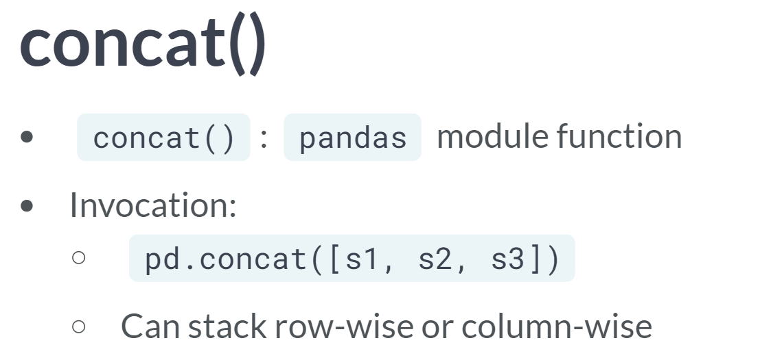  
By contrast, the function ***concat()*** accepts a list or sequence of several Series or DataFrames to concatenate. While the ***.append()*** methods can only stack vertically (or row-wise), the ***concat()*** is more flexible, concatenating either vertically or horizontally.

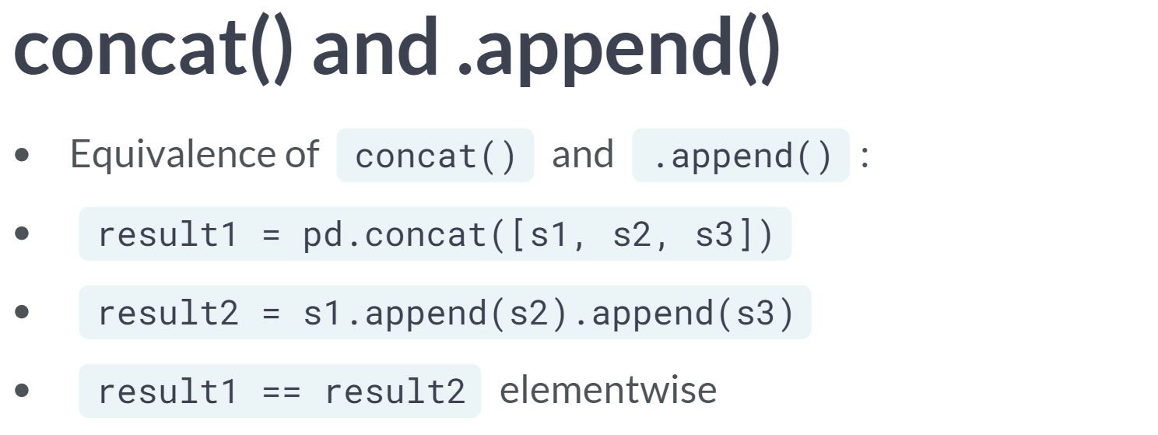  
When stacking multiple Series, ***pd.concat()*** is, in fact, equivalent to chaining method call to ***.append()***.

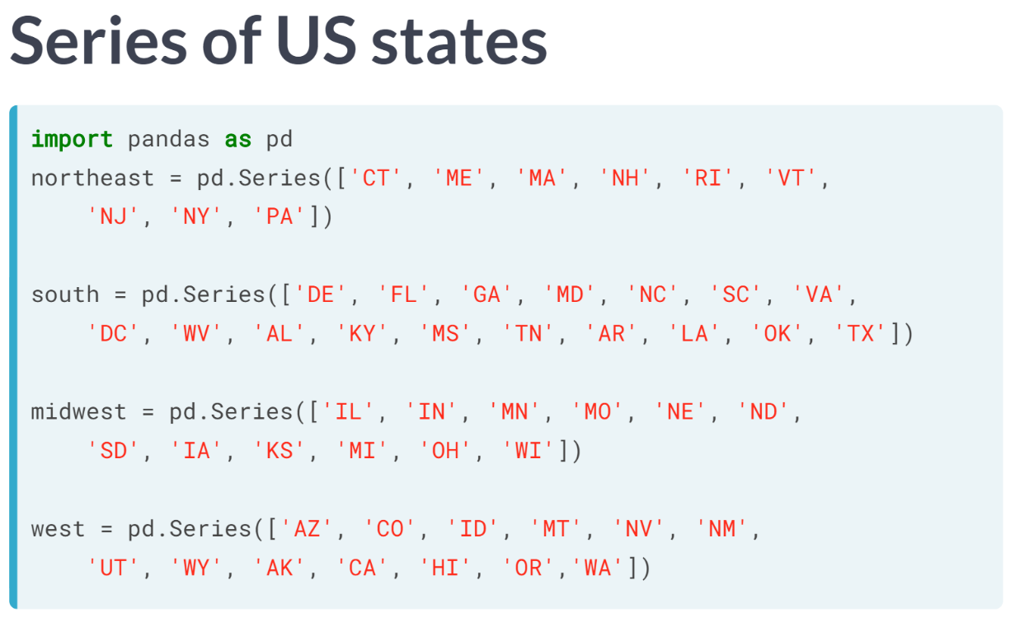  
Let's look at an example. By default, all four Series are indexed by integers starting at zero.

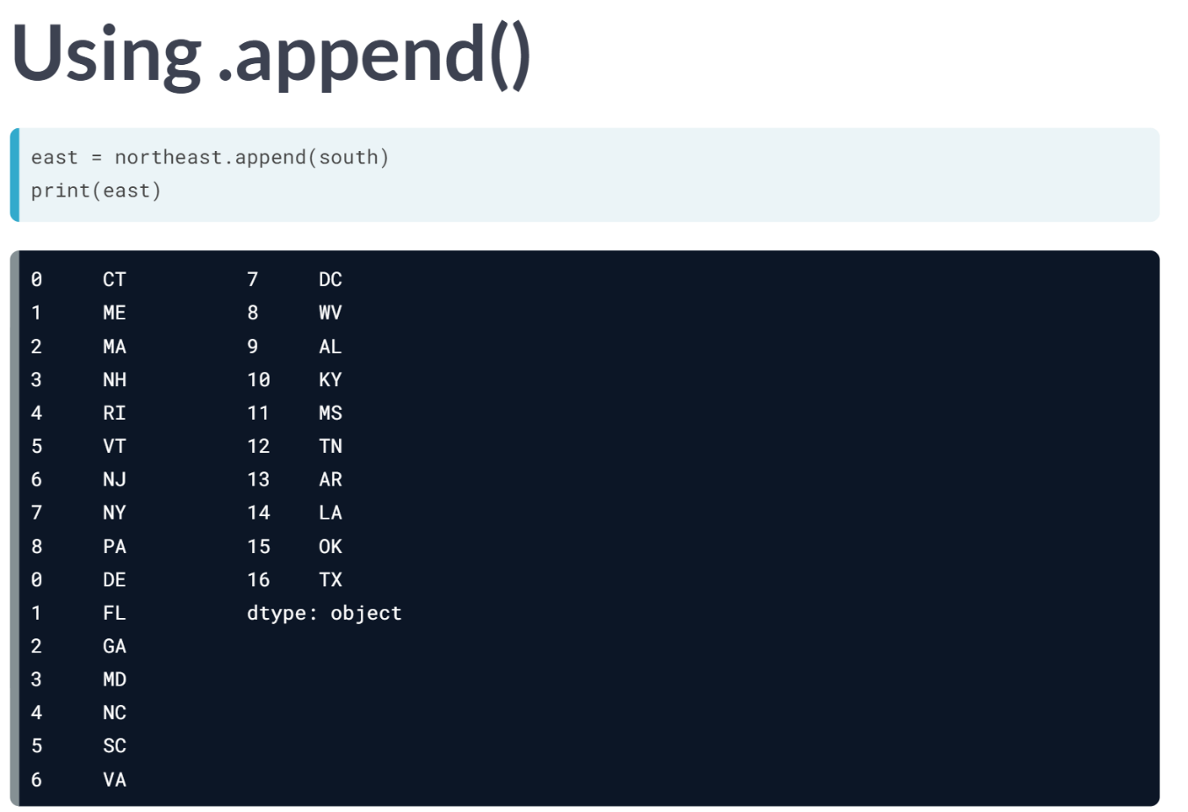  
The first nine rows of east are the rows from the Series *northeast*, and the subsequent rows are the entries of the Series *south*. Notice the ***.append()*** method stacks rows without adjusting index values.

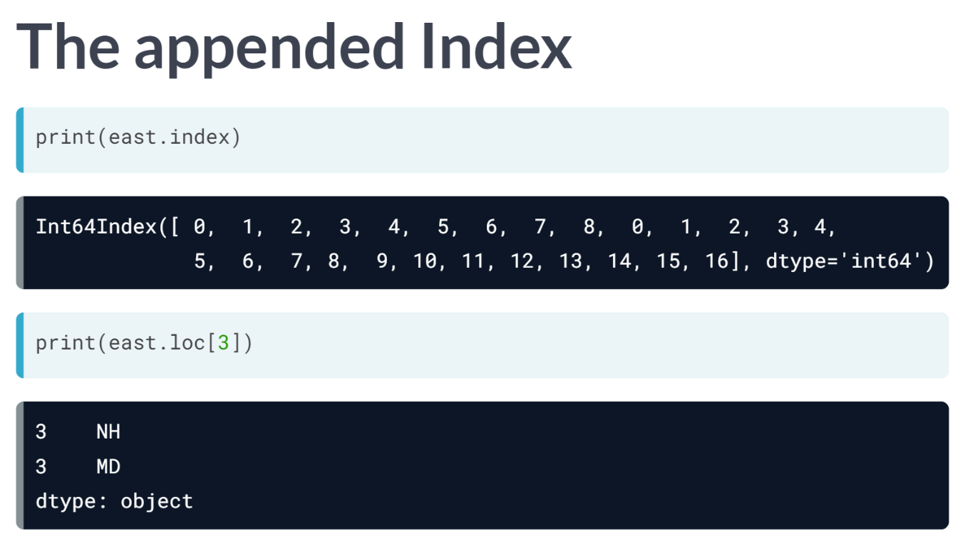  
As a result, when we examine the index of the Series east, it has index labels from the original two Series in order. Thus, using the ***.loc[]*** accessor with argument 3 returns two rows: one from northeast, the other from south.

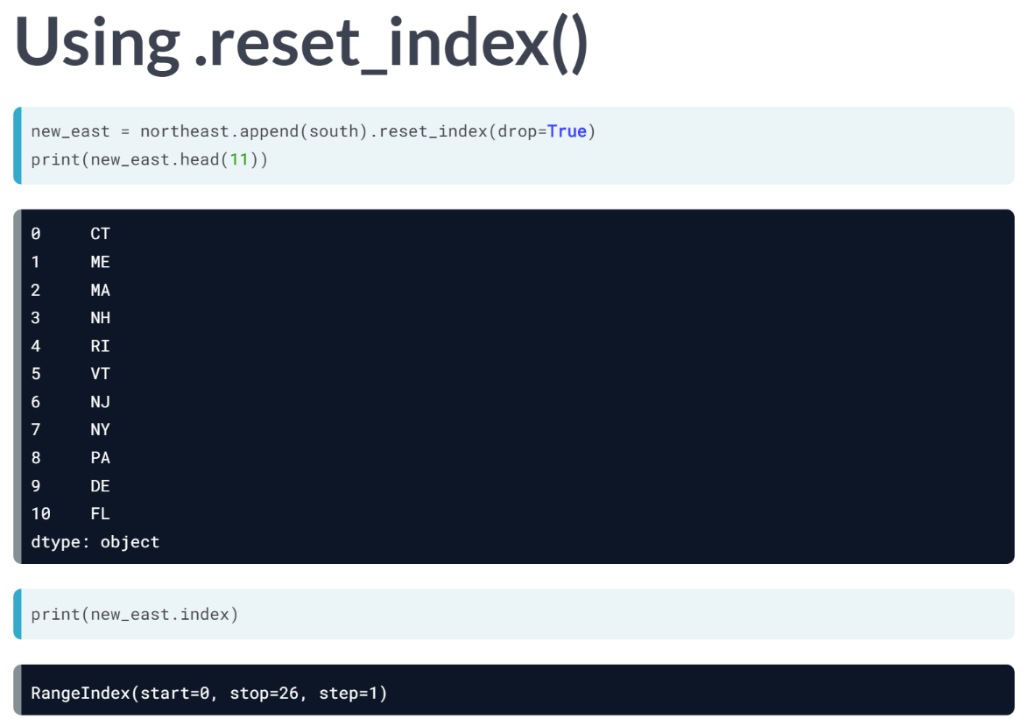  
Having unique indices is important in most situations. We can create a Series *new_east* with the method ***.reset_index()***. The option *drop = True* discards the old Index with repeated entries (rather than keeping it as a column in a DataFrame).

The new index is of type *RangeIndex* with labels 0 through 25.

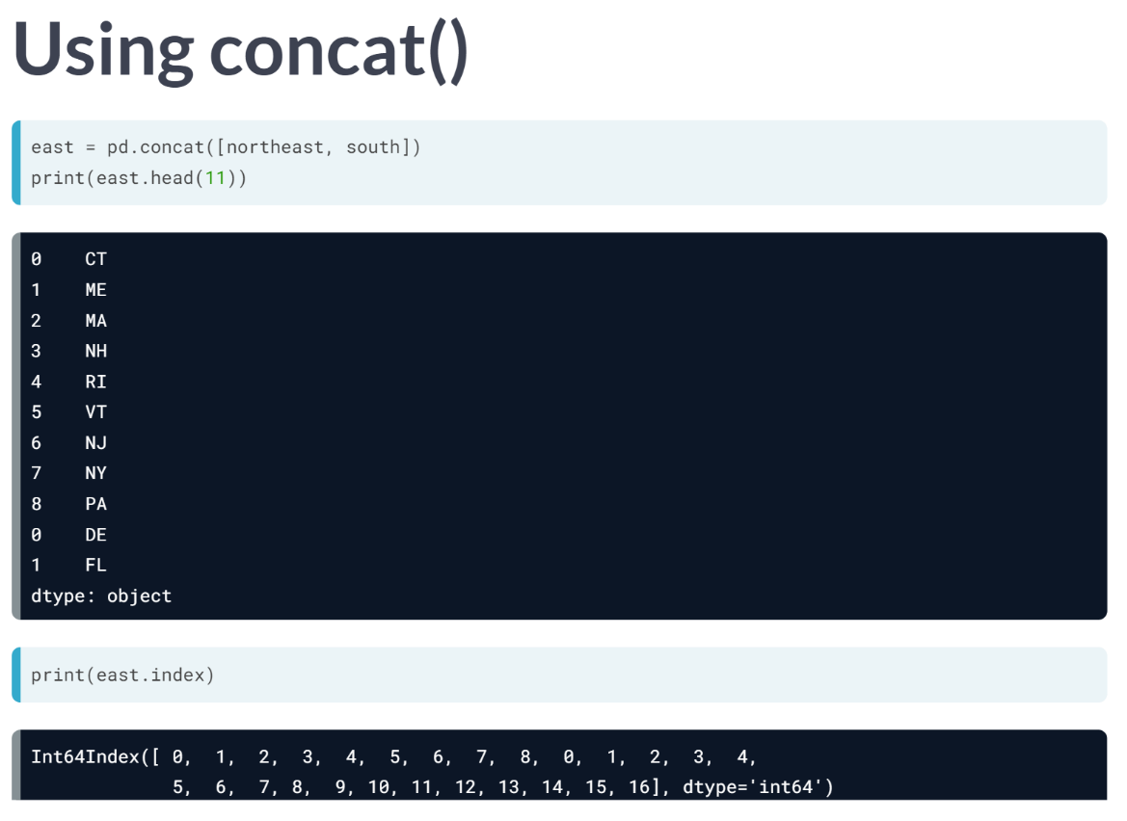  
The function ***concat()*** can equivalently construct the Series east. In this case, the required input is a list of Series or DataFrames. The resulting index, as before, contains repeated values.

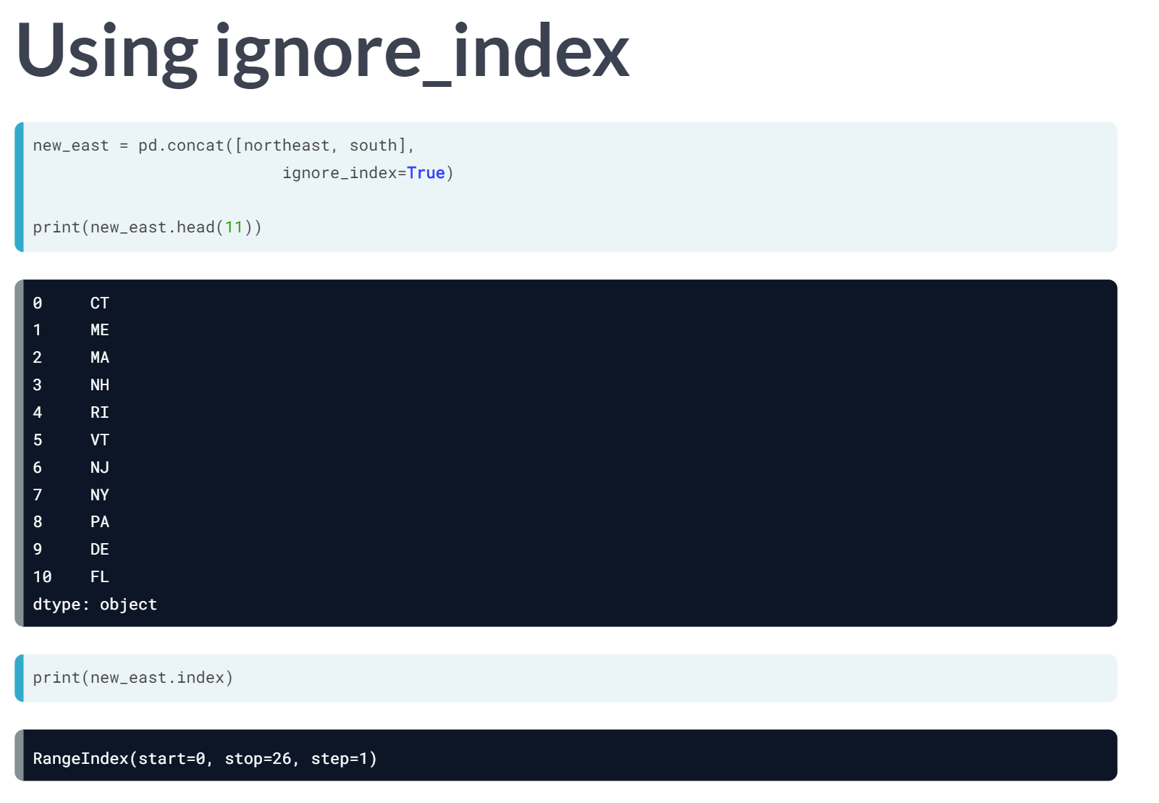  
***concat()*** can also reconstruct the Series *new_east* as before. Using the option *ignore_index* spares us having to invoke ***.reset_index()*** explicitly. The resulting Series has no repeated indices as before.

# Appending Series with nonunique Indices

The Series bronze and silver, which have been printed in the IPython Shell, represent the 5 countries that won the most bronze and silver Olympic medals respectively between 1896 & 2008. The Indexes of both Series are called Country and the values are the corresponding number of medals won.

If you were to run the command combined = bronze.append(silver), how many rows would combined have? And how many rows would combined.loc['United States'] return? Find out for yourself by running these commands in the IPython Shell.

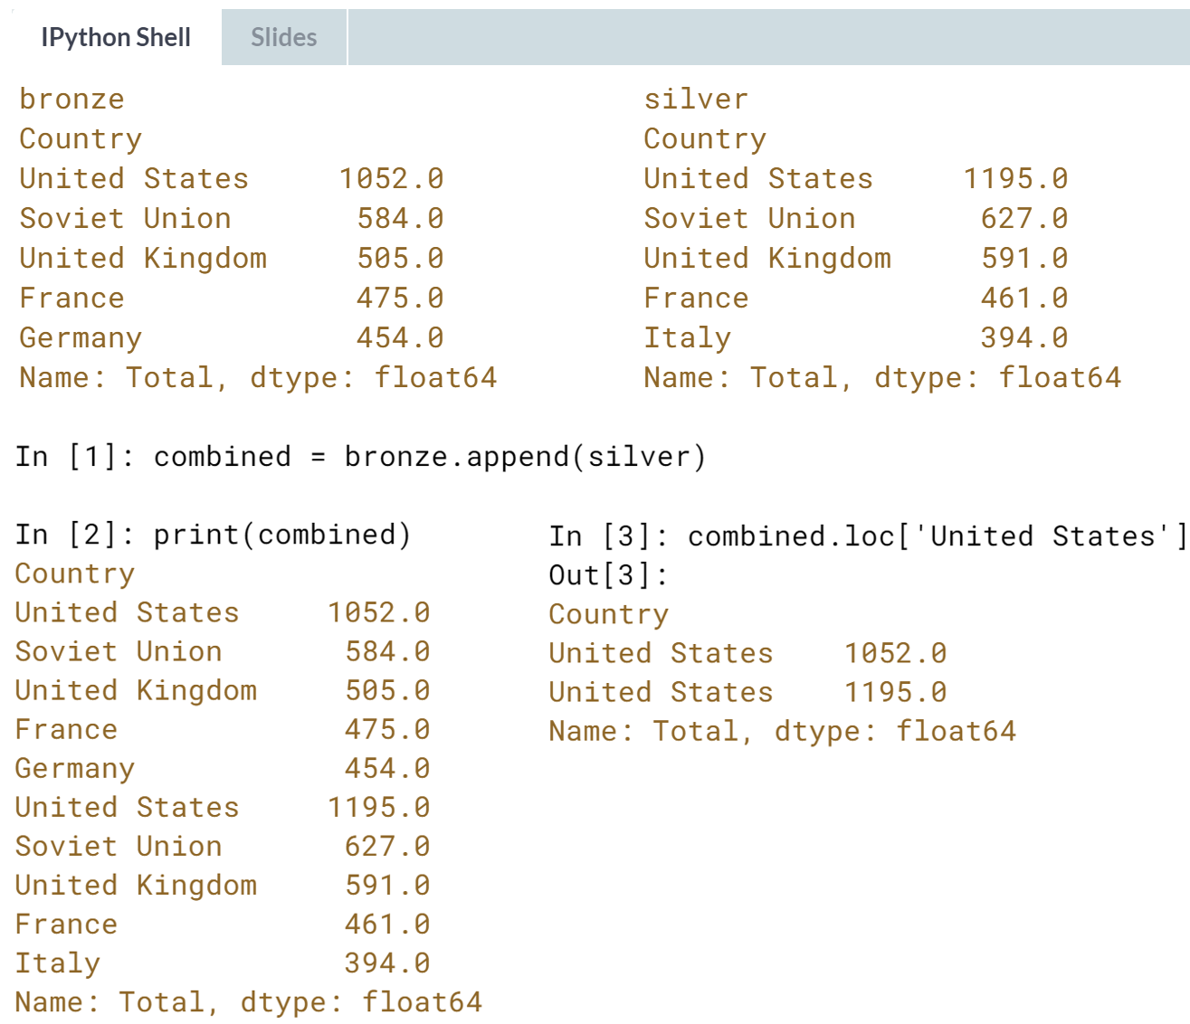  
  
Correct! The combined Series has 10 rows and **combined.loc['United States']** has two rows, since the index value 'United States' occurs in both series bronze and silver.

# Appending pandas Series

In this exercise, you'll load sales data from the months January, February, and March into DataFrames. Then, you'll extract Series with the 'Units' column from each and append them together with method chaining using .append().

To check that the stacking worked, you'll print slices from these Series, and finally, you'll add the result to figure out the total units sold in the first quarter.

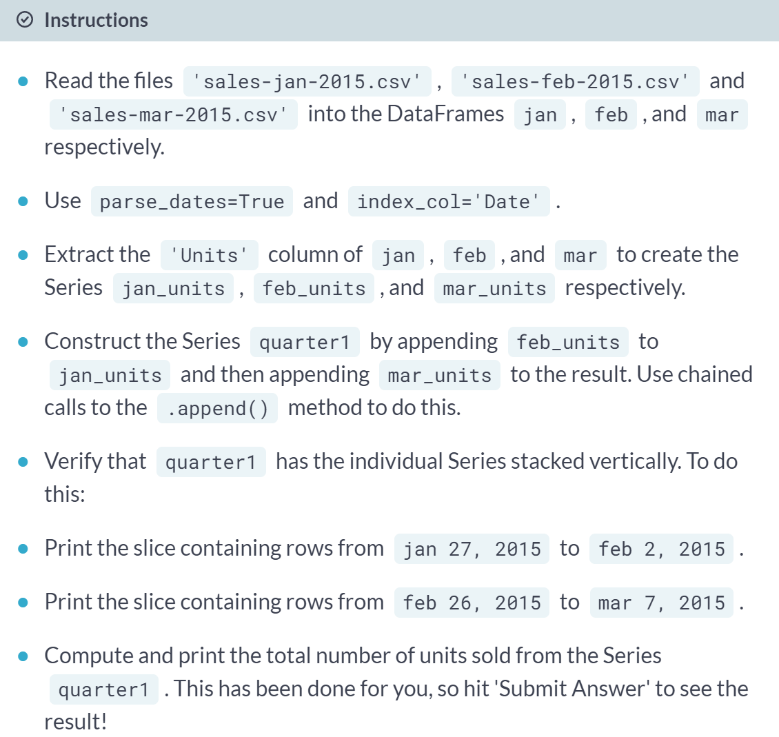

(Exercise begins on the next page)

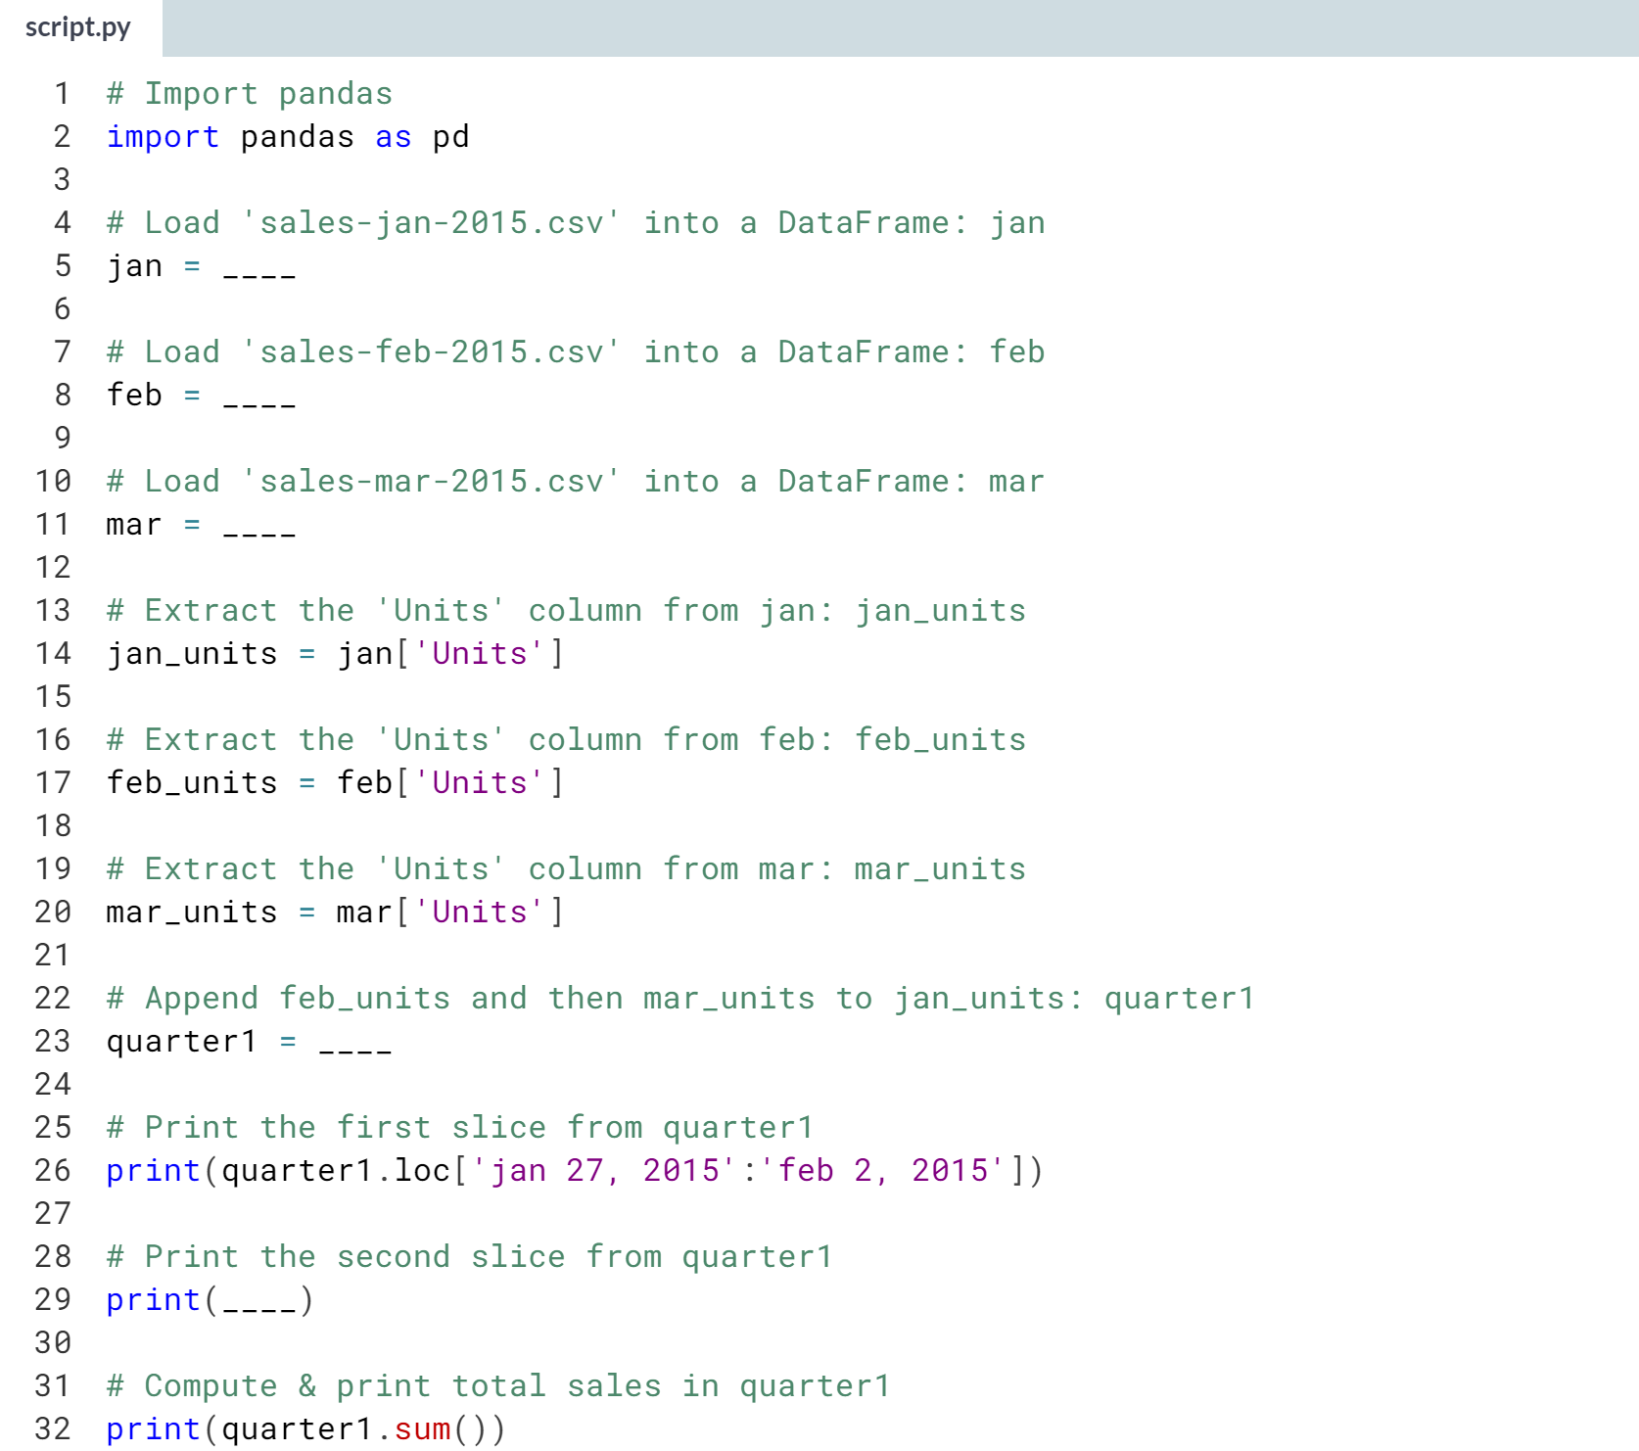

Hint

1. Use the ***pd.read_csv()*** function with the name of the CSV file as an argument along with the keyword arguments **parse_dates=True** and **index_col='Date'**.
2. You can extract the column *'column'* from a DataFrame *df* using **df['column']**. Do this for the *'Units'* column of the DataFrames *jan, feb,* and *mar*.
3. First, use the ***.append()*** method on *jan_units* with *feb_units* as the argument. To this, chain another call to ***.append()*** with *mar_units* as the argument.
4. Use the ***.loc[]*** accessor to slice *quarter1* appropriately, referring to the first slice as example on how to slice dates.

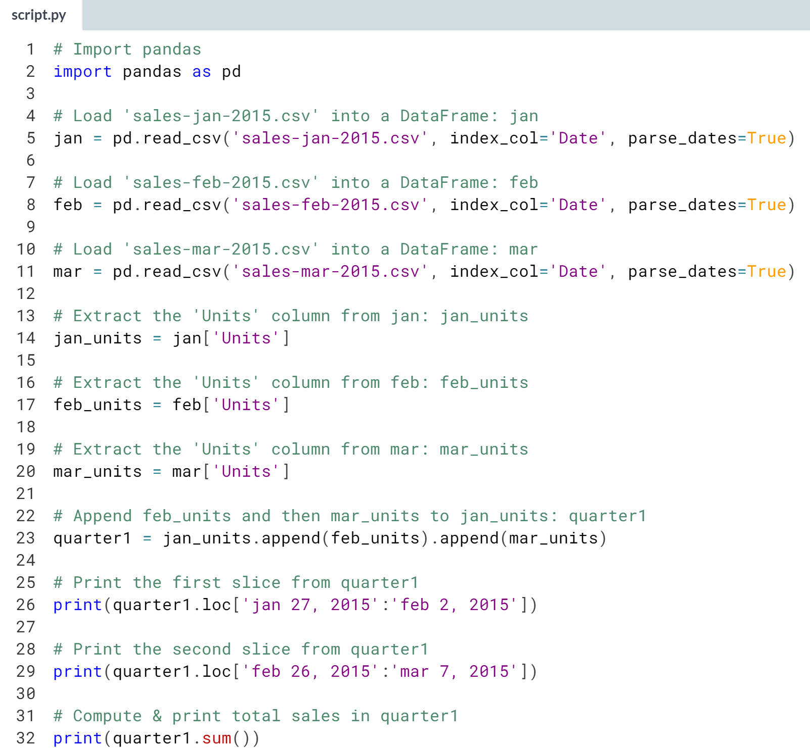

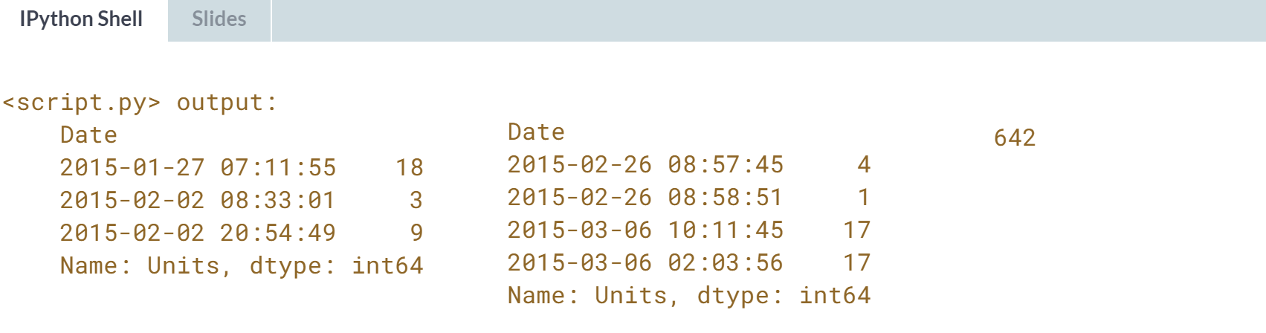  
Well done! As you can see, appending *pandas* Series is very straightforward!

# Concatenating pandas Series along row axis

Having learned how to append Series, you'll now learn how to achieve the same result by concatenating Series instead.

You'll continue to work with the sales data you've seen previously. This time, the DataFrames jan, feb, and mar have been pre-loaded.

Your job is to use pd.concat() with a list of Series to achieve the same result that you would get by chaining calls to .append().

You may be wondering about the difference between pd.concat() and pandas' .append() method.

One way to think of the difference is that .append() is a specific case of a concatenation, while pd.concat() gives you more flexibility, as you'll see in later exercises.

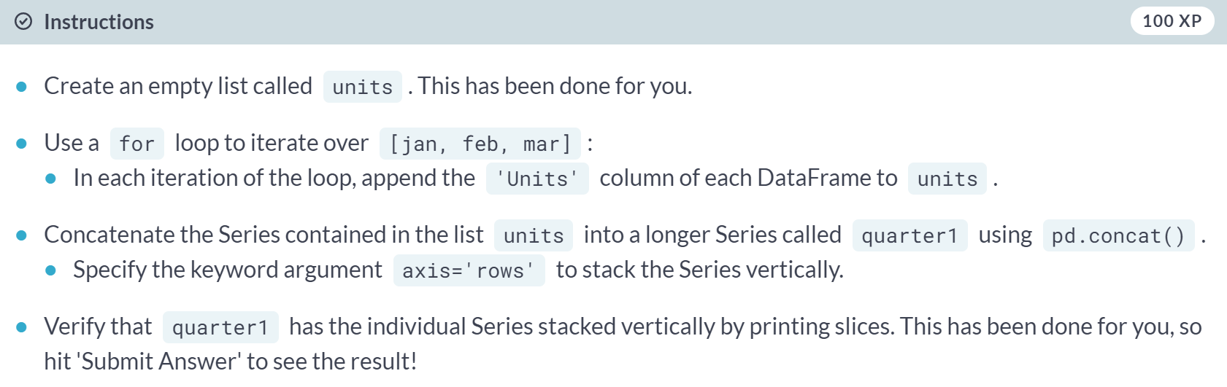  
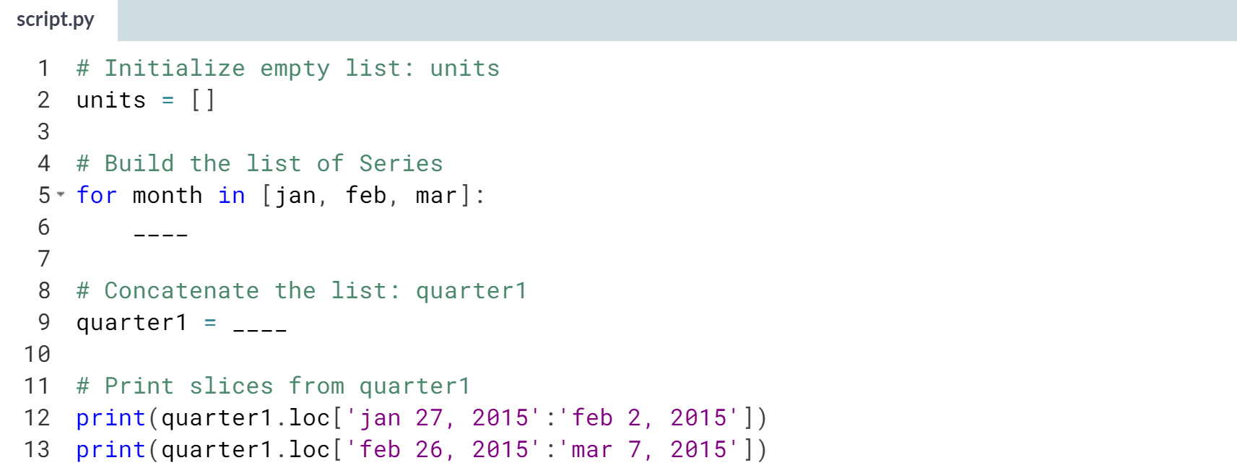

Hint

1. Inside the for loop, use the ***.append()*** method on units to append the *'Units'* column of month.
2. Use **pd.concat** with units with the keyword argument **axis='rows'** to concatenate and stack the Series vertically.

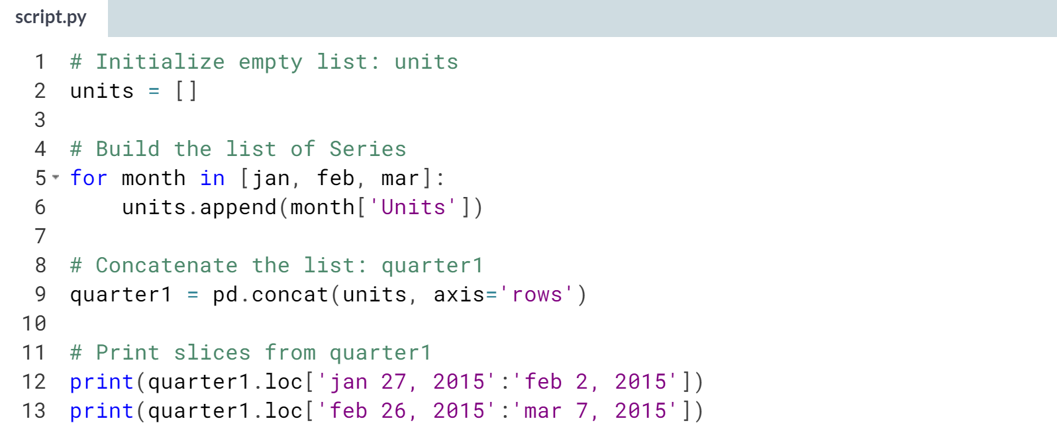

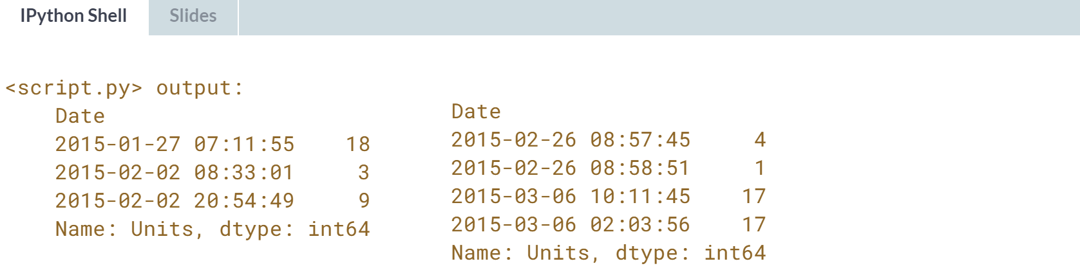  
Great work! As in this exercise, you can achieve the same results as appending by concatenating along the row axis.



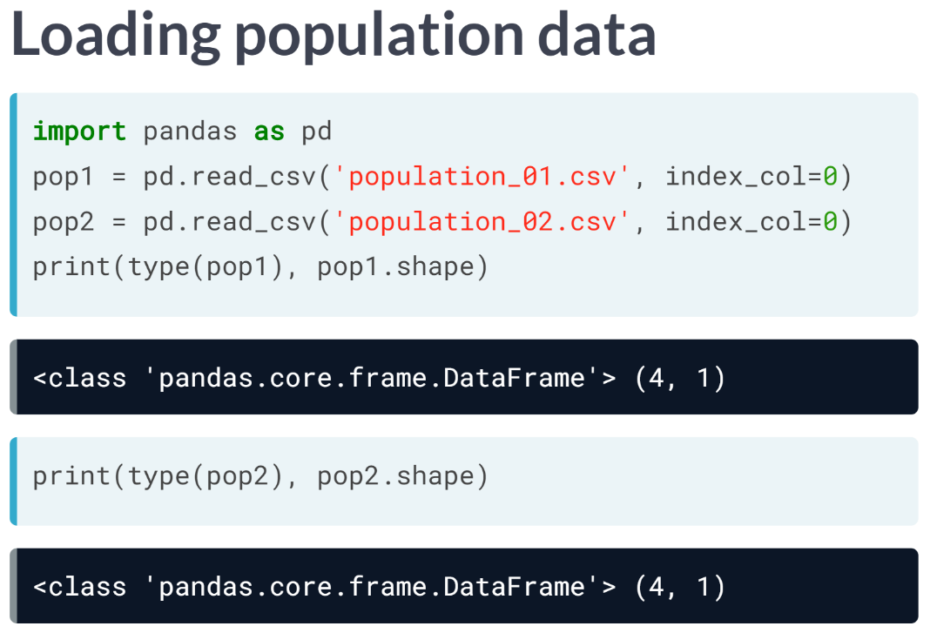  
Let's start by loading DataFrames pop1 and pop2 from CSV using ***read_csv()***. Notice both Pandas DataFrames have four rows and a single column.

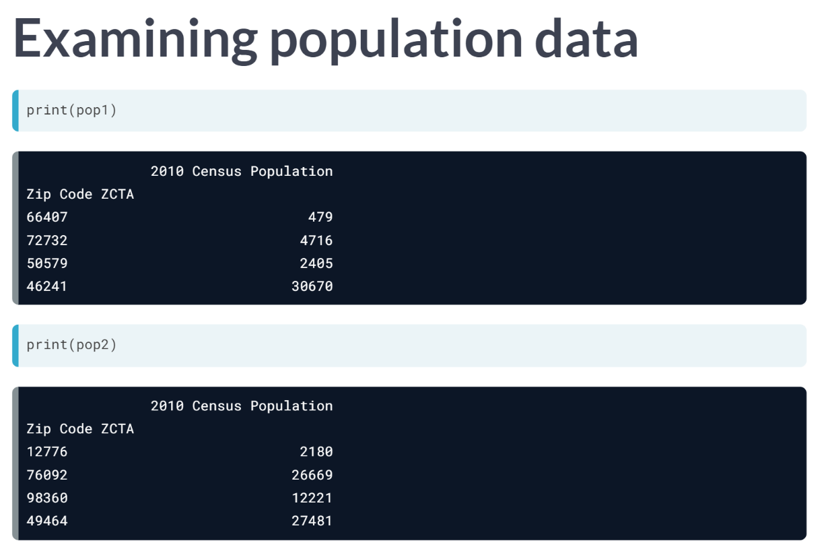  
Both DataFrames have a column 2010 Census Population and an Index Zip Code ZCTA. The rows, then, tell the population of a certain region of the US from the 2010 Census labeled by postal code.

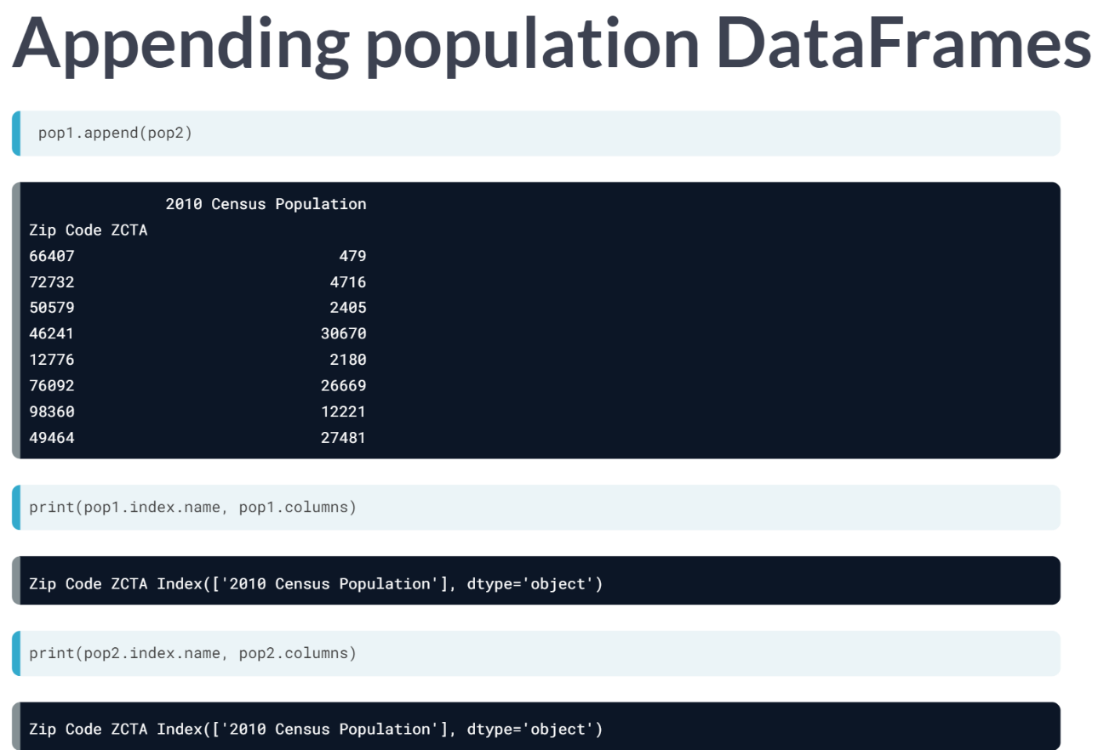  
When appended, these DataFrames are readily stacked row-wise, just like Series, while having identical index and column names.

Both ***.append()*** and ***concat()*** preserve the row indices in this case.

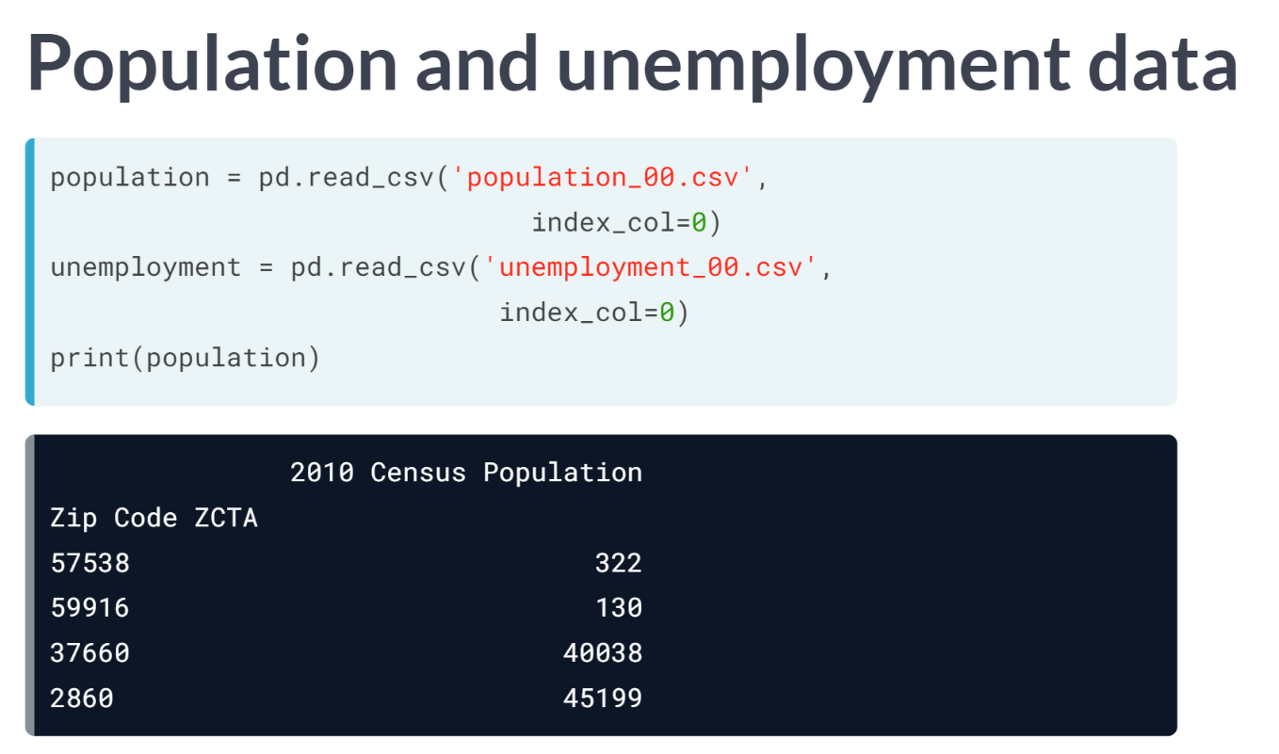  
By contrast, let's stack DataFrames with different column names. We use the same method to load the Pandas DataFrames from CSV files. population has the same column name and index name as the previous DataFrames, pop1 and pop2.

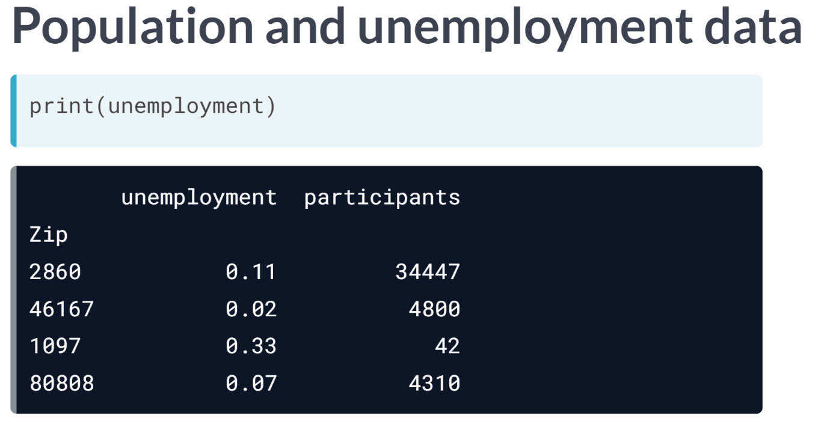  
By contrast, the DataFrame unemployment has two columns, unemployment and participants. Moreover, the index name for unemployment is called Zip instead. Notice that 2860 is the only label that occurs in both DataFrame indexes.

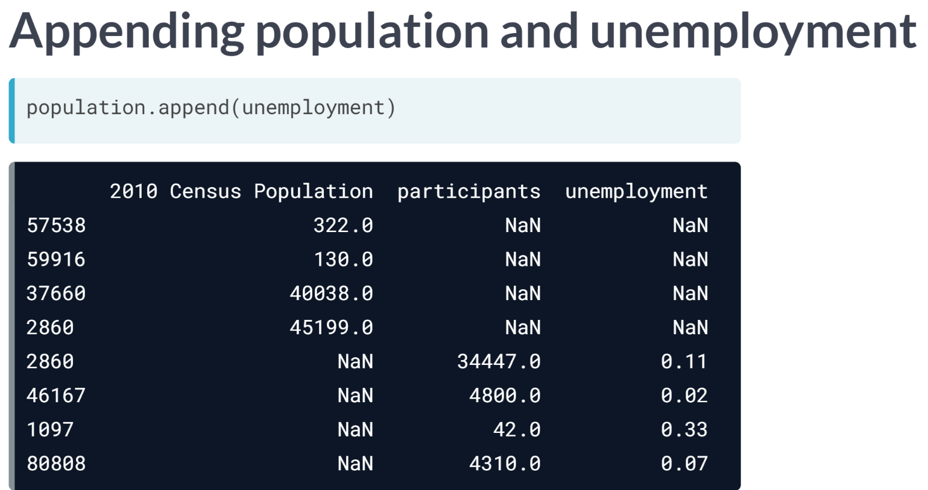

When appending DataFrame unemployment under DataFrame population, the resulting DataFrame has eight rows and three columns. The columns are the union of the columns from the input. The top four rows come from population DataFrame and have null values filling the unemployment and participants columns.

The bottom four rows (previously from the unemployment DataFrame) have the population column filled with NaNs. Again, the null entries are inserted because the appended DataFrames have disjoint column labels.

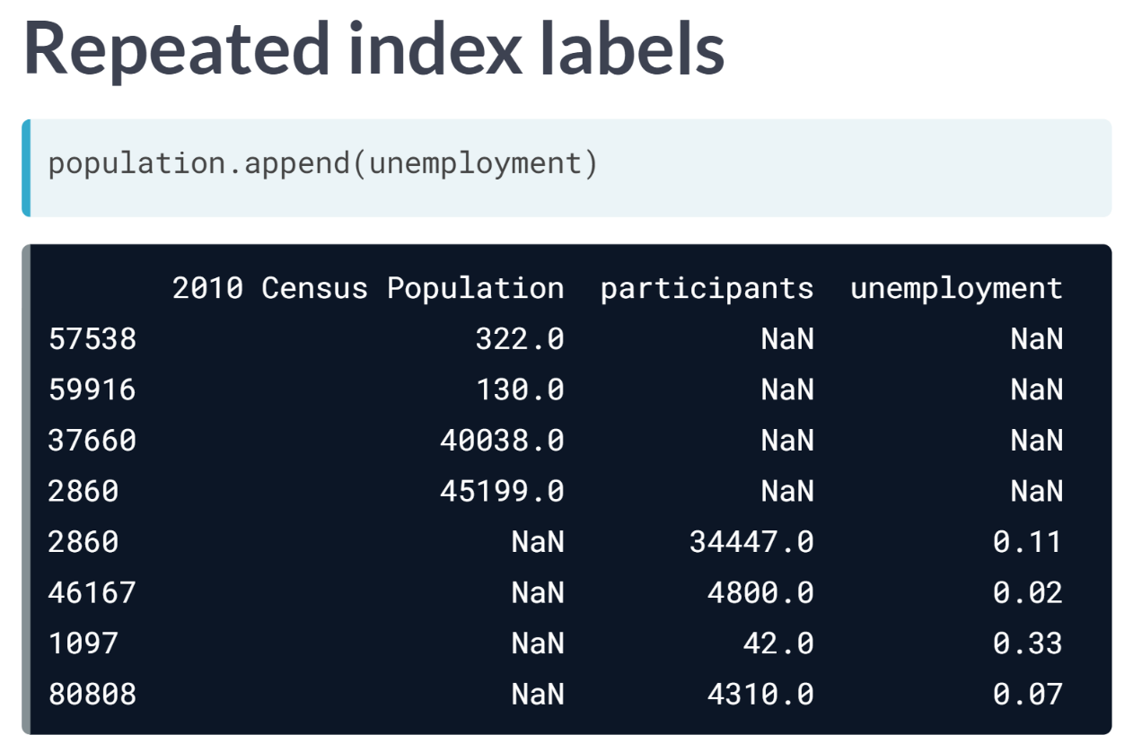  
Furthermore, notice that the appended DataFrame has two rows with the same index label 2860. The first comes from the population DataFrame; the second comes from the unemployment DataFrame.

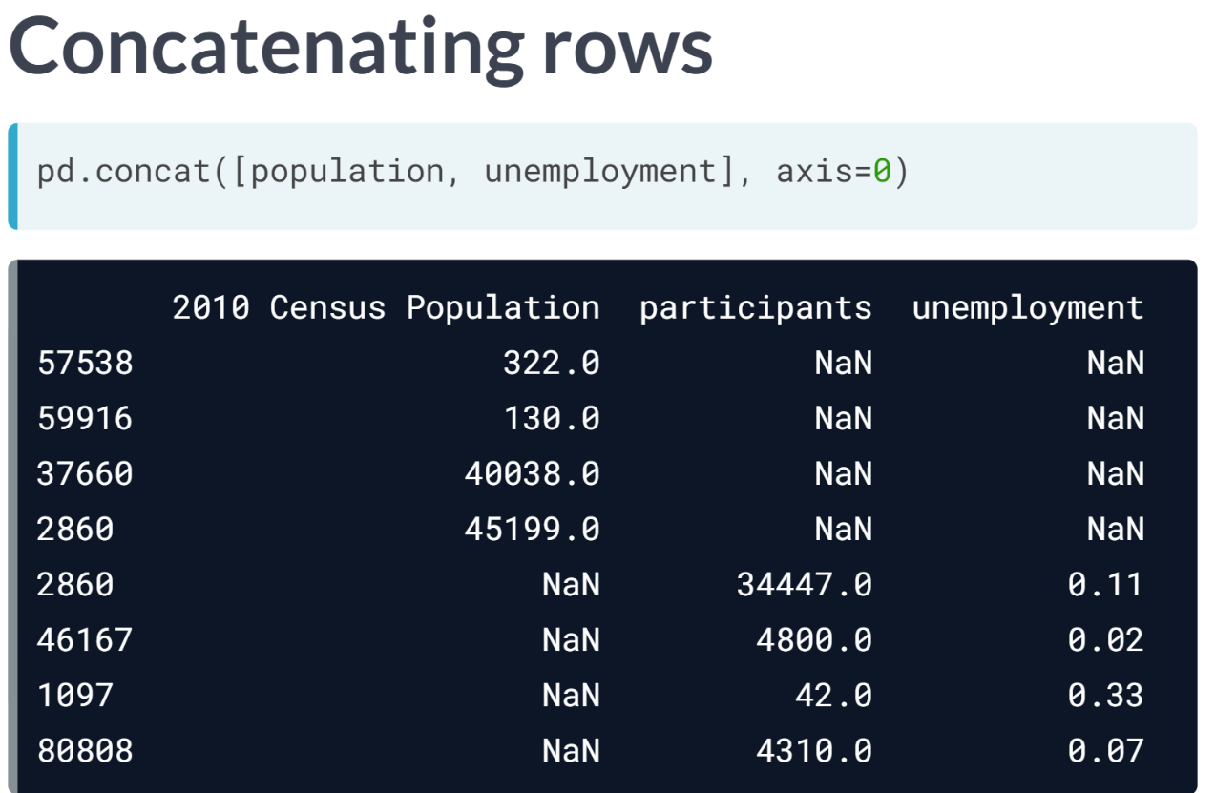  
Finally, let's try this again using the function ***concat()***. Concatenating unemployment after population along *axis=0* means stacking rows vertically at the bottom.

The result is identical to invoking ***population.append(unemployment)***. Also, since it is a default behavior, stating *axis=0* or *axis='rows'* is optional.

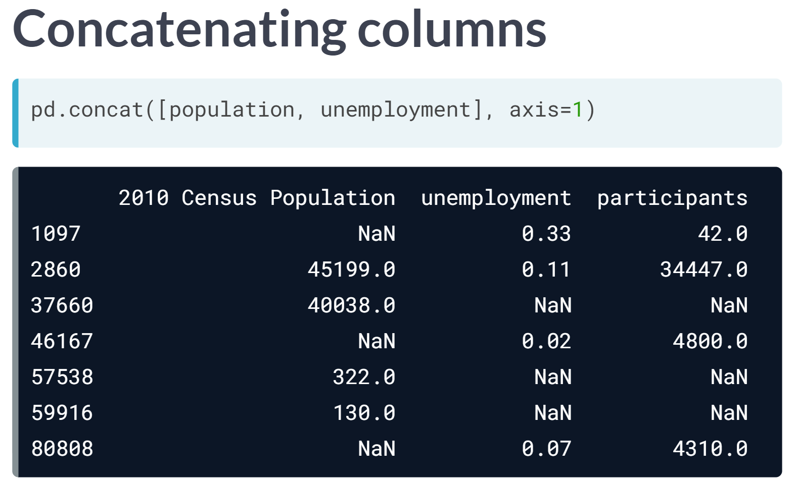  
By contrast, sing axis=1 or axis='columns' stacks DataFrame columns horizontally on the right. In that case, the resulting DataFrame has seven rows and three columns.

The rows with index value 2860 get aligned when concatenating. That is, values get propagated from both DataFrames, population and unemployment, to fill the row.

For these rows here that are present in population but not unemployment, the columns unemployment and participants are filled with NaNs.

Similarly, for these other rows that occur in employment but not in population, the 2010 Census population column is filled with NaN. This is what we call an outer join, as it will be covered later.

# Appending DataFrames with ignore_index

In this exercise, you'll use the [**Baby Names Dataset**](https://www.data.gov/developers/baby-names-dataset/) (from [**data.gov**](http://data.gov/)) again. This time, both DataFrames names_1981 and names_1881 are loaded without specifying an Index column (so the default Indexes for both are RangeIndexes).

You'll use the DataFrame .append() method to make a DataFrame combined_names. To distinguish rows from the original two DataFrames, you'll add a 'year' column to each with the year (1881 or 1981 in this case).

In addition, you'll specify ignore_index=True so that the index values are not used along the concatenation axis. The resulting axis will instead be labeled 0, 1, ..., n-1, which is useful if you are concatenating objects where the concatenation axis does not have meaningful indexing information.

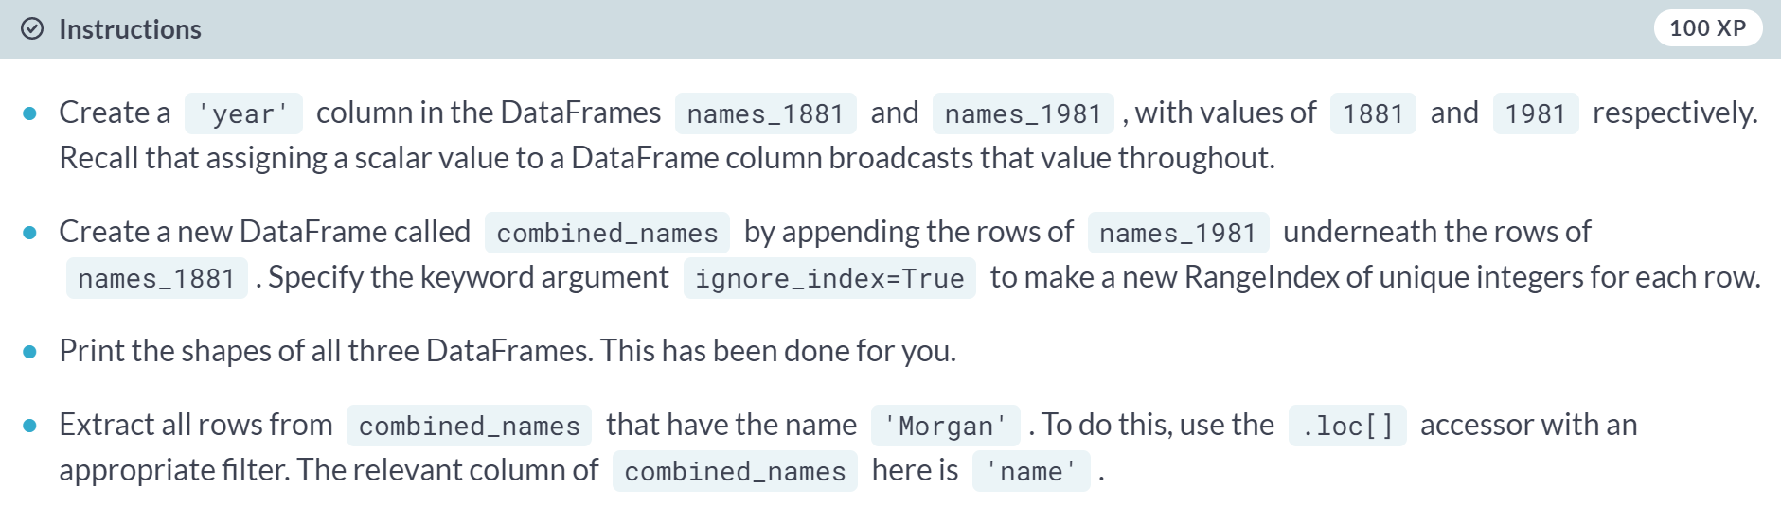

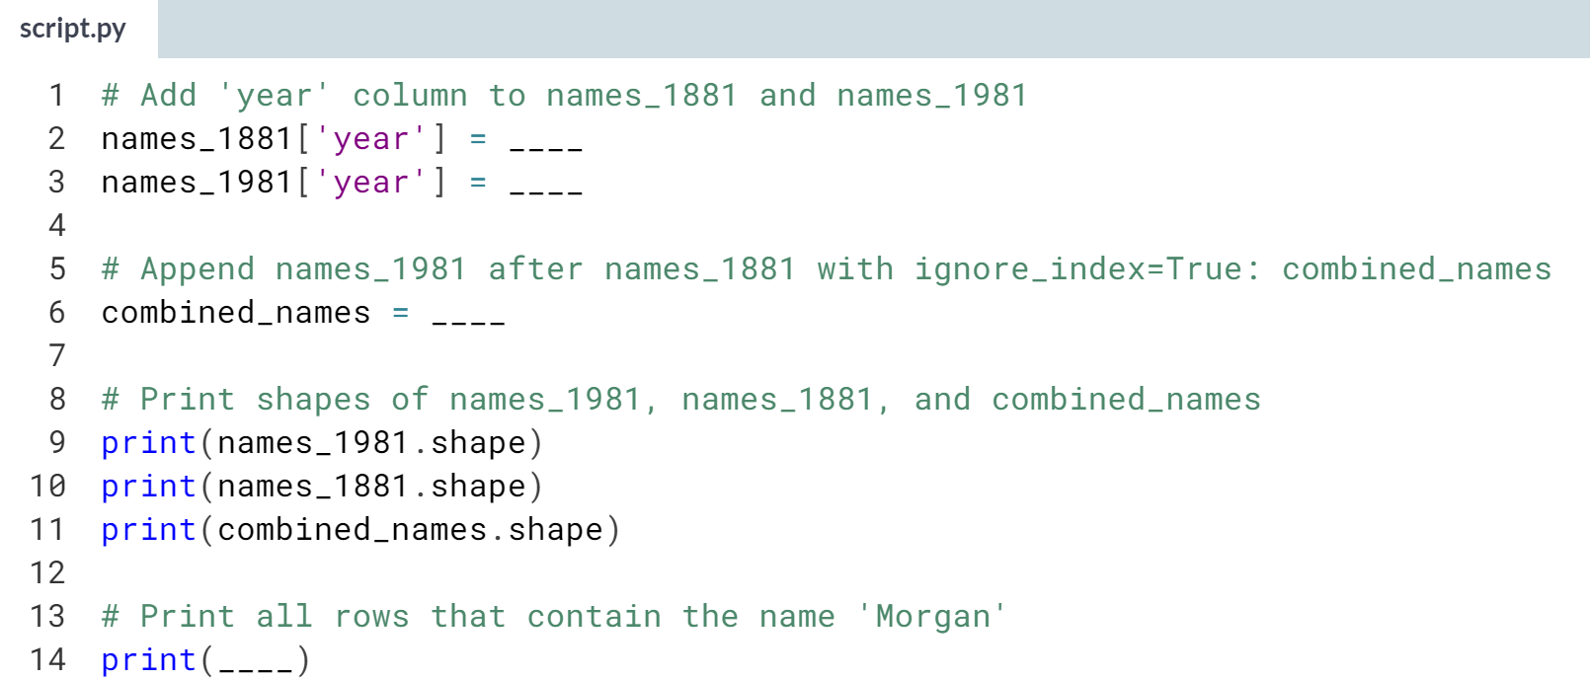

Hint

1. Assign the values 1881 and 1981 to **names_1881['year']** and **names_1981['year']**, respectively.
2. Use the ***.append()*** method on *names_1881* with *names_1981* as an argument along with the keyword argument **ignore_index=True**.
3. To extract the rows with name *'Morgan'*, use the **.loc[]** accessor on *combined_names* with the Boolean condition **combined_names['name']=='Morgan'**.

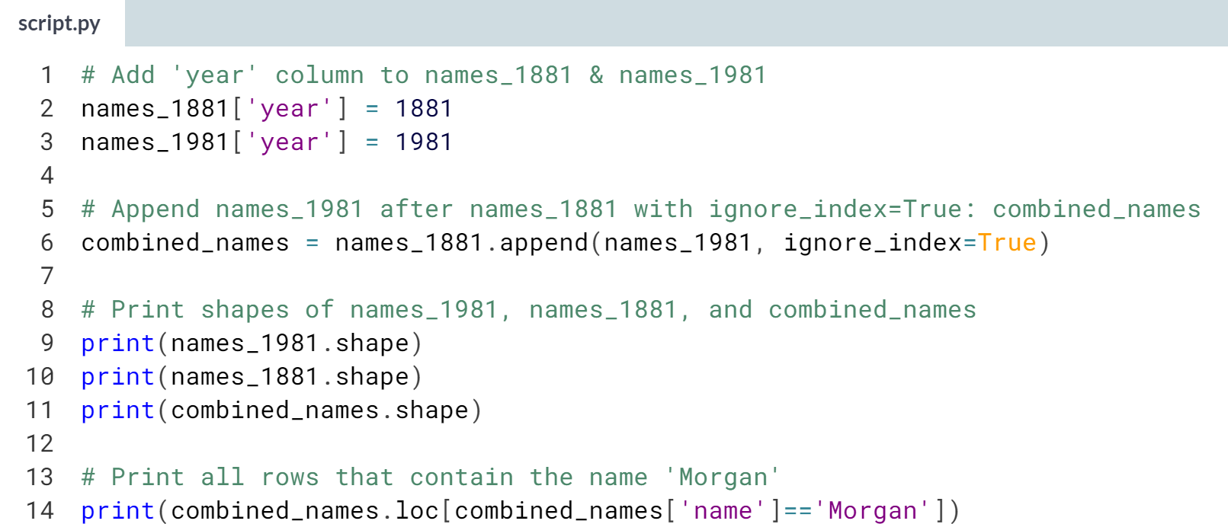

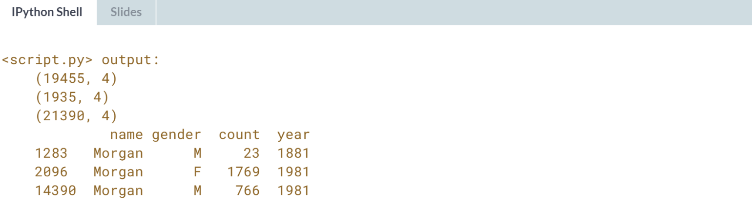

# Concatenating pandas DataFrames along column axis

The function pd.concat() can concatenate DataFrames horizontally as well as vertically (vertical is the default). To make the DataFrames stack horizontally, you have to specify the keyword argument axis=1 or axis='columns'.

In this exercise, you'll use weather data with maximum and mean daily temperatures sampled at different rates (quarterly versus monthly).

You'll concatenate the rows of both and see that, where rows are missing in the coarse DataFrame, null values are inserted in the concatenated DataFrame.

This corresponds to an outer join (which you will explore in more detail in later exercises).

The files 'quarterly_max_temp.csv' and 'monthly_mean_temp.csv' have been pre-loaded into the DataFrames weather_max and weather_mean respectively, and pandas has been imported as pd.

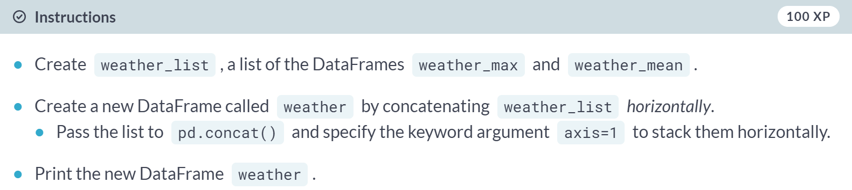

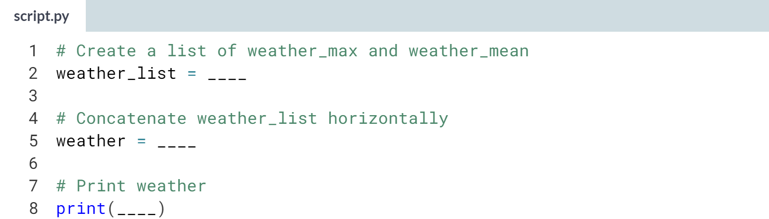

Hint

1. Use the ***pd.concat()*** function, passing in *weather_list*. Don't forget to also specify **axis=1**.
2. To print *weather*, pass it in as an argument to the provided ***print()*** function.

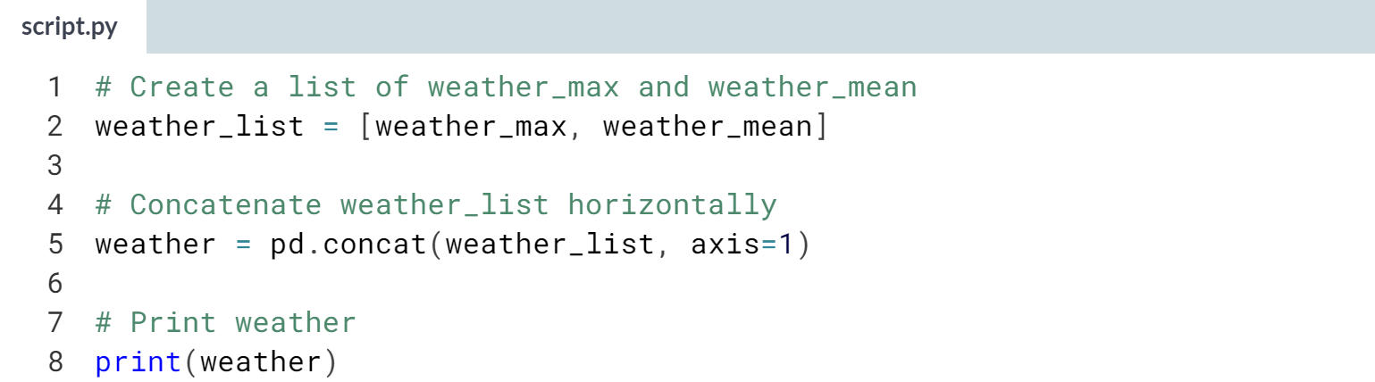

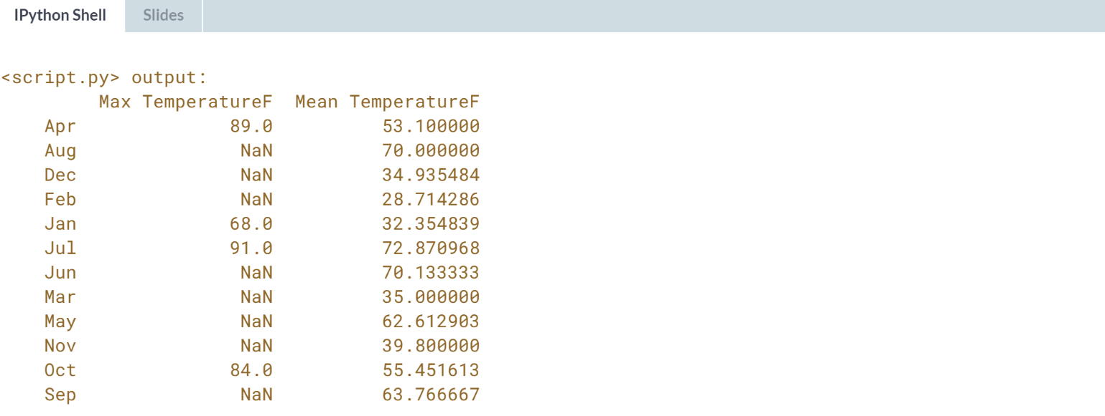

Well done! This is where you start to see the advantages of concatenating over appending.

# Reading multiple files to build a DataFrame

It is often convenient to build a large DataFrame by parsing many files as DataFrames and concatenating them all at once.

You'll do this here with three files, but, in principle, this approach can be used to combine data from dozens or hundreds of files.

Here, you'll work with DataFrames compiled from [**The Guardian's Olympic medal dataset**](https://www.theguardian.com/sport/datablog/2012/jun/25/olympic-medal-winner-list-data).

pandas has been imported as pd and the list medal_types has been pre-loaded for you, which contains the strings 'bronze', 'silver', and 'gold'.

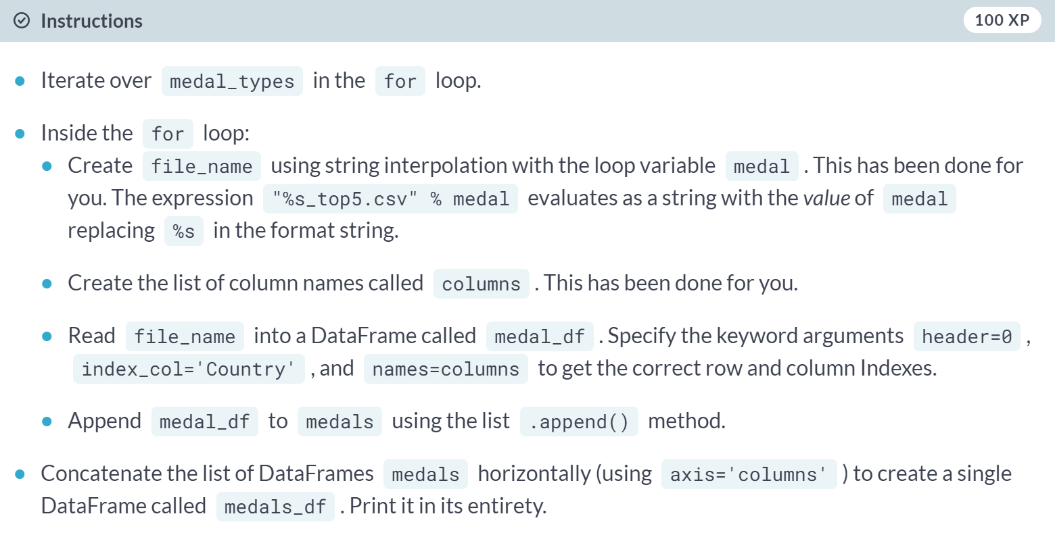

(Exercise begins on the next page)

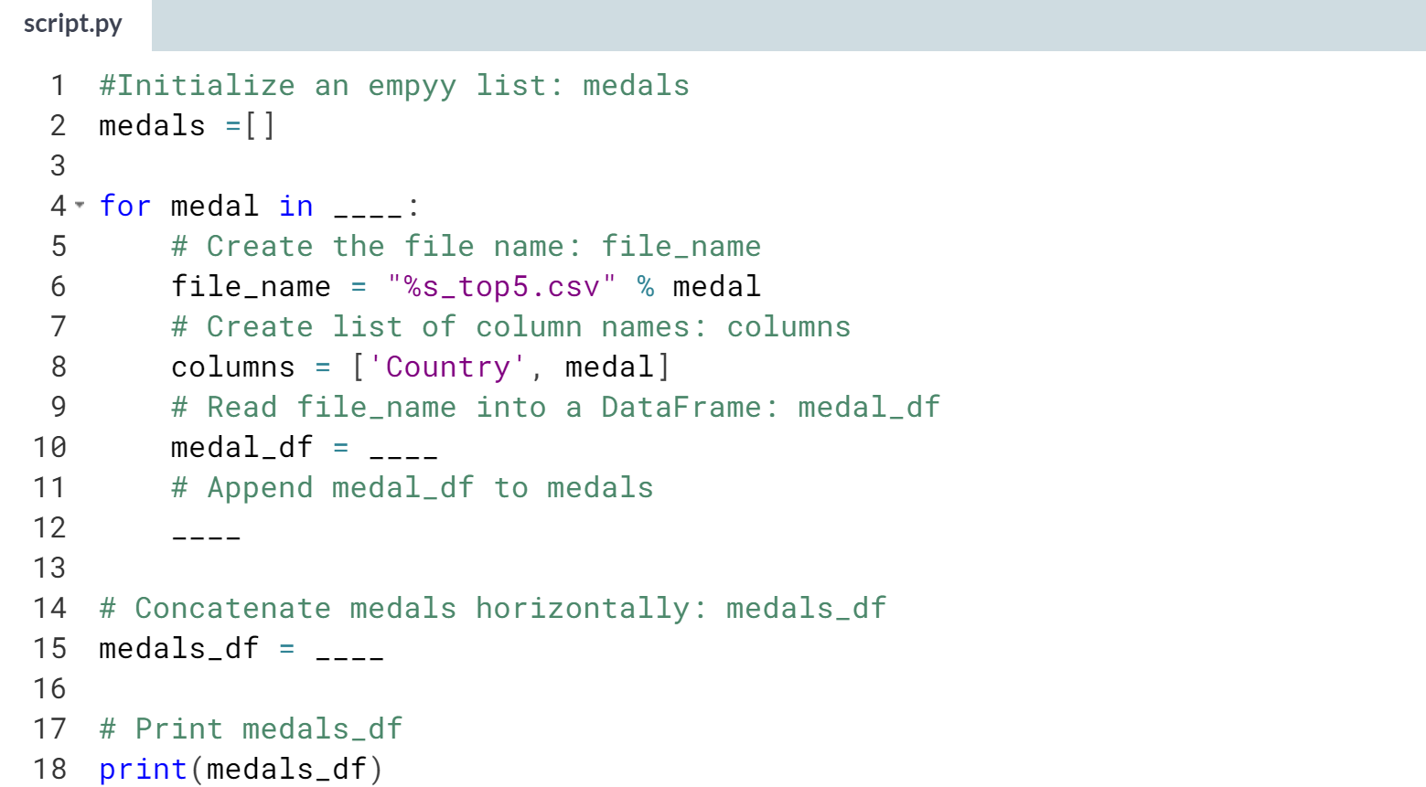

Hint

1. In the for loop, make sure you are iterating over the list **medal_types**.
2. Inside the loop, use ***pd.read_csv()*** to read in *file_name*. Make sure you specify the additional keyword arguments **header=0**, **index_col='Country'**, and **names=columns**.
3. Inside the loop, use the ***.append()*** method on *medals* with *medal_df* as the argument.
4. Use the ***pd.concat()*** function with the arguments medals and **axis='columns'** to concatenate medals horizontally.

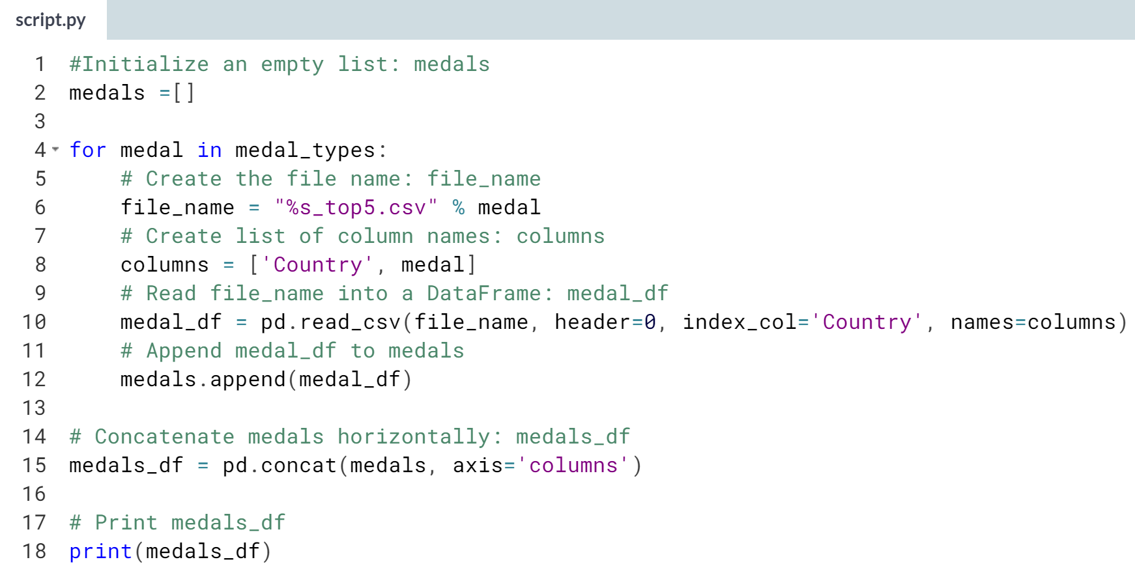

(Result on the next page)

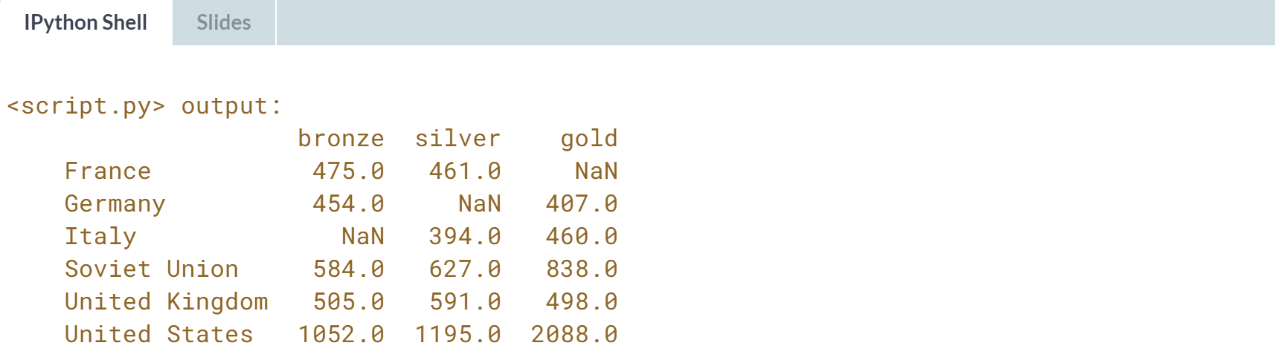

Fantastic! Being able to build DataFrames from multiple files like this can be incredibly useful.



Let's learn about how we can concatenate DataFrames that may share common row labels or common column names.

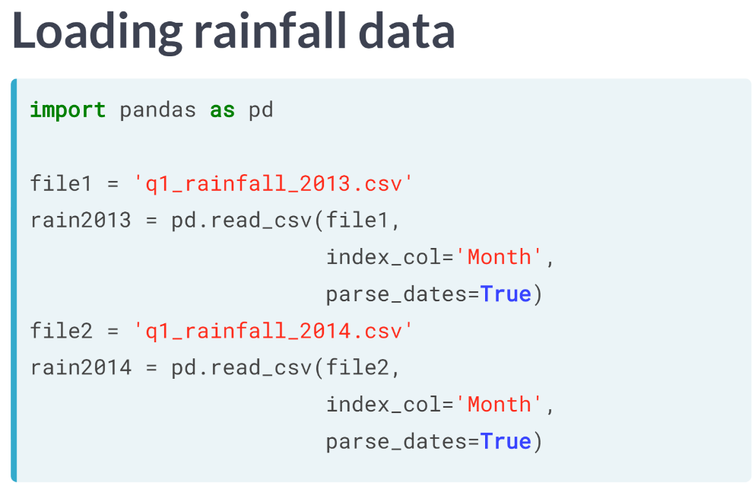  
Let's begin by loading two small DataFrames. This file contains monthly average rainfall for the first three months of 2013 and 2014, respectively.

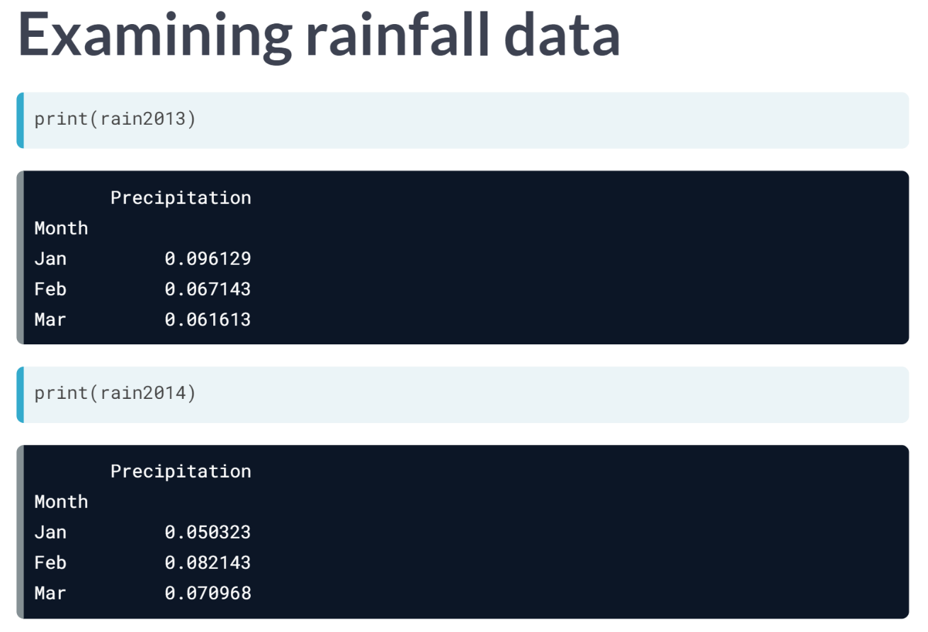  
We can see that they have common row labels. The column label precipitation is also common to both DataFrames.

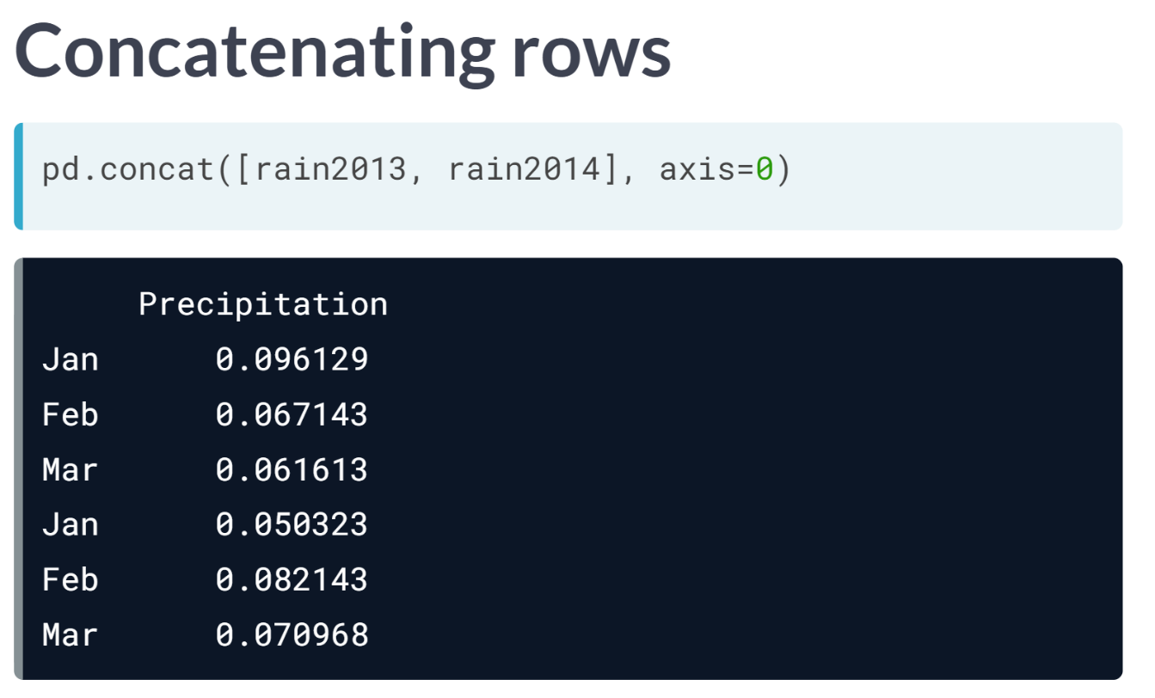  
We can concatenate the DataFrames in rain2013 and rain2014 using ***pd.concat()*** with axis = 0. Notice the resulting DataFrame that has a single column with repeated index labels.

This obscures the fact that the bottom three rows come from months of a different year than the top three rows.

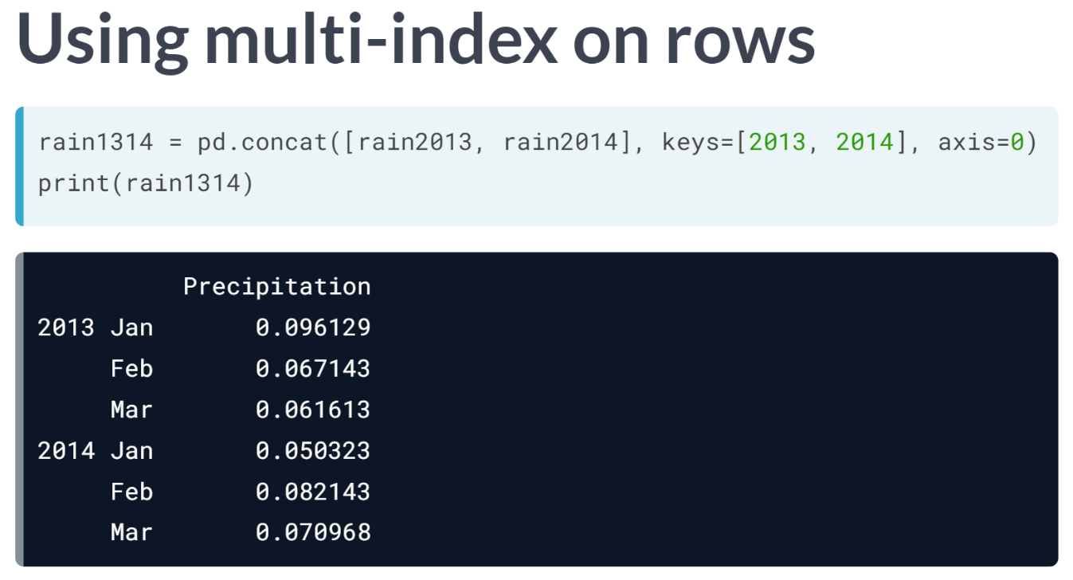  
One fix is to use a multi-level index for the rows. Here, the argument keys = 2013, 2014 assigns an outer index label associated with each of the original input DataFrames.

Notice that the order of the list of keys MUST match the order of the list of DataFrames. When printed, the DataFrame is displayed with distinctive levels for the multi-index. This makes it clear which year is associated with the month for each row.

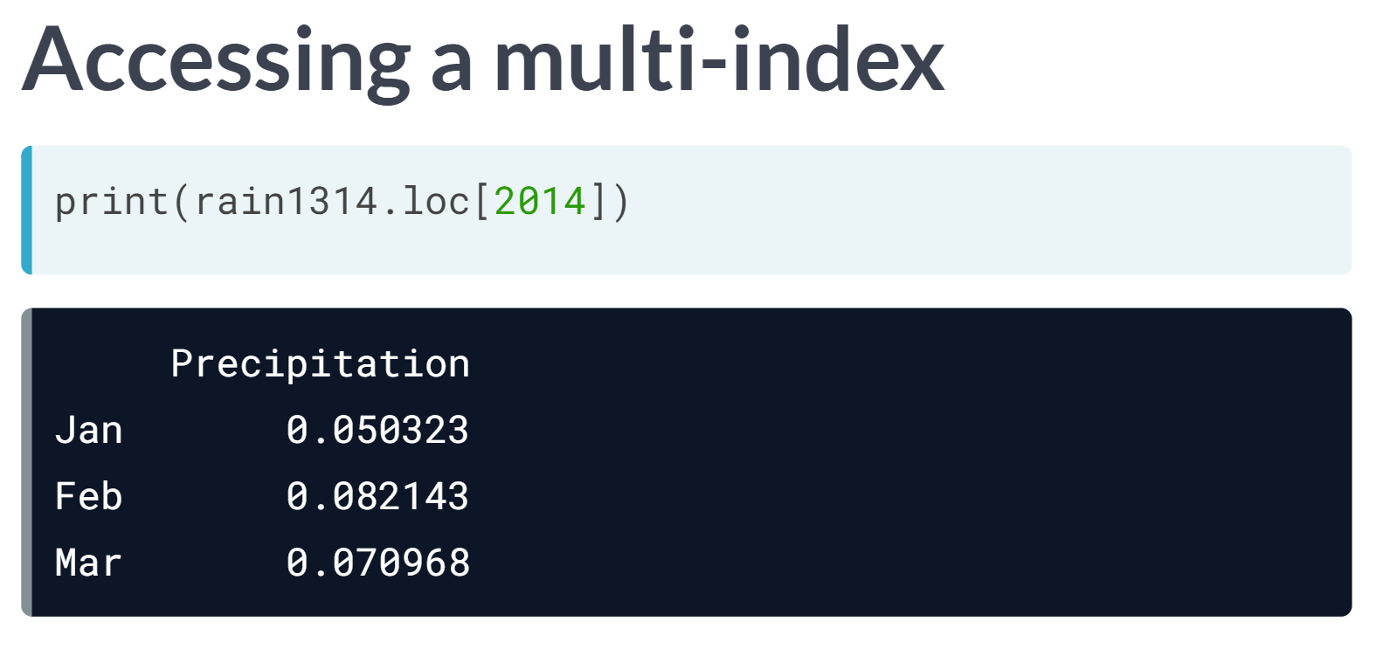  
As usual, the multi-index can be sliced on the outermost level with the .loc accessor.

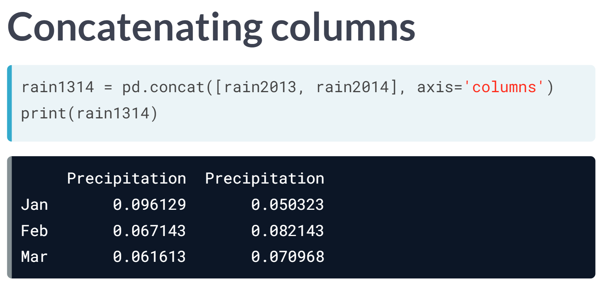  
A different strategy is to concatenate the columns from DataFrame rain2014 to the right of the columns of DataFrame rain2013. We do this by using the option *axis=1* or *axis='columns'* in the call to ***pd.concat()***.

But since the column label Precipitation is common to both DataFrames, the result has two Precipitation columns, again obscuring which column name comes from which year's data.

Important: Just as Pandas Series can have repeat index labels, DataFrames can have repeated column labels. Slicing with a repeated column label yields all matching columns.

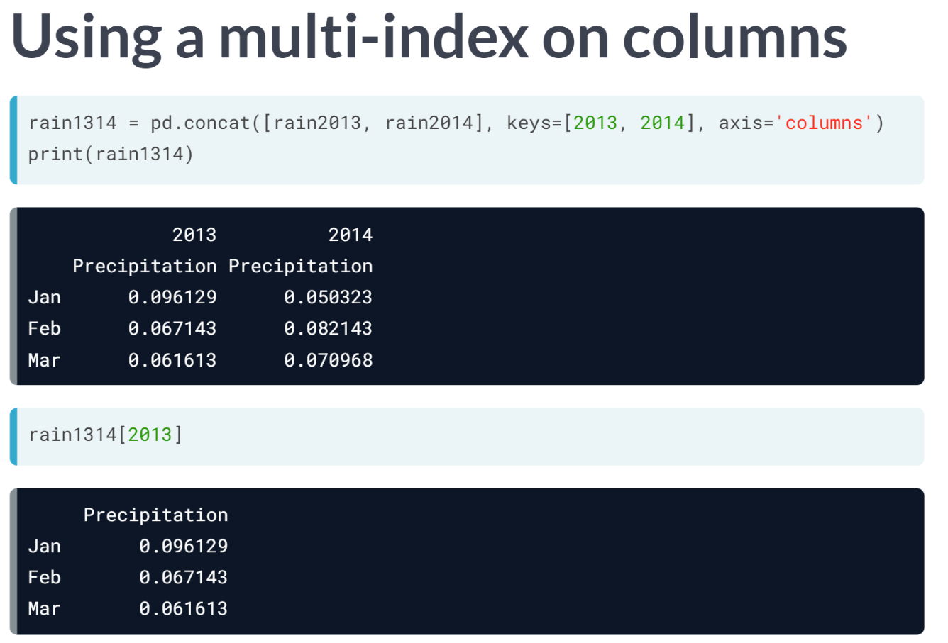  
To avoid repeated column indices, we use the option keys = 2013, 2014 and axis = 'columns' with ***concat()***. The result has a multi-level column index showing 'Precipitation' by year. Again, we can slice the year 2013 in a dictionary-style.

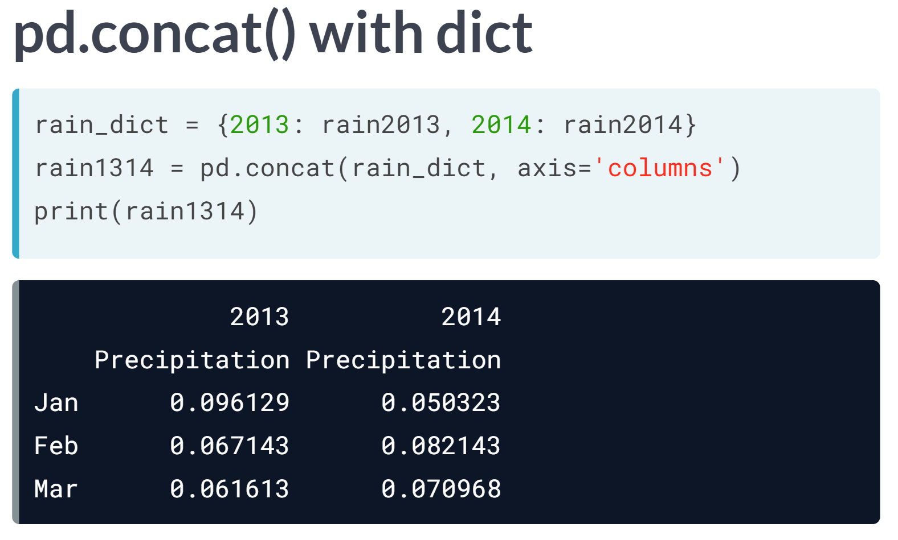  
Finally, the function ***pd.concat()*** can also accept a dictionary (rather than a list) of DataFrame as input. In that case, the dictionary keys from *rain_dict* are automatically treated as values for the keys=argument in building a multi-index on the columns. The result is the same DataFrame from before.

# Concatenating vertically to get MultiIndexed rows

When stacking a sequence of DataFrames vertically, it is sometimes desirable to construct a MultiIndex to indicate the DataFrame from which each row originated. This can be done by specifying the keys parameter in the call to pd.concat(), which generates a hierarchical index with the labels from keys as the outermost index label. So you don't have to rename the columns of each DataFrame as you load it. Instead, only the Index column needs to be specified.

Here, you'll continue working with DataFrames compiled from [**The Guardian's Olympic medal dataset**](https://www.theguardian.com/sport/datablog/2012/jun/25/olympic-medal-winner-list-data). Once again, pandas has been imported as pd and two lists have been pre-loaded: An empty list called medals, and medal_types, which contains the strings 'bronze', 'silver', and 'gold'.

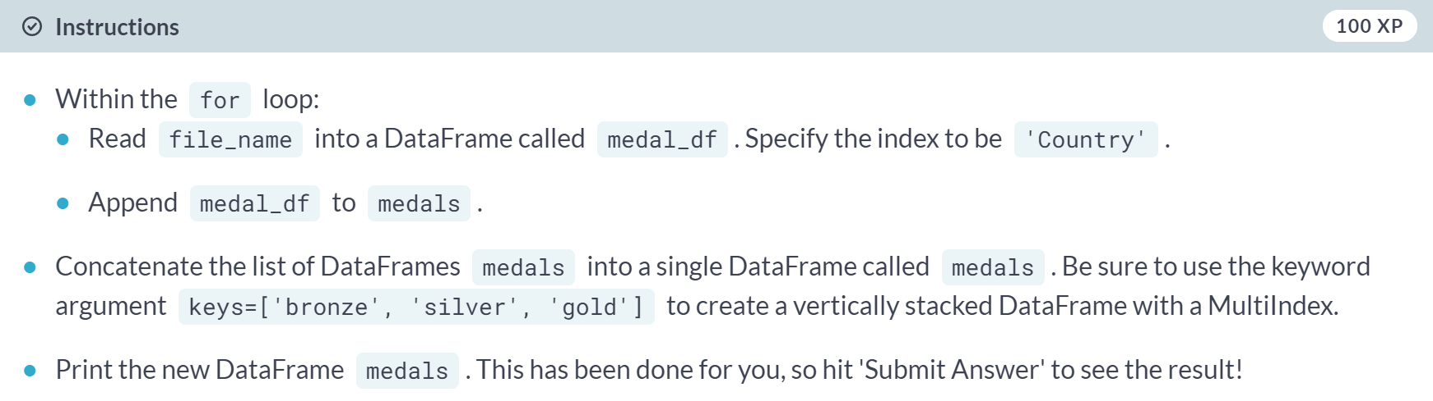

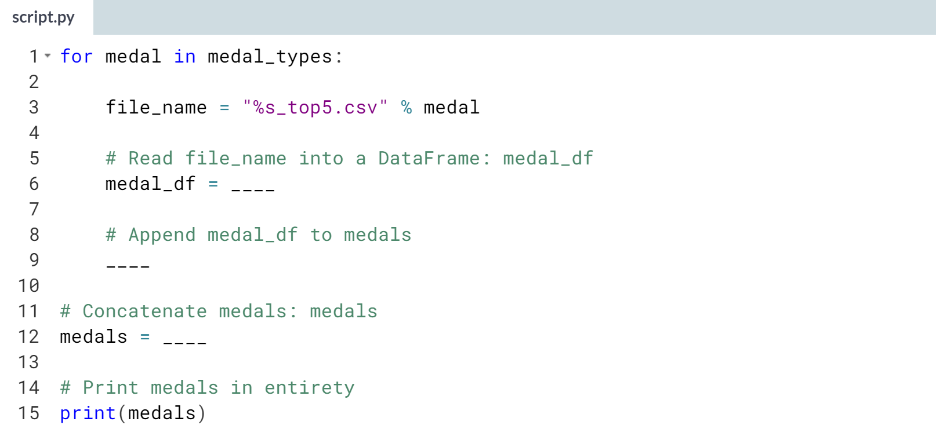

1. Use ***pd.read_csv()*** with **file_name** as an argument along with **index_col='Country'**.
2. Use the list ***.append()*** method on medals with **medal_df** as the argument.
3. Use ***pd.concat()*** with medals and the keyword argument **keys=['bronze', 'silver', 'gold']** to create the vertically stacked DataFrame.

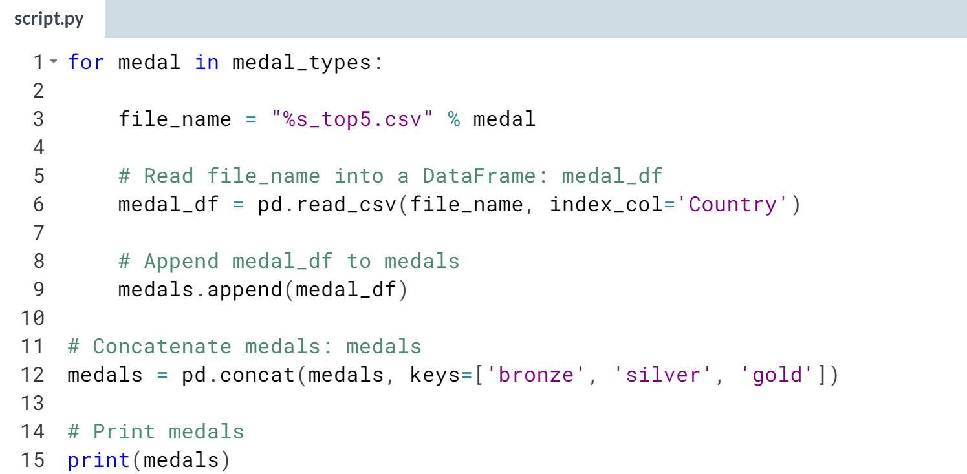

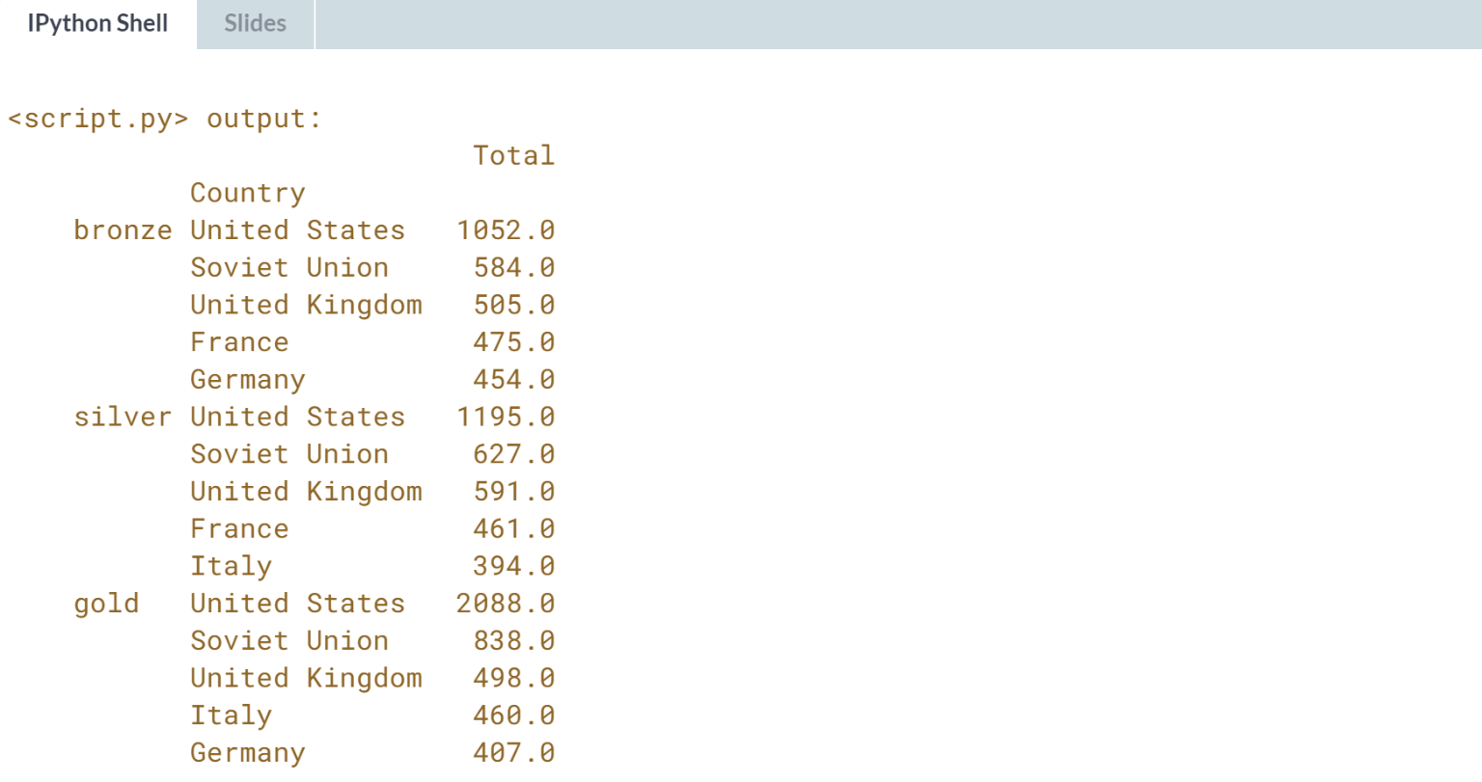

Well done! Notice the MultiIndex of *medals*.

# Slicing MultiIndexed DataFrames

This exercise picks up where the last ended (again using [**The Guardian's Olympic medal dataset**](https://www.theguardian.com/sport/datablog/2012/jun/25/olympic-medal-winner-list-data)).

You are provided with the MultiIndexed DataFrame as produced at the end of the preceding exercise. Your task is to sort the DataFrame and to use the pd.IndexSlice to extract specific slices.

Check out [**this exercise**](https://campus.datacamp.com/courses/manipulating-dataframes-with-pandas/advanced-indexing?ex=10) from Manipulating DataFrames with pandas to refresh your memory on how to deal with MultiIndexed DataFrames.

pandas has been imported for you as pd and the DataFrame medals is already in your namespace.

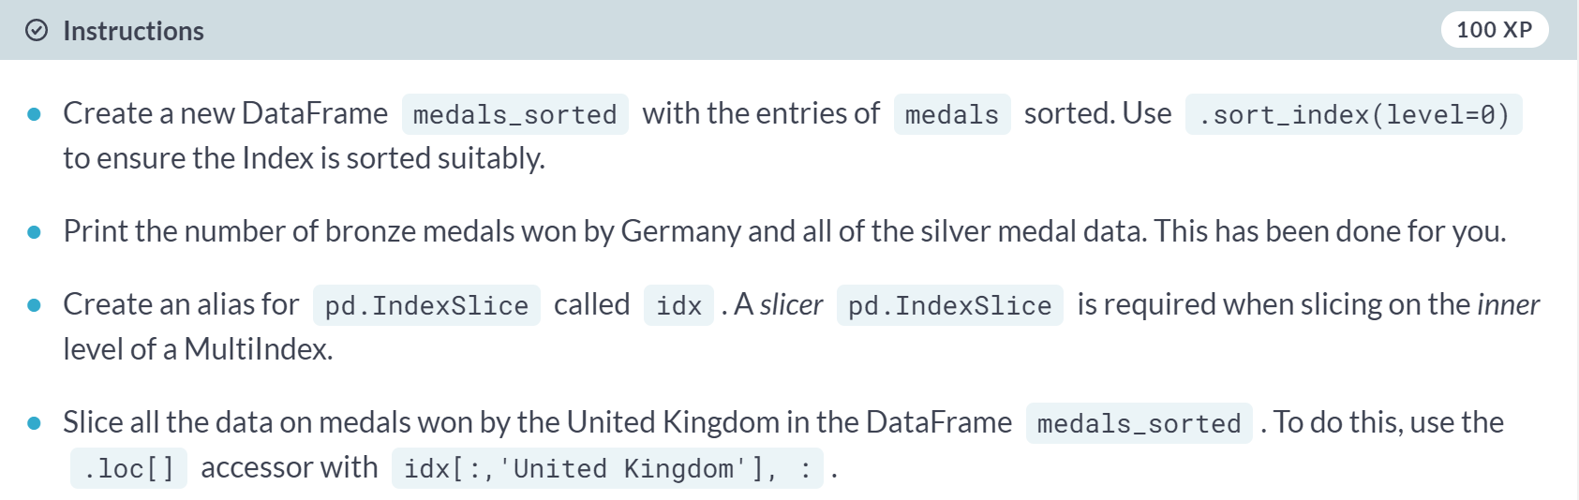

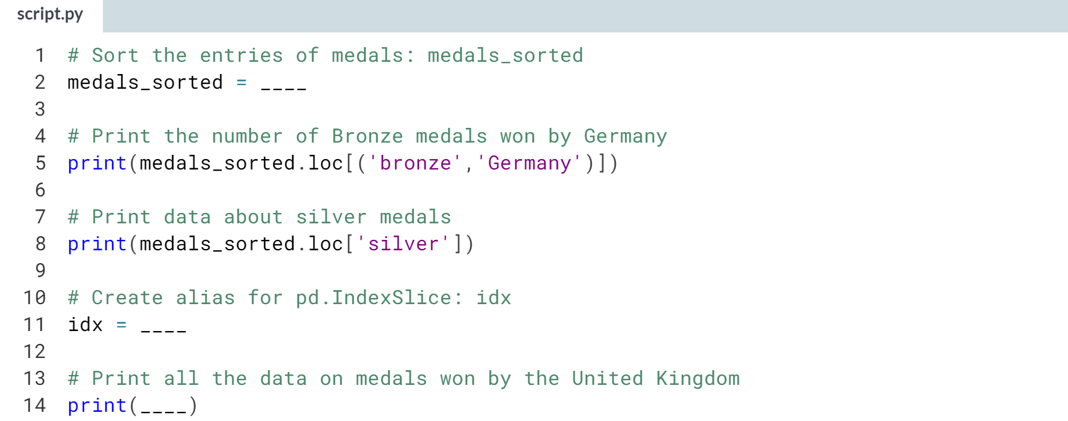

1. Use the ***.sort_index()*** method on medals with **level=0** to sort the entries of medals.
2. Assign **pd.IndexSlice** to **idx** to create the alias.
3. Use **.loc[idx[:,'United Kingdom'], :]** on **medals_sorted** to extract the medal data pertaining to the *'United Kingdom'*.

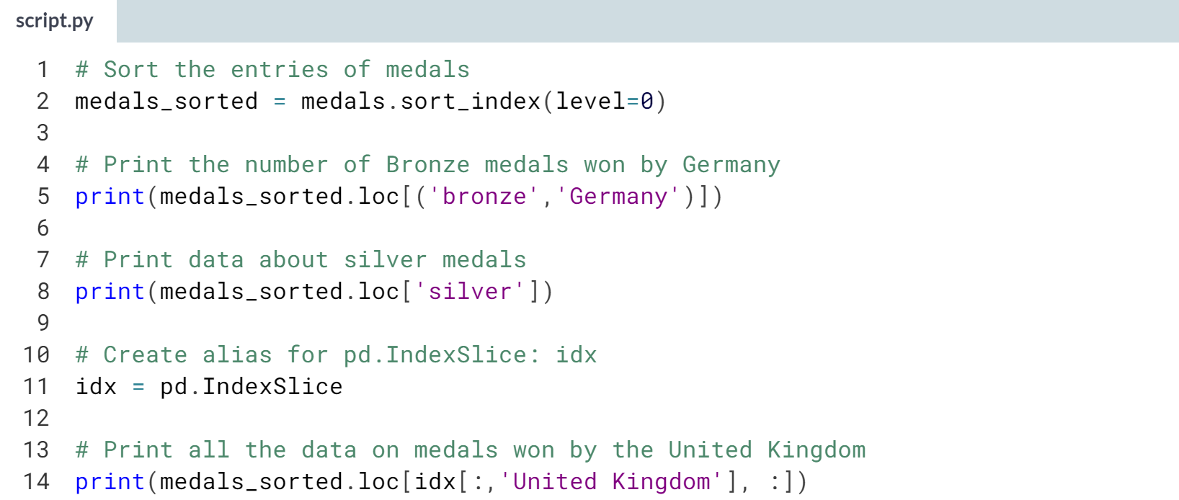

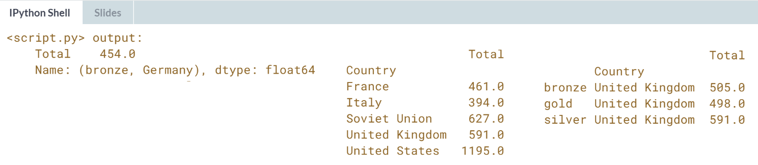

Great work! It looks like only the United States and the Soviet Union have won more Silver medals than the United Kingdom.

# Concatenating horizontally to get MultiIndexed columns

It is also possible to construct a DataFrame with hierarchically indexed columns. For this exercise, you'll start with pandas imported and a list of three DataFrames called dataframes.

All three DataFrames contain 'Company', 'Product', and 'Units' columns with a 'Date' column as the index pertaining to sales transactions during the month of February, 2015.

The first DataFrame describes Hardware transactions, the second describes Software transactions, and the third, Service transactions.

Your task is to concatenate the DataFrames horizontally and to create a MultiIndex on the columns. From there, you can summarize the resulting DataFrame and slice some information from it.

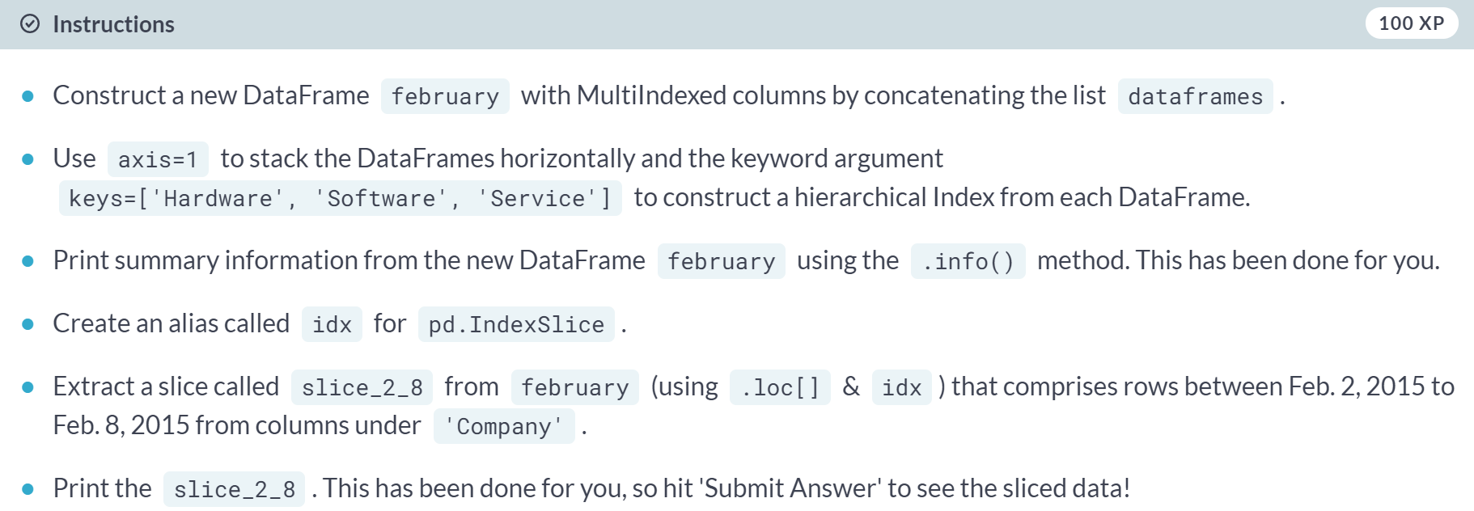

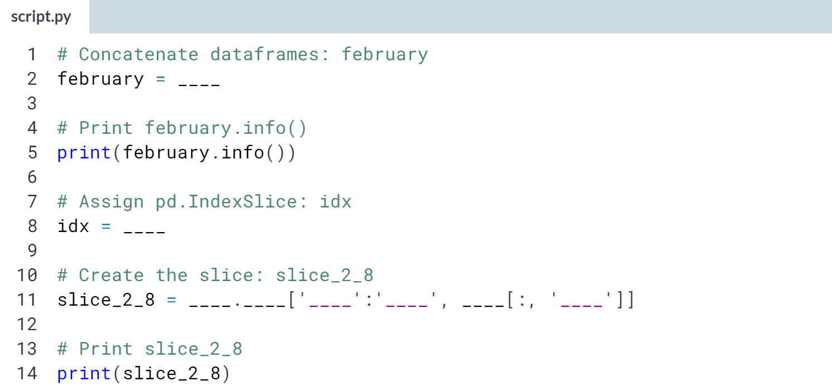

Hint

1. Use the ***pd.concat()*** method with *dataframes* as an argument along with the keyword arguments **axis=1** and **keys=['Hardware', 'Software', 'Service']**.
2. Assign **pd.IndexSlice** to **idx**.
3. Use the **.loc[]** accessor on february. Extract all the rows between *'2015-2-2'* and *'2015-2-8'* from columns under *'Company'*. To get the columns, use **idx[]** with **:, 'Company'**.

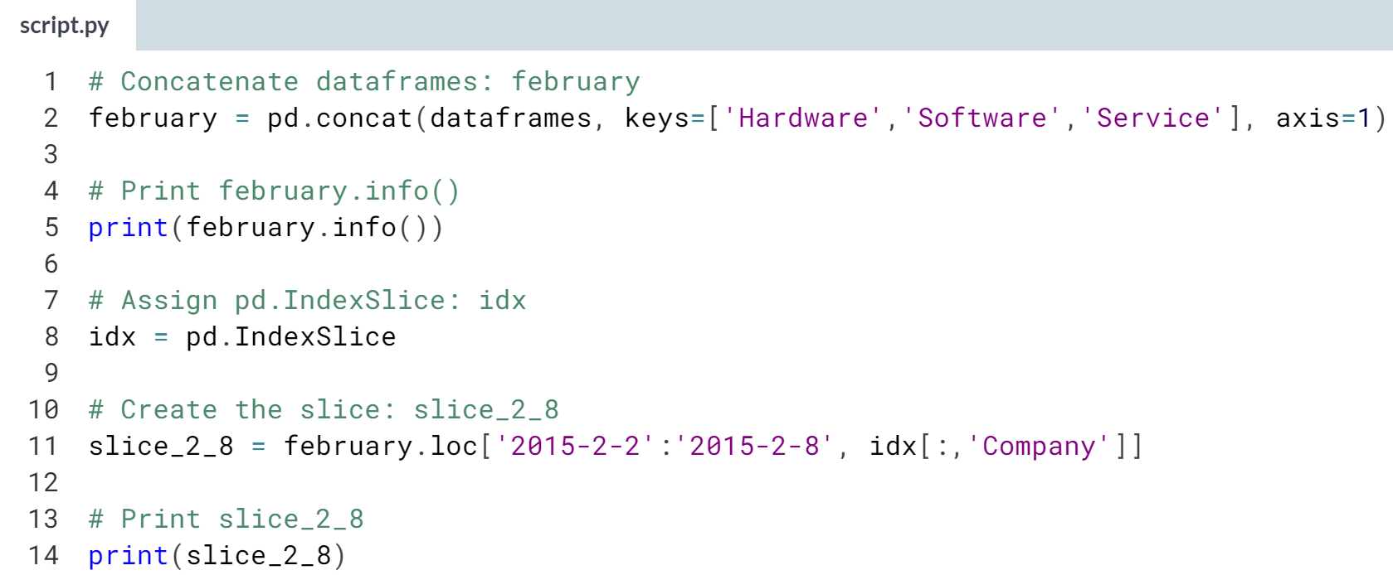  
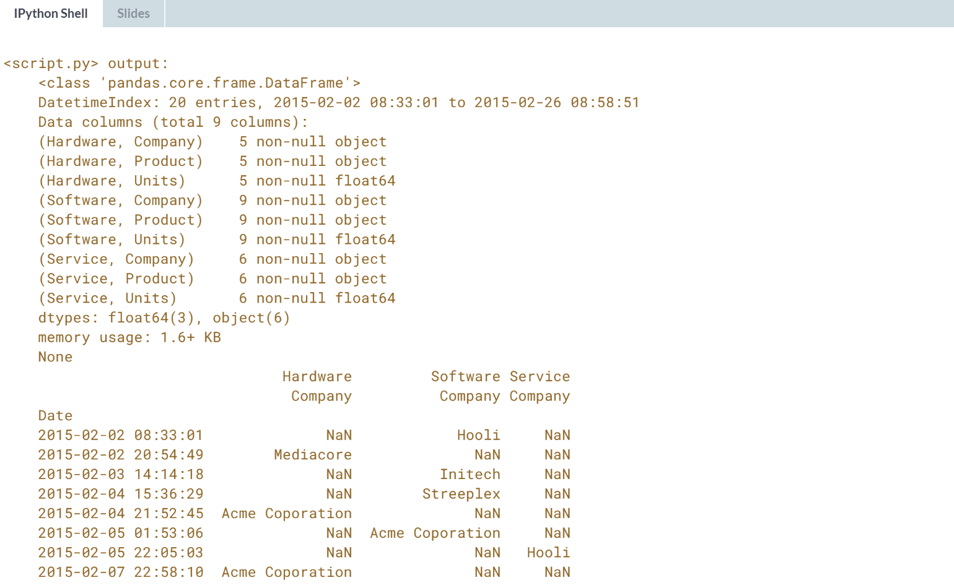  
Excellent work! Working with MultiIndexes and MultiIndexed columns can seem tricky at first, but with practice, it will become second nature.

# Concatenating DataFrames from a dict

You're now going to revisit the sales data you worked with earlier in the chapter. Three DataFrames jan, feb, and mar have been pre-loaded for you. Your task is to aggregate the sum of all sales over the 'Company' column into a single DataFrame. You'll do this by constructing a dictionary of these DataFrames and then concatenating them.

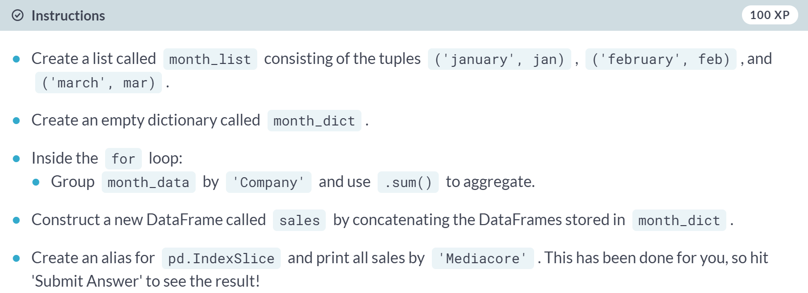  
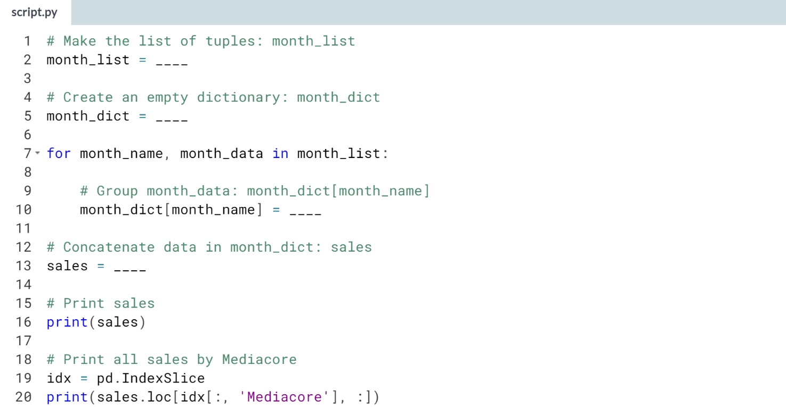

1. You can create the list of tuples by assigning **[('january', jan), ('february', feb), ('march', mar)]** to **month_list**.
2. Use **{}** to create an empty dictionary.
3. Use the ***.groupby()*** method on **month_data** with *'Company'* as the argument. Then, to aggregate by sum, chain the ***.sum()*** method to this.
4. Use the ***pd.concat()*** function with *month_dict* as the argument to concatenate the DataFrames.

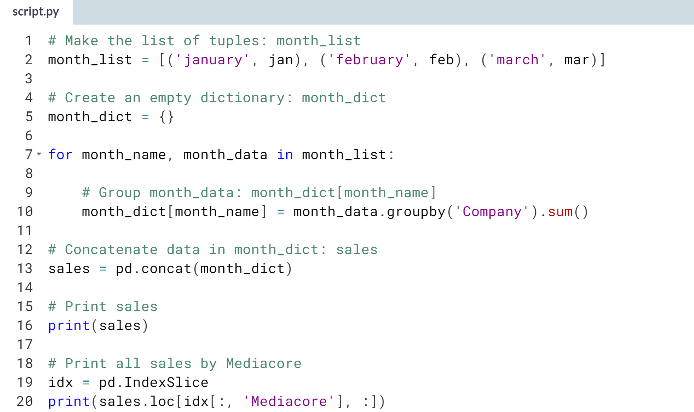

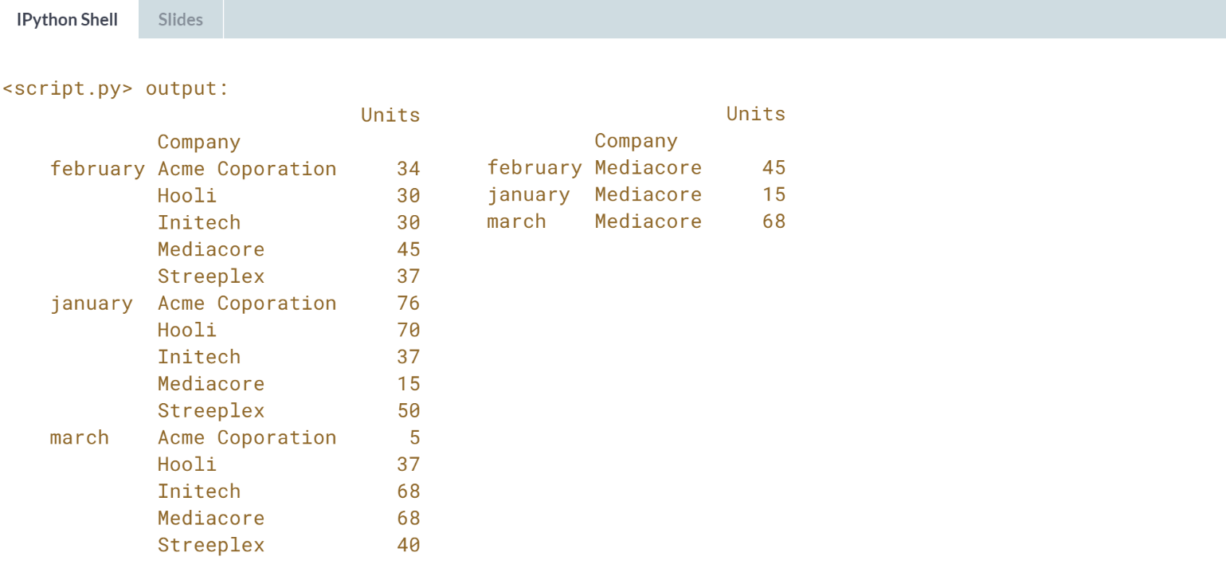

Well done! Now that you've mastered of the basics of concatenating your data, it's time to learn about different types of joins!



Let's introduce some terminology to explain how concatenating DataFrames and Series works.

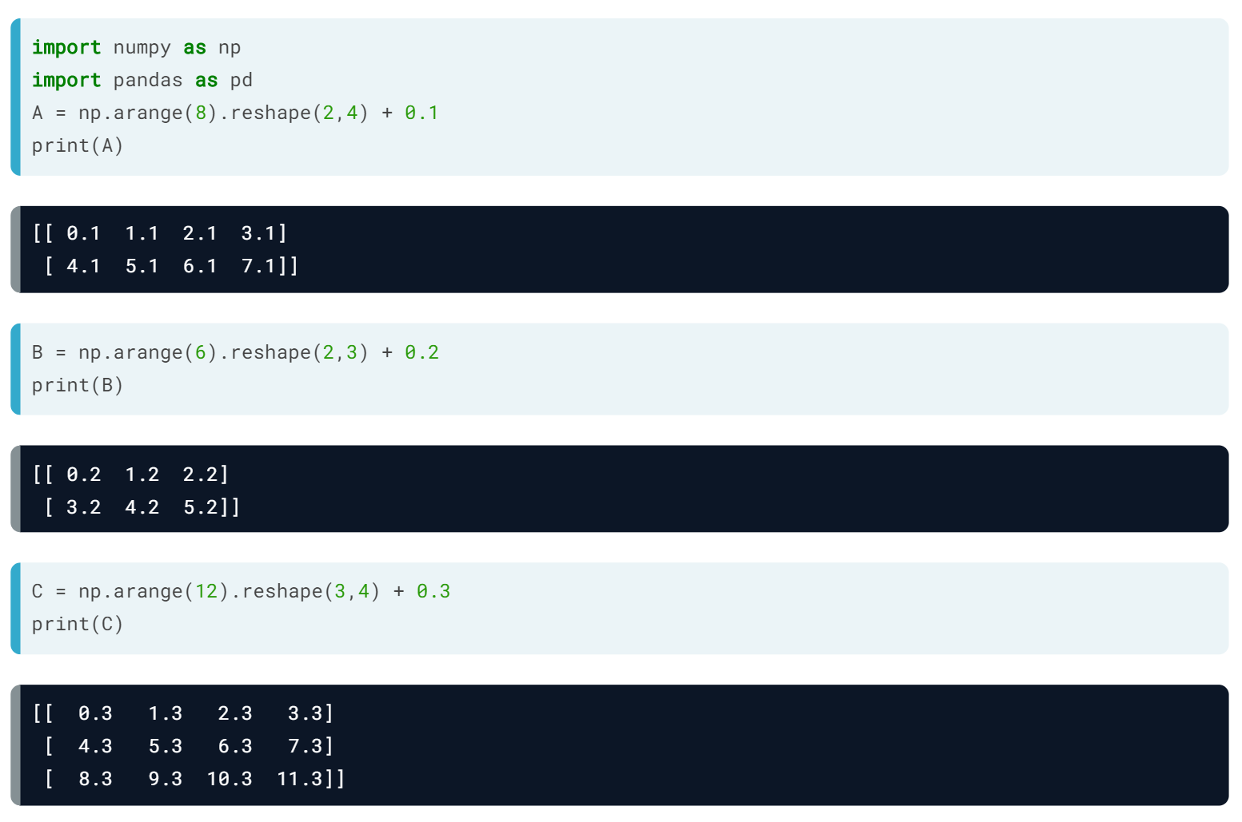  
Let's consider stacking two-dimensional arrays first. We will create three matrices by creating a range of consecutive integers using ***range()***, transforming a one-dimensional array into a rectangular shape with the ***reshape()*** method, and adding different constants to make them easy to distinguish.

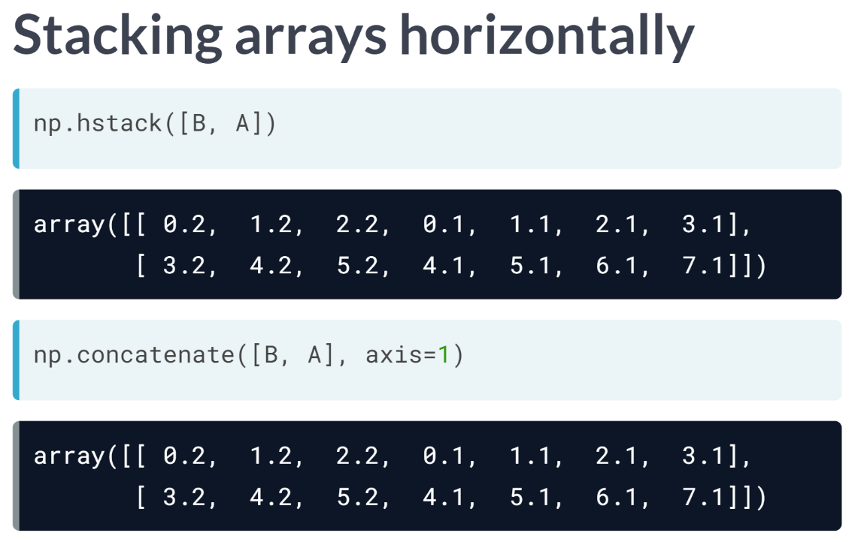  
We can stack 2 by 4 matrix A and 2 by 3 matrix B horizontally using ***np.hstack()***. The input is a list of NumPy arrays. Equivalently, we can use ***np.concatenate()*** with the same sequence and axis = 1 to append columns horizontally.

In both cases, both A and B must have the same number of rows, although the number of columns can differ.

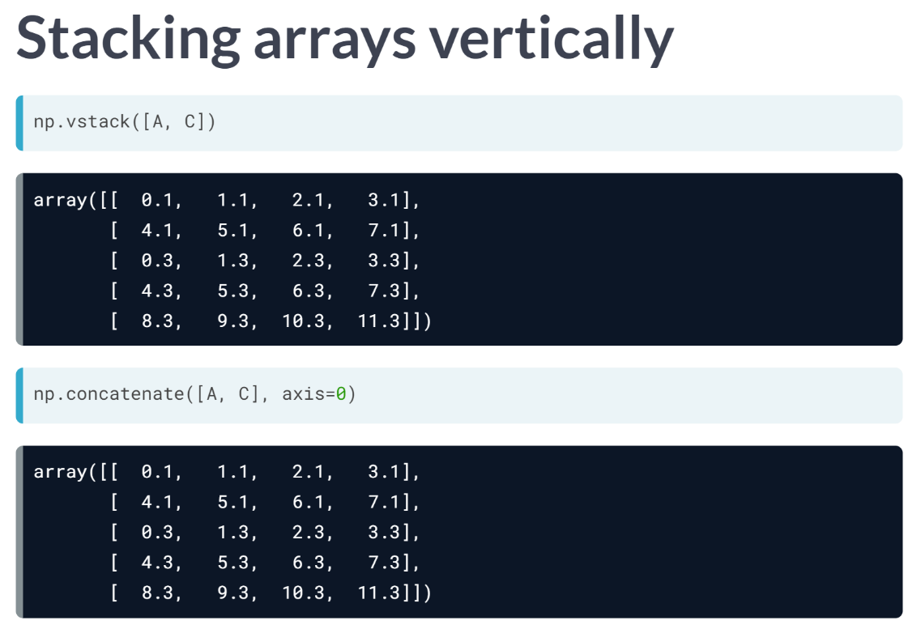  
We can also stack the 2 by 4 matrix A and the 3 by 4 matrix C vertically using ***np.vstack()*** or ***np.concatenate()*** with axis = 0.

Again, it's important here that both matrices have four columns. The argument axis=0 is default and optional.

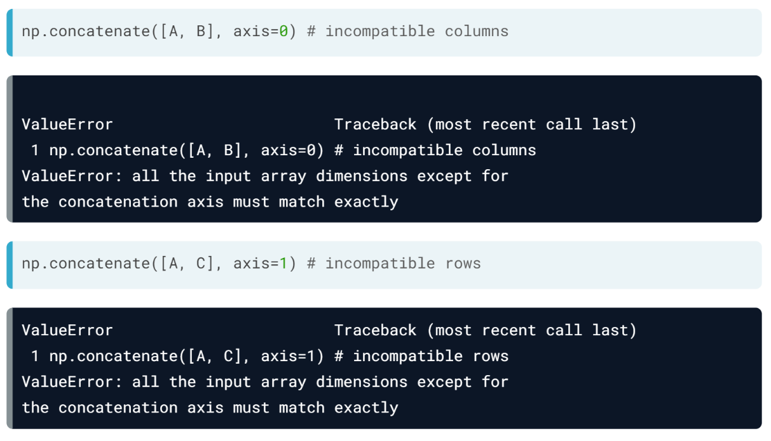  
A ValueError exception is raised when the arrays have different sizes along the concatenation axis. For instance, trying to stack arrays A and B horizontally or A and C vertically causes problems.

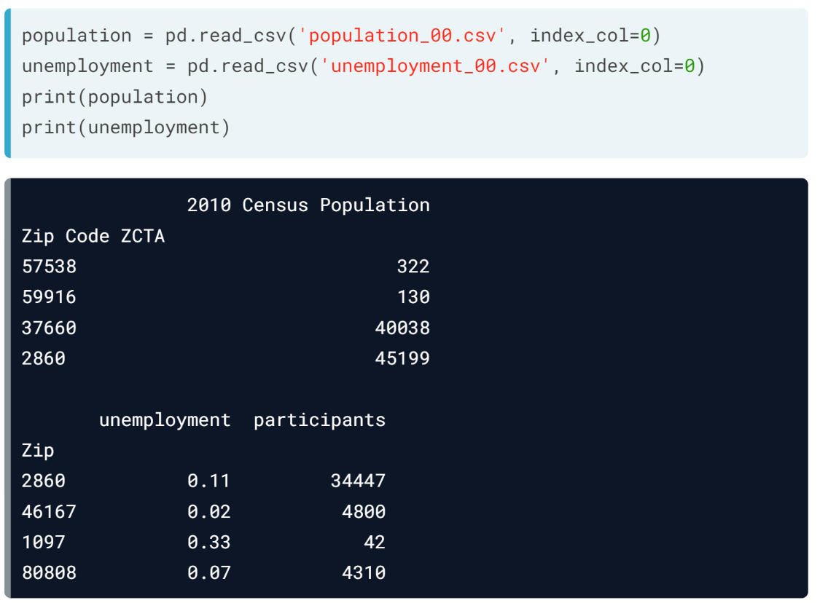  
Coming back to the dataset, population has four rows and one column, while unemployment has four rows with two columns. And the indices of these two DataFrames differ in all but one row with zip code 2860.

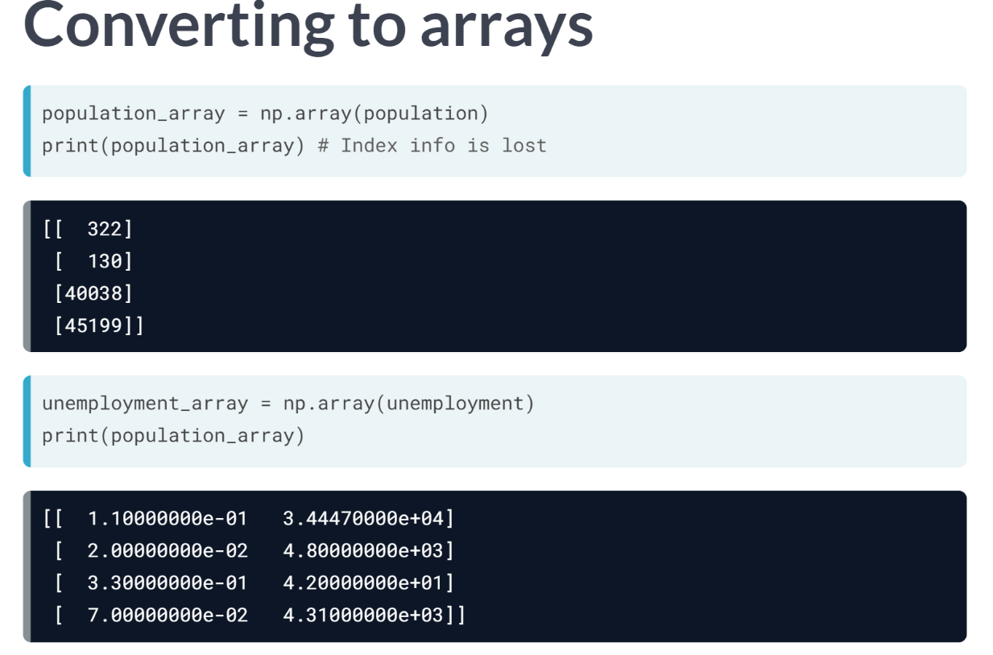  
Remember, pandas was developed after NumPy. Let's pretend we've received these DataFrames as NumPy arrays by converting them to arrays with the NumPy ***np.array()*** constructor.

When we do this, the index information is lost; there are simply two NumPy arrays of dimension 4 by 1 and 4 by 2.

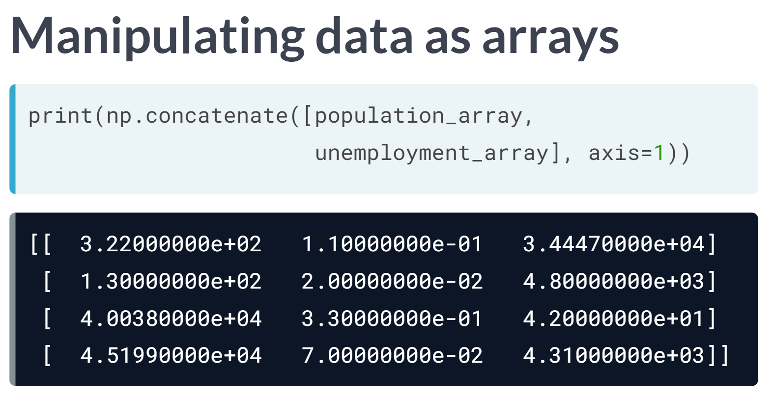  
We could apply ***np.concatenate()*** or ***np.hstack()*** to these two arrays to yield a new array of dimensions 4 by 3. But this result is meaningless; the rows are glued together independent of the original meanings. We would have to store zip codes in other lists or arrays to align rows properly. It turns out that appending labeled tables in this way corresponds to what is called a database join.

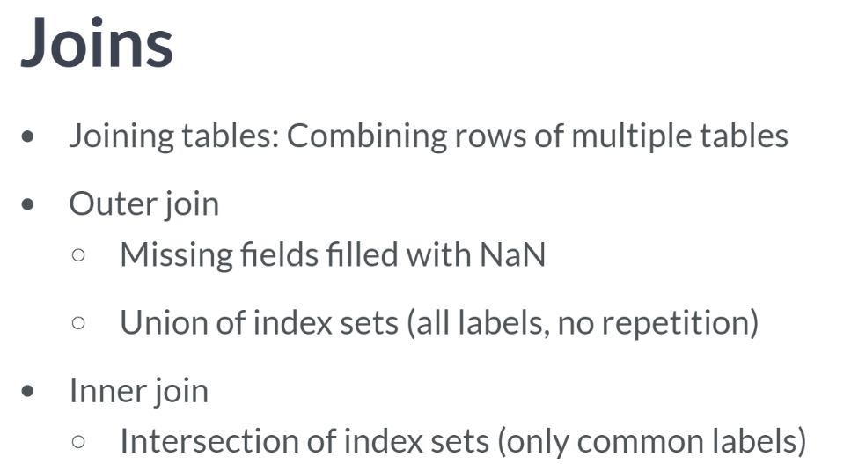  
Joining tables involves meaningfully gluing indexed rows together. We will look at more types of joins later, but let's focus now on outer and inner joins.

An outer join preserved the indices in the original tables filling null values for missing rows.

An outer joined table has all the indices of the original tables without repetition (like a set union). Conversely, an inner join has only index labels common to both tables (like a set intersection).

Let's make this concept clear with the population and unemployment DataFrames.

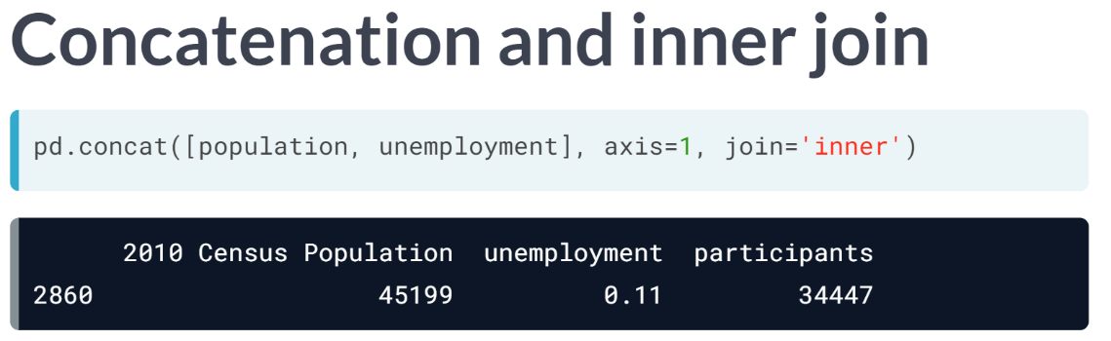  
We call ***concat()*** along axis=1 and explicitly specify join='inner' for an inner join, meaning only the row label present in both DataFrame Indexes (2860 in this case) is preserved in the joined DataFrame.

The column values in this single row are filled in from the corresponding columns of the population and unemployment DataFrames, respectively.

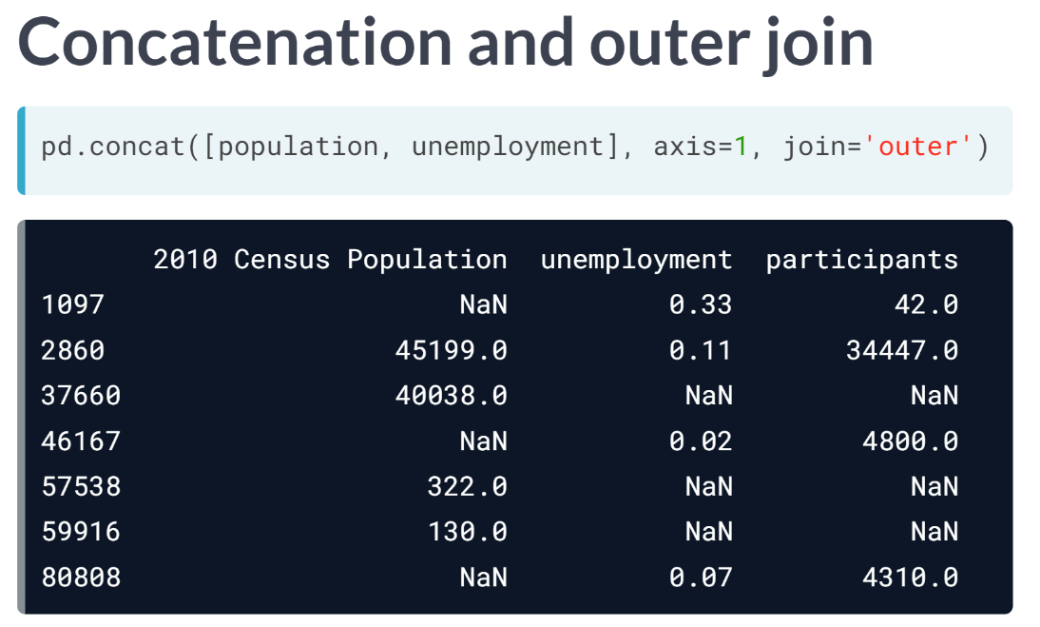  
When we specify join='outer' when concatenating along axis=1, we get an outer join.

This is the behavior of ***concat()*** that we originally observed because, if unspecified, the join parameter defaults to 'outer'.

All row indices from the original two indexes exist in the joined DataFrame Index. When a row occurs in one DataFrame, but not in the other, the missing column entries are filled with null values.

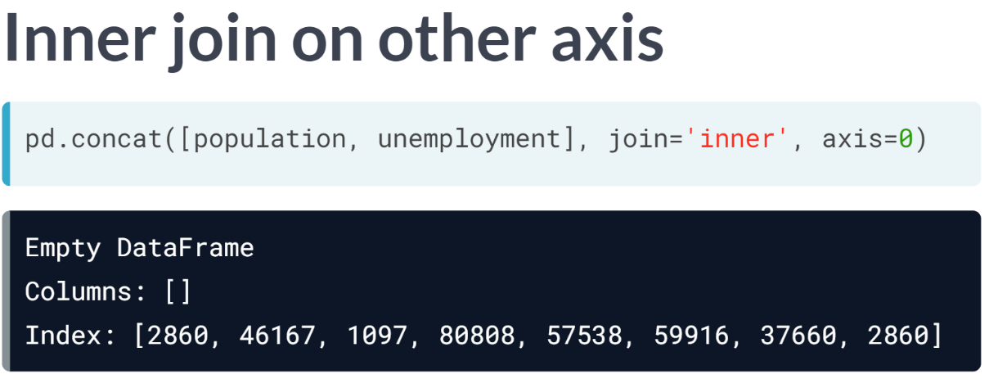  
Notice we could do an inner join along axis = 0 instead. The resulting DataFrame is empty because no column index label occurs in both population and unemployment

# Concatenating DataFrames with inner join

Here, you'll continue working with DataFrames compiled from [**The Guardian's Olympic medal dataset**](https://www.theguardian.com/sport/datablog/2012/jun/25/olympic-medal-winner-list-data).

The DataFrames bronze, silver, and gold have been pre-loaded for you. Your task is to compute an inner join.

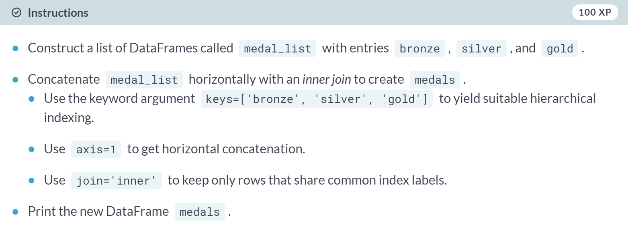

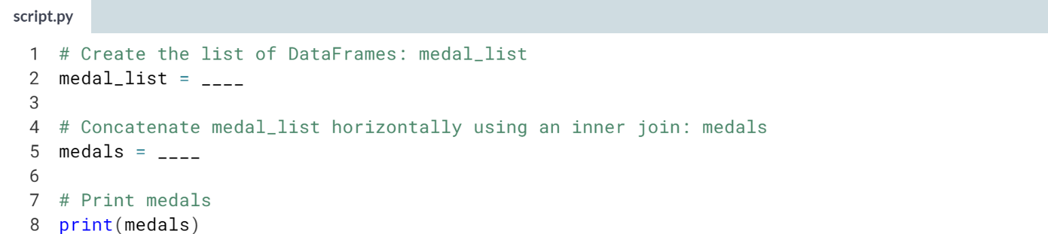

1. Assign **[bronze, silver, gold]** to *medal_list* to construct the list of DataFrames.
2. To compute the inner join, use ***pd.concat()*** with the following arguments:
   1. The list of DataFrames *medal_list*.
   2. keys=['bronze', 'silver', 'gold'].
   3. axis=1.
   4. join='inner'.

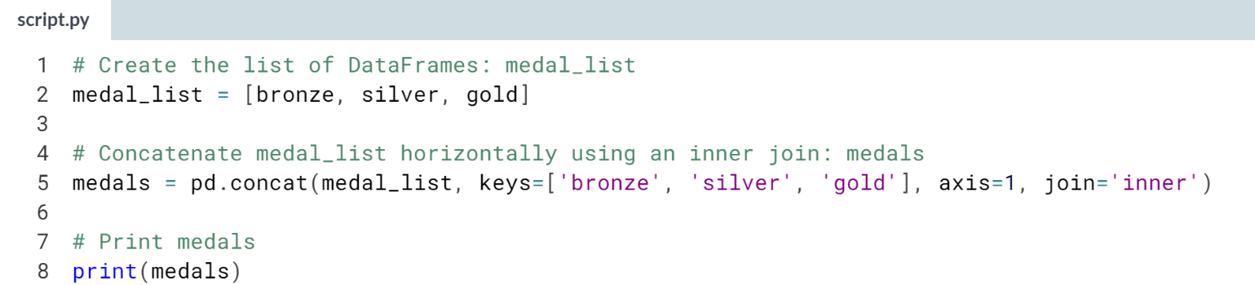

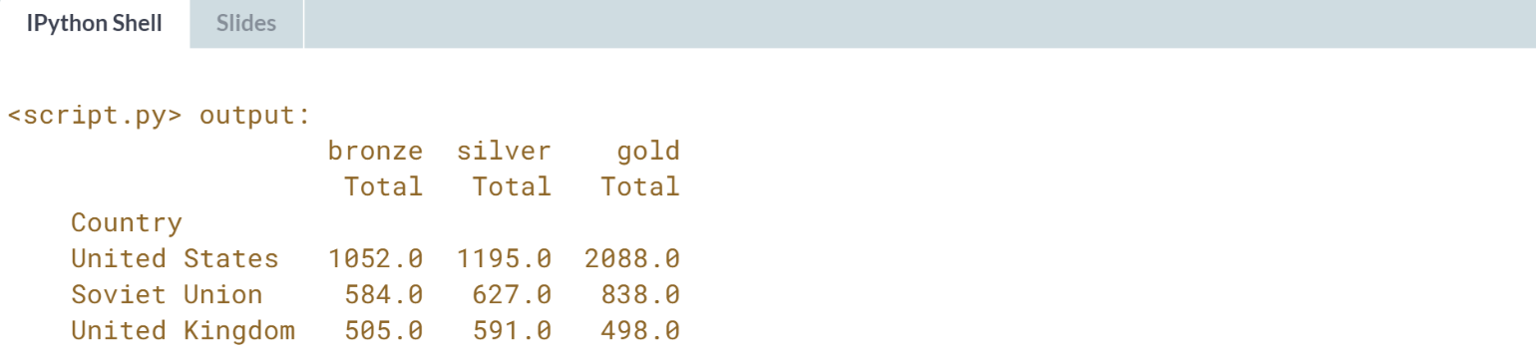

Well done! France, Italy, and Germany got dropped as part of the join since they are not present in each of bronze, silver, and gold.

Therefore, the final DataFrame has only the United States, Soviet Union, and United Kingdom.

# Resampling & concatenating DataFrames with inner join

In this exercise, you'll compare the historical 10-year GDP (Gross Domestic Product) growth in the US and in China. The data for the US starts in 1947 and is recorded quarterly; by contrast, the data for China starts in 1961 and is recorded annually.

You'll need to use a combination of resampling and an inner join to align the index labels. You'll need an appropriate [**offset alias**](http://pandas.pydata.org/pandas-docs/stable/timeseries.html#offset-aliases) for resampling, and the method .resample() must be chained with some kind of aggregation method (.pct_change() and .last() in this case).

pandas has been imported as pd, and the DataFrames china and us have been pre-loaded, with the output of china.head() and us.head() printed in the IPython Shell.

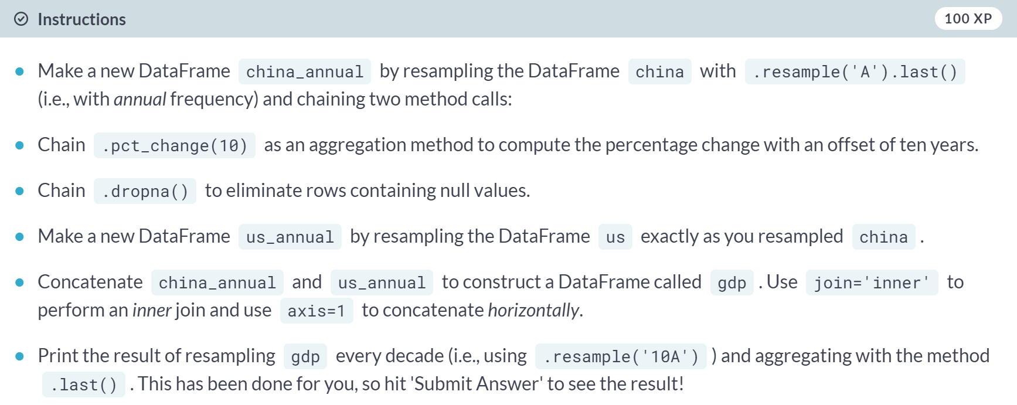

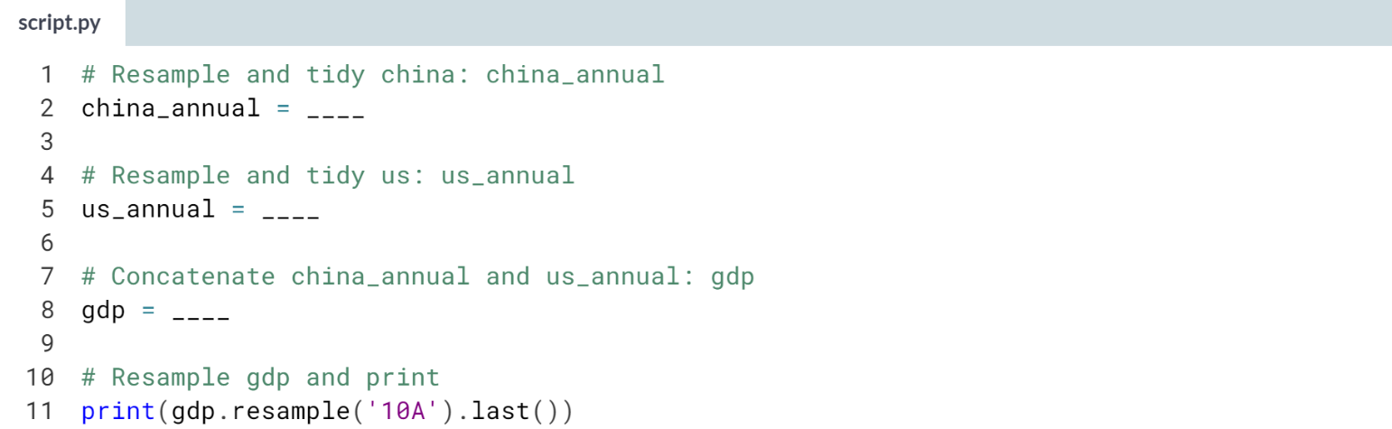

1. Use the method chain ***.resample('A').last().pct_change(10).dropna()*** on china to perform the resampling.
2. Follow exactly the same procedure as above to resample us.
3. Use ***pd.concat()*** with the list **[china_annual, us_annual]** as an argument, along with the keyword arguments **axis=1** and **join='inner'**.

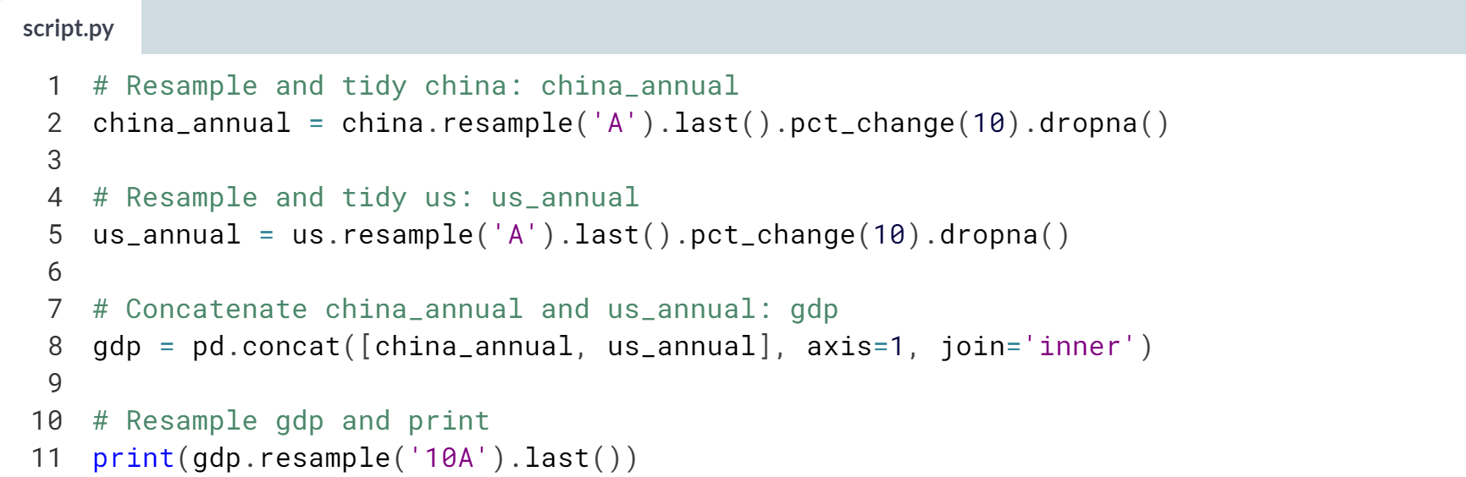

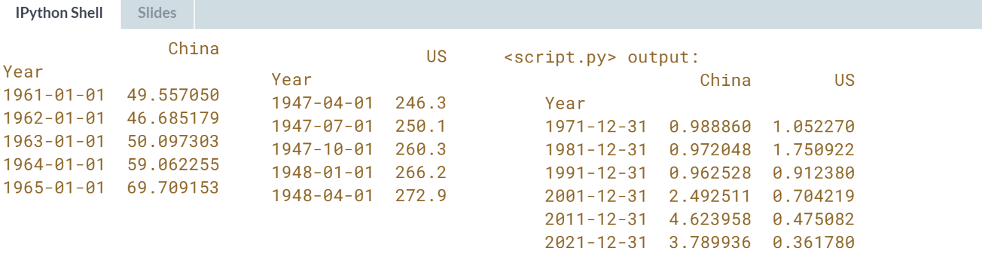

Great work! It looks like the 10 year GDP growth of China has been higher than the US since the 1990s.

**3. Merging data**

You'll learn all about merging pandas DataFrames. You'll explore different techniques for merging, and learn about left joins, right joins, inner joins, and outer joins, as well as when to use which. You'll also learn about ordered merging, which is useful when you want to merge DataFrames with columns that have natural orderings, like date-time columns.



We can stack DataFrames vertically using append(), and we can stack DataFrames vertically or horizontally using ***concat()***. This ***concat()*** method is also able to align DataFrames cleverly with respect to their indexes.

However, very often, we need to combine DataFrames either along multiple columns OR along columns other than the Index. This is the world of merging Pandas DataFrames. To be clear, the ***merge()*** function extends ***concat()*** with the ability to align rows using multiple columns.

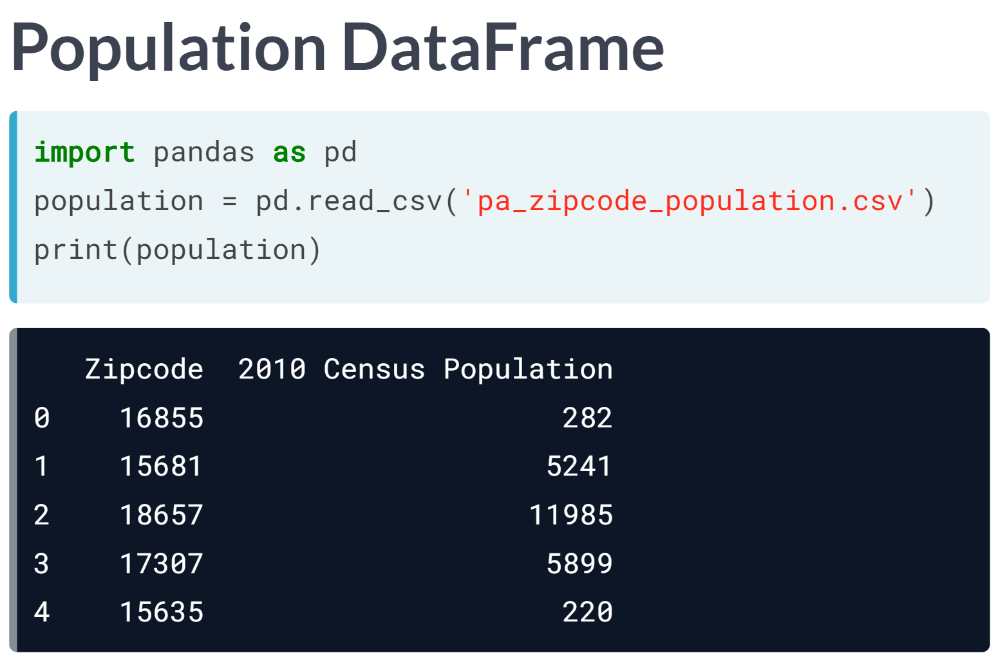  
To demonstrate, let's load a small DataFrame population with five rows and two columns (Zip code and 2010 Census Population).

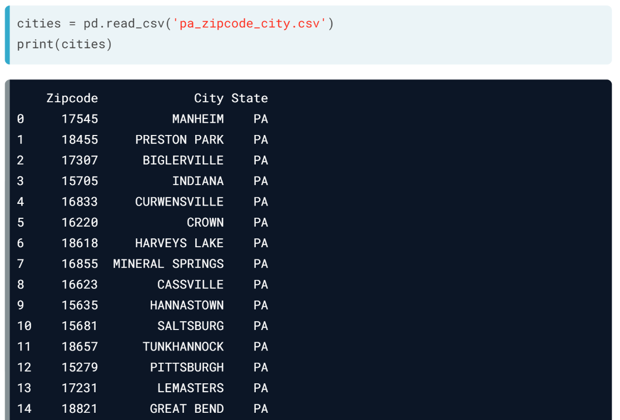  
The longer DataFrame cities has 15 rows and 3 columns: *Zipcode*, *City*, and *State*. The State column is uniformly the string *'PA'* for Pennsylvania, and, again, the default index is an integer range.

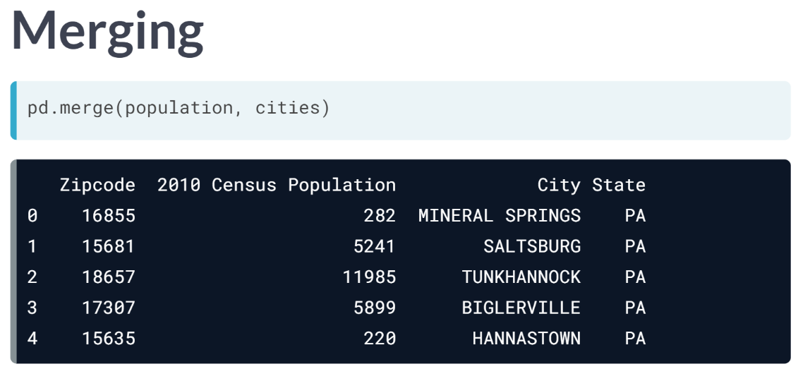  
What we want to do is merge these two DataFrames into one linking city names and populations to a given zip code. That is, we want to combine the DataFrames and do so aligning the *Zipcode* column. We do this with ***pd.merge(population, cities)***.

This computes a merge on ALL columns that occur in both DataFrames. In this case, this is only the *Zipcode* column. What this means is that, for any row in which the *Zipcode* entry in cities matches a row in population, a new row is made in the merged DataFrame. That new row contains the row from population with the other columns from the corresponding row in cities appended.  
  
Thus, the merged DataFrame looks like population with the other columns from cities on the right. This is, by default, an inner join, as we saw previously.

It is an inner join because it glues together only rows that match in the joining column of BOTH DataFrames.

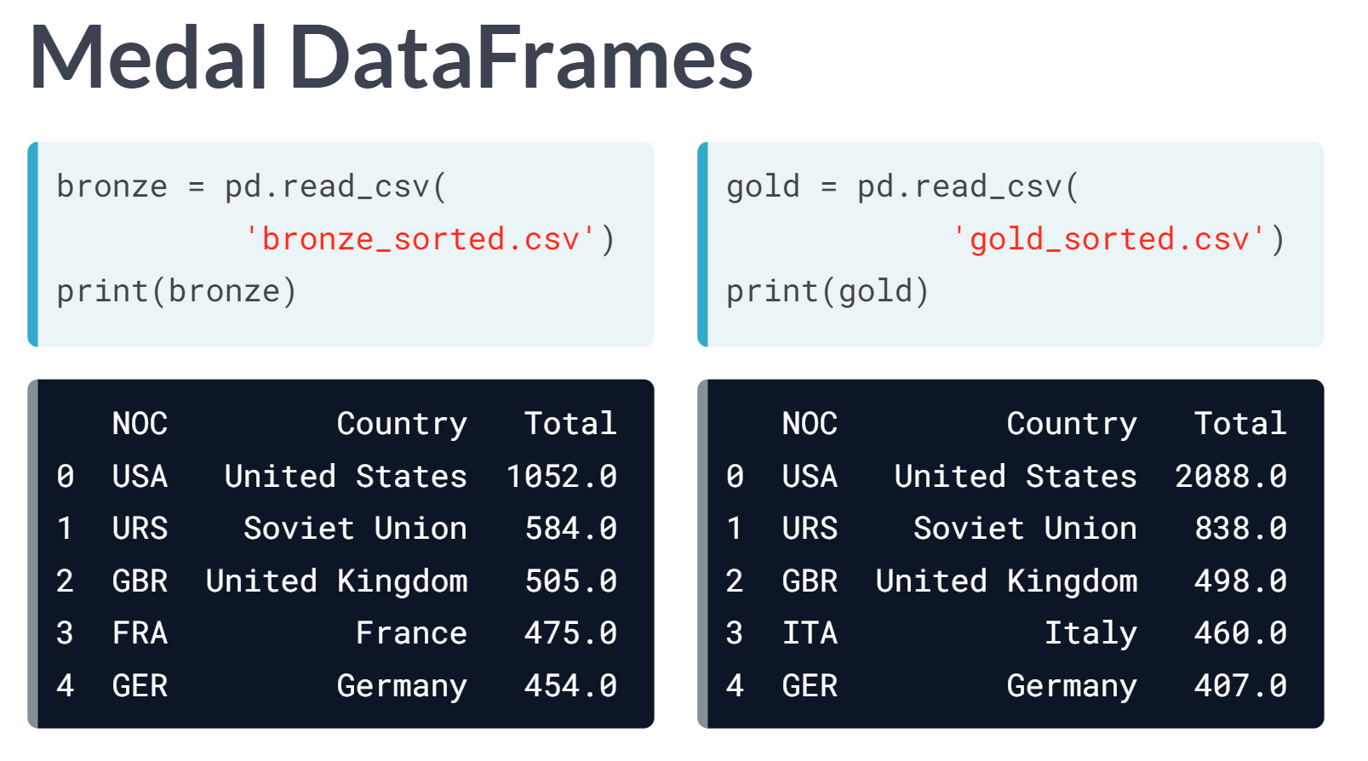  
Let's try again using the top 5 Bronze and Gold medal-winning countries from the Summer Olympics. Both DataFrames have three columns: the country code *‘NOC’,* the *‘Country name’*, and the *‘Total’* number of medals won.

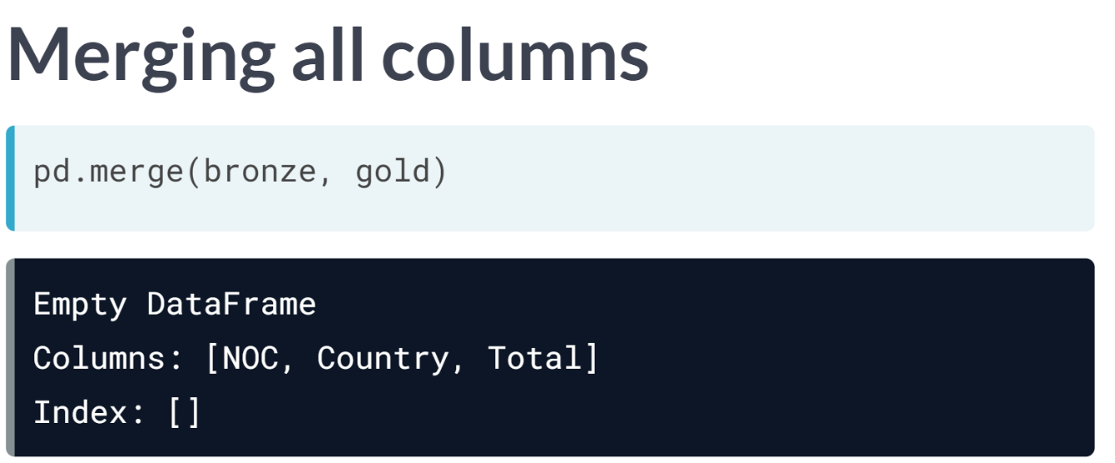  
By default, ***pd.merge()*** uses all columns common to both DataFrames to merge. That is, the rows of the merged DataFrame consist of all rows where the NOC, Country, and Totals columns are identical in both DataFrames bronze and gold. Thus, this merge yields an empty DataFrame because the Totals columns never match.

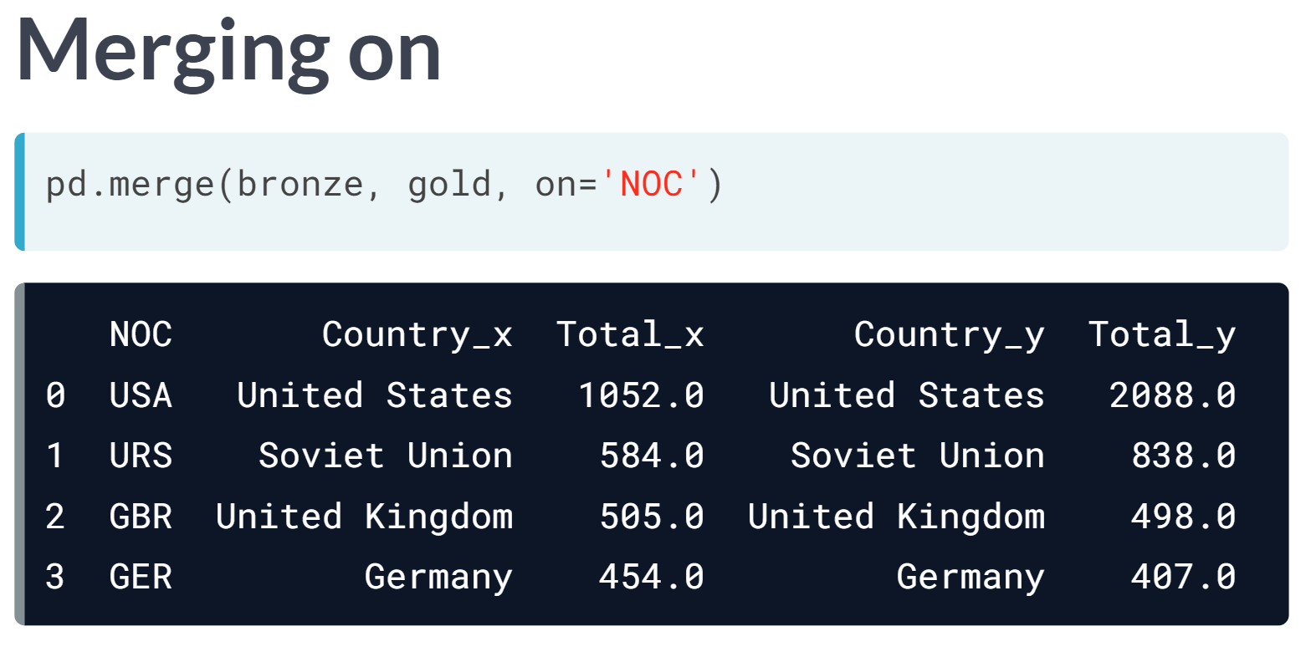  
Instead, we can choose a particular column to merge on: *NOC* in this case, meaning matches are sought only in the NOC column. Remaining columns are appended to the right.

The column labels are modified with the suffixes _x and _y to indicate their origin. Observe the columns *Country_x* and *Country_y* is identical.

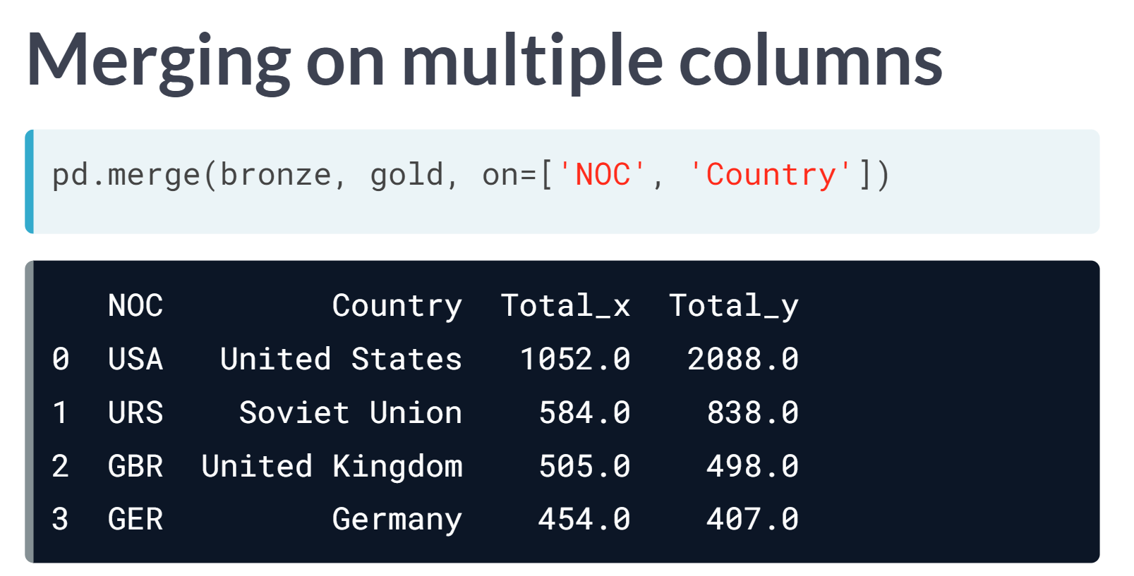  
To eliminate the redundant Country column, use **on=['NOC', 'Country']** to merge on both those columns. This is where merging extends concatenation in allowing matching on multiple columns.

The result has only one column for Country. The Total columns still have suffixes to indicate their origin.

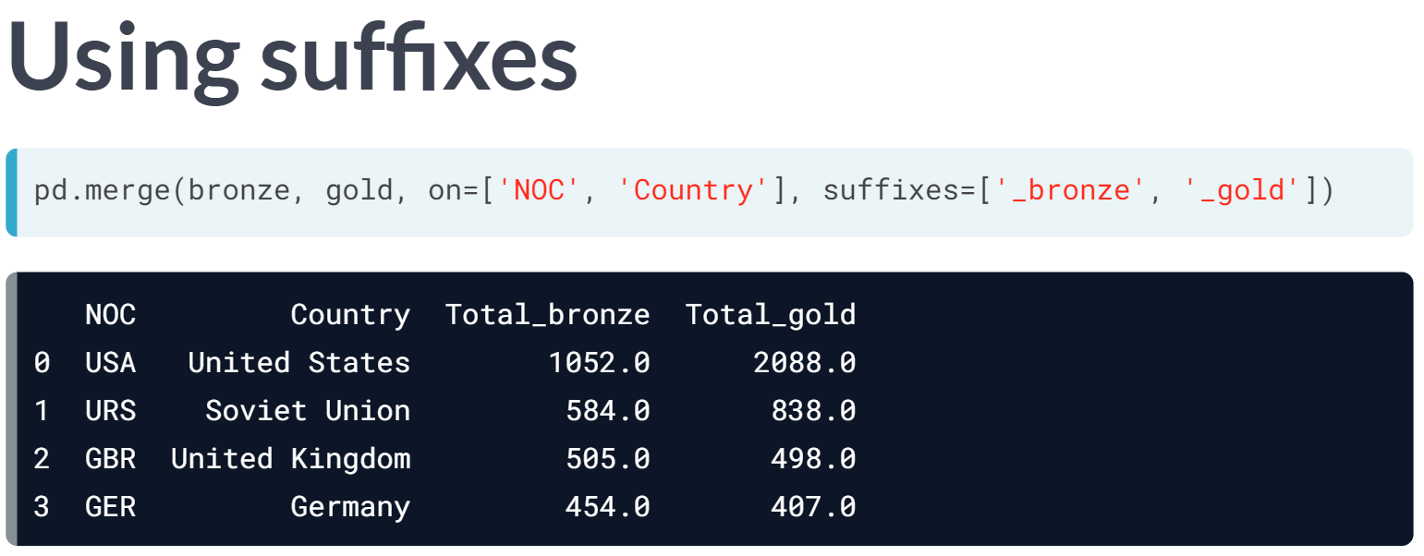  
We can tailor column labels with the argument suffixes, which replaces them with whatever custom names we choose. Thus, we now have a much tidier table without redundant columns and with the total labeled appropriately.

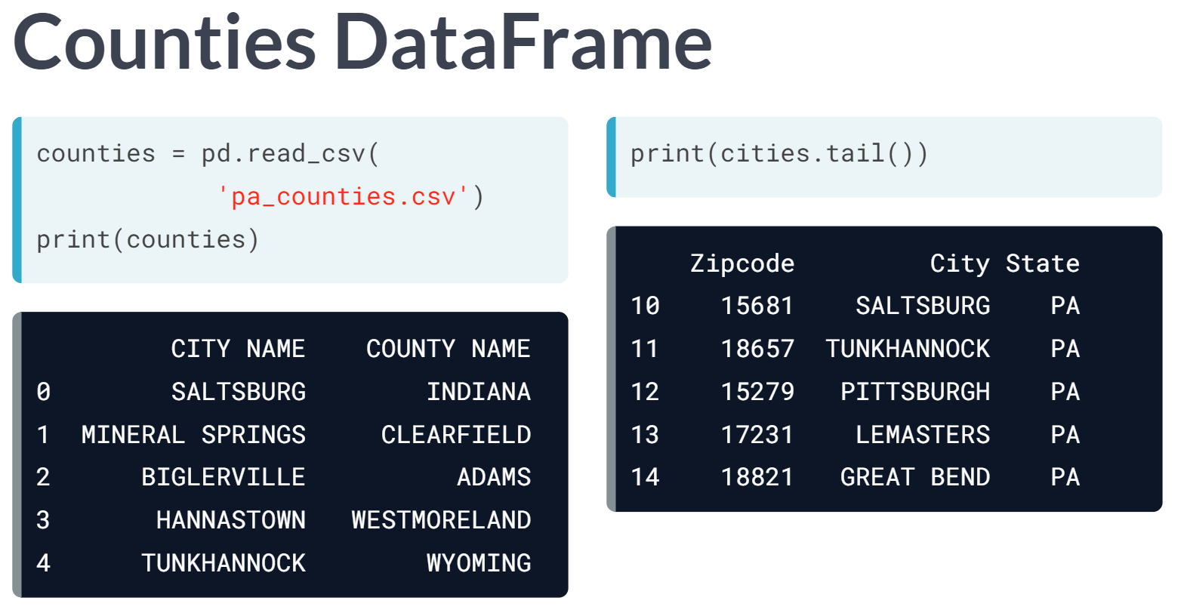  
Merging works well when the column labels match. Let's figure out what we should do when they don't. Even though column names differ, CITY NAME from counties table matches with CITY from cities table.

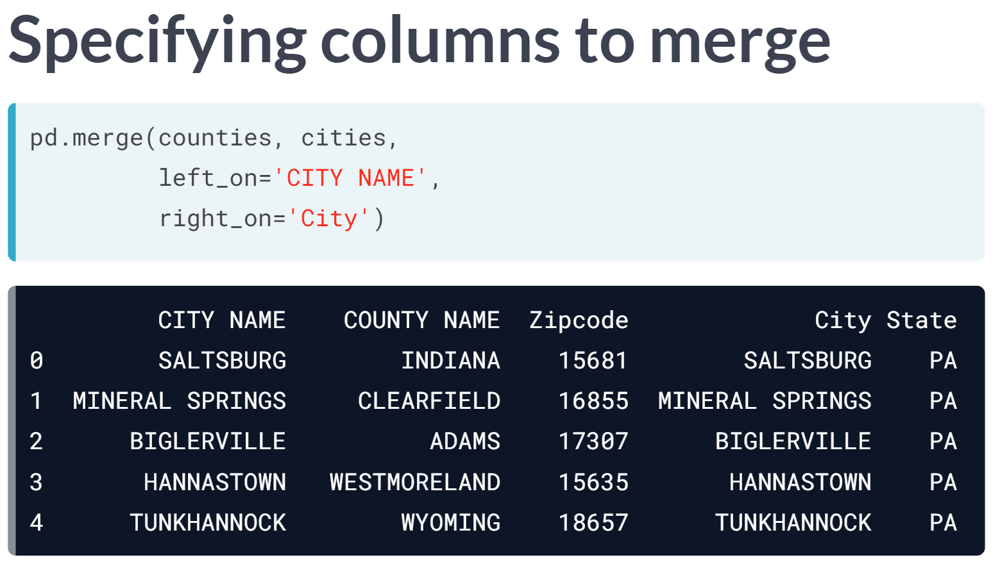  
As the labels differ, we have to declare which columns to merge on. Specifically, we look for matches in CITY NAME from the left DataFrame counties and City from the right DataFrame cities. Notice both columns are retained in the merged DataFrame.

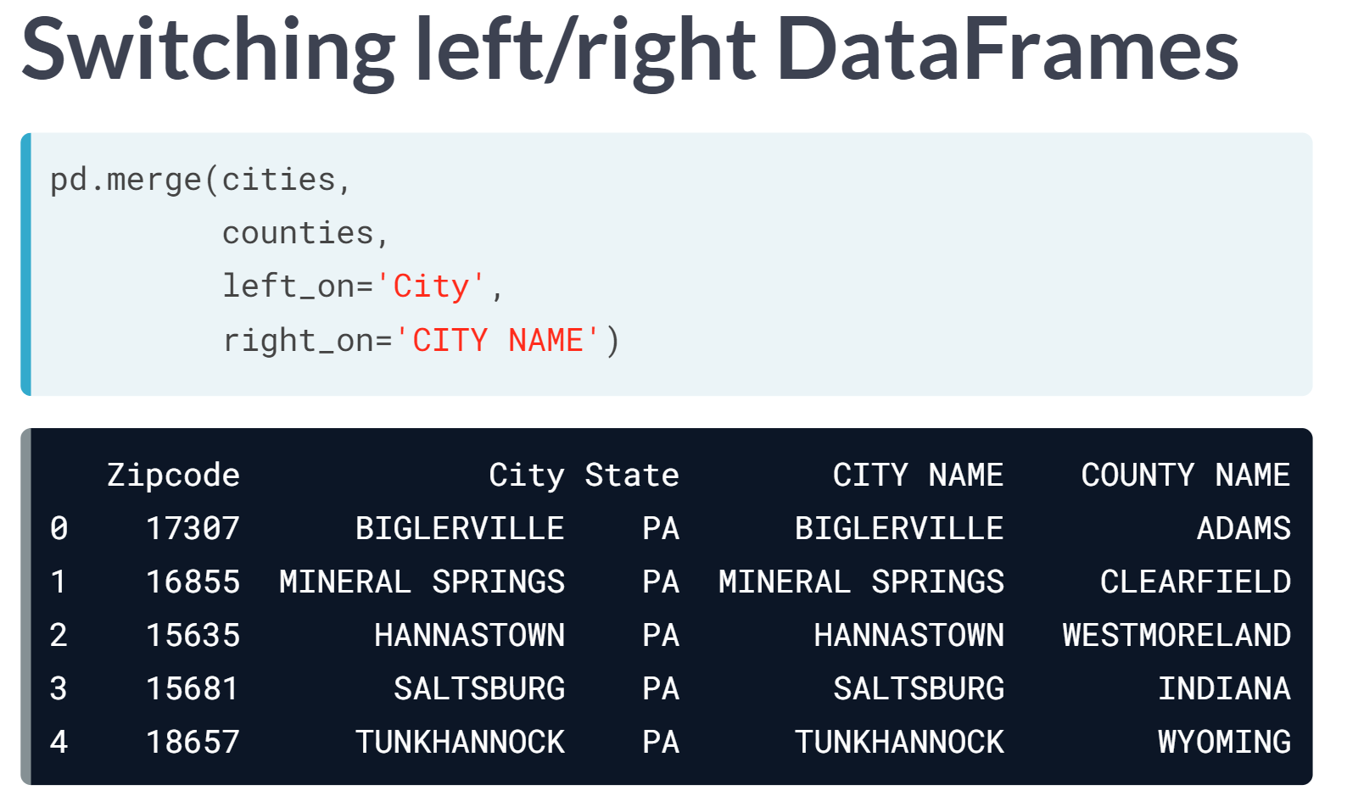  
Switching the order of the left and right DataFrames in the call to ***pd.merge()*** yields a permuted DataFrame; that is, the order of the rows and columns is different, but the content is the same.

# Merging company DataFrames

Suppose your company has operations in several different cities under several different managers. The DataFrames revenue and managers contain partial information related to the company. That is, the rows of the city columns don't quite match in revenue and managers (the Mendocino branch has no revenue yet since it just opened, and the manager of Springfield branch recently left the company).

The DataFrames have been printed in the IPython Shell. If you were to run the command combined = pd.merge(revenue, managers, on='city'), how many rows would combined have?

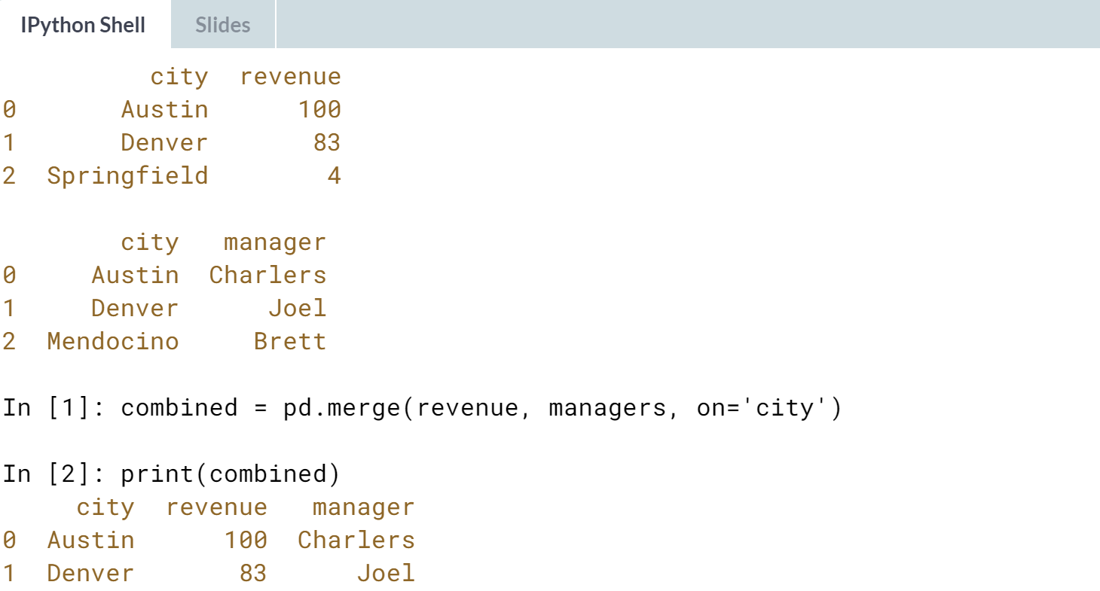



Correct! Since the default strategy for ***pd.merge()*** is an inner join, combined will have 2 rows.

# Merging on a specific column

This exercise follows on the last one with the DataFrames revenue and managers for your company. You expect your company to grow and, eventually, to operate in cities with the same name on different states.

As such, you decide that every branch should have a numerical branch identifier. Thus, you add a branch_id column to both DataFrames.

Moreover, new cities have been added to both the revenue and managers DataFrames as well. pandas has been imported as pd and both DataFrames are available in your namespace.

At present, there should be a 1-to-1 relationship between the city and branch_id fields. In that case, the result of a merge on the city columns ought to give you the same output as a merge on the branch_id columns. Do they? Can you spot an ambiguity in one of the DataFrames?

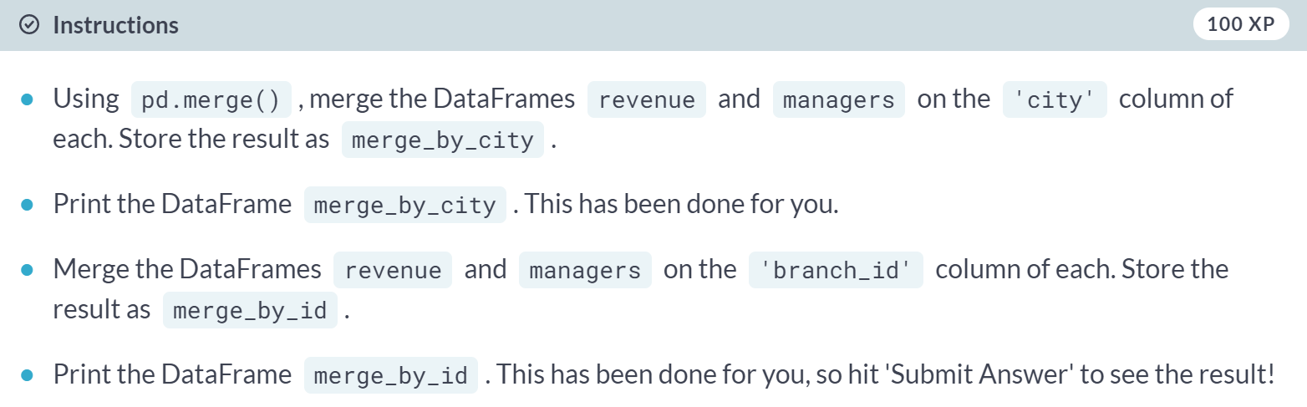

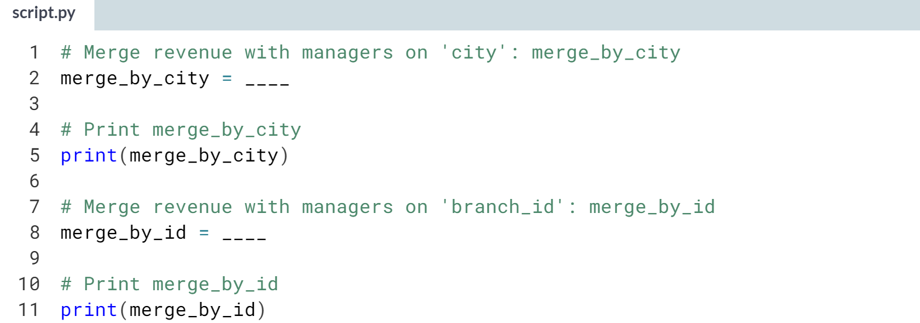

* Use ***pd.merge()*** with the two DataFrames you are merging as arguments and specify the additional parameter on to be the name of the column on which you want to merge - either *'city'* or *'branch_id'*.

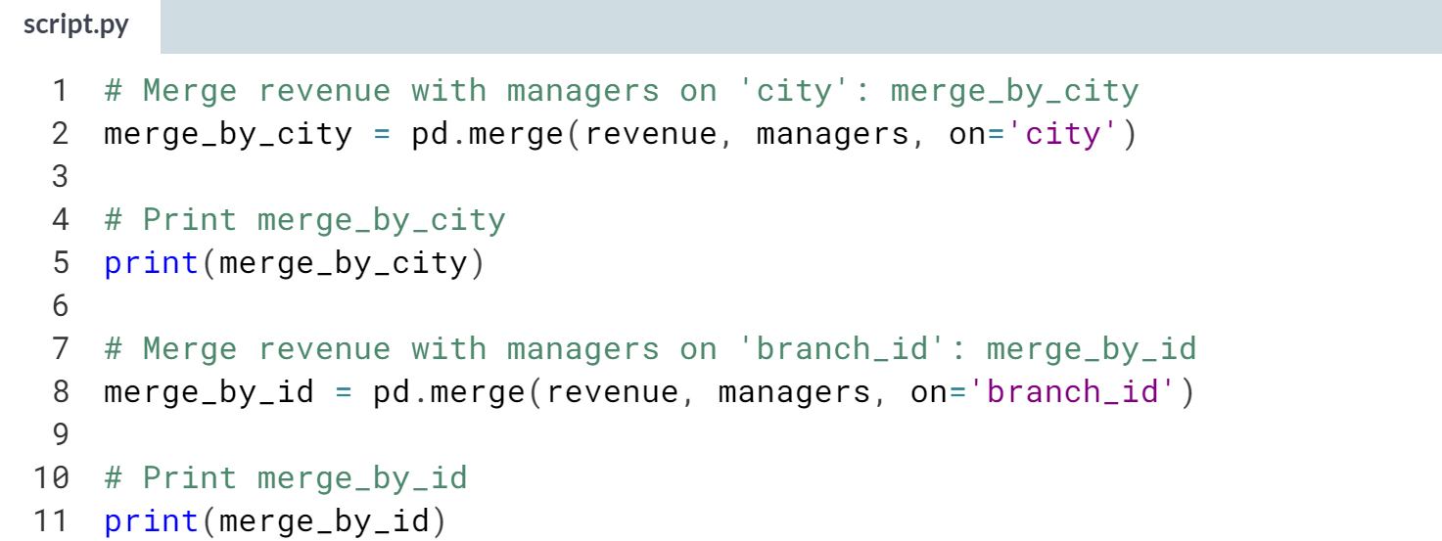

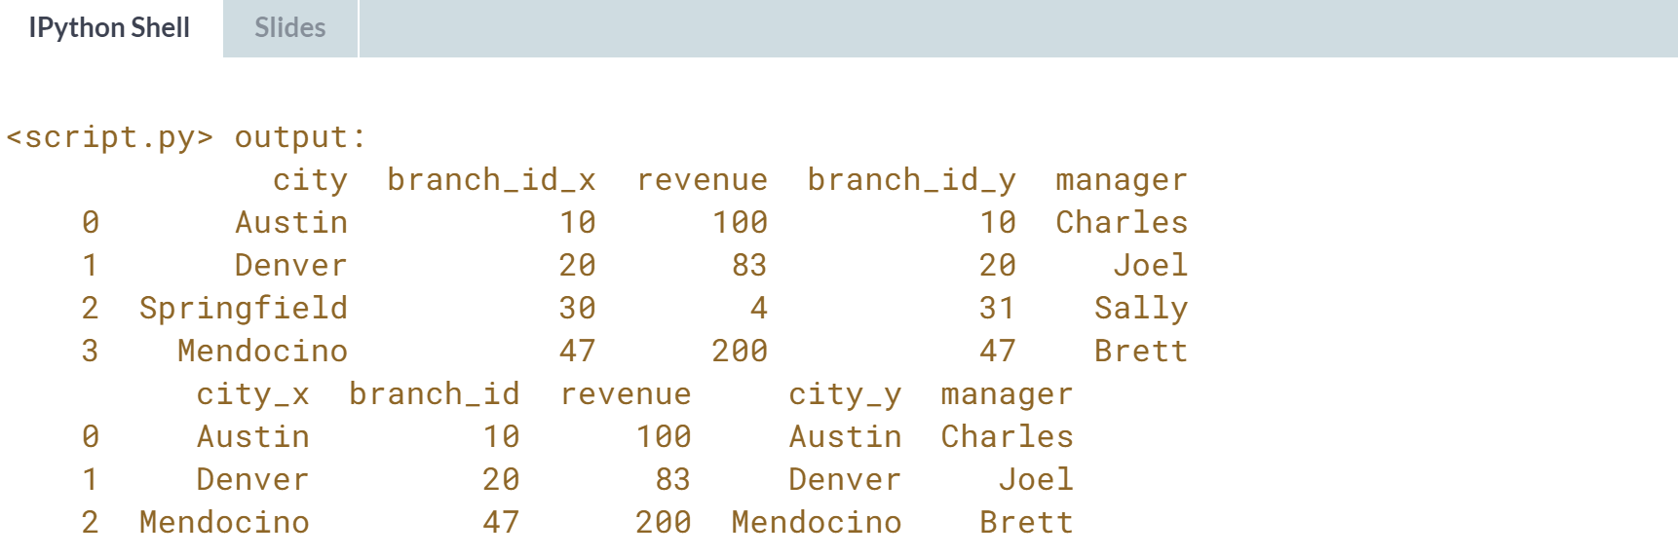

Well done! Notice that when you merge on *'city'*, the resulting DataFrame has a peculiar result: In row 2, the city Springfield has two different branch IDs. This is because there are actually two different cities named Springfield - one in the State of Illinois, and the other in Missouri.

The revenue DataFrame has the one from Illinois, and the managers DataFrame has the one from Missouri.

Consequently, when you merge on *'branch_id'*, both of these get dropped from the merged DataFrame.

# Merging on columns with non-matching labels

You continue working with the revenue & managers DataFrames from before. This time, someone has changed the field name 'city' to 'branch' in the managers table. Now, when you attempt to merge DataFrames, an exception is thrown:

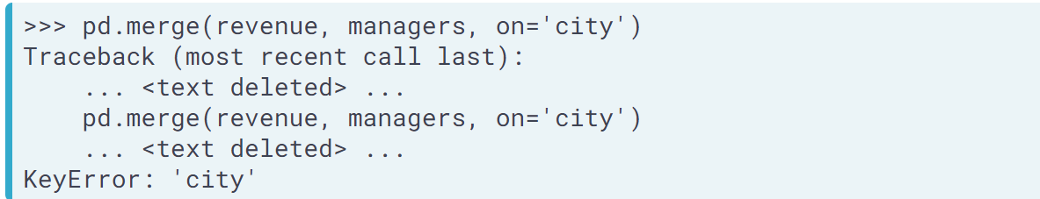

Given this, it will take a bit more work for you to join or merge on the city/branch name. You have to specify the left_on and right_on parameters in the call to pd.merge().

As before, pandas has been pre-imported as pd and the revenue and managers DataFrames are in your namespace. They have been printed in the IPython Shell so you can examine the columns prior to merging.

Are you able to merge better than in the last exercise? How should the rows with Springfield be handled?

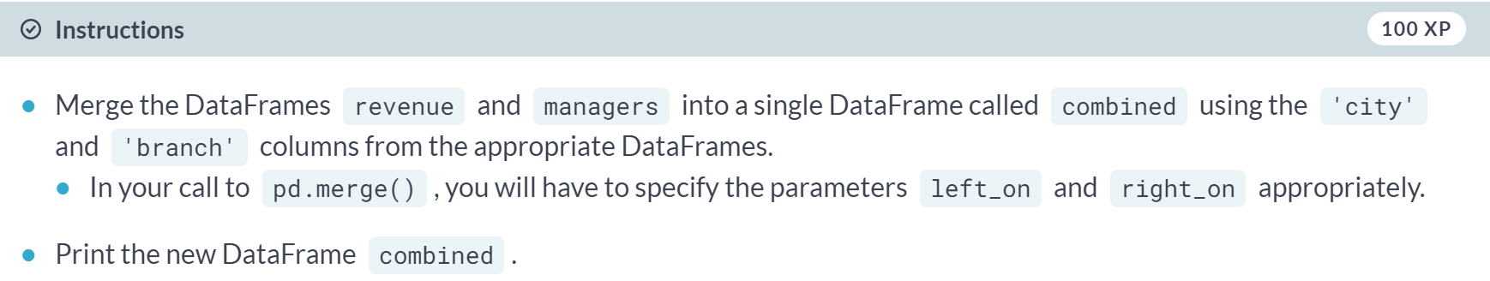

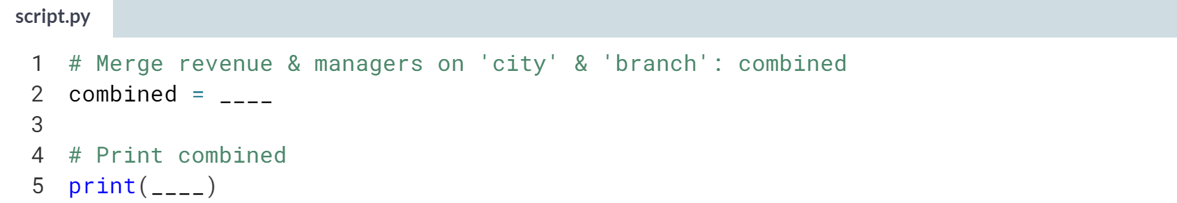

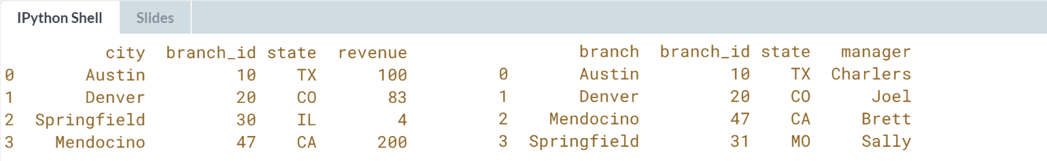

1. The revenue DataFrame has the column *'city'* and the managers DataFrame has the column *'branch'*.
2. Use this information to specify arguments for the **left_on** and **right_on** parameters in your call to ***pd.merge()***.

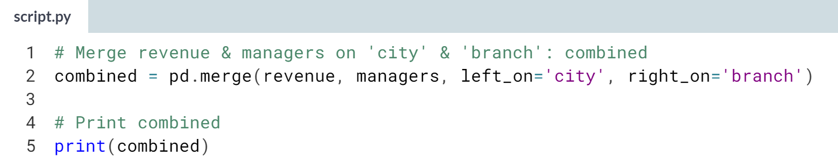

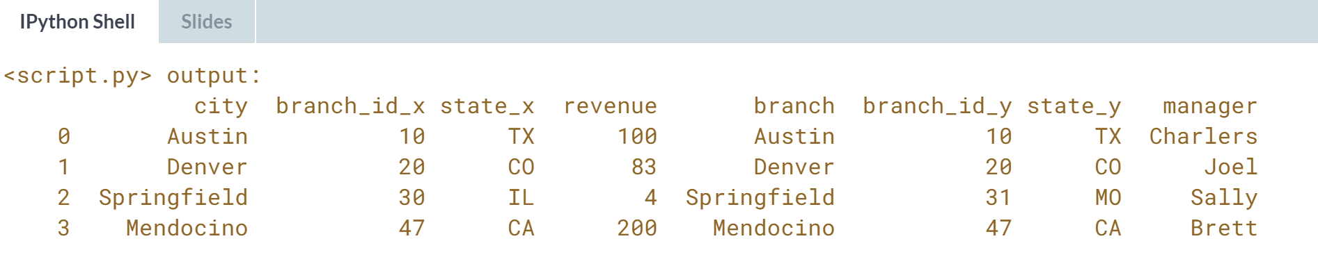

Great work! It is important to pay attention to how columns are named in different DataFrames.

# Merging on multiple columns

Another strategy to disambiguate cities with identical names is to add information on the states in which the cities are located. To this end, you add a column called state to both DataFrames from the preceding exercises.

Again, pandas has been pre-imported as pd and the revenue and managers DataFrames are in your namespace.

Your goal in this exercise is to use pd.merge() to merge DataFrames using multiple columns (using 'branch_id', 'city', and 'state' in this case).

Are you able to match all your company's branches correctly?

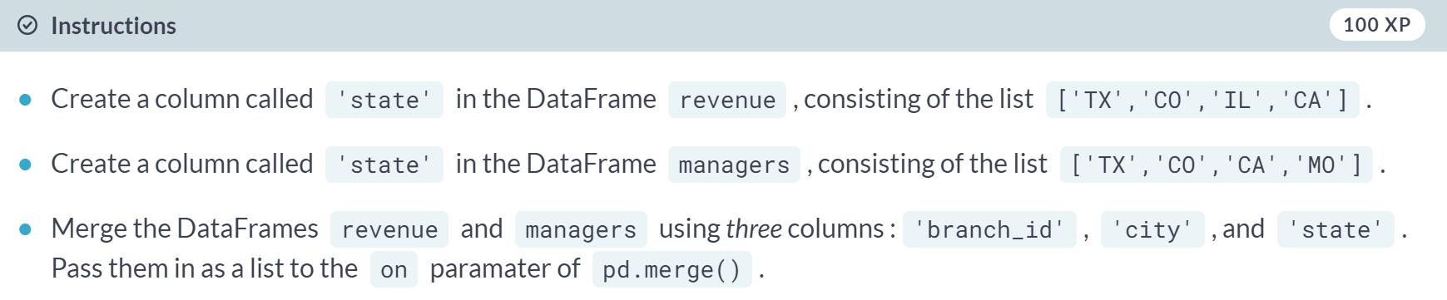

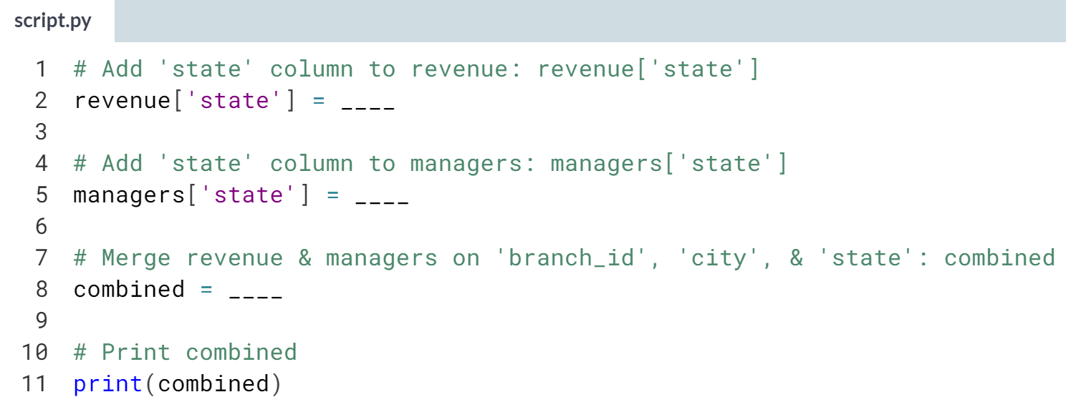

Hint

1. Assign the list **['TX','CO','IL','CA']** to *revenue['state']*.
2. Assign the list **['TX','CO','CA','MO']** to *managers['state']*.
3. Use ***pd.merge()*** with revenue and managers as arguments and specify the additional keyword argument **on=['branch_id', 'city', 'state']**.

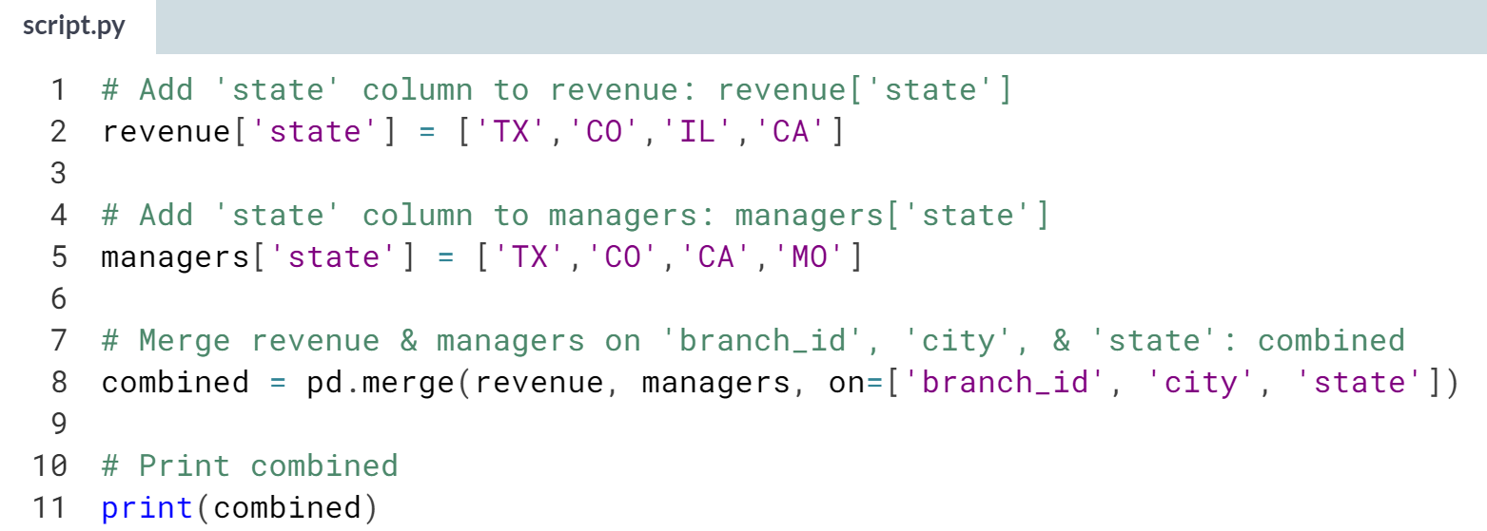

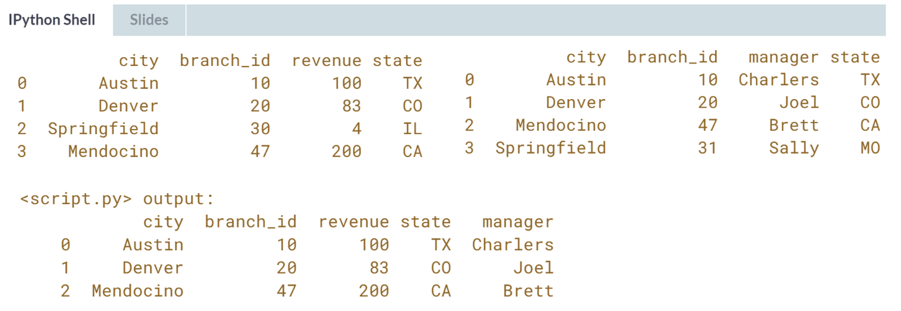

Excellent work! You've matched all the branches correctly!



Pandas has to search through DataFrame rows for matches when computing joins and merges, so it is useful to have different kinds of joins to mitigate costs.

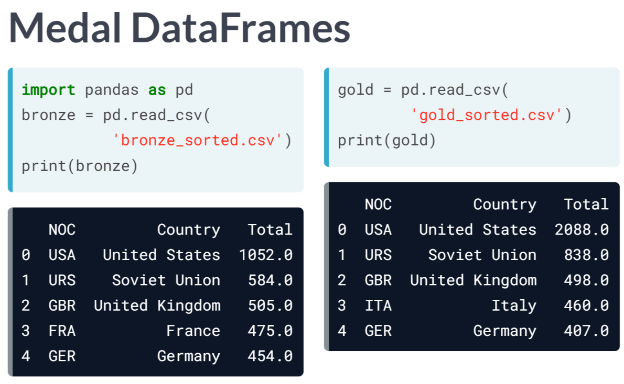

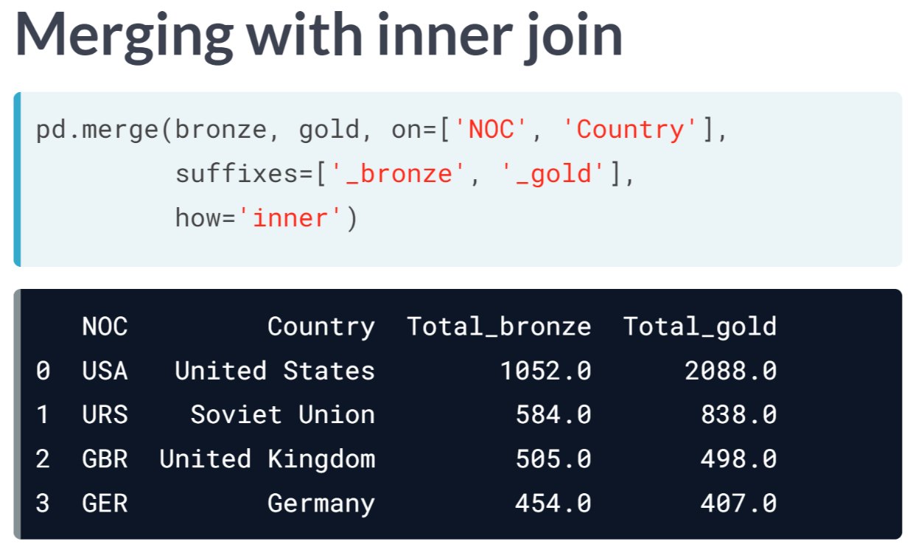  
The function ***merge()*** does an inner join by default. We can specify the keyword argument how='inner', but this is, in fact, the default behavior for ***merge()***.

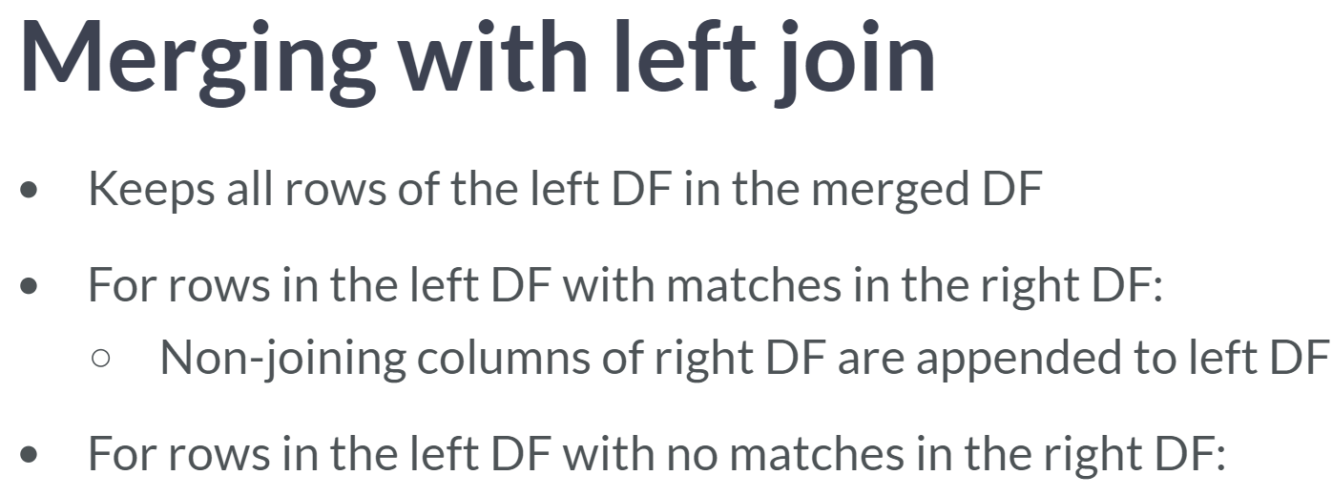  
Alternatively, using how='left' keeps all rows of the left DataFrame in the merged DataFrame.

For rows in the left DataFrame with matches in the joining columns of the right DataFrame, the non-joining columns of the right DataFrames are appended to the left DataFrame.

For rows in the left DataFrame with no matches in the joining columns of the right DataFrame, the non-joining columns are filled with null values.

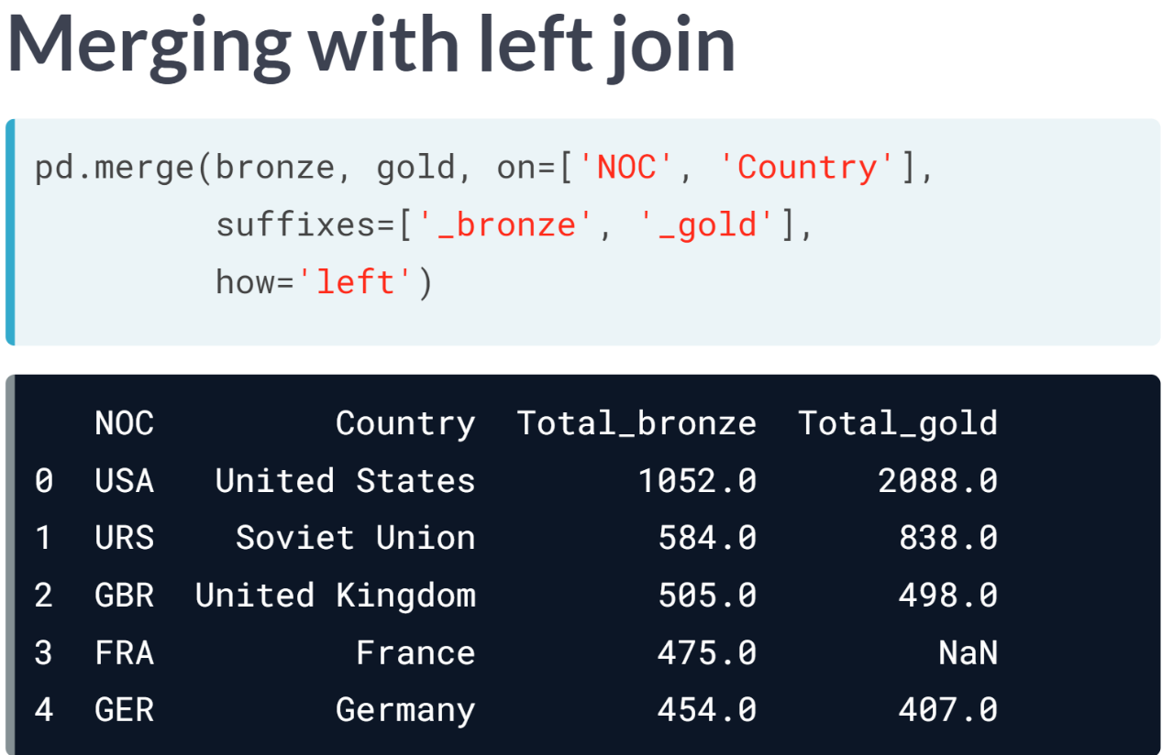  
As an example, when doing a left join with bronze on the left and gold on the right, the row for 'France' is retained, and a null value is inserted into the *Total_gold* column (because gold has no France row).

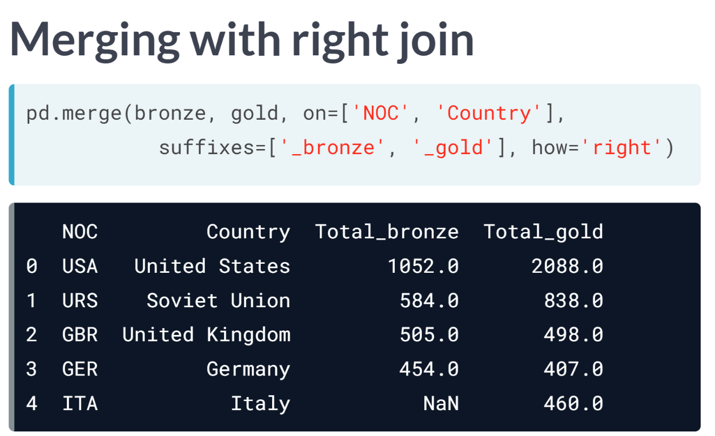  
Conversely, using how = 'right' does a right join doing the same thing with the roles of left and right interchanged. Thus, we retain all five rows from the gold DataFrame; this time, 'Italy' has a NaN entry in the *Total_bronze* column (because bronze has no Italy row).

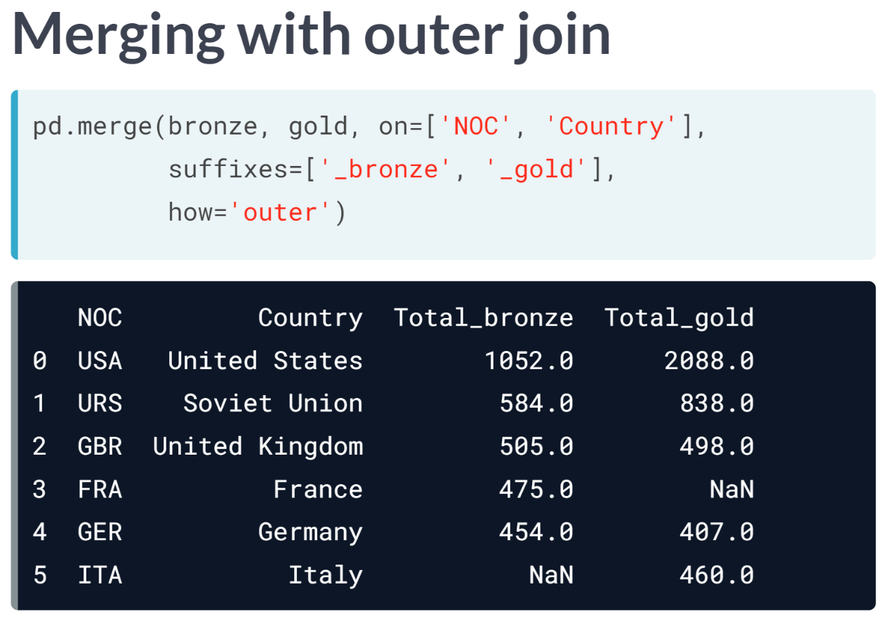  
Finally, the union of all rows from the left and right DataFrames can be preserved with an outer join. With the argument how='outer', we can clearly see that 'France' was not in the top 5 gold-medal-winning countries, and 'Italy' was not in the top 5 bronze-medal winning countries.

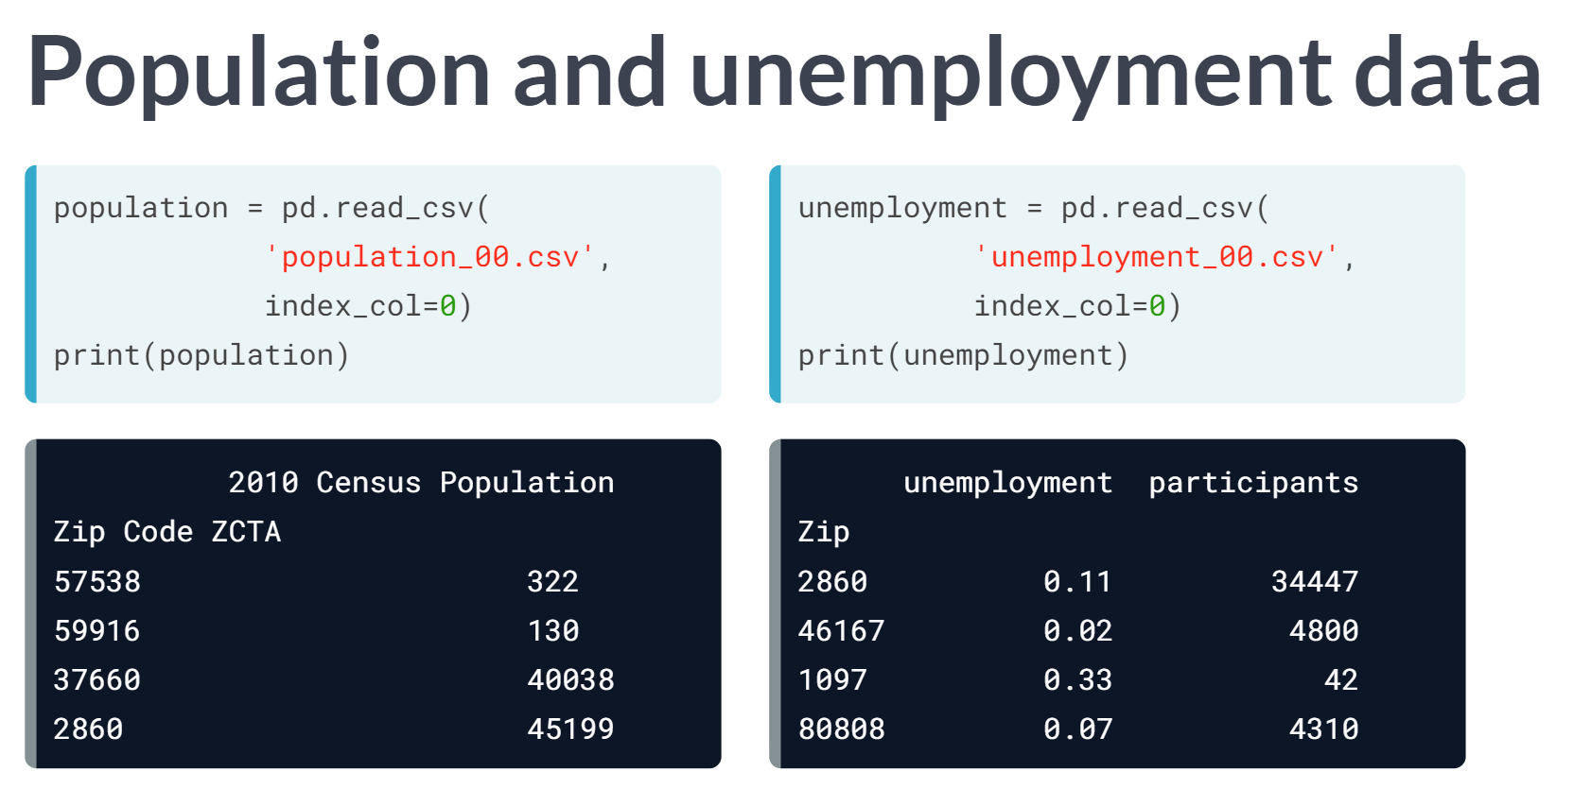  
To understand a bit better how joining works, let's examine the Census dataset again. We load two 5-row DataFrames population and unemployment indexed by Zip Code. Remember, the only common row label is 2860.

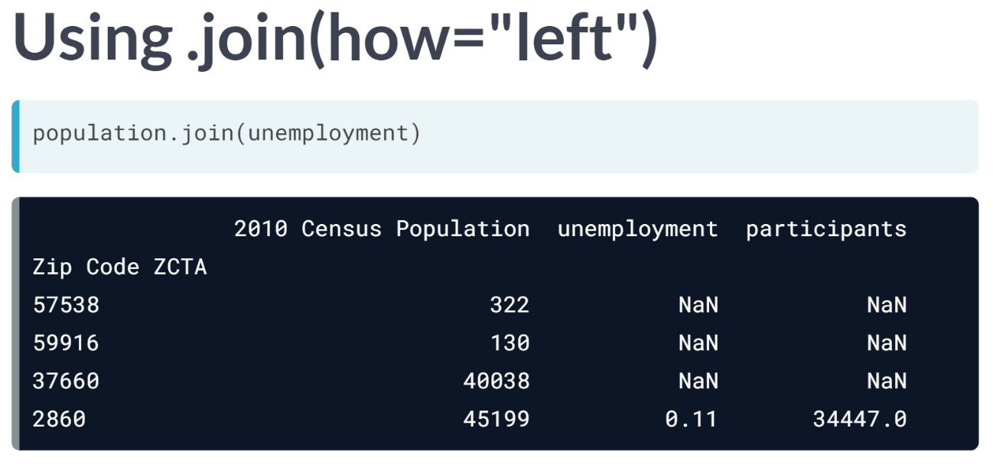  
Pandas DataFrames have a ***.join()*** method built-in. Calling population .join(unemployment) computes a left join using the Index by default.

Only the row 2860 is complete; the remaining rows are preserved from population with the unemployment and participants columns filled with NaNs. The row order also matches that of the left DataFrame in this case.

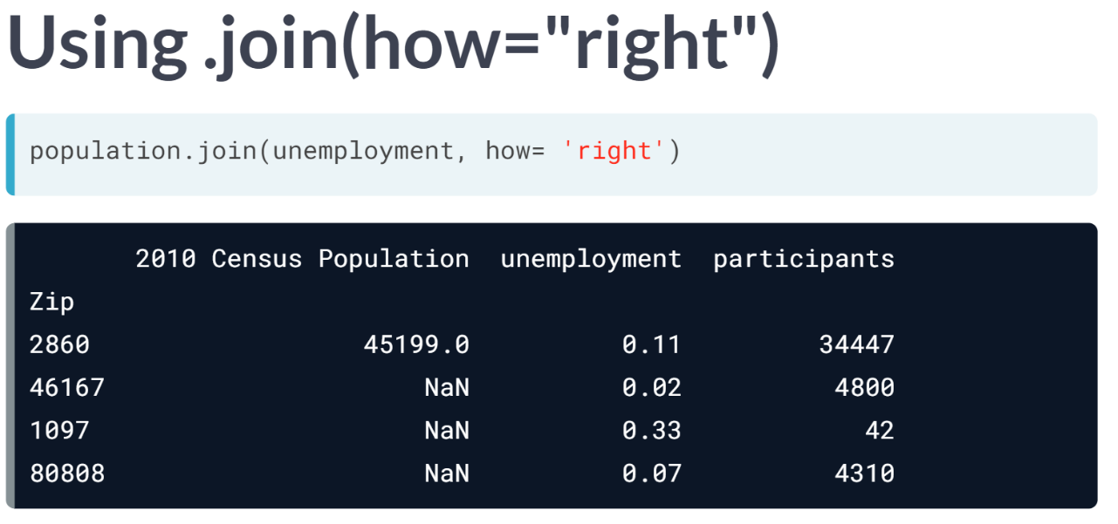  
The ***.join()*** method with how = 'right' achieves right join. In this case, the 2860 row is preserved again, but the other rows are extracted from the right unemployment DataFrame with the 2010 Census Population values set to NaN. Notice the row ordering matches that in unemployment this time.

The ***join()*** method also supports inner and outer joins on the indexes.

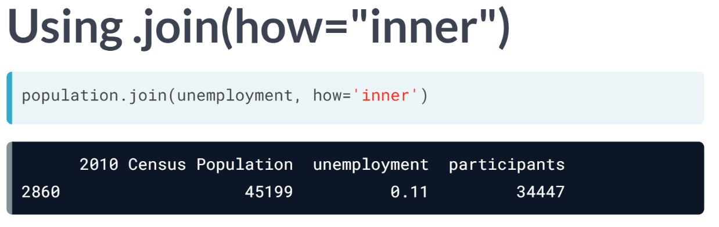  
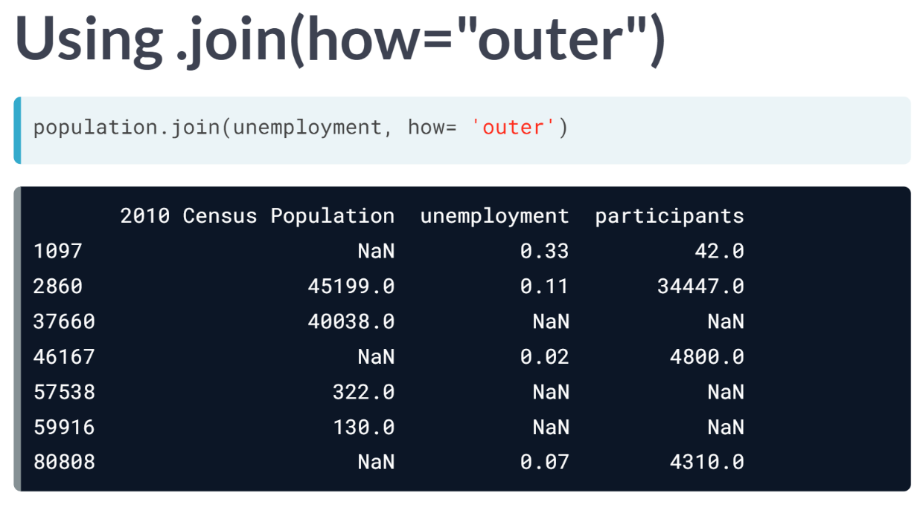  
Notice the outer join sorts the combined index.

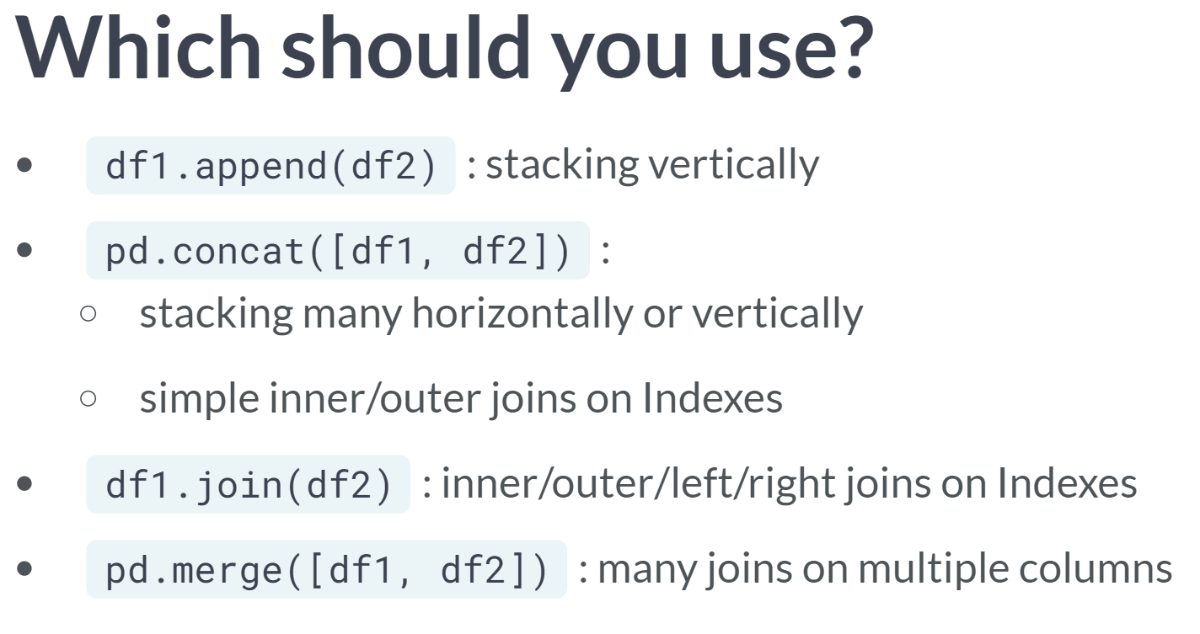  
We've looked at a lot of equivalent Pandas tools for joining. Occam's razor is a good principle here: use the simplest tool that works.

* If you only need to stack two Series or DataFrames vertically, the ***.append()*** method is sufficient.
* If you need more flexible stacking, or an inner or an outer join on indexes, the ***concat()*** function gets you further.
* The ***.join()*** method also joins on indexes but gives more flexibility for left and right joins.
* Finally, the ***merge()*** function is the power tool for joining when you need to join on several columns.

# Joining by Index

The DataFrames revenue and managers are displayed in the IPython Shell. Here, they are indexed by 'branch_id'.

Choose the function call below that will join the DataFrames on their indexes and return 5 rows with index labels [10, 20, 30, 31, 47]. Explore each of them in the IPython Shell to get a better understanding of their functionality.

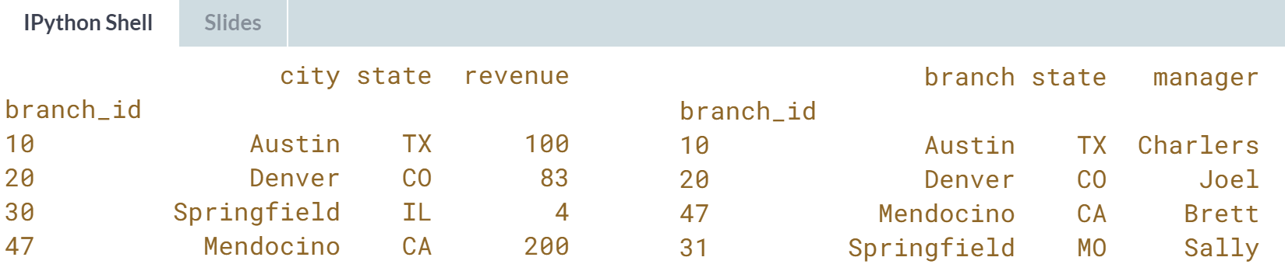

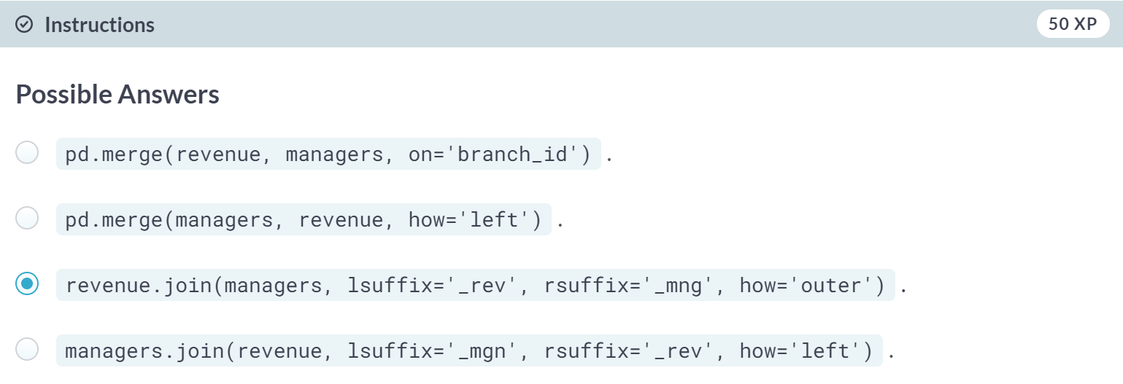  
Correct! This function call does indeed return 5 rows with index labels [10, 20, 30, 31, 47]

(Result of each choice is shown on the next page)

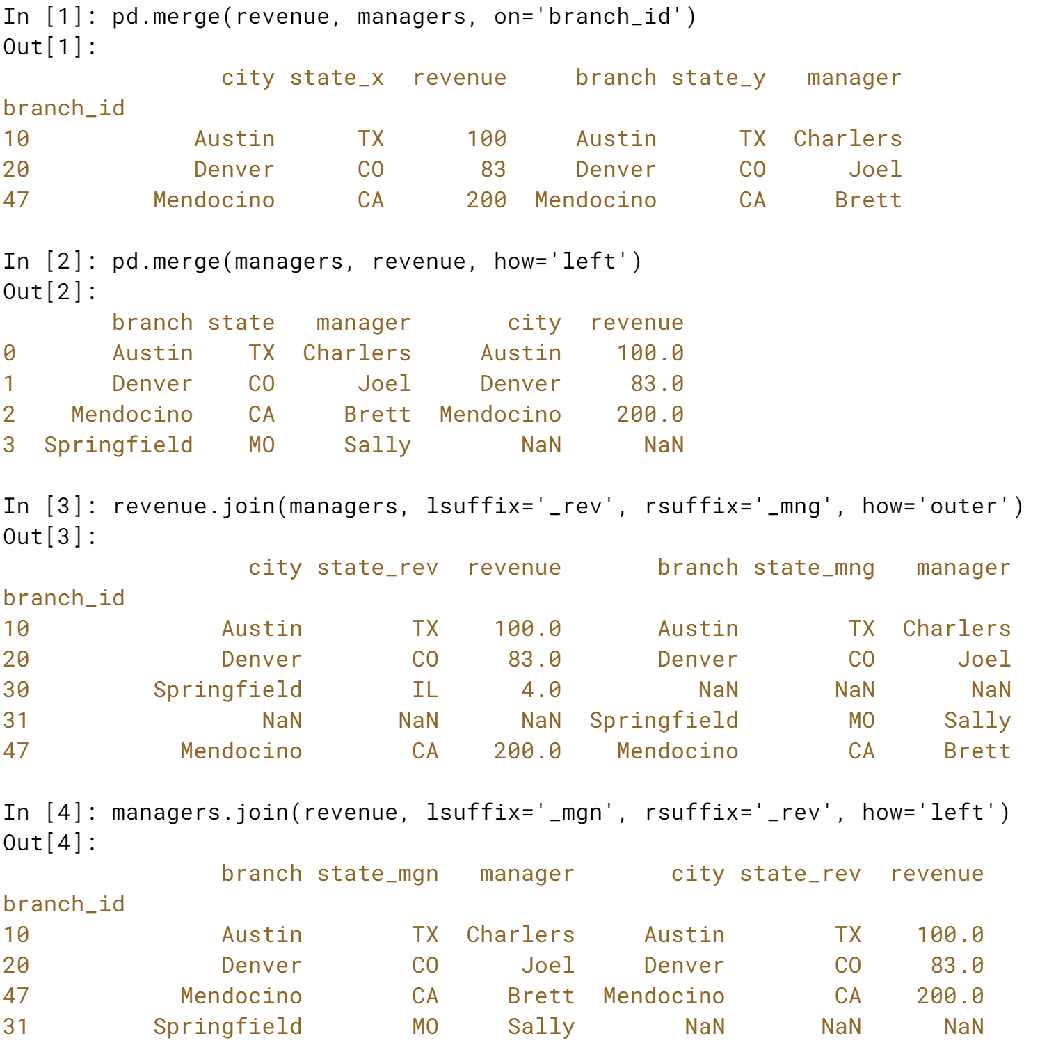

# Choosing a joining strategy

Suppose you have two DataFrames: students (with columns 'StudentID', 'LastName', 'FirstName', and 'Major') and midterm_results (with columns 'StudentID', 'Q1', 'Q2', and 'Q3' for their scores on midterm questions).

You want to combine the DataFrames into a single DataFrame grades, and be able to easily spot which students wrote the midterm and which didn't (their midterm question scores 'Q1', 'Q2', & 'Q3' should be filled with NaN values).

You also want to drop rows from midterm_results in which the StudentID is not found in students.

Which of the following strategies gives the desired result?

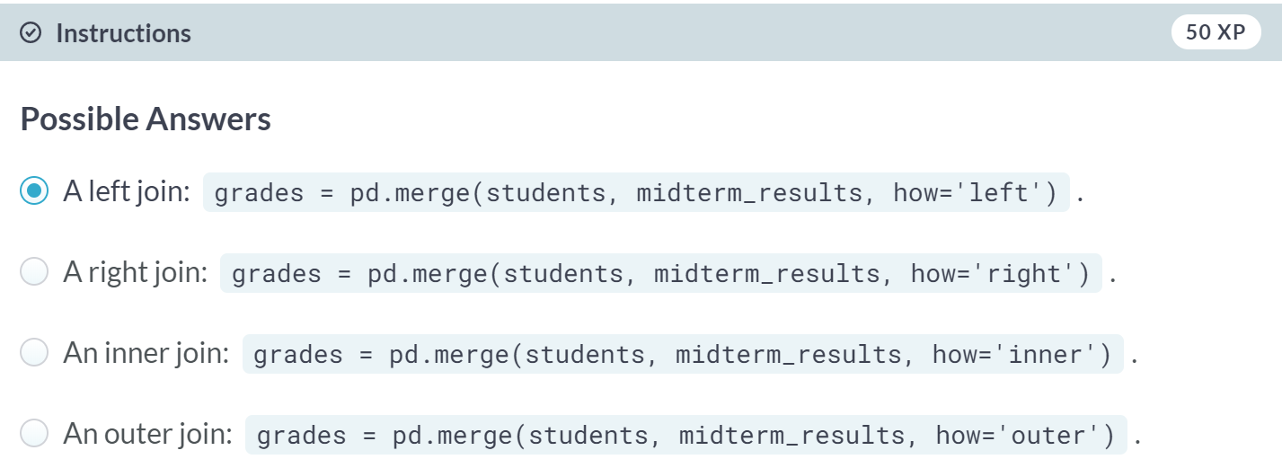

Correct! A left join is indeed the right strategy here.

B: Not quite. A right join will not result in 'Q1', 'Q2', and 'Q3' being filled with NaN values for students who didn't take the midterm.

C: Incorrect. An inner join is not the appropriate choice here.

D: Incorrect. An outer join will not drop any rows.

# Left & right merging on multiple columns

You now have, in addition to the revenue and managers DataFrames from prior exercises, a DataFrame sales that summarizes units sold from specific branches (identified by city and state but not branch_id).

Once again, the managers DataFrame uses the label branch in place of city as in the other two DataFrames. Your task here is to employ left and right merges to preserve data and identify where data is missing.

By merging revenue and sales with a right merge, you can identify the missing revenue values. Here, you don't need to specify left_on or right_on because the columns to merge on have matching labels.

By merging sales and managers with a left merge, you can identify the missing manager. Here, the columns to merge on have conflicting labels, so you must specify left_on and right_on. In both cases, you're looking to figure out how to connect the fields in rows containing Springfield.

pandas has been imported as pd and the three DataFrames revenue, managers, and sales have been pre-loaded. They have been printed for you to explore in the IPython Shell.

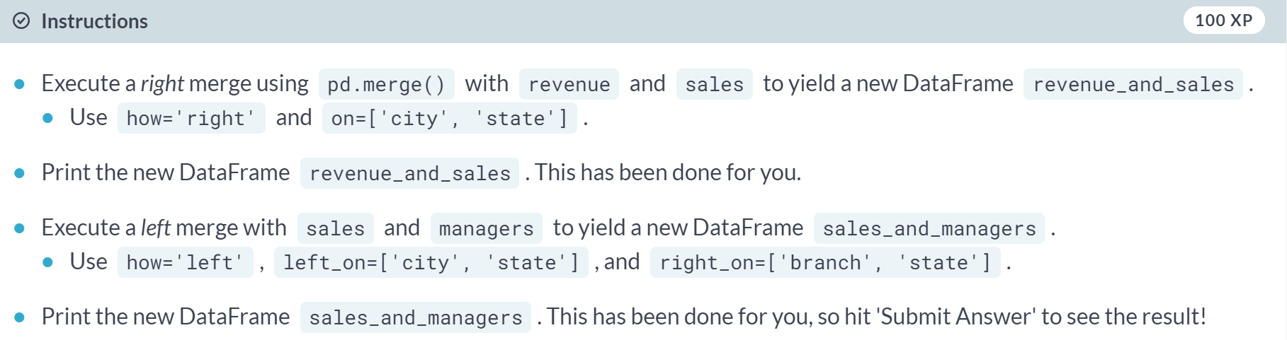

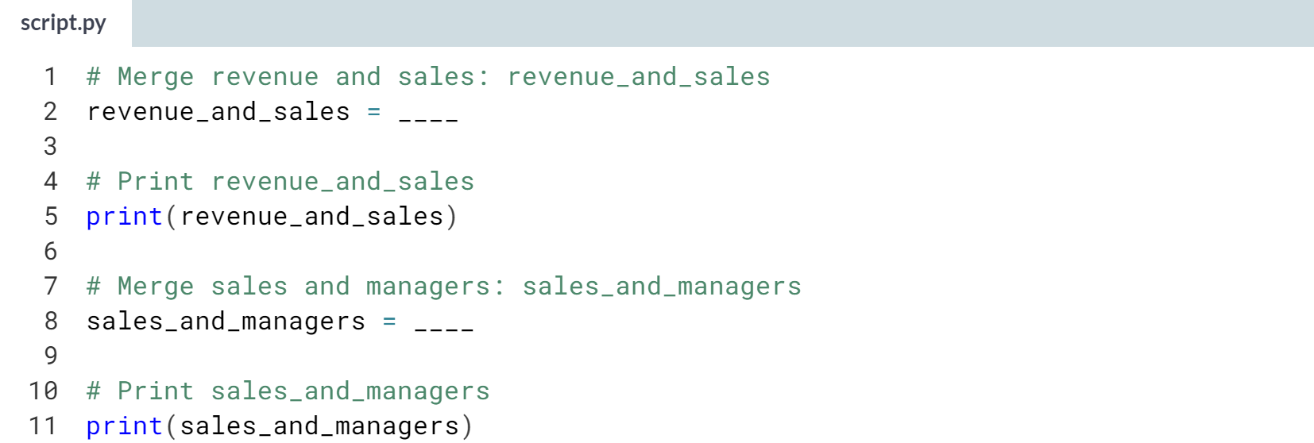

Hint

1. For the first merge, you need to pass in revenue and sales to ***pd.merge()*** and specify the additional keyword arguments **how='right'** and **on=['city', 'state']**.
2. For the second merge, you need to pass in sales and managers to ***pd.merge()*** and specify the additional keyword arguments **how='left'**, **left_on=['city', 'state']** and **right_on=['branch', 'state']**.

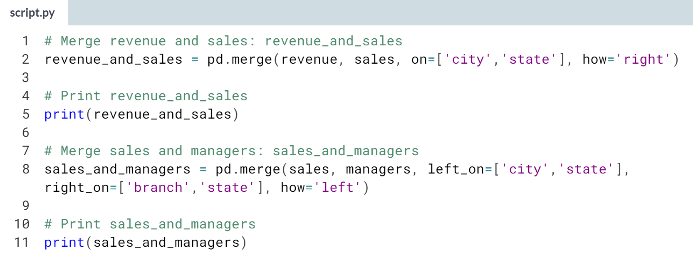

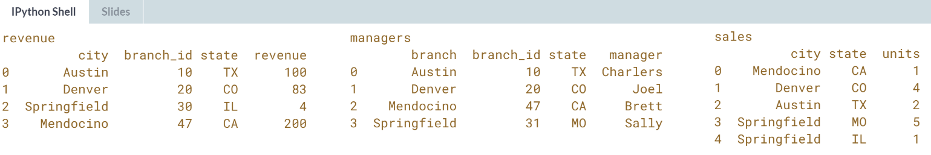

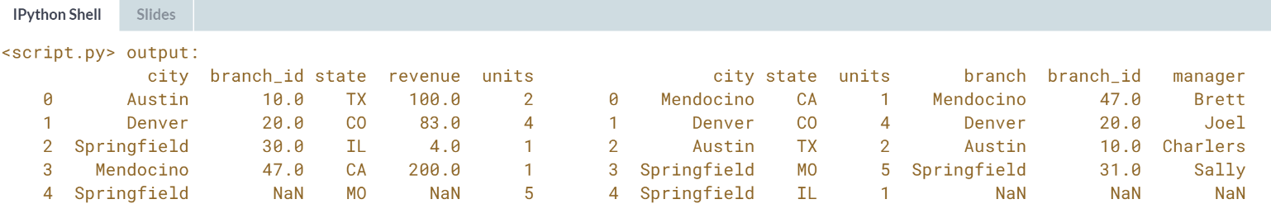

# Merging DataFrames with outer join

This exercise picks up where the previous one left off. The DataFrames revenue, managers, and sales are pre-loaded into your namespace (and, of course, pandas is imported as pd). Moreover, the merged DataFrames revenue_and_sales and sales_and_managers have been pre-computed exactly as you did in the previous exercise.

The merged DataFrames contain enough information to construct a DataFrame with 5 rows with all known information correctly aligned and each branch listed only once. You will try to merge the merged DataFrames on all matching keys (which computes an inner join by default). You can compare the result to an outer join and also to an outer join with restricted subset of columns as keys.

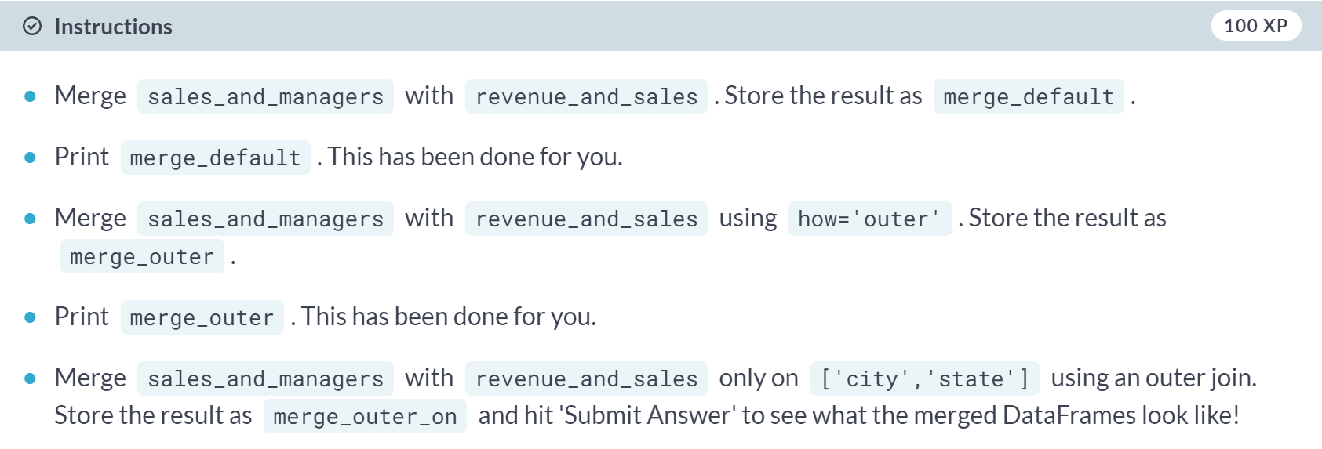

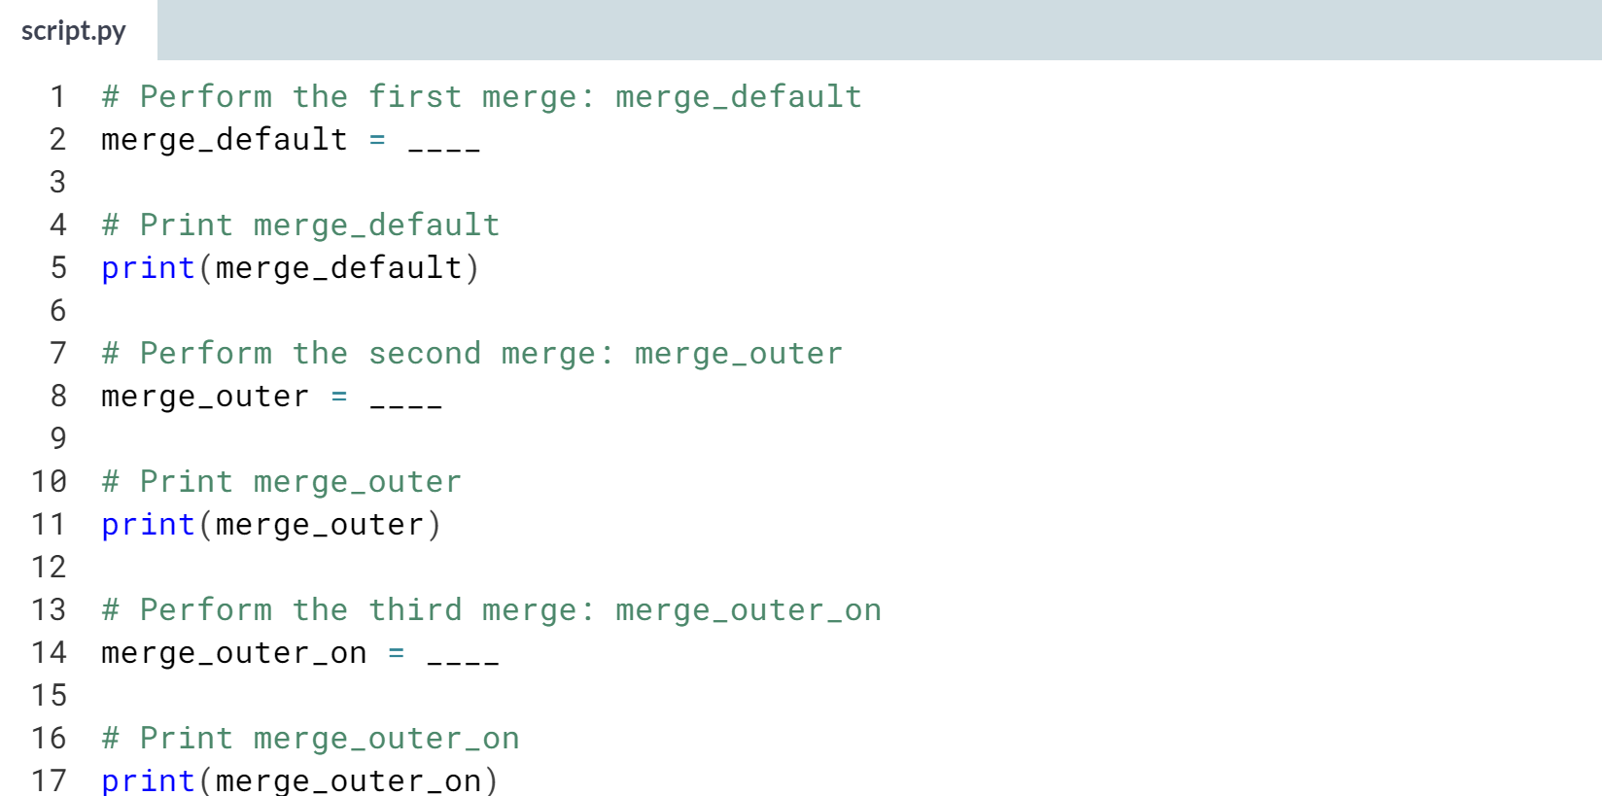

Hint

1. For the first merge, just pass in *sales_and_managers* and *revenue_and_sales* as arguments to ***pd.merge()***.
2. For the second merge, pass in *sales_and_managers* and *revenue_and_sales* as arguments to ***pd.merge()*** and specify the additional keyword argument **how='outer'**.
3. For the third merge, pass in *sales_and_managers* and *revenue_and_sales* as arguments to ***pd.merge()*** and specify the additional keyword arguments **how='outer'** and **on=['city','state']**.

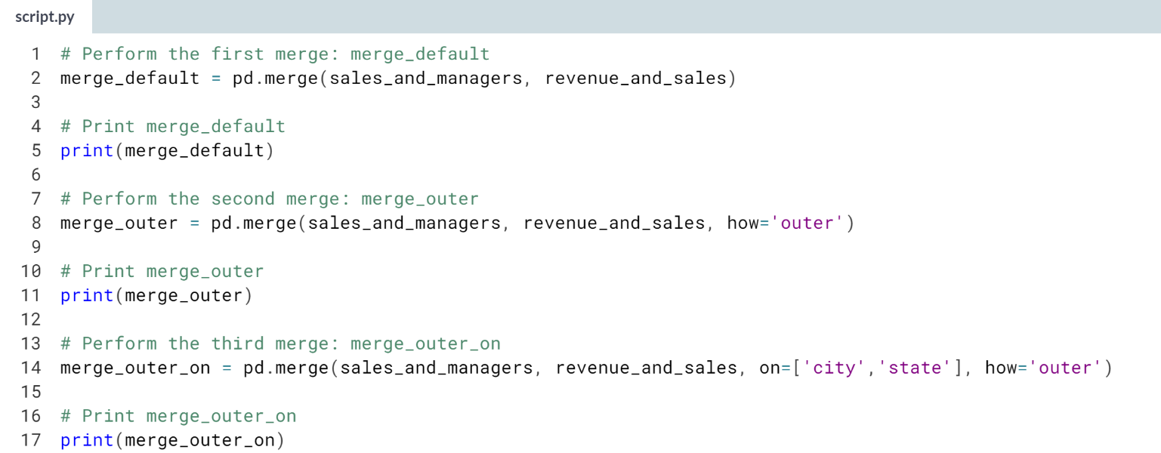

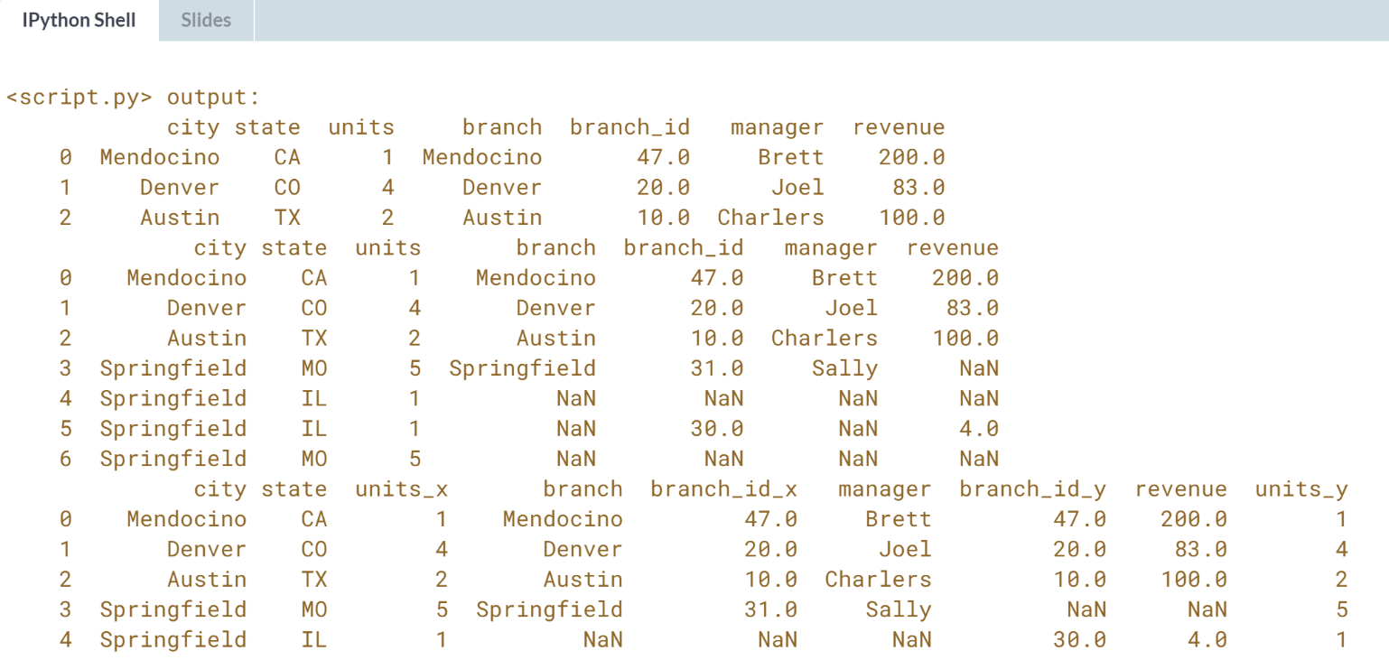

Fantastic work! Notice how the default merge drops the Springfield rows, while the default outer merge includes them twice.



We often want to merge DataFrames whose columns have natural ordering, like date-time columns. This is the domain of ordered merging; let's explore this now.

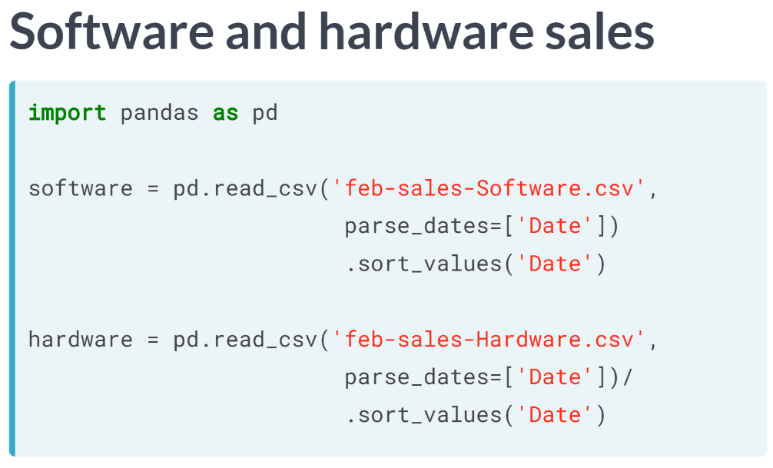  
We start with DataFrames of sales from a company that sells software and hardware product. We make sure that the DataFrames are sorted by their respective 'Date' columns using the ***sort_values()*** method.

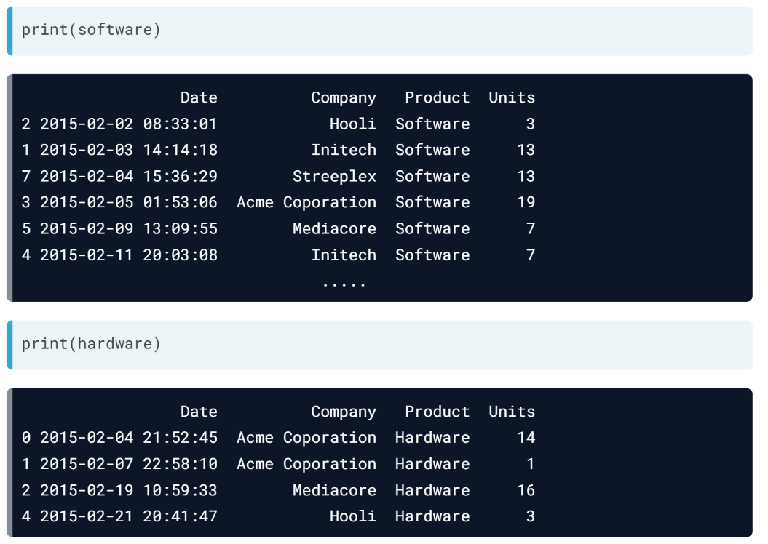  
When we examine the DataFrames, software has 9 rows and hardware has 5. Both have identical column labels Date, Company, Product, and Units. The Date columns of both are sorted chronologically and the indexes are jumbled ranges of integers.

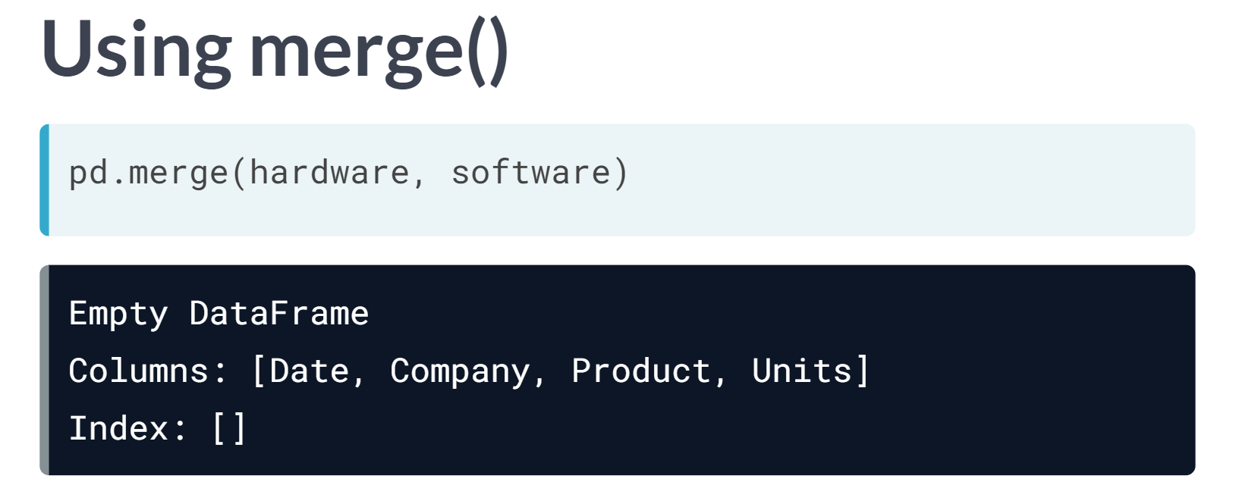  
Attempting to merge yields an empty DataFrame because it is actually doing an INNER join on all columns with matching names by default. In particular, the 'Units' and 'Date' columns have no overlapping values, so the result is empty.

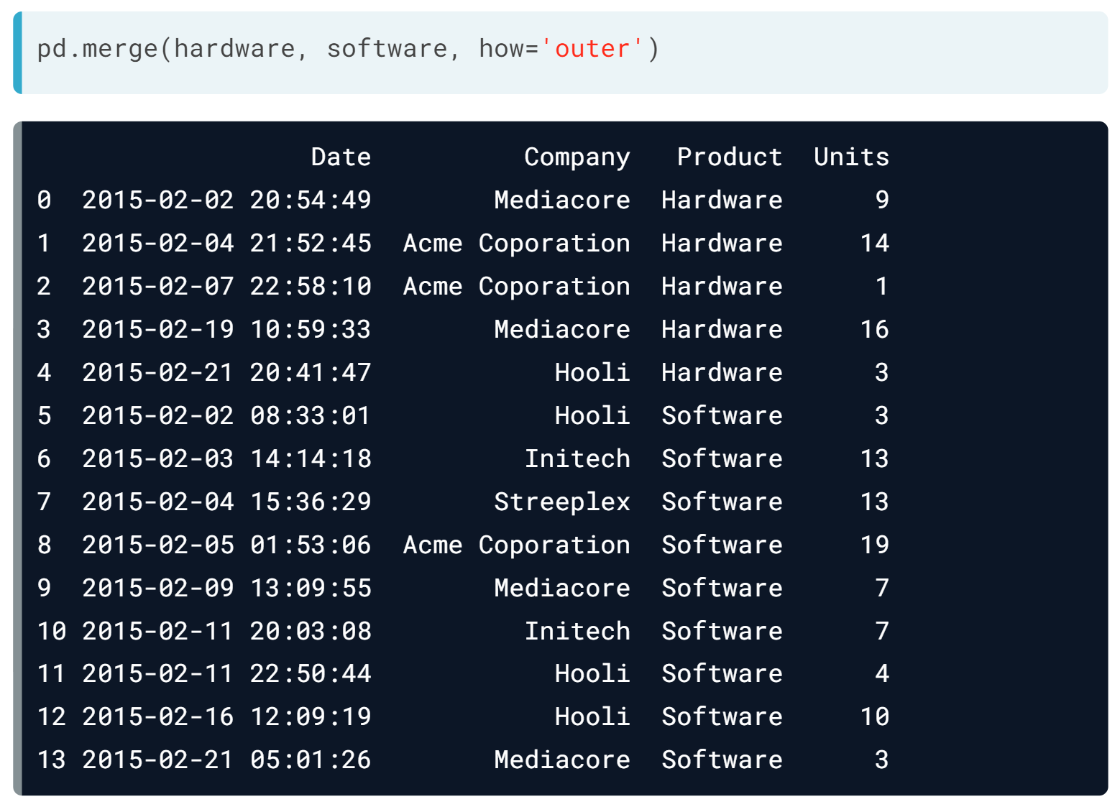  
If we do a merge with how = 'outer', the result is no longer empty.

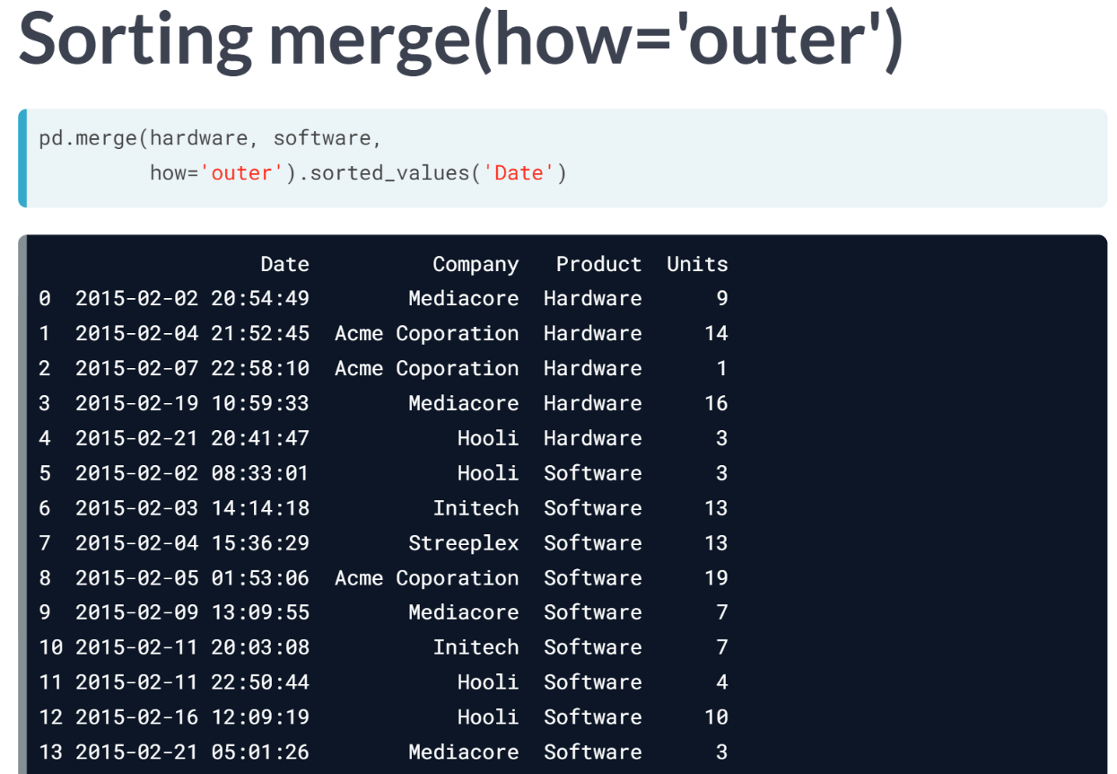  
We can also sort by the values in the 'Date' column giving a nicely ordered DataFrame.

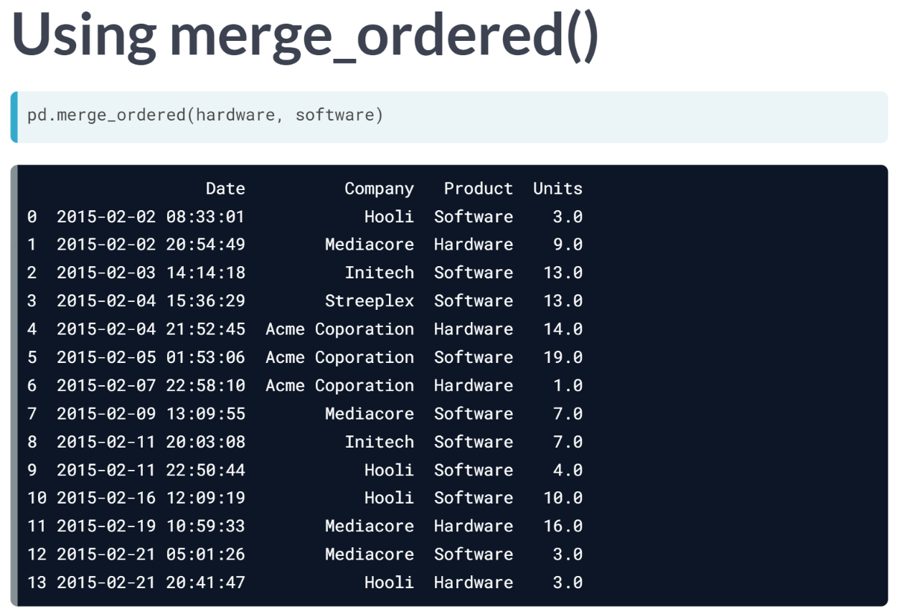  
This is what the pandas function ***merge_ordered()*** does. It behaves like ***merge()*** when columns can be ordered. The merged DataFrame has rows sorted lexicographically according to the column ordering in the input DataFrames. The default join for ***merge_ordered()*** in an outer join contrasting the default inner join for ***merge()***.

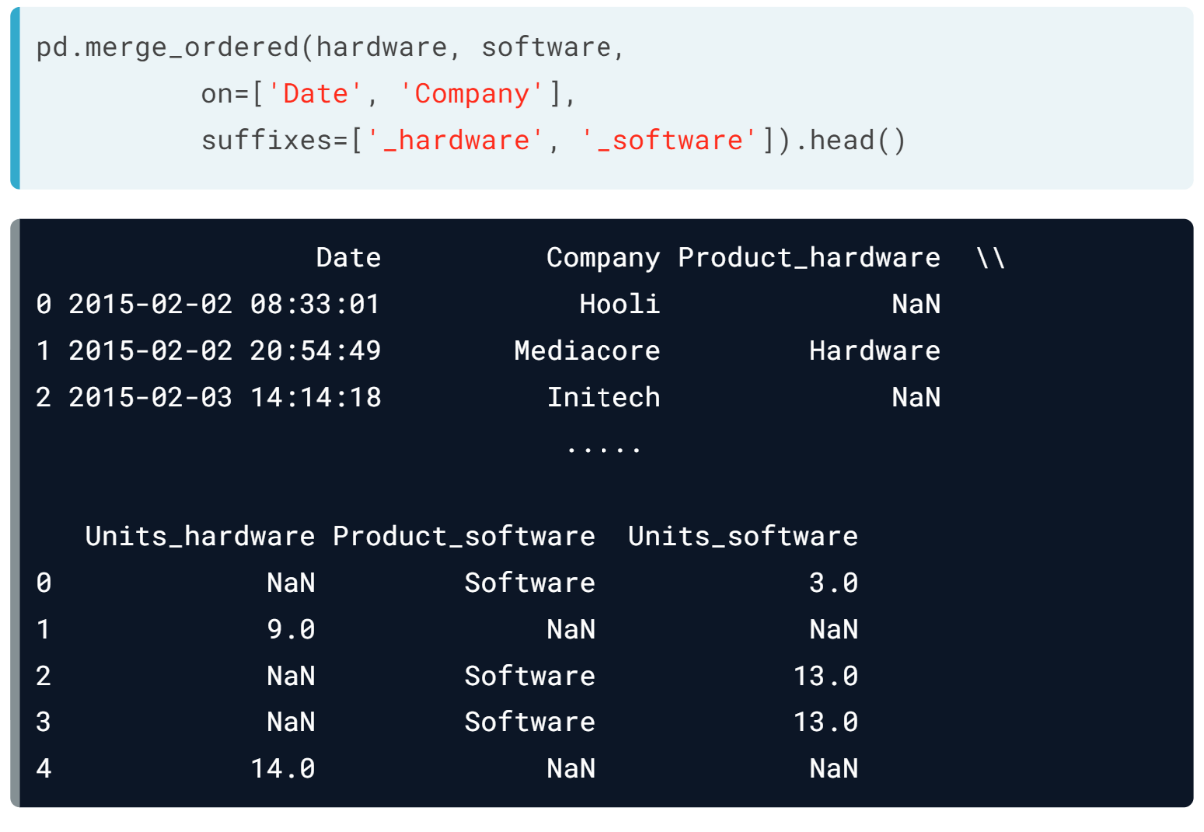  
Like ***merge()***, the function ***merge_ordered()*** accepts keyword arguments on and suffixes. Here, we select only the *'Date'* and *'Company'* fields for merging, and we provide suffixes.

The function ***merge_ordered()*** also supports filling null values.

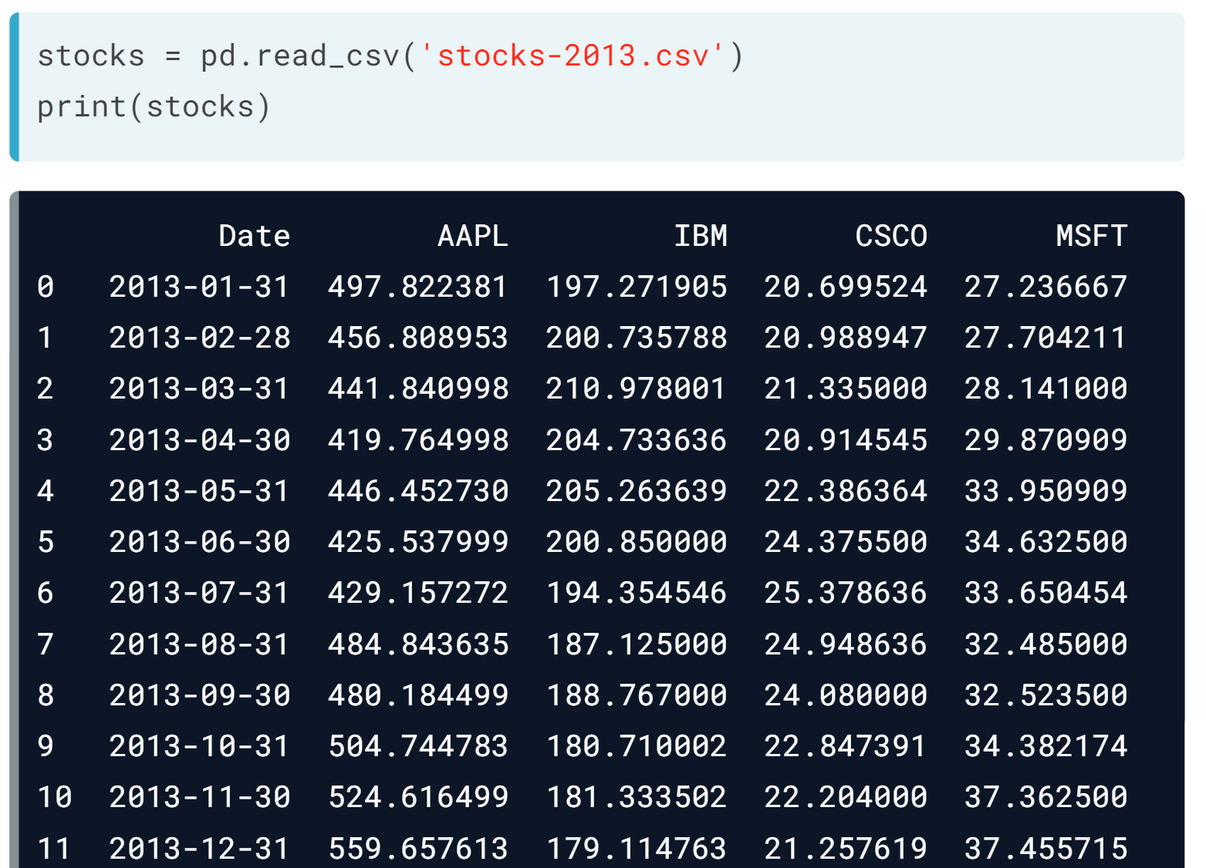  
To illustrate this, let's load some monthly stock data from 2013 into a DataFrame stocks.

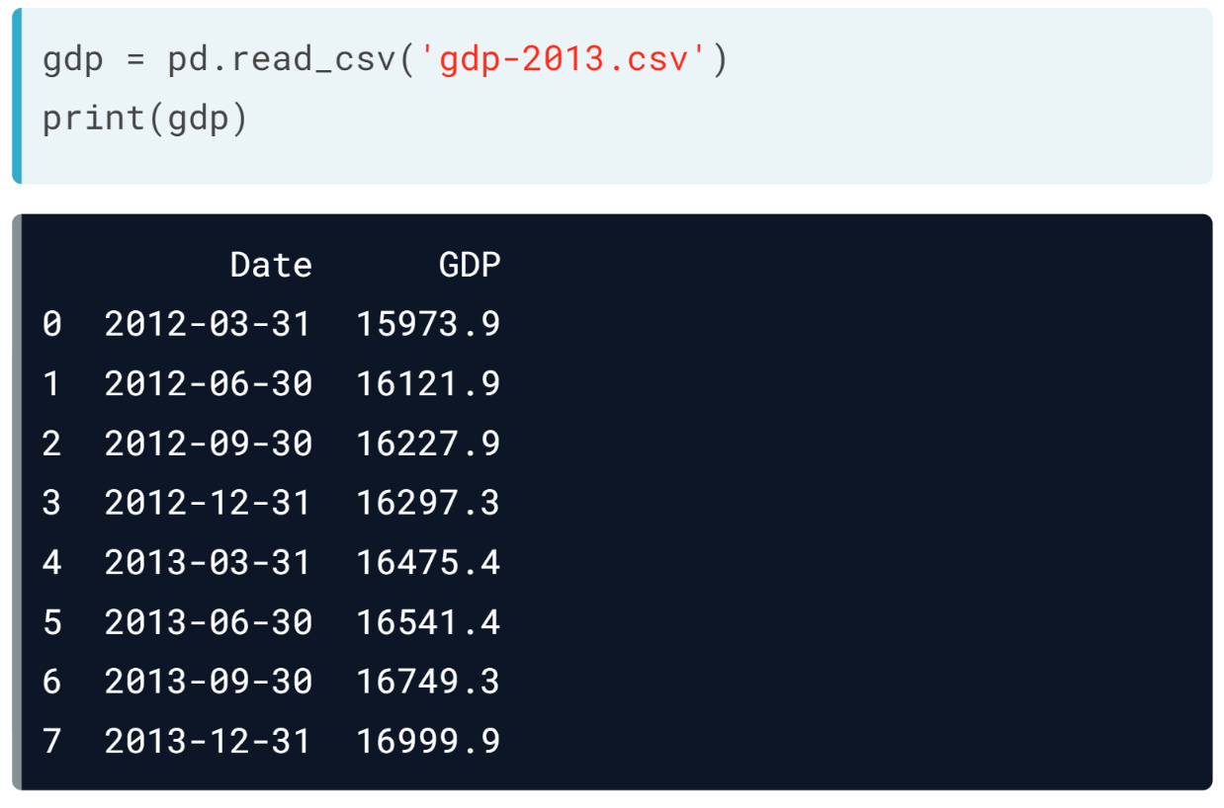  
and also some quarterly GDP data from 2012 and 2013 into a DataFrame *gdp*. Notice *gdp* has 8 rows while stocks has 12 rows. All date entries correspond to the end of a calendar month.

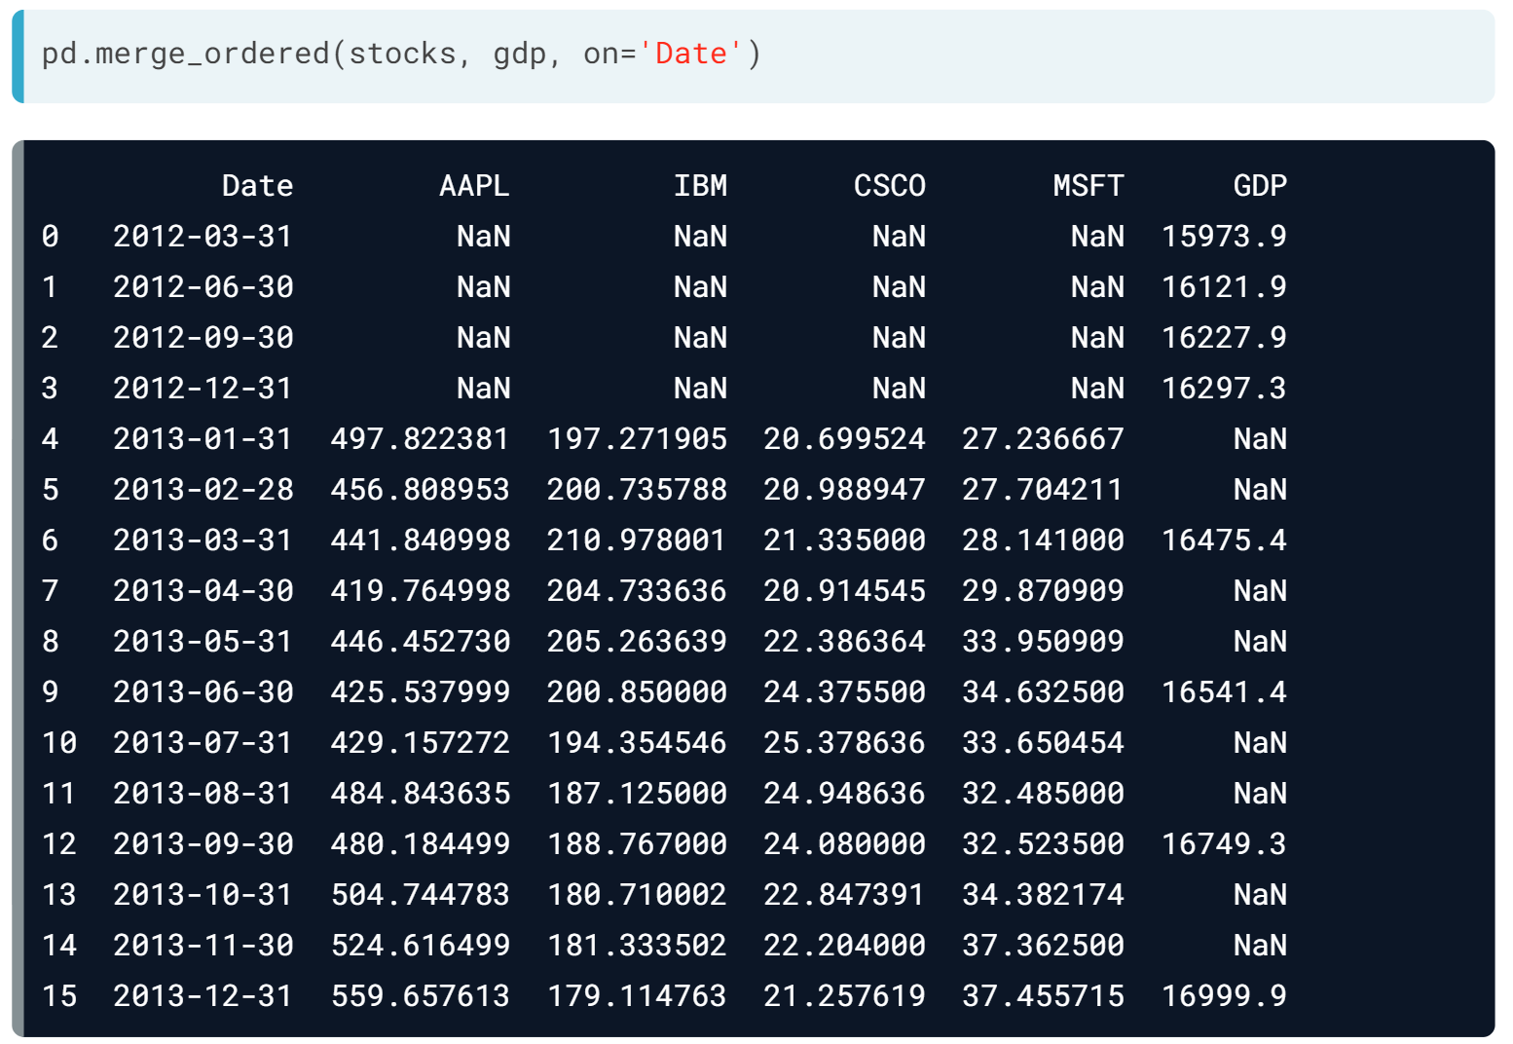  
When trying to do an ordered merge of both DataFrames on 'Date', the date columns have different frequencies (monthly versus quarterly) over different intervals (2013 versus 2012 and 2013). The resulting merged DataFrame has many NaN entries from the mismatched month ends from each DataFrame.

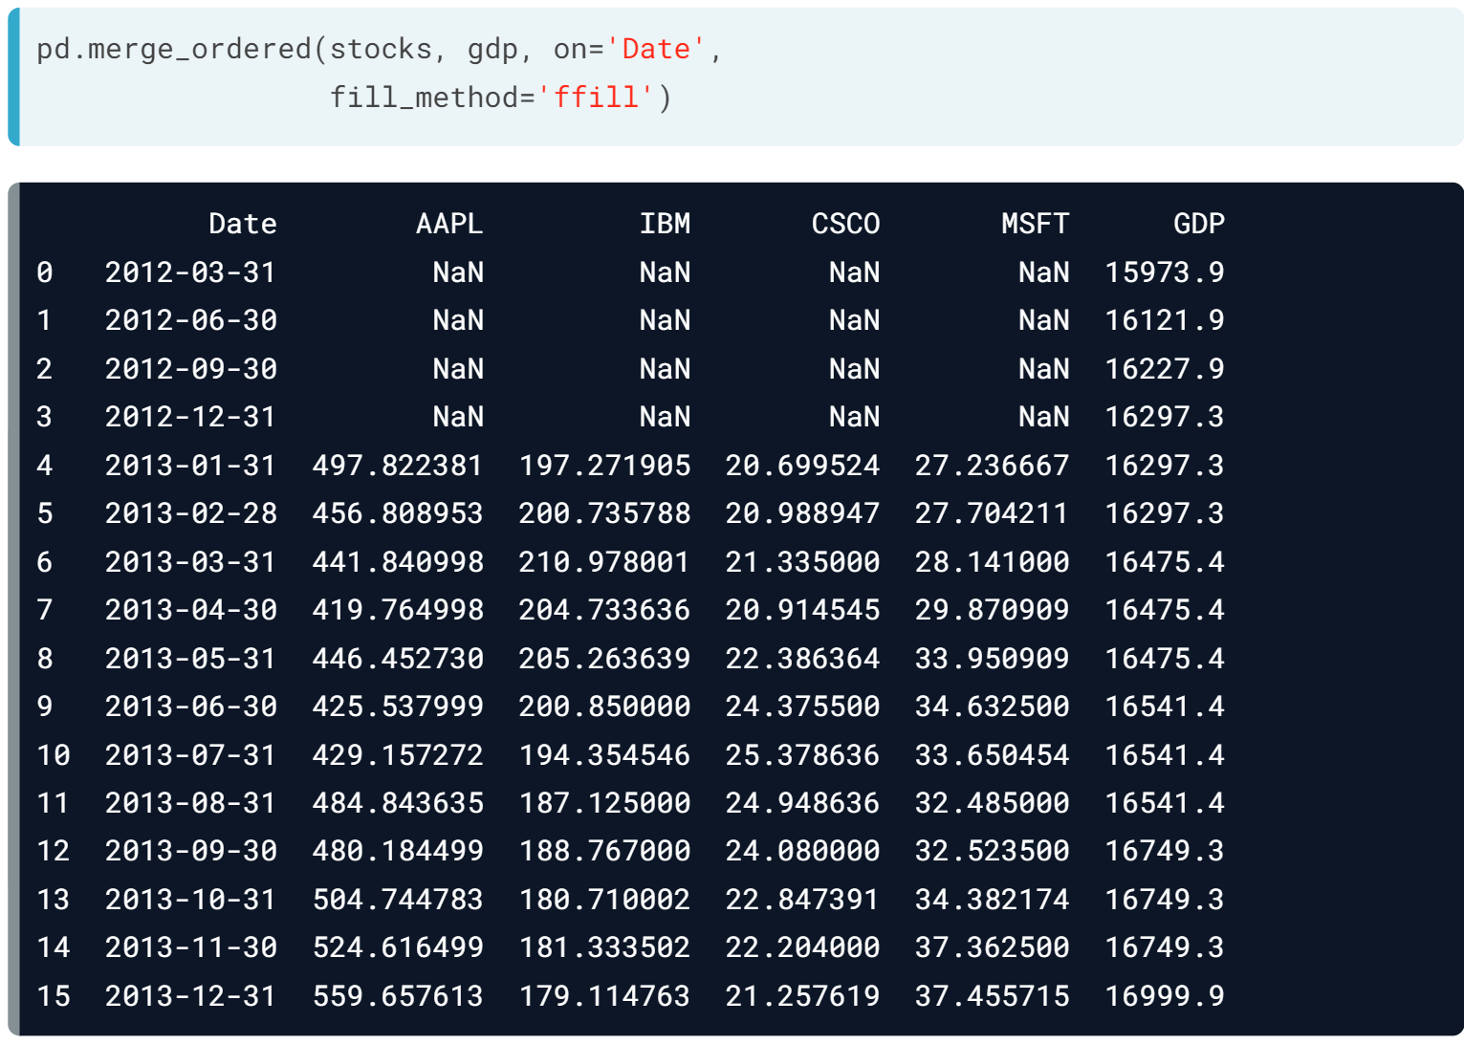  
Specifying fill_method = 'ffill' as an option in calling ***merge_ordered()*** uses forward-filling to replace the NaN values by the most recent non-null value.

This fills in the gaps in the GDP data, but the null stock values from 2012 are unchanged.

Forward-filling does not help when the entries at the very start of a time series are null.

# Using merge_ordered()

This exercise uses pre-loaded DataFrames austin and houston that contain weather data from the cities Austin and Houston respectively. They have been printed in the IPython Shell for you to examine.

Weather conditions were recorded on separate days and you need to merge these two DataFrames together such that the dates are ordered. To do this, you'll use pd.merge_ordered(). After you're done, note the order of the rows before and after merging.

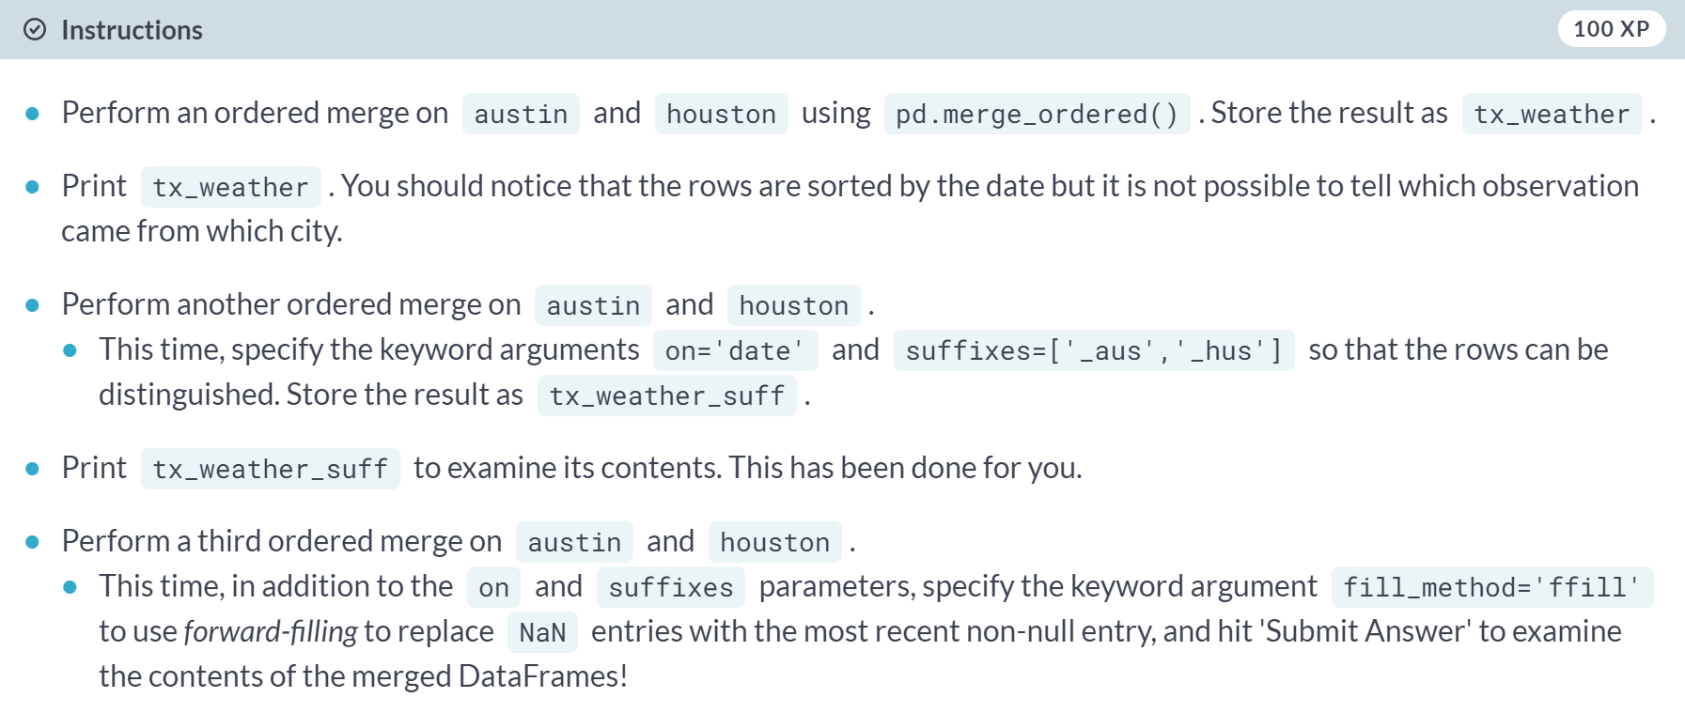

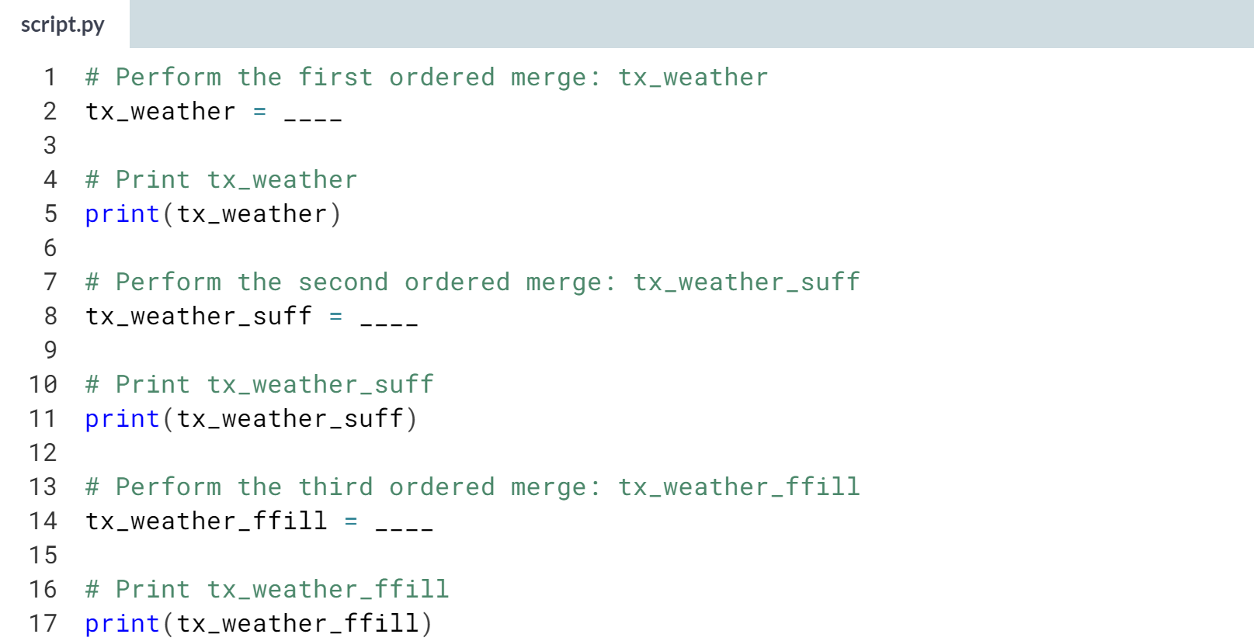

Hint

1. For the first ordered merge, just pass in **austin** and **houston** as arguments to ***pd.merge_ordered()***.
2. For the second ordered merge, pass in **austin** and **houston** to ***pd.merge_ordered()*** as before, and specify the additional keyword arguments **on='date'** and **suffixes=['_aus','_hus']**.
3. For the third ordered merge, follow the same steps as you did for the second ordered merge, and specify the additional keyword argument **fill_method='ffill'**.

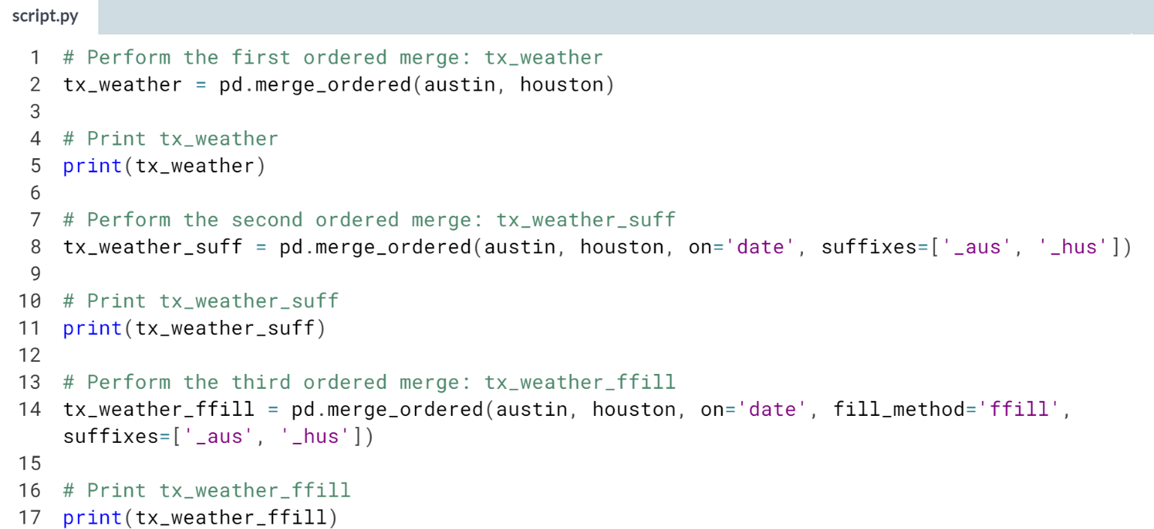

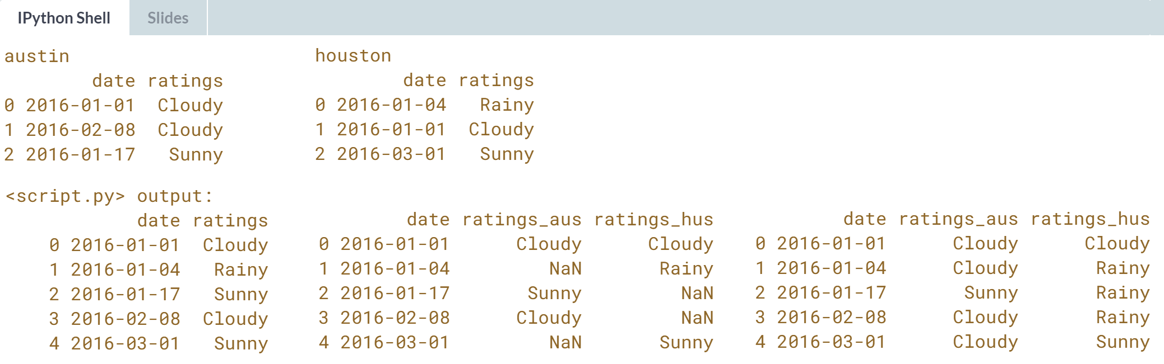

Well done! Notice how after using a fill method, there are no more NaN entries.

# Using merge_asof()

Similar to pd.merge_ordered(), the pd.merge_asof() function will also merge values in order using the on column, but for each row in the left DataFrame, only rows from the right DataFrame whose 'on' column values are **less** than the left value will be kept.

This function can be used to align disparate datetime frequencies without having to first resample.

Here, you'll merge monthly oil prices (US dollars) into a full automobile fuel efficiency dataset. The oil and automobile DataFrames have been pre-loaded as oil and auto. The first 5 rows of each have been printed in the IPython Shell for you to explore.

These datasets will align such that the first price of the year will be broadcast into the rows of the automobiles DataFrame. This is considered correct since by the start of any given year, most automobiles for that year will have already been manufactured.

You'll then inspect the merged DataFrame, resample by year and compute the mean 'Price' and 'mpg'. You should be able to see a trend in these two columns, that you can confirm by computing the Pearson correlation between resampled 'Price' and 'mpg'.

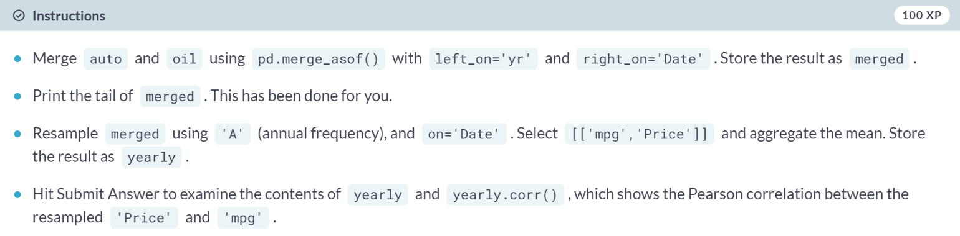

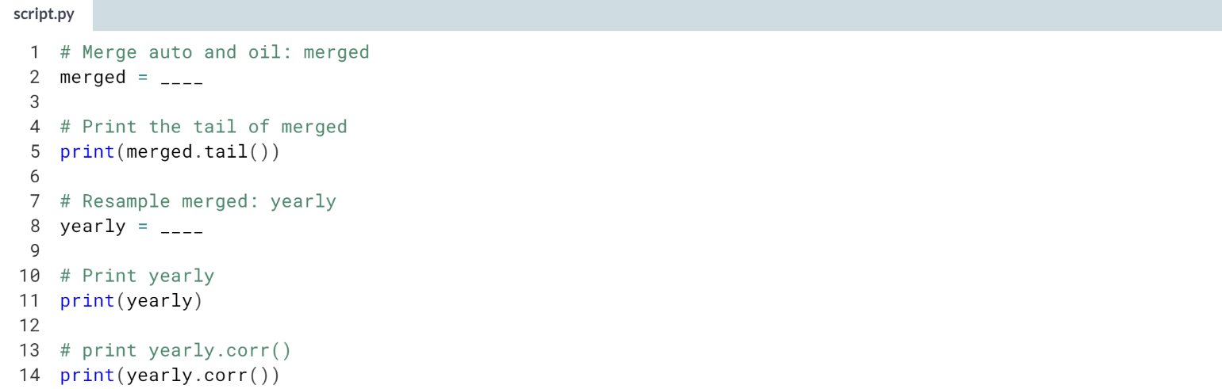

1. Use ***pd.merge_asof()*** with auto and oil as arguments along with the keyword arguments **left_on='yr'** and **right_on='Date'**.
2. To resample merged, use the ***.resample()*** method on merged with **'A'** and **on='Date'** as arguments. Then select **[['mpg','Price']]** and chain the ***.mean()*** method to this.

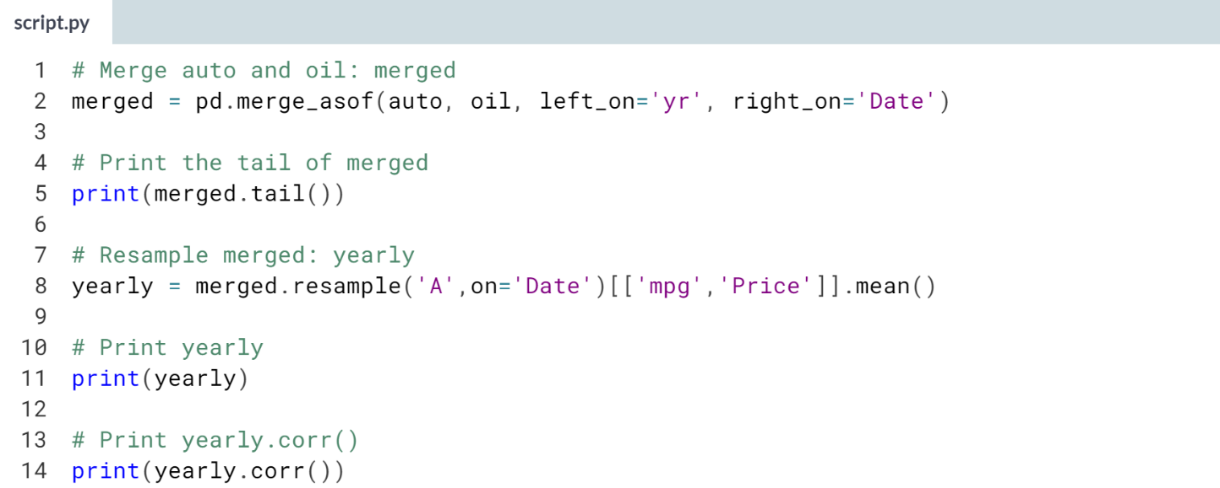

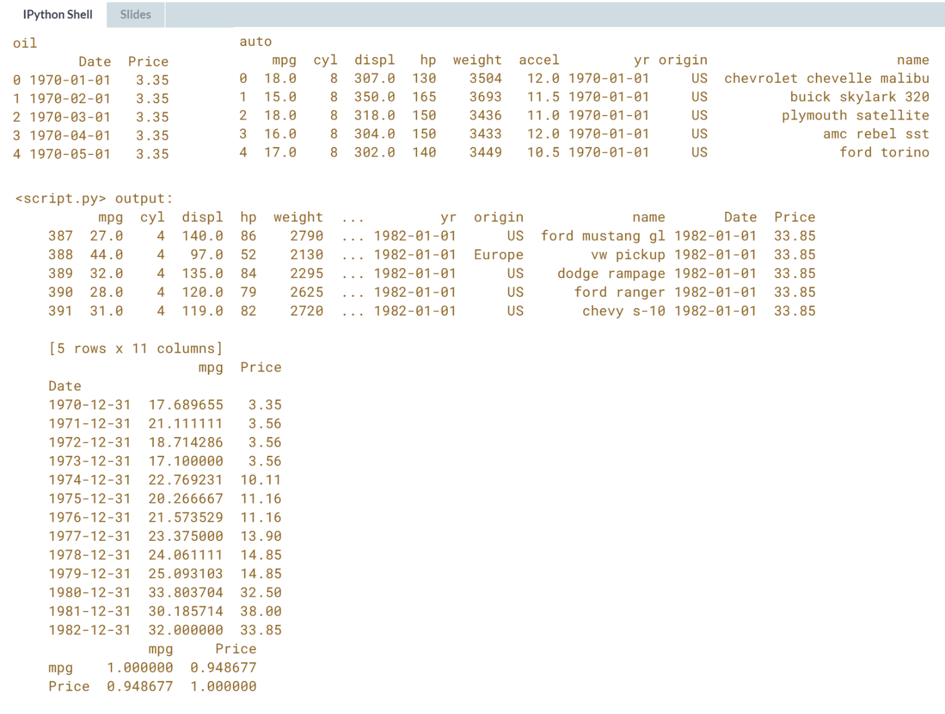

Great work! It looks like there is a strong correlation between miles per gallon and the price of oil!

**4. Case Study - Summer Olympics**

To reinforce your new skills, you'll apply them to an in-depth case study using Olympic medal data. The analysis involves integrating your multi-DataFrame skills from this course and skills you've gained in previous pandas courses. This is a rich dataset that will allow you to fully leverage your pandas data manipulation skills.



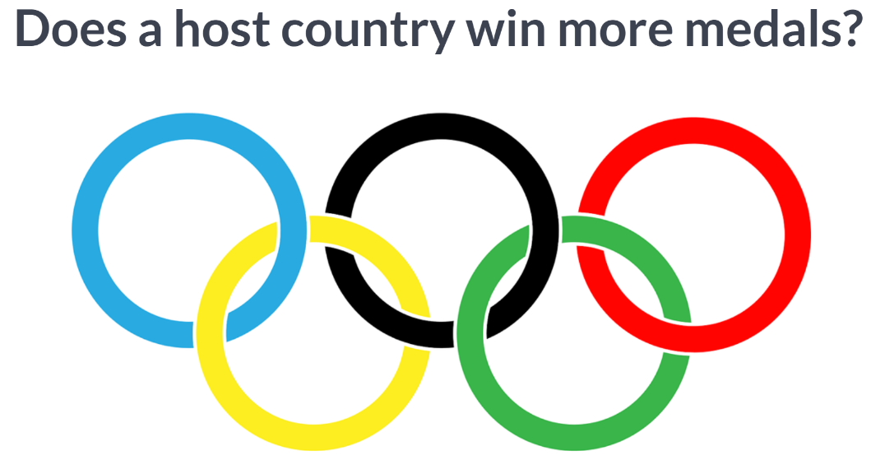  
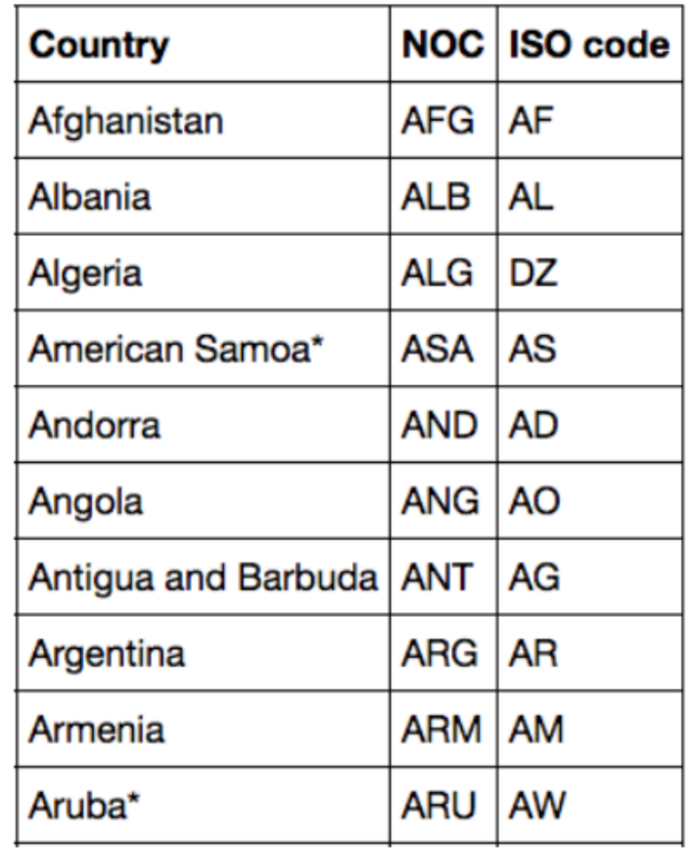  
To answer this question, we have a collection of flat text files from the Guardian containing; a summary of country codes used by the IOC between 1896 and 2008.

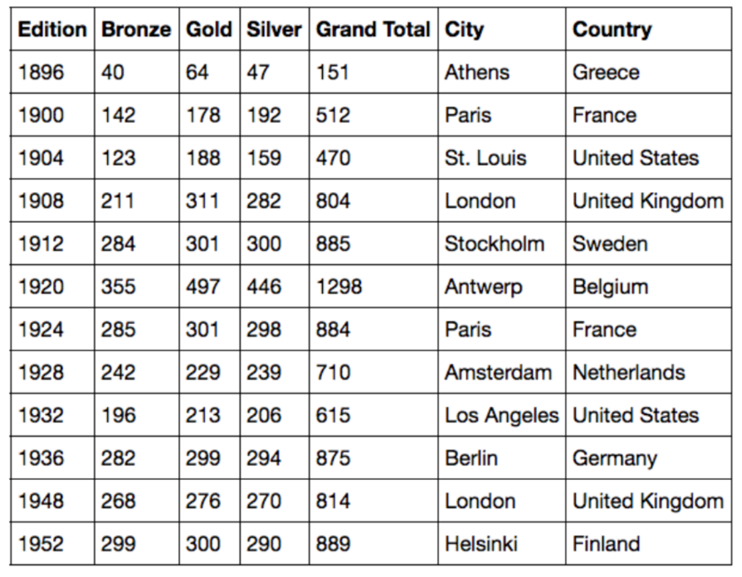  
And a description of all the Editions of the Summer Olympics over that period,

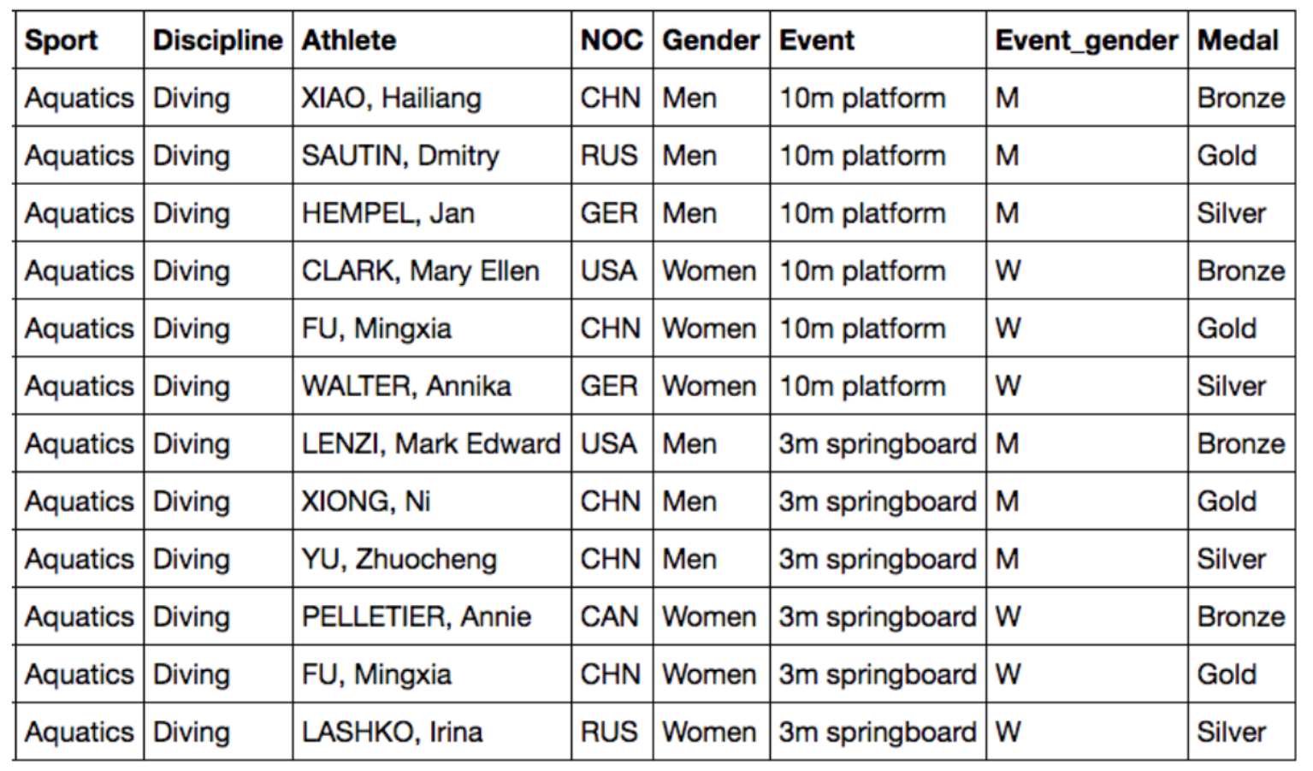  
and a collection of CSV files detailing medals won in individual sports for each of the corresponding Olympic editions.

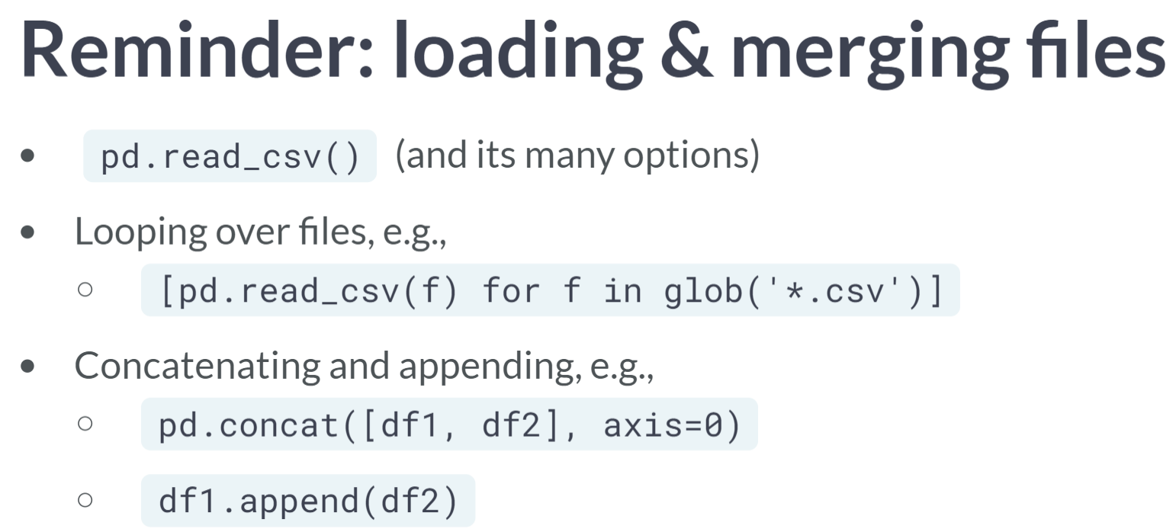  
To start, you will load the data from the relevant CSV files.

You've used the pandas ***read_csv()*** function a lot by now with many of its operational parameters, you've applied loops and comprehensions to process many files efficiently, and you've combined DataFrames through appending or concatenating.

# Loading Olympic edition DataFrame

In this chapter, you'll be using [**The Guardian's Olympic medal dataset**](https://www.theguardian.com/sport/datablog/2012/jun/25/olympic-medal-winner-list-data).

Your first task here is to prepare a DataFrame editions from a tab-separated values (TSV) file.

Initially, editions has 26 rows (one for each Olympic edition, i.e., a year in which the Olympics was held) and 7 columns: 'Edition', 'Bronze', 'Gold', 'Silver', 'Grand Total', 'City', and 'Country'.

For the analysis that follows, you won't need the overall medal counts, so you want to keep only the useful columns from editions: 'Edition', 'Grand Total', City, and Country.

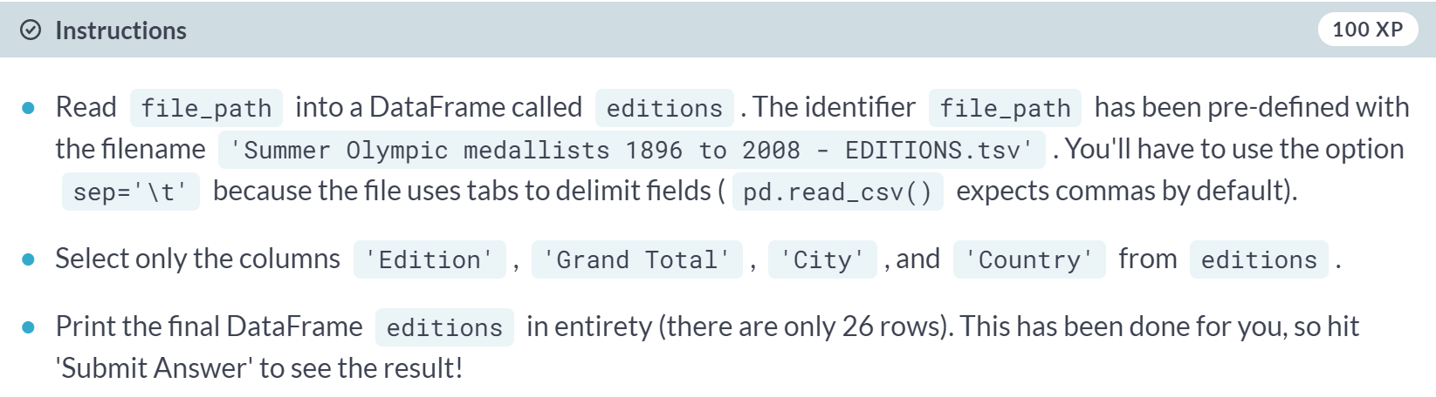

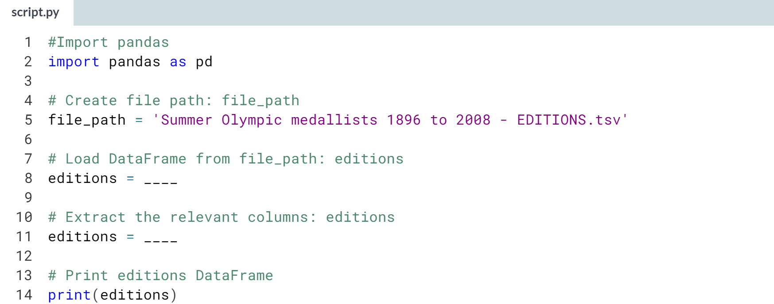

Hint

1. Use ***pd.read_csv()*** with *file_path* and *sep='\t'* as arguments to read the TSV file into DataFrame.
2. To subset editions, pass the list **['Edition', 'Grand Total', 'City', 'Country']** to **editions[]**.

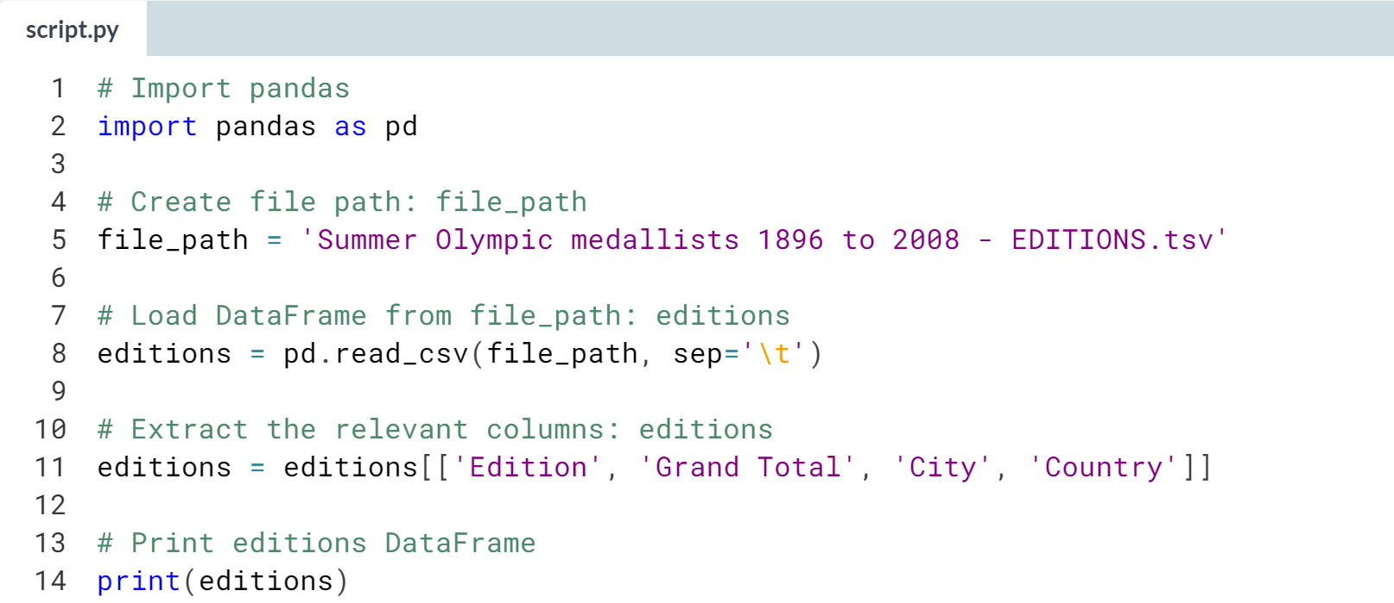

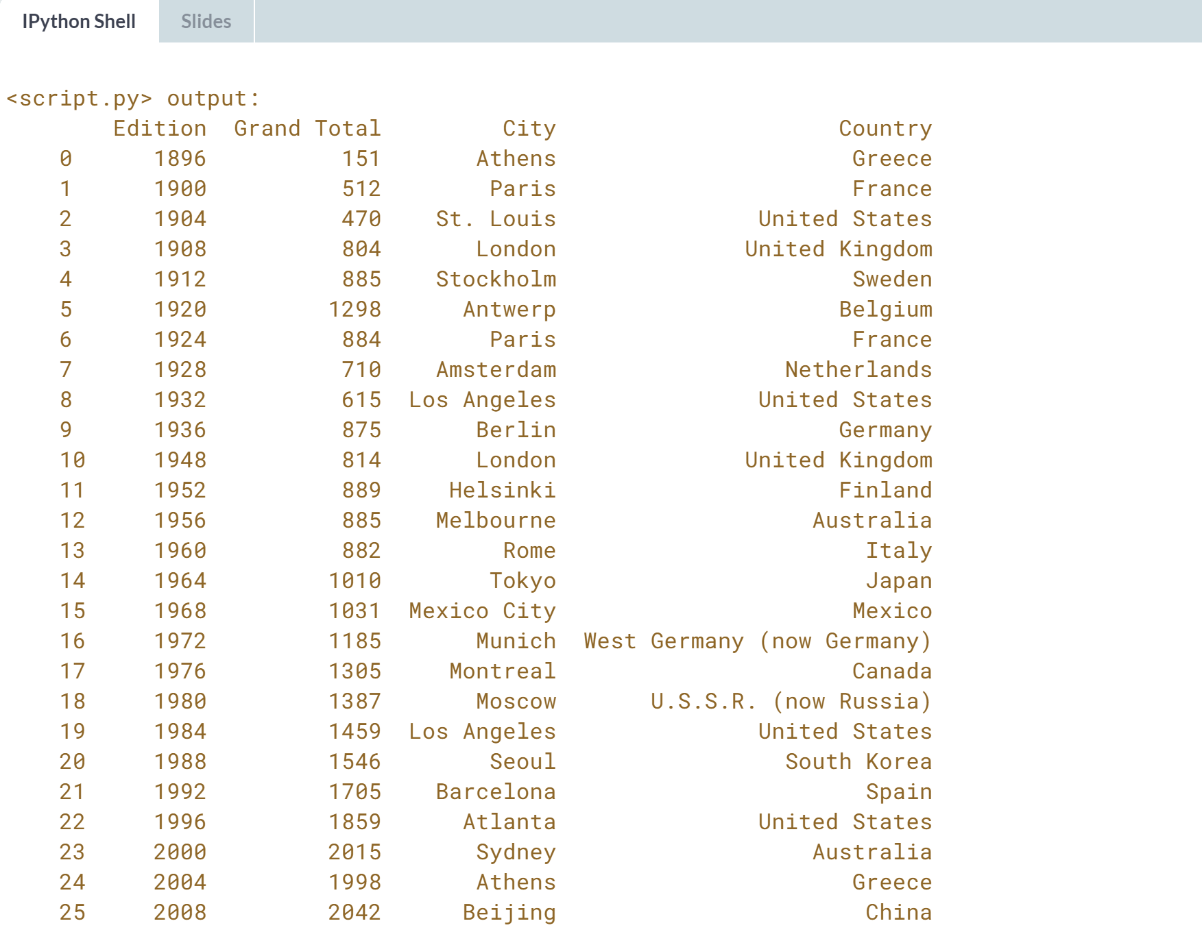

Great work! Next, you'll prepare a DataFrame of IOC codes.

# Loading IOC codes DataFrame

Your task here is to prepare a DataFrame ioc_codes from a comma-separated values (CSV) file.

Initially, ioc_codes have 200 rows (one for each country) and 3 columns: 'Country', 'NOC', & 'ISO code'.

For the analysis that follows, you want to keep only the useful columns from ioc_codes: 'Country' and 'NOC' (the column 'NOC' contains three-letter codes representing each country).

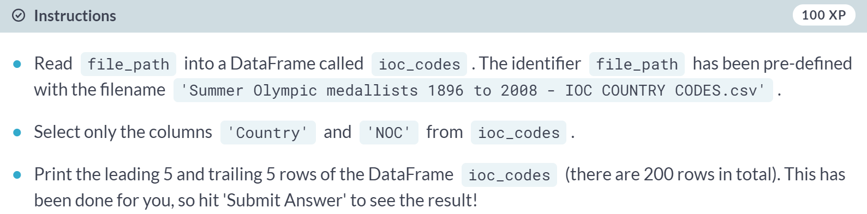

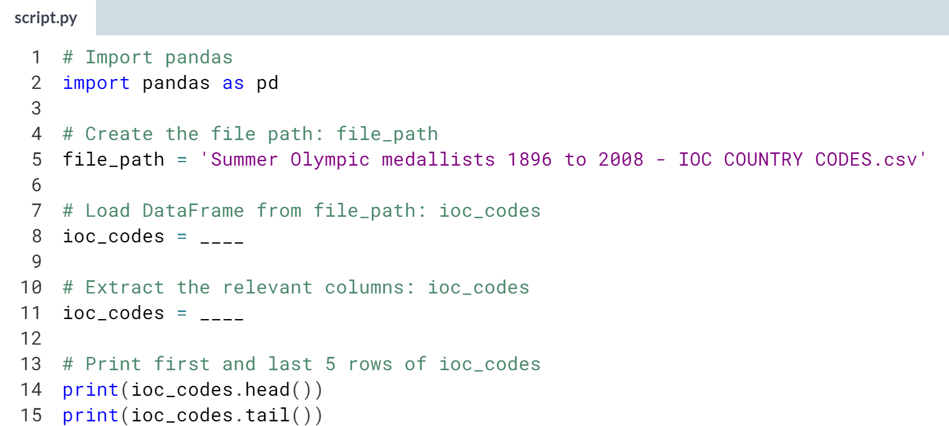

Hint

1. Use ***pd.read_csv()*** with **file_path** as argument to read the CSV file into a DataFrame.
2. To subset *ioc_codes*, pass the list **['Country', 'NOC']** to **ioc_codes[]**.

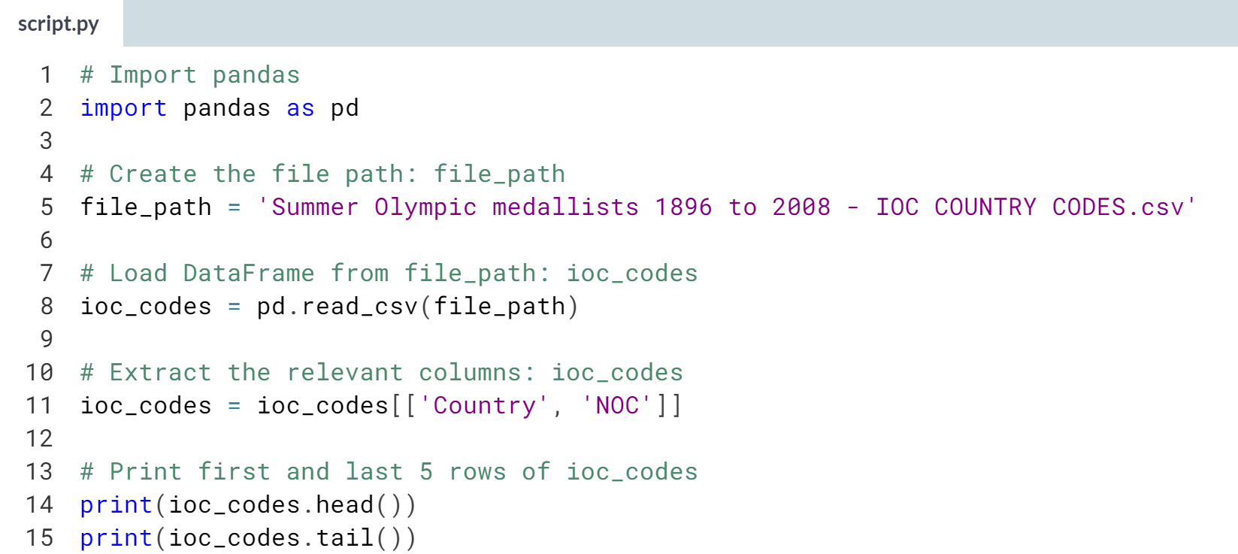

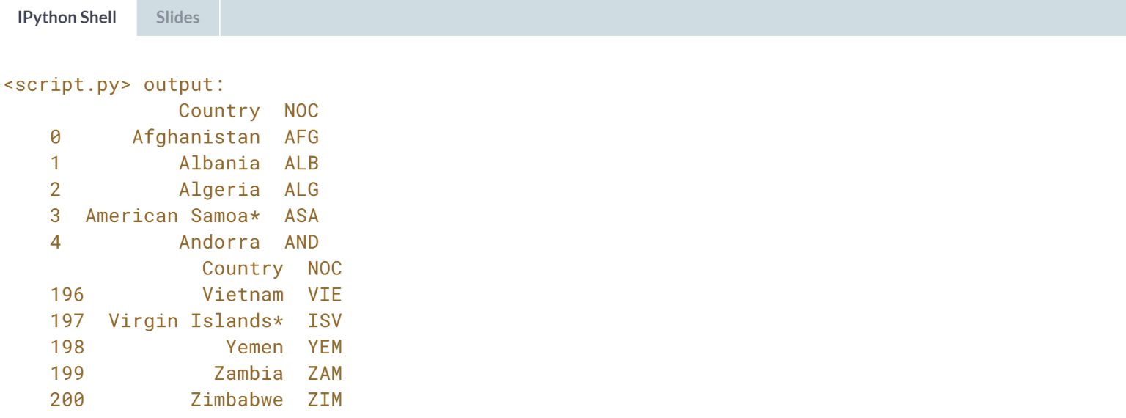

Excellent work!

# Building medals DataFrame

Here, you'll start with the DataFrame editions from the previous exercise.

You have a sequence of files summer_1896.csv, summer_1900.csv, …, summer_2008.csv, one for each Olympic edition (year). You will build up a dictionary medals_dict with the Olympic editions (years) as keys and DataFrames as values.

The dictionary is built up inside a loop over the year of each Olympic edition (from the Index of editions). Once the dictionary of DataFrames is built up, you will combine the DataFrames using pd.concat().

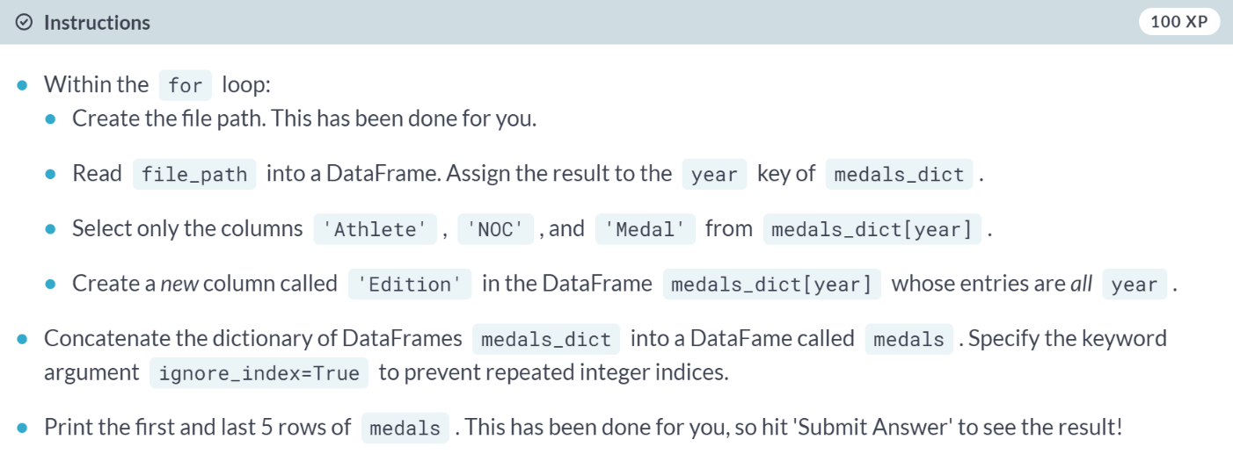

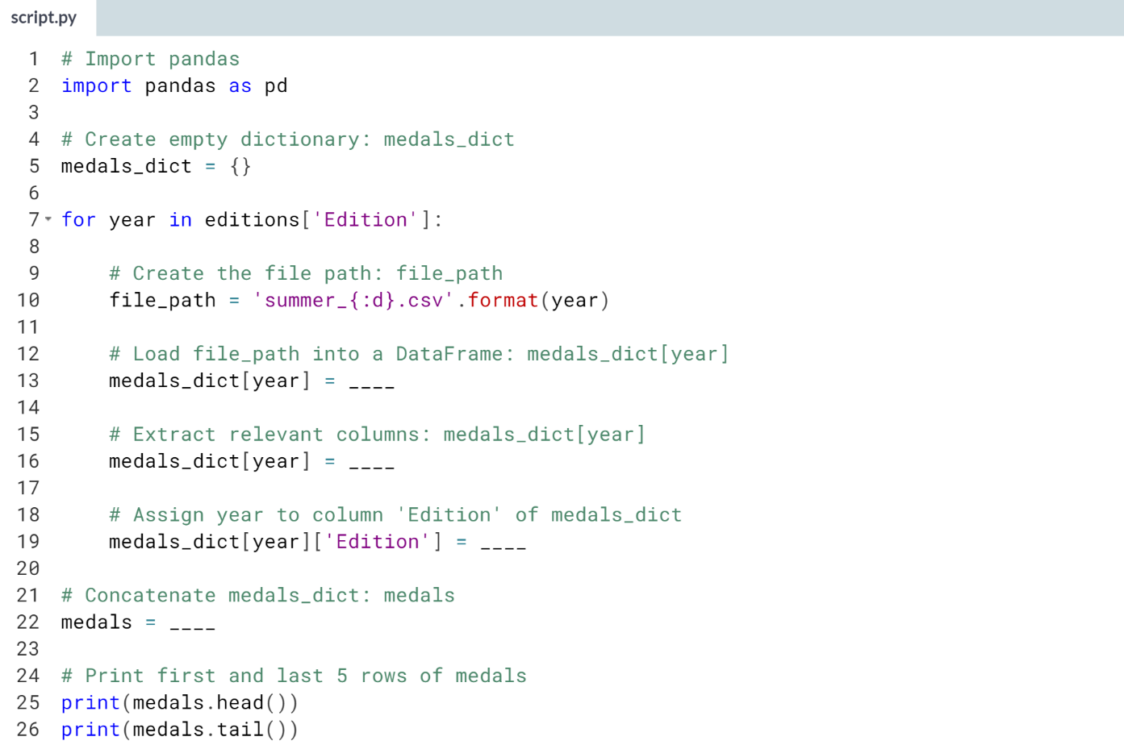

Hint

1. Use ***pd.read_csv()*** to read **file_path** into a DataFrame. Be sure to save the result to **medals_dict[year]**.
2. Use **[['Athlete', 'NOC', 'Medal']]** on **medals_dict[year]** to extract the relevant columns.
3. Assign *year* to **medals_dict[year]['Edition']** to create the new column whose entries are all year.
4. Use ***pd.concat()*** with **medals_dict** and **ignore_index=True** as arguments to create medals.

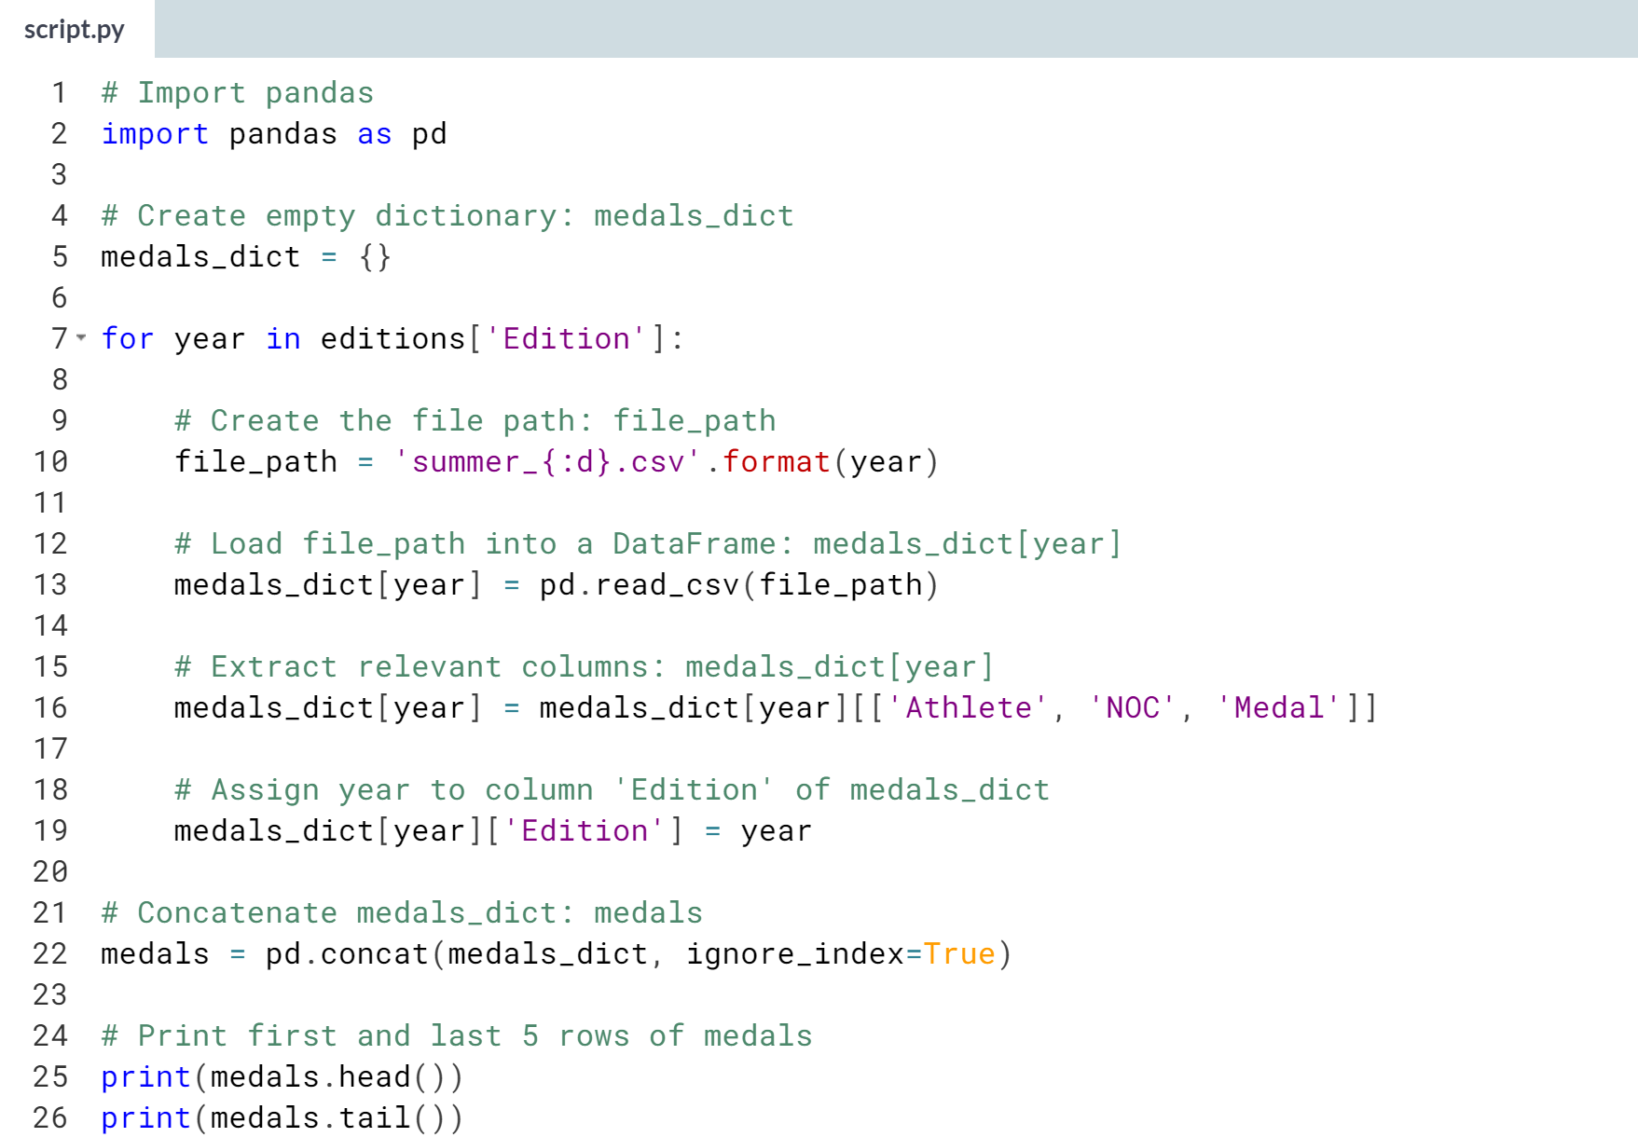

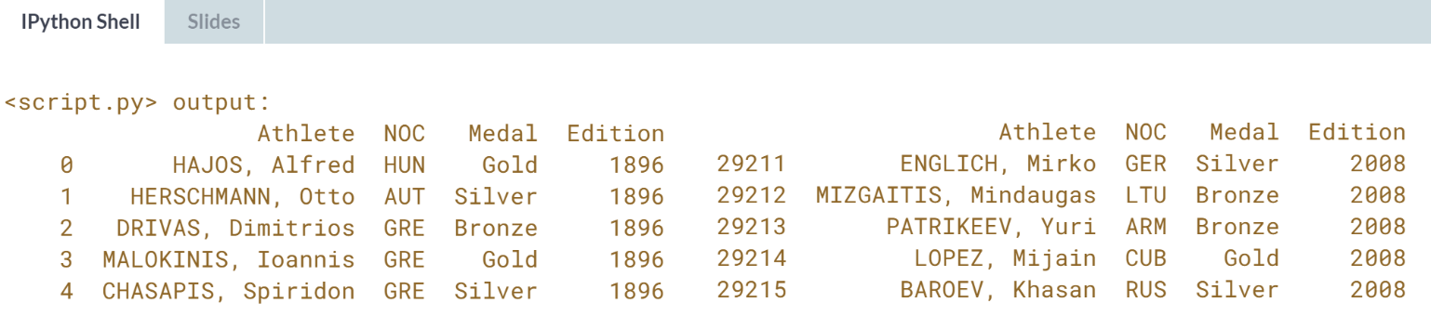

Fantastic! You're now ready to begin analyzing the medal data.



You've now created a set of DataFrames that represent the raw Olympic medal data.

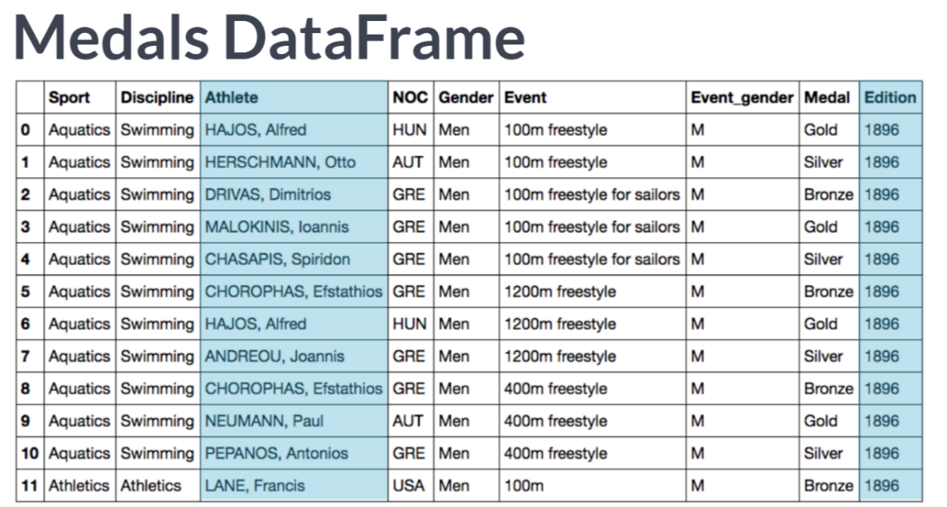  
The DataFrame, medals, describes each Athlete who won a medal in each Summer Olympic Edition.

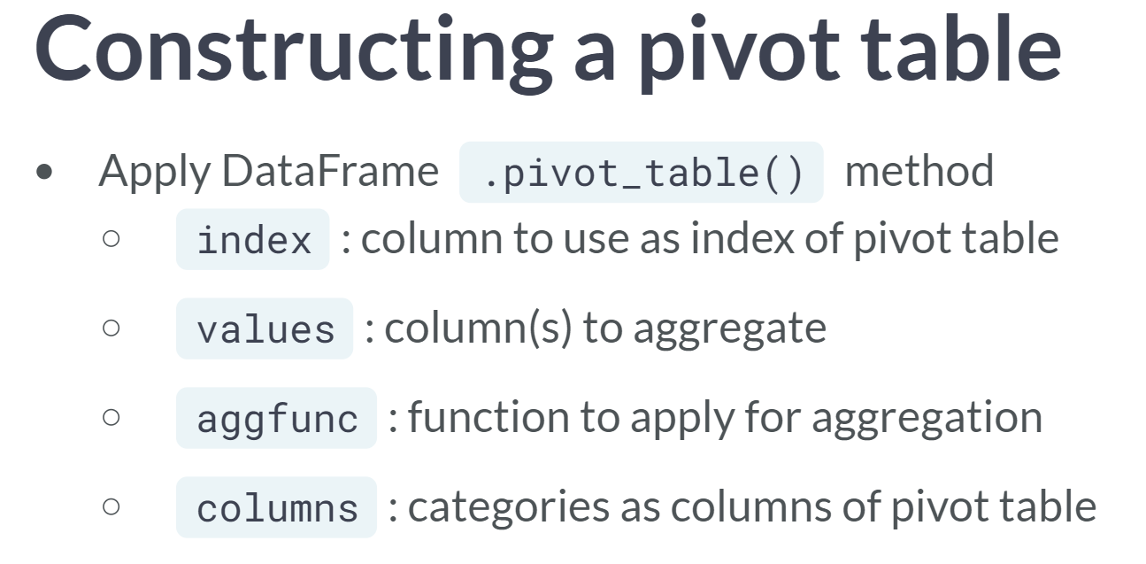  
Do some analysis now to quantify how well each country performed. You can use a pivot table to find useful patterns in the data.

Remember, the DataFrame method ***.pivot_table()*** requires the specification of the index of the table, the values to aggregate, the specific aggregation function, and the categorical columns for grouping.

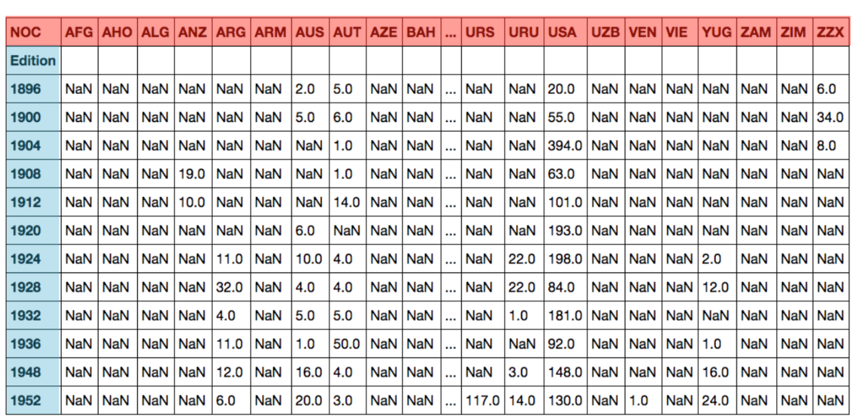  
The resulting pivot table will have the Olympic Edition on the Index and all the country codes as columns.

The entries will be the total medals awarded to each country in each year. As most competing countries fail to win medals, most entries are null.

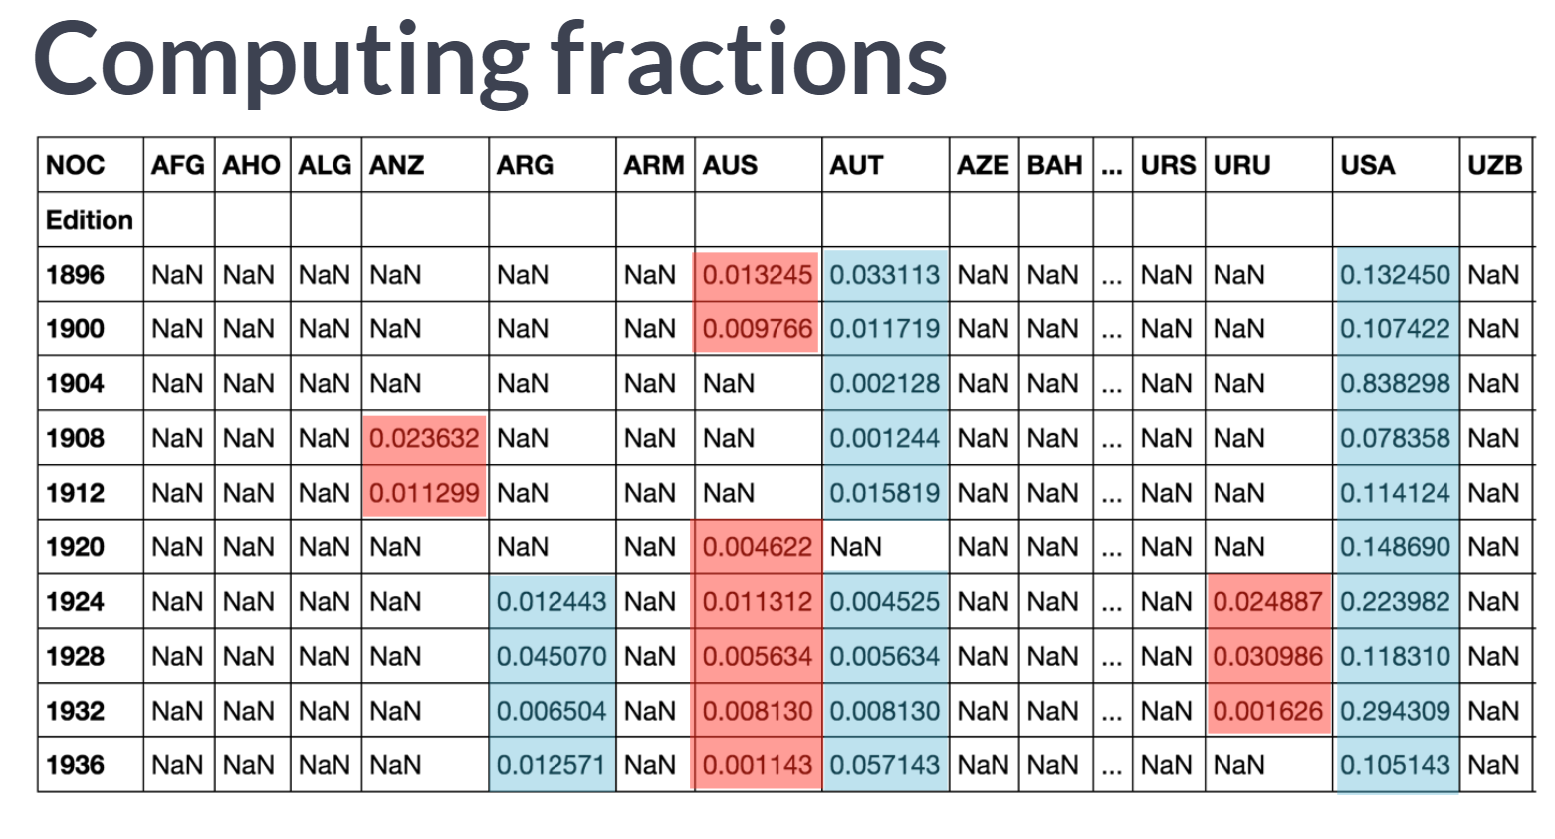  
You'll then need to normalize the number of medals won using the total number of medals awarded each Edition.

This number obviously varies from Edition to Edition. Once the data is normalized, other trends can be quantified.

# Counting medals by country/edition in a pivot table

Here, you'll start with the concatenated DataFrame medals from the previous exercise.

You can construct a pivot table to see the number of medals each country won in each year. The result is a new DataFrame with the Olympic edition on the Index and with 138 country NOC codes as columns. If you want a refresher on pivot tables, it may be useful to refer back to the relevant exercises in [**Manipulating DataFrames with pandas**](https://campus.datacamp.com/courses/manipulating-dataframes-with-pandas/rearranging-and-reshaping-data?ex=14).

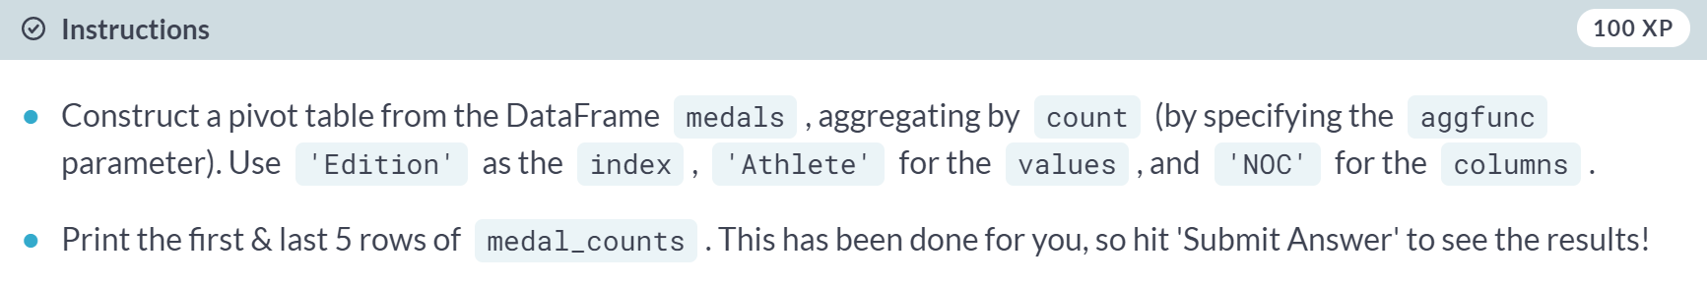

* Use the ***.pivot_table()*** method on medals and specify the keyword arguments *index='Edition'*, *values='Athlete'*, *columns='NOC'*, and *aggfunc='count'*.

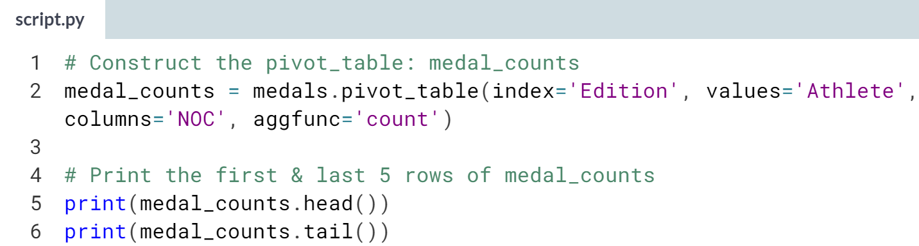  
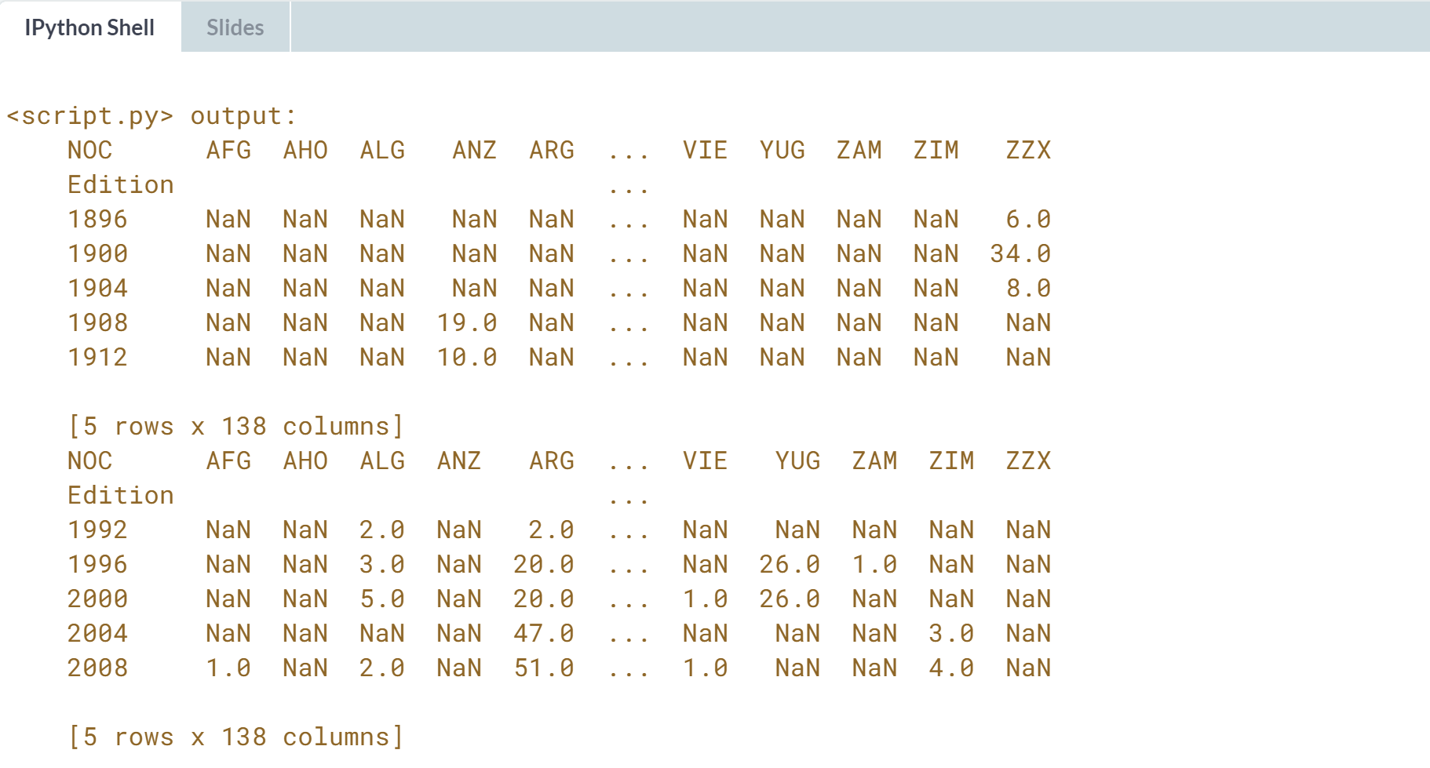  
Great work! As you can see, the pivot table DataFrame has mostly NaN entries (because most countries do not win any medals in a given Olympic edition).

# Computing fraction of medals per Olympic edition

In this exercise, you'll start with the DataFrames editions, medals, & medal_counts from prior exercises.

You can extract a Series with the total number of medals awarded in each Olympic edition.

The DataFrame medal_counts can be divided row-wise by the total number of medals awarded each edition; the method .divide() performs the broadcast as you require.

This gives you a normalized indication of each country's performance in each edition.

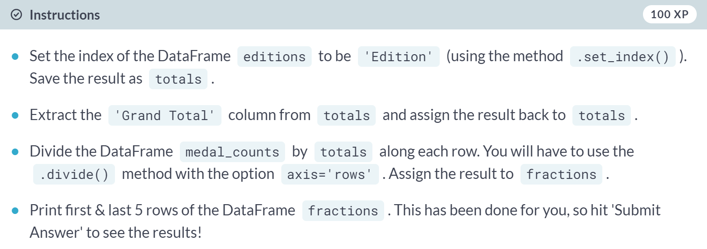

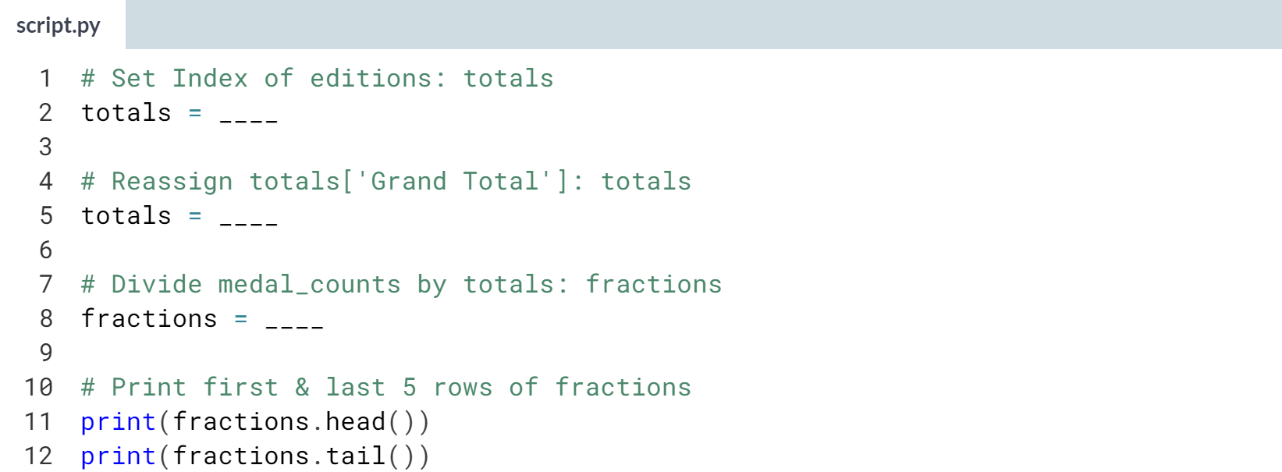

Hint

1. Use the ***.set_index()*** method on editions with *'Edition'* as the argument.
2. Assign **totals['Grand Total']** back to **totals**.
3. Use the ***.divide()*** method on **medal_counts** with **totals** and **axis='rows'** as the arguments.

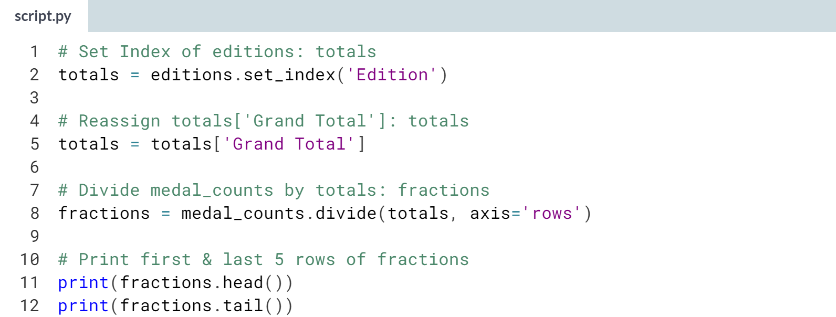

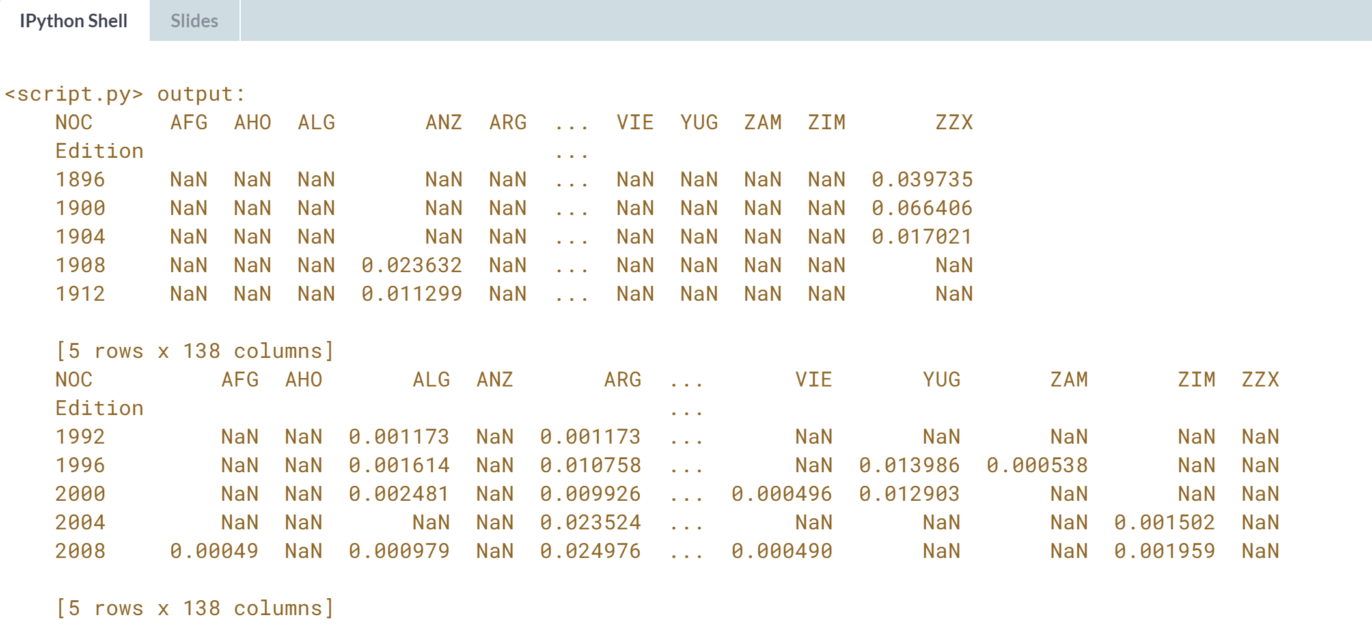

# Computing percentage change in fraction of medals won

Here, you'll start with the DataFrames editions, medals, medal_counts, & fractions from prior exercises.

To see if there is a host country advantage, you first want to see how the fraction of medals won changes from edition to edition.

The expanding mean provides a way to see this down each column. It is the value of the mean with all the data available up to that point in time. If you are interested in learning more about pandas' expanding transformations, this section of the [**pandas documentation**](http://pandas.pydata.org/pandas-docs/stable/computation.html#expanding-windows) has additional information.

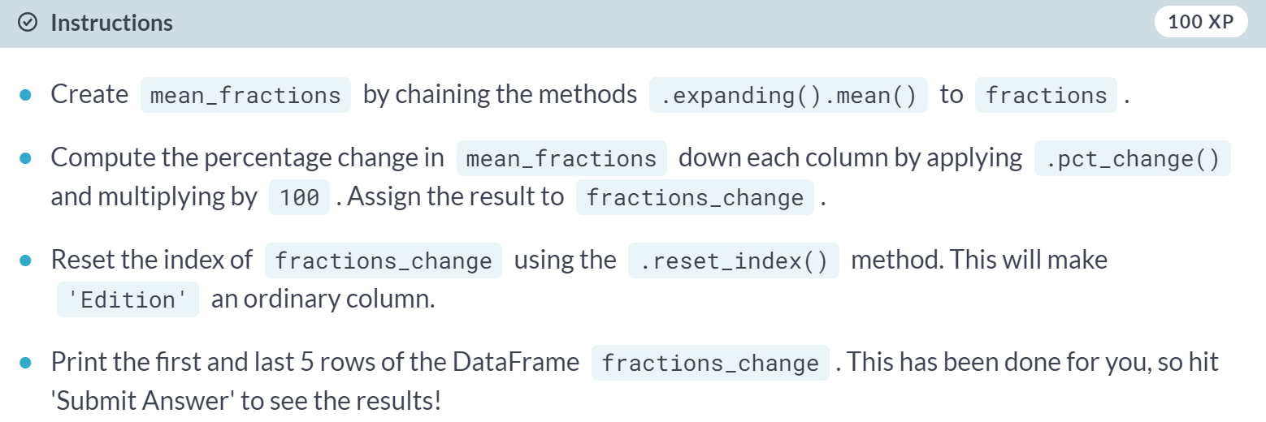

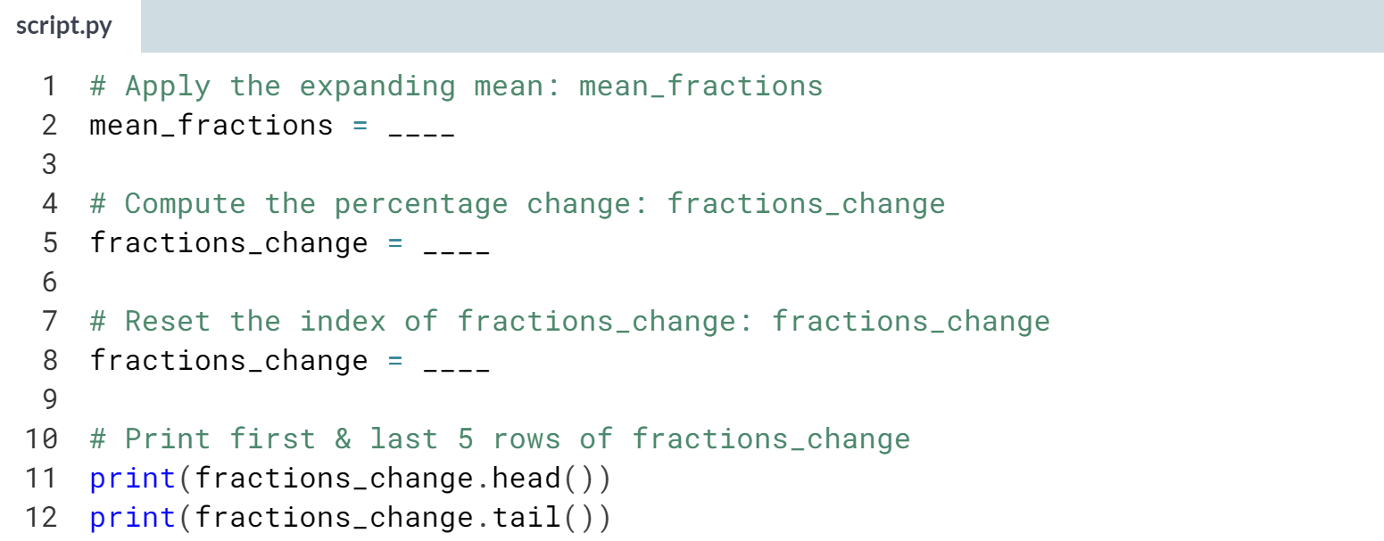

1. Apply the method chain **.expanding().mean()** on fractions to compute **mean_fractions**.
2. Use the method ***.pct_change()*** on **mean_fractions** and multiply this by 100 to compute the percentage change.
3. Use the ***.reset_index()*** method on **fractions_change** to reset its index.

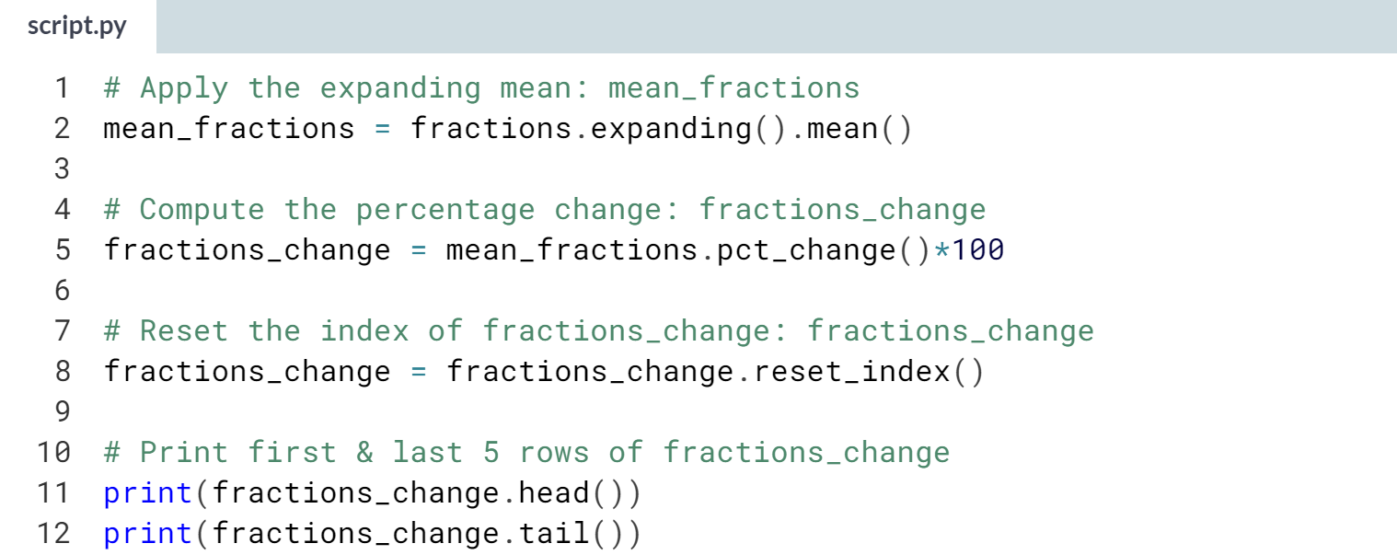

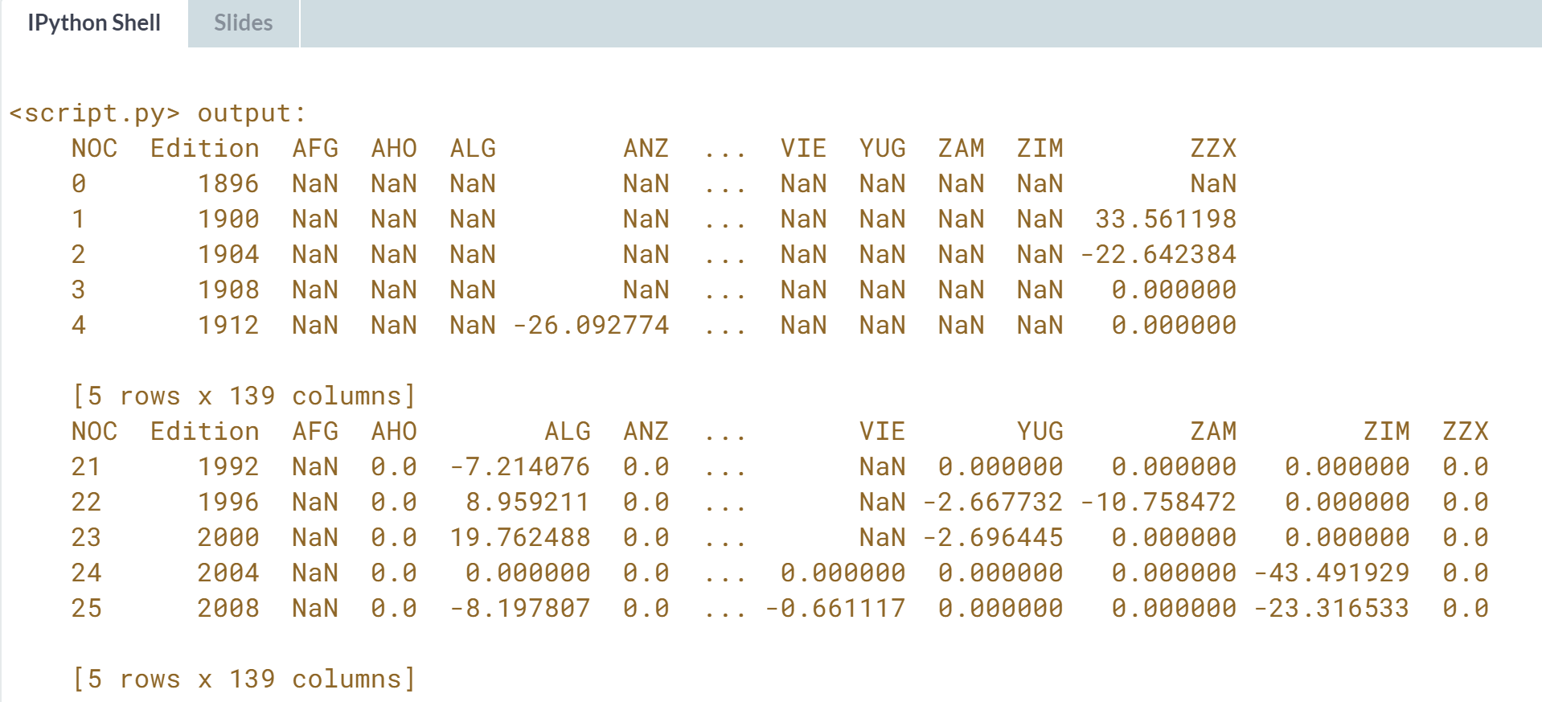

Great work!



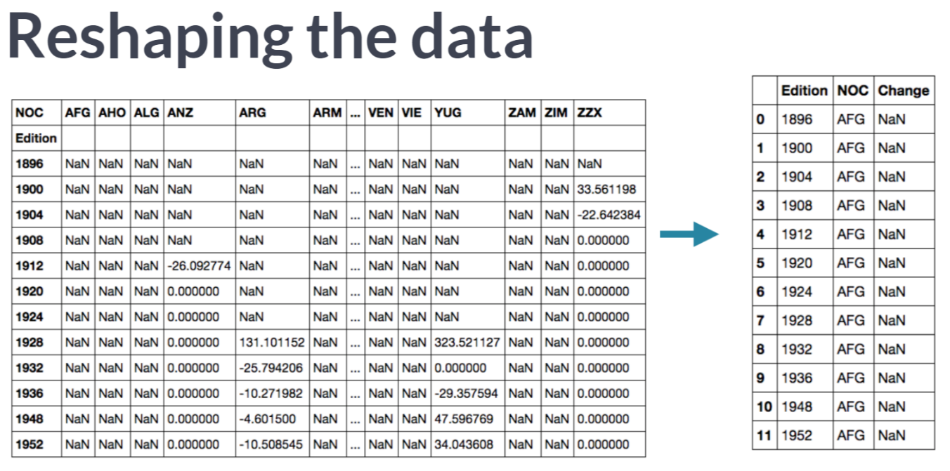  
To get an idea of the trends, you now want to melt or reshape the data to make it easier to work with.

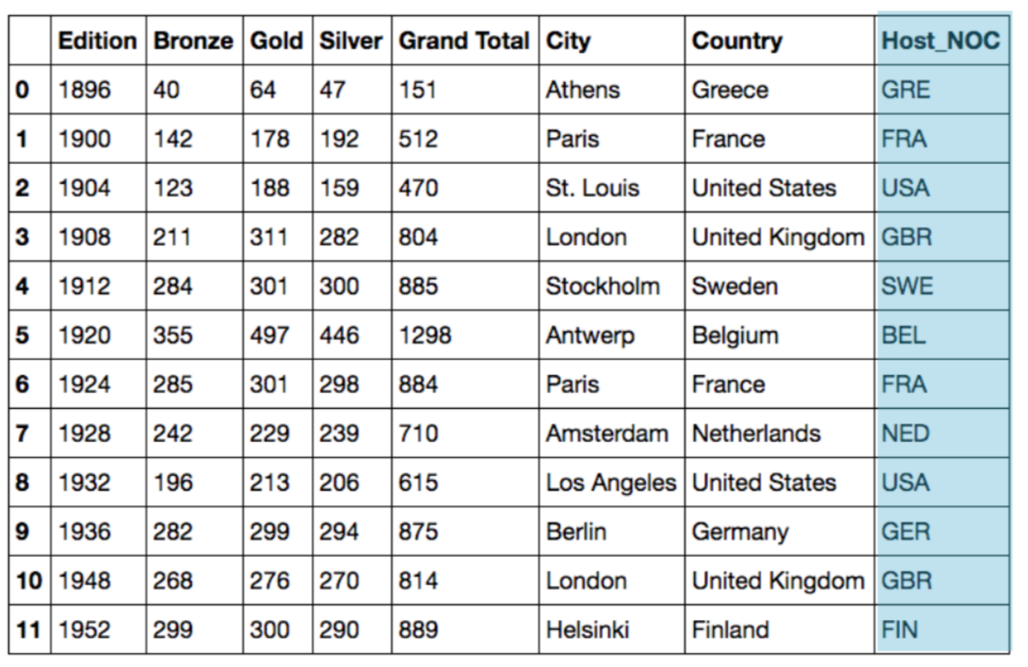  
You will also need to integrate the host country data into your analysis. You will merge that information into a new DataFrame using other DataFrames from before.

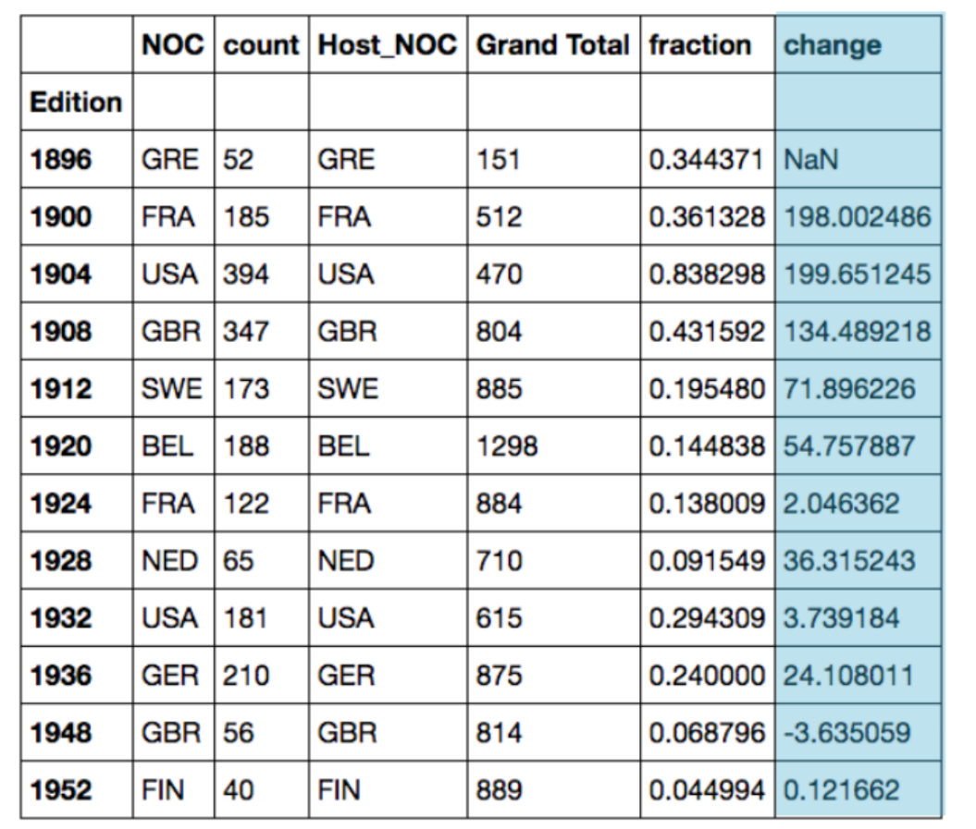  
You will execute another merge to yield a DataFrame that quantifies the influence of being the hosting country on the percentage change in the fraction of medals won.

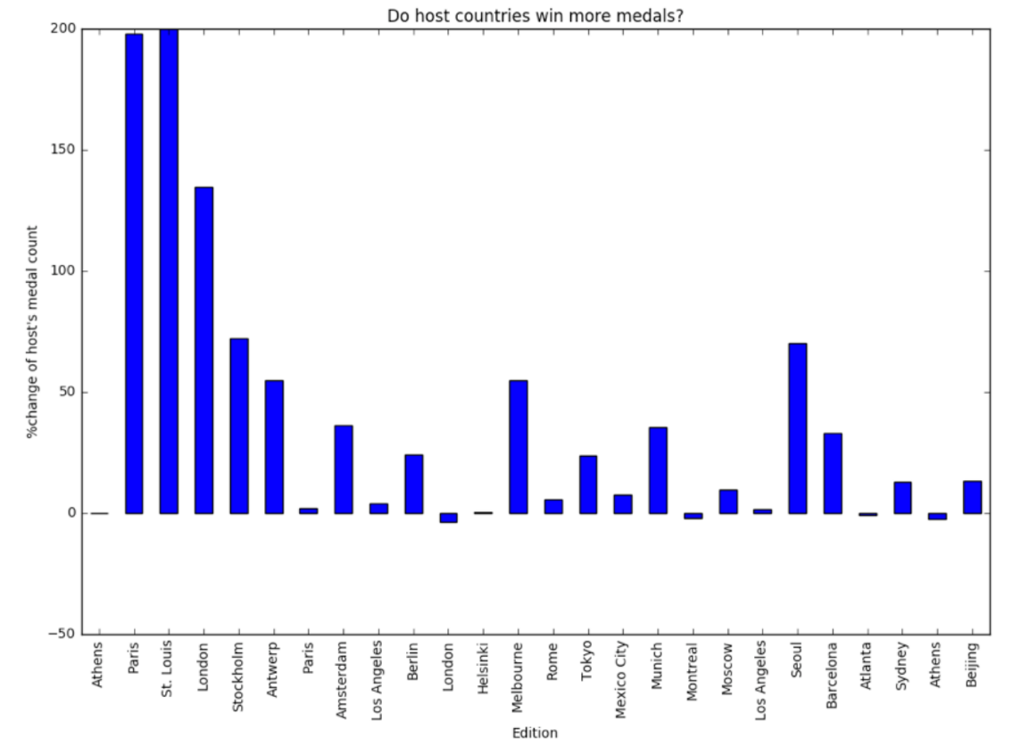  
Finally, you will summarize these values in a bar plot. If the plot shows large positive changes systematically, then you've gathered evidence to support the notion of a host advantage.

# Building hosts DataFrame

Your task here is to prepare a DataFrame hosts by left joining editions and ioc_codes. Once created, you will subset the Edition and NOC columns and set Edition as the Index.

There are some missing NOC values; you will set those explicitly. Finally, you'll reset the Index & print the final DataFrame.

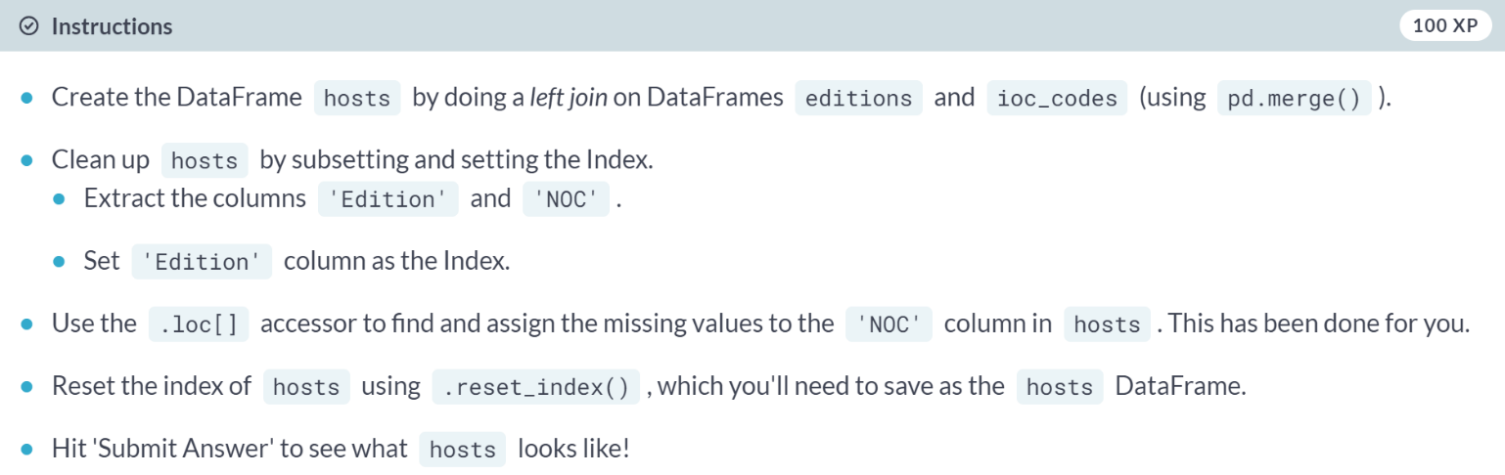

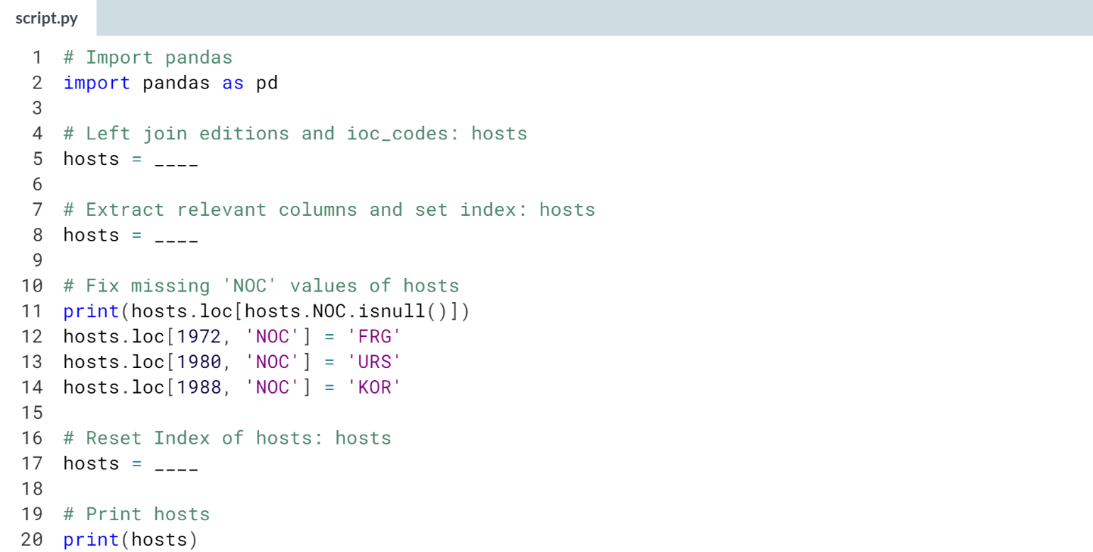

Hint

1. Use ***pd.merge()*** with editions and *ioc_codes* as arguments as well as the keyword argument *how='left'*.
2. First extract the columns *'Edition'* and *'NOC'* using **[['Edition','NOC']]**, and then use ***.set_index()*** method to set the *Index* to be *'Edition'*.
3. Use the ***.reset_index()*** method on hosts to reset the Index. Assign this to the hosts DataFrame.

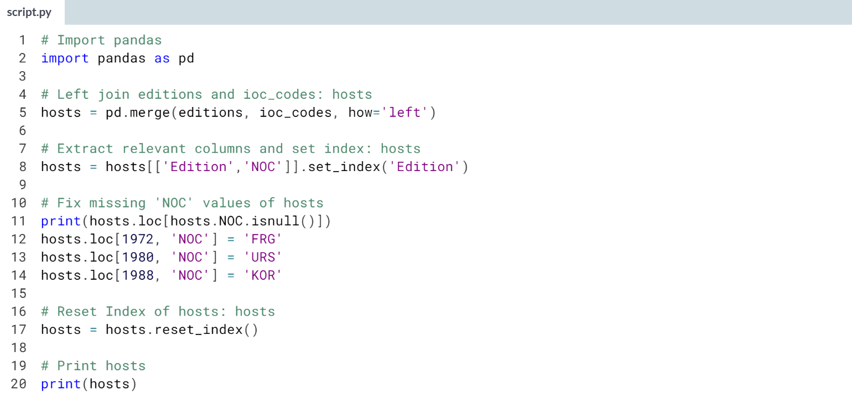

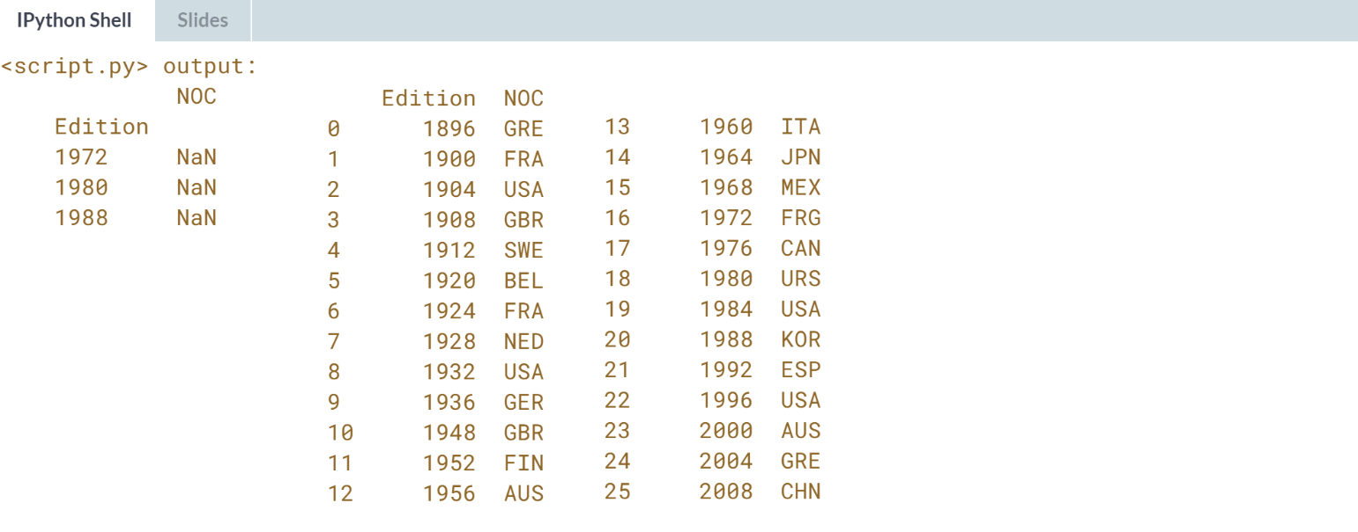

Good job! You now have a DataFrame consisting of all the hosts.

# Reshaping for analysis

This exercise starts off with fractions_change and hosts already loaded. Your task here is to reshape the fractions_change DataFrame for later analysis.

Initially, fractions_change is a wide DataFrame of 26 rows (one for each Olympic edition) and 139 columns (one for the edition and 138 for the competing countries).

On reshaping with pd.melt(), as you will see, the result is a tall DataFrame with 3588 rows and 3 columns that summarizes the fractional change in the expanding mean of the percentage of medals won for each country in blocks.

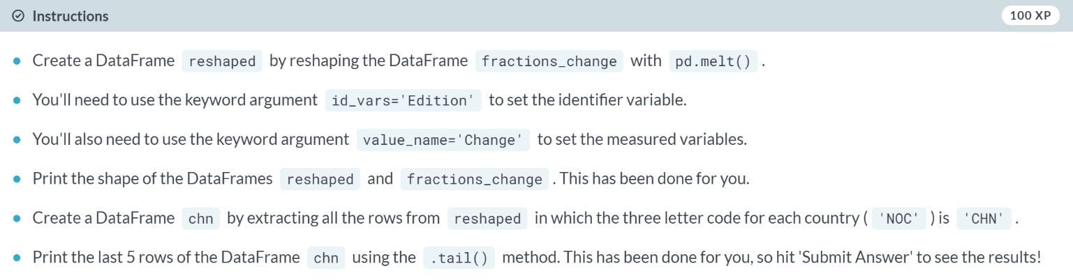

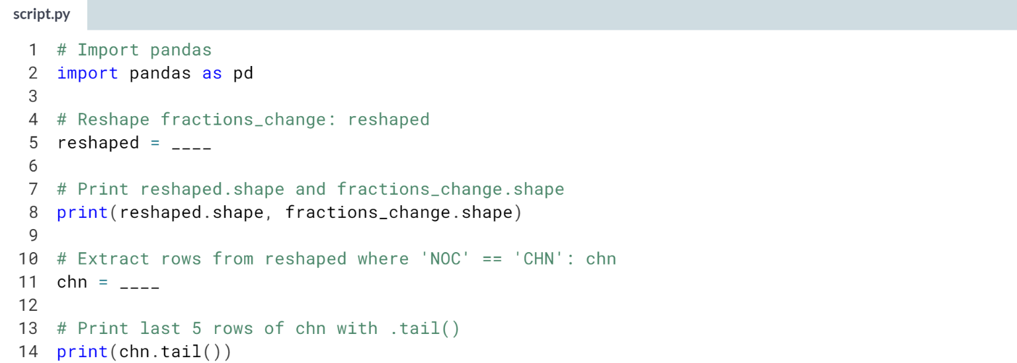

Hint

1. Use the ***pd.melt()*** function on *fractions_change* with the keyword arguments **id_vars='Edition'** and **value_name='Change'**.
2. Use the **.loc[]** accessor with **reshaped.NOC == 'CHN'** to extract the relevant rows.

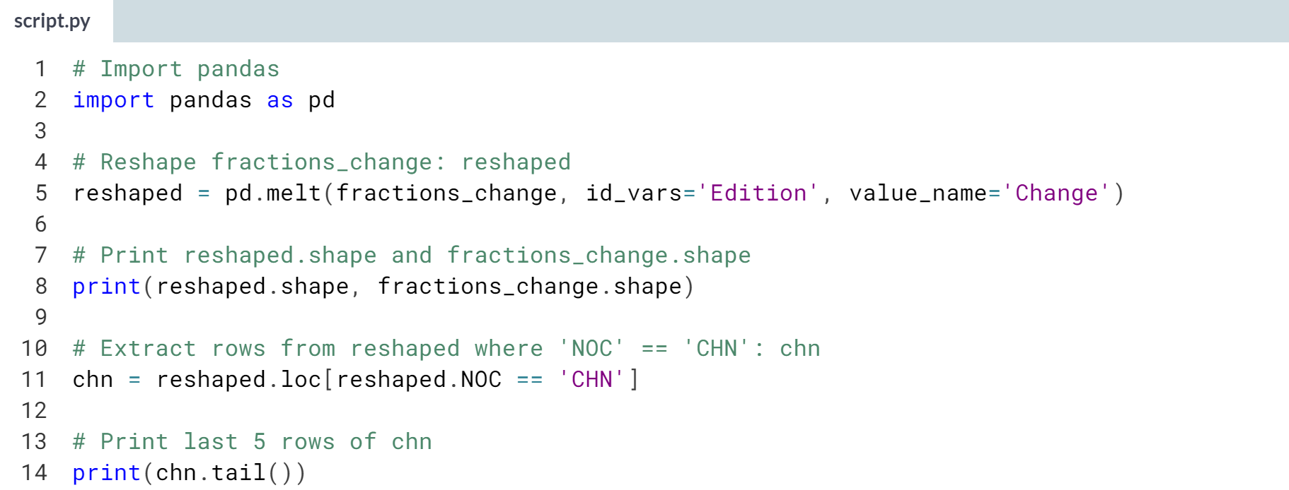

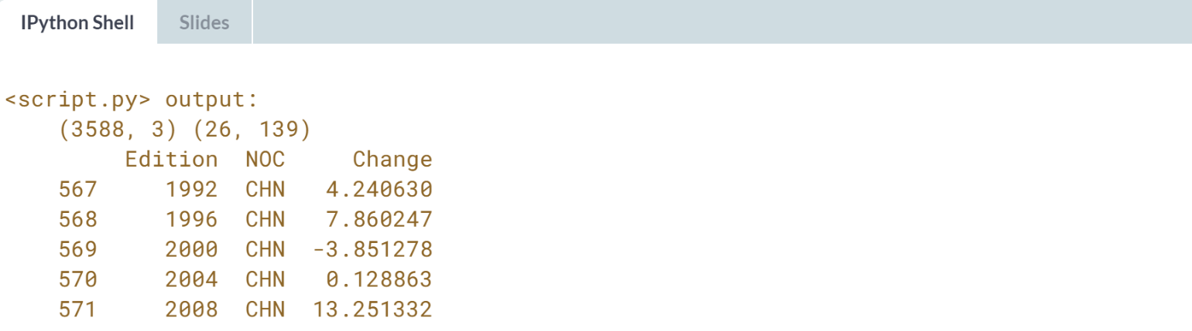

Great work! On looking at the hosting countries from the last 5 Olympic editions and the fractional change of medals won by China the last 5 editions, you can see that China fared significantly better in 2008 (i.e., when China was the host country).

# Merging to compute influence

This exercise starts off with the DataFrames reshaped and hosts in the namespace.

Your task is to merge the two DataFrames and tidy the result.

The end result is a DataFrame summarizing the fractional change in the expanding mean of the percentage of medals won for the host country in each Olympic edition.

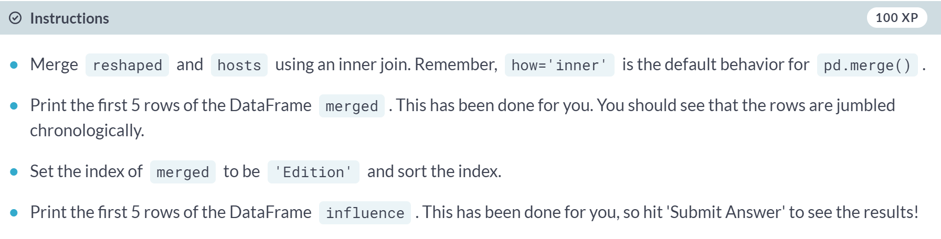

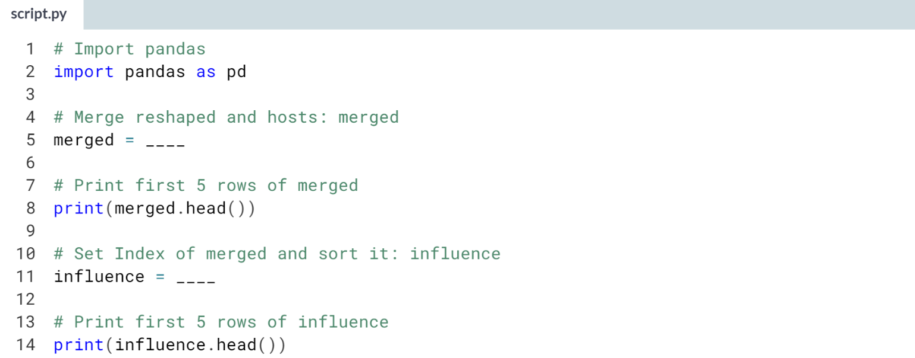

1. Use ***pd.merge()*** with reshaped and hosts as the two arguments. There is no need to specify **how='inner'** since it is the default behavior of ***pd.merge()***.
2. Use ***.set_index()*** on merged to set its *Index* to *'Edition'*. Then, use the ***.sort_index()*** on this to sort the index.

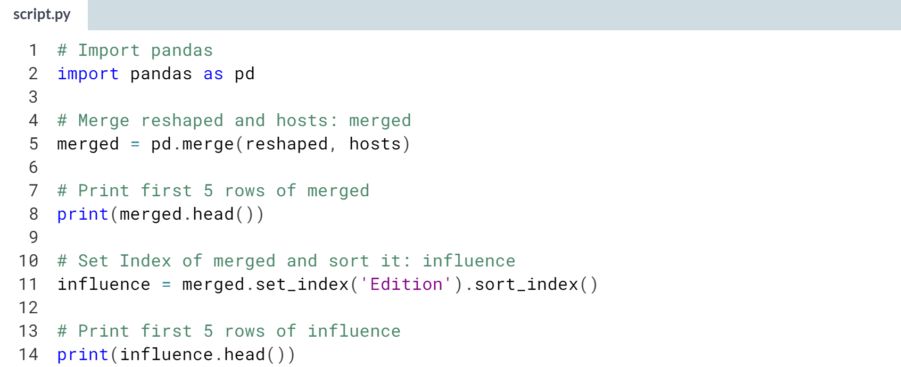

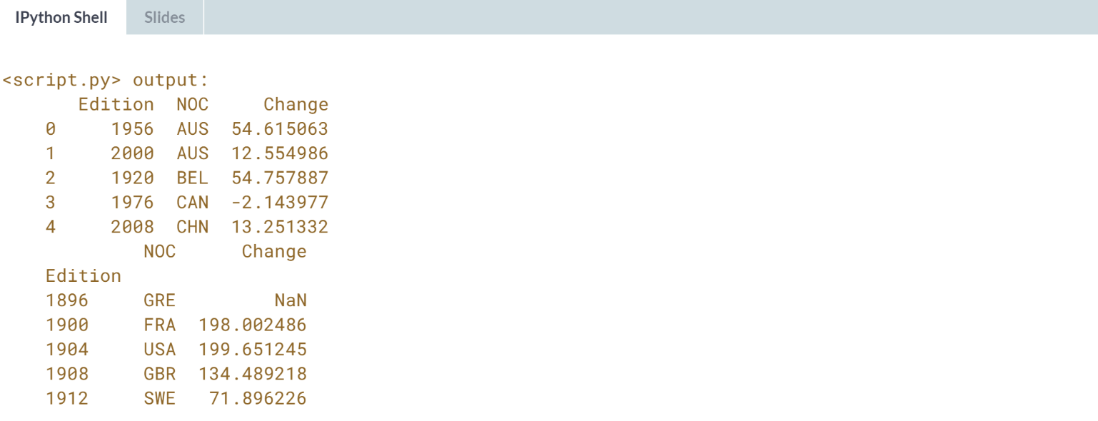

Well done! It would be far more informative to visualize these results. This is exactly what you'll do in the next exercise!

# Plotting influence of host country

This final exercise starts off with the DataFrames influence and editions in the namespace. Your job is to plot the influence of being a host country.

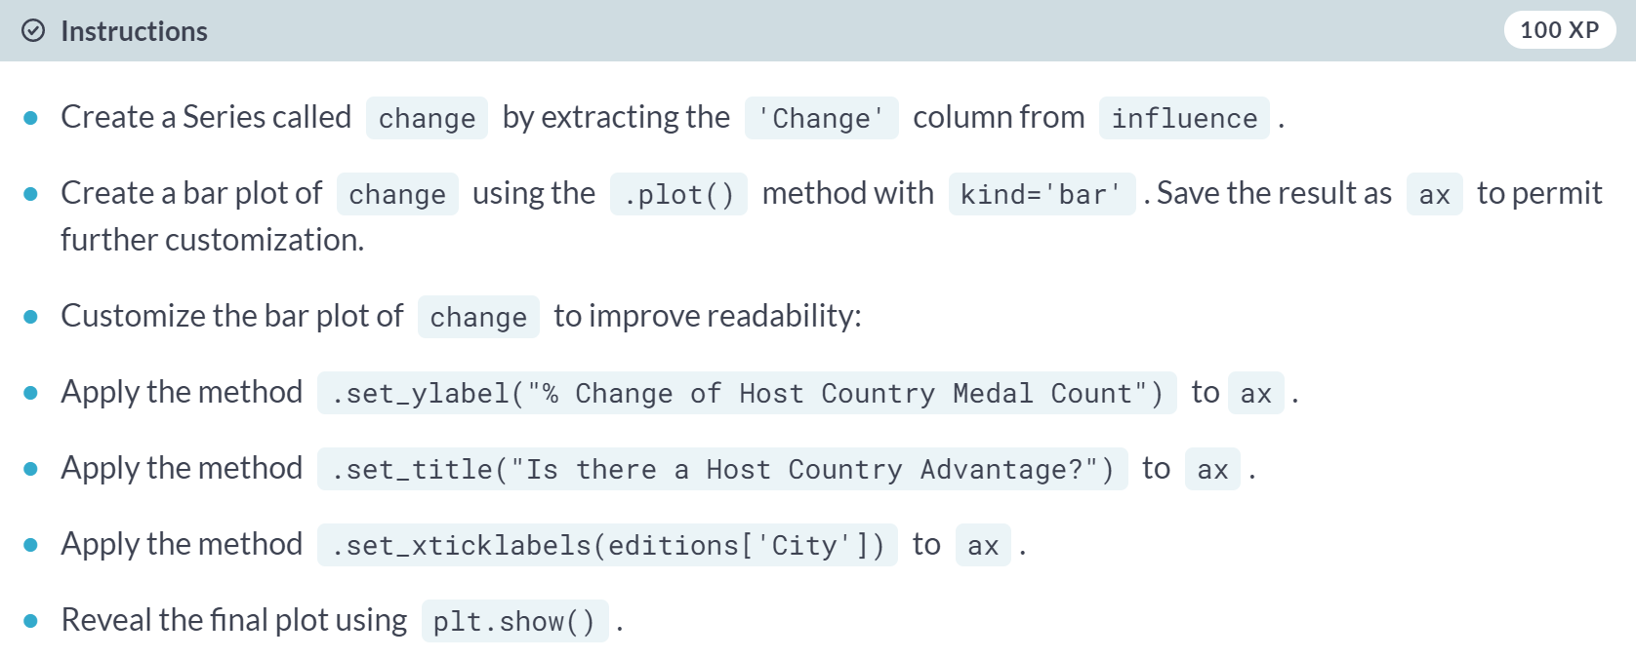

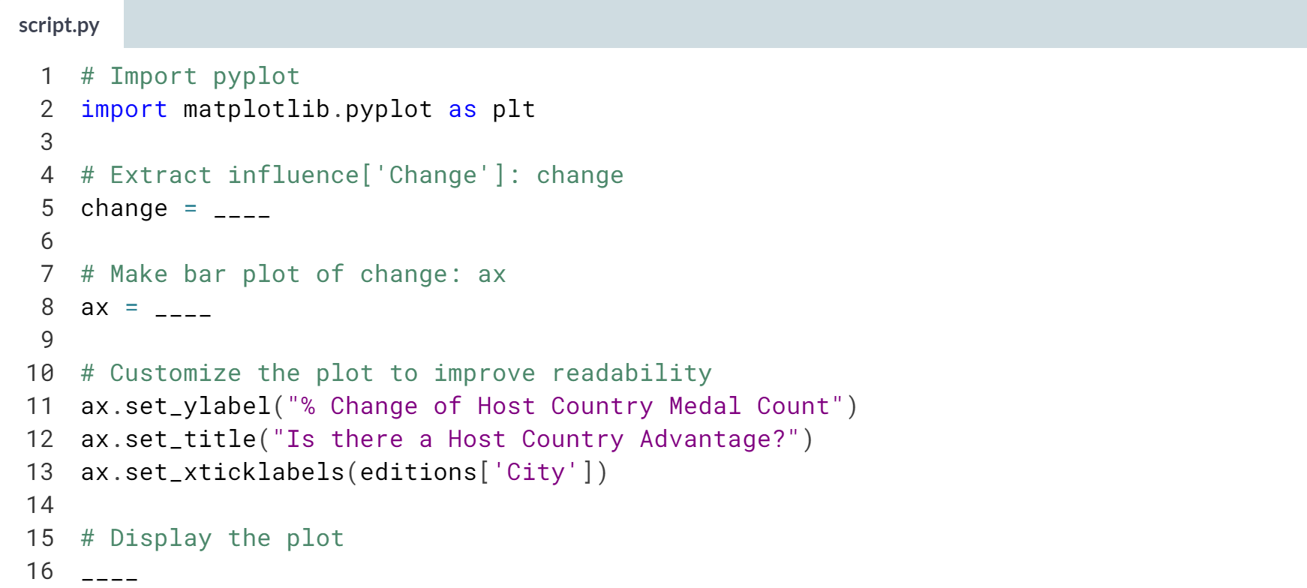

1. To create the Series, assign **influence['Change']** to **change**.
2. To create the bar plot, use the ***.plot()*** method on change with **kind='bar'** as the argument.
3. Follow the steps described in the instructions to customize the bar plot. Apply the relevant methods on the object **ax**.
4. Be sure to end your plotting statements with ***plt.show()*** to display the plot.

